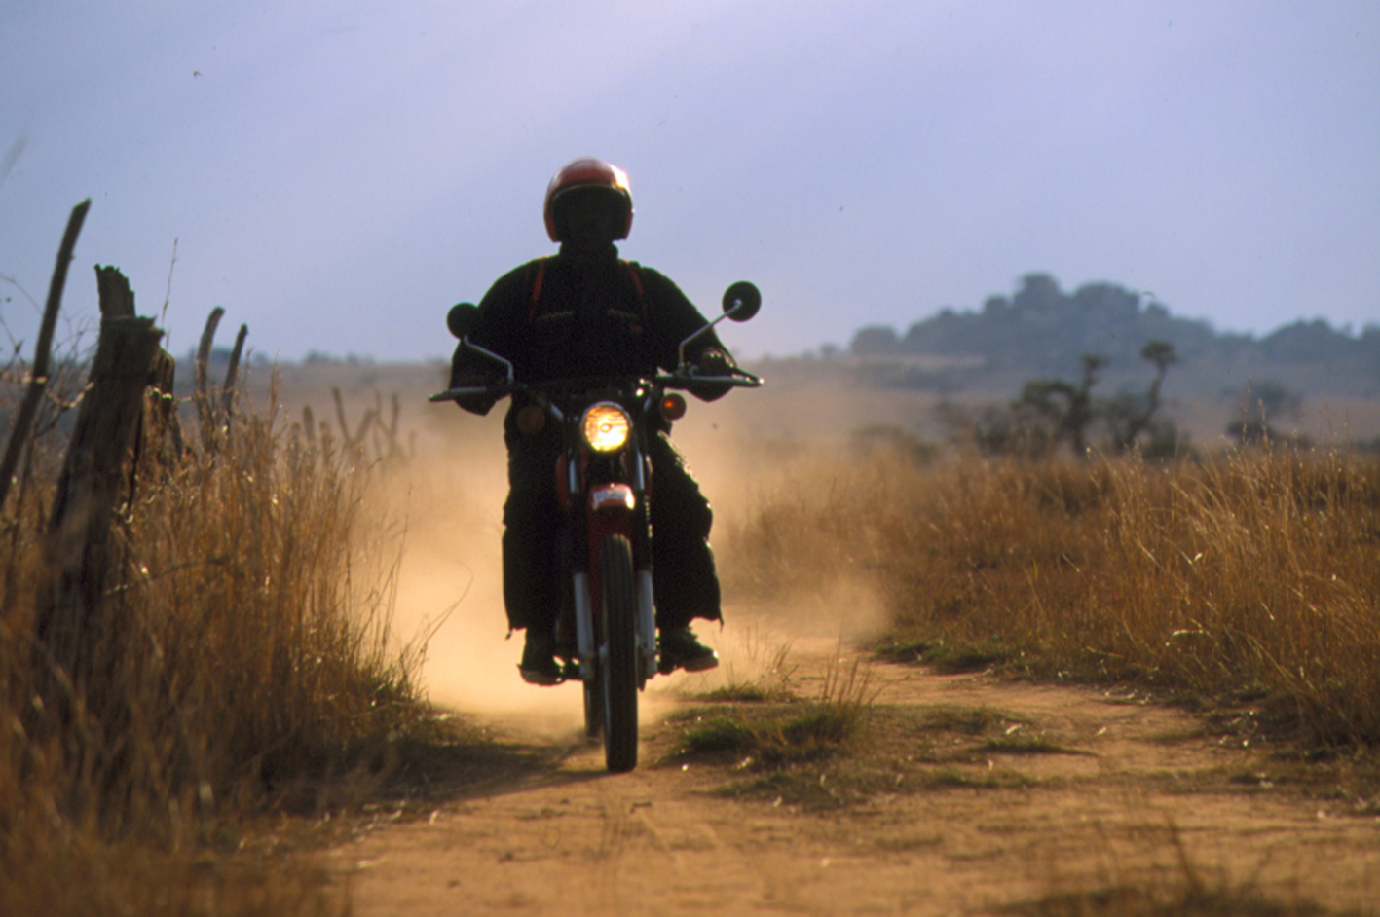

“With Riders, we can deliver our emergency services,
we can visit the communities, we can help the people”.
Permanent Secretary, Dept of Health and Child Welfare, Zimbabwe.

Riders for Health Zimbabwe update report – 2006

Reaching communities

In 2006, the Riders Zimbabwe programme reached a milestone of ten years in operation. The impact of Riders’ services on the mobility of the Ministry of Health and Child Welfare has been incredible. Approximately 90% more health workers are now using vehicles to reach their communities, while the annual motorcycle fleet maintenance cost per thousand people reached by those health workers has dropped by 62%.

Two years ago, Honda Motor Company made the landmark decision to donate 75 XL125 motorcycles to the Riders programme in Zimbabwe, together with parts to keep them running for five years. These resilient motorcycles have now been handed over to the Ministry of Health and Child Welfare, and have all been allocated to health workers on a district by district basis.

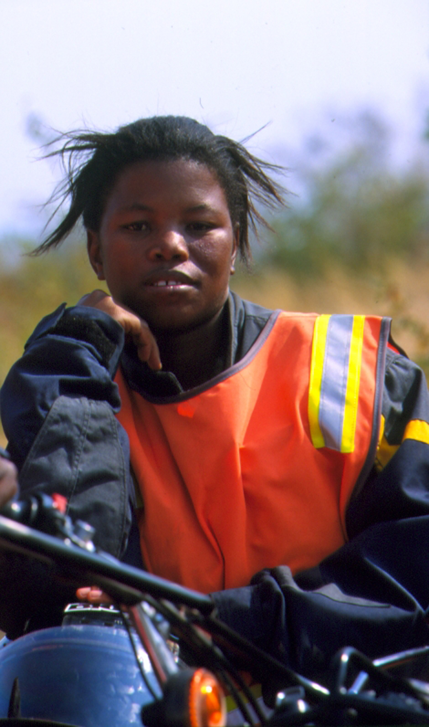
The success of this systematic approach has been proven in Binga, one of the poorest districts in the country, where Riders manages the motorcycles for all 15 environmental health technicians and one family planning worker.

The 16 health workers – known locally as the Riders – are a tight-knit group and together they check the hygiene conditions of a 250km wide area, where there are almost no roads. Their head office is at Binga hospital where they meet to plan their work based on the needs of the various villages.

Pumilani (pictured right) is the youngest of the Binga Riders.
”I am extremely proud of my bike”, she says. “I live in a village near the hospital and I feel very important knowing that thanks to this bike I can help my people.”

Simangiwe is a nurse at Binga hospital. She says of the Riders: “Medical care here is entirely in our hands and the hands of the Riders. People are very suspicious about coming to the hospital for medical help. Only the Riders, whom everyone trusts, manage to convince the people to come.”

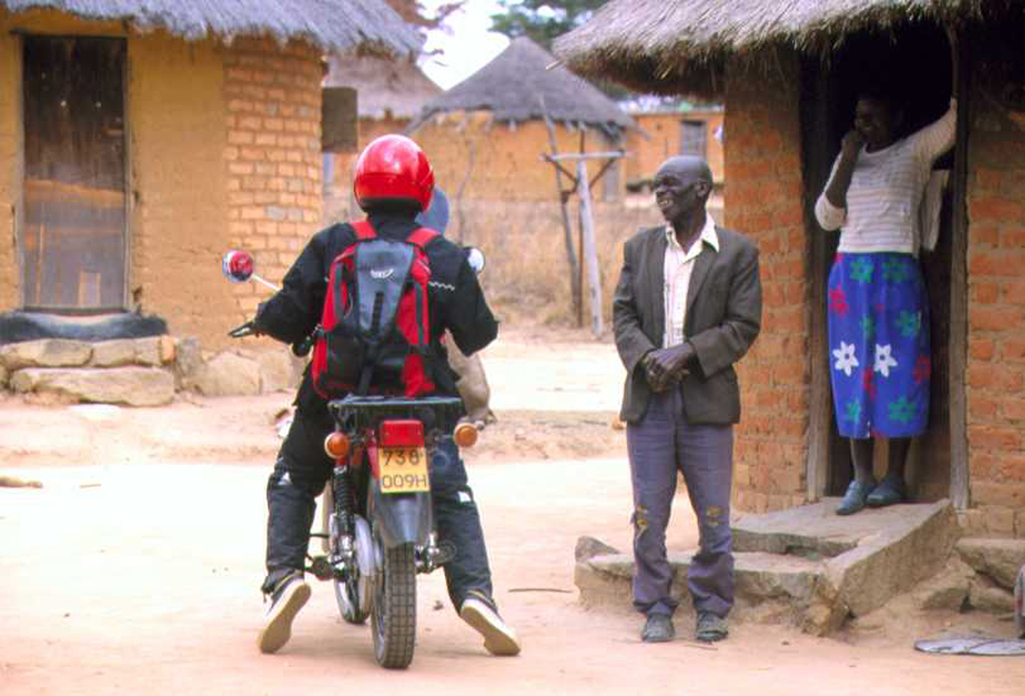
The increased mobility of the health workers means that they can make regular visits to communities and schools to give advice on preventative health measures such as hygiene rules, family planning and ways to prevent the spread of diseases such as cholera and HIV/Aids. “It’s difficult talking about sexually transmitted diseases’, says Barbara, one of the Riders. “You need to be particularly sensitive and encourage the listener to trust you.”
Above: A health worker visits a family.

The Riders are also responsible for the fight against malaria – one of the region’s biggest killers. As well as advising villages on the necessary precautions, the health workers distribute mosquito nets and tools for disinfestations, and instruct the village volunteers on how to use them. Academic research suggests that this systematic coverage has resulted in a 20% drop in deaths from malaria in the district.

Sharing expertise – the IAVM

Riders’ International Academy of Vehicle Management has continued to grow as a respected centre of excellence for training in safe riding/driving and vehicle maintenance. 289 delegates received training during 2006 – many of whom trained under the bursary scheme for small, local NGOs with few resources.

Happyson Simango, who works with orphans and vulnerable children, attended the Motorcycle Riding and Basic Maintenance Course and commented: “The course helped me so much because, before, I was not able to ride, but now I am able to ride like nobody’s business. The entire team within the Riders’ Academy is very encouraging and friendly and, above all, they know their job. Keep up the good work!”

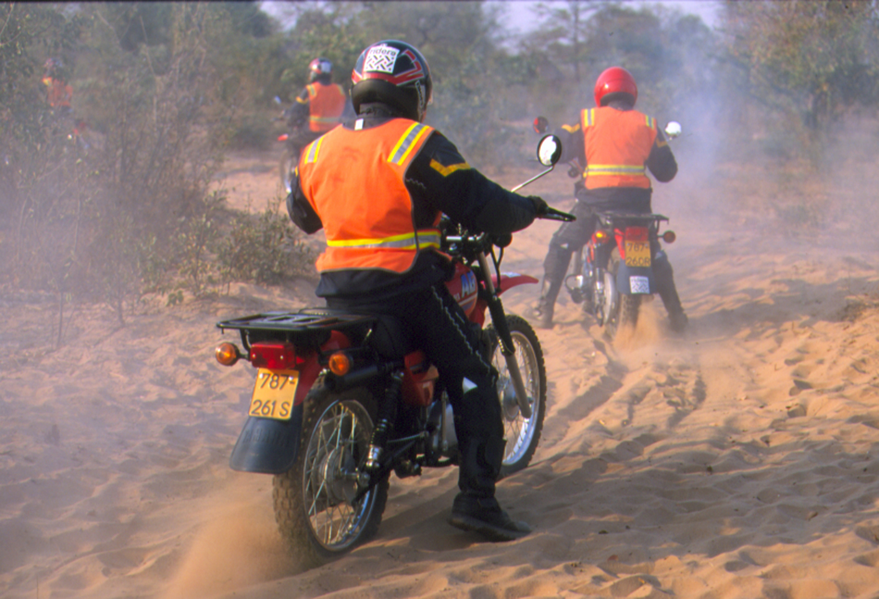

Above: A trainee learns to ride through sand at the IAVM.

Thank you

None of Riders’ achievements in 2006 would have been possible without the generous support we have received through GlobalGiving. On behalf of all the people in Zimbabwe who are now able to access the kind of healthcare services the developed world takes for granted, Riders for Health would like to say “thank you”.

For more information

Riders for Health 0044 (0) 1327 300047
3 New Street rfh@riders.org
Daventry www.riders.org
Northants
NN11 4BT UK REGISTERED CHARITY NUMBER 1054565

