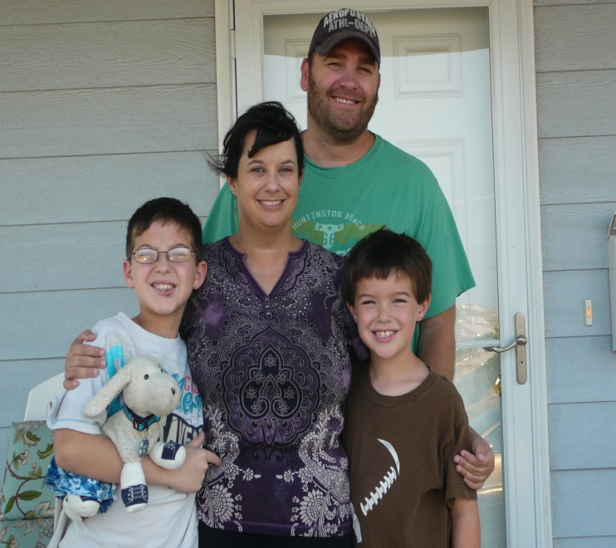

“**I just tell people to hold their heads up high. It’s in times of tragedy that God shows you His mercy and His grace. We don’t know what the bigger picture is, but look for every little blessing. You’ve just got to start looking.”**