Jordan Program Summary

Schools Online has been operational in school connectivity and training programs in Jordan since 2001, opening 11 internet learning centers throughout the country and developing their capacities and applications through training and program direction.
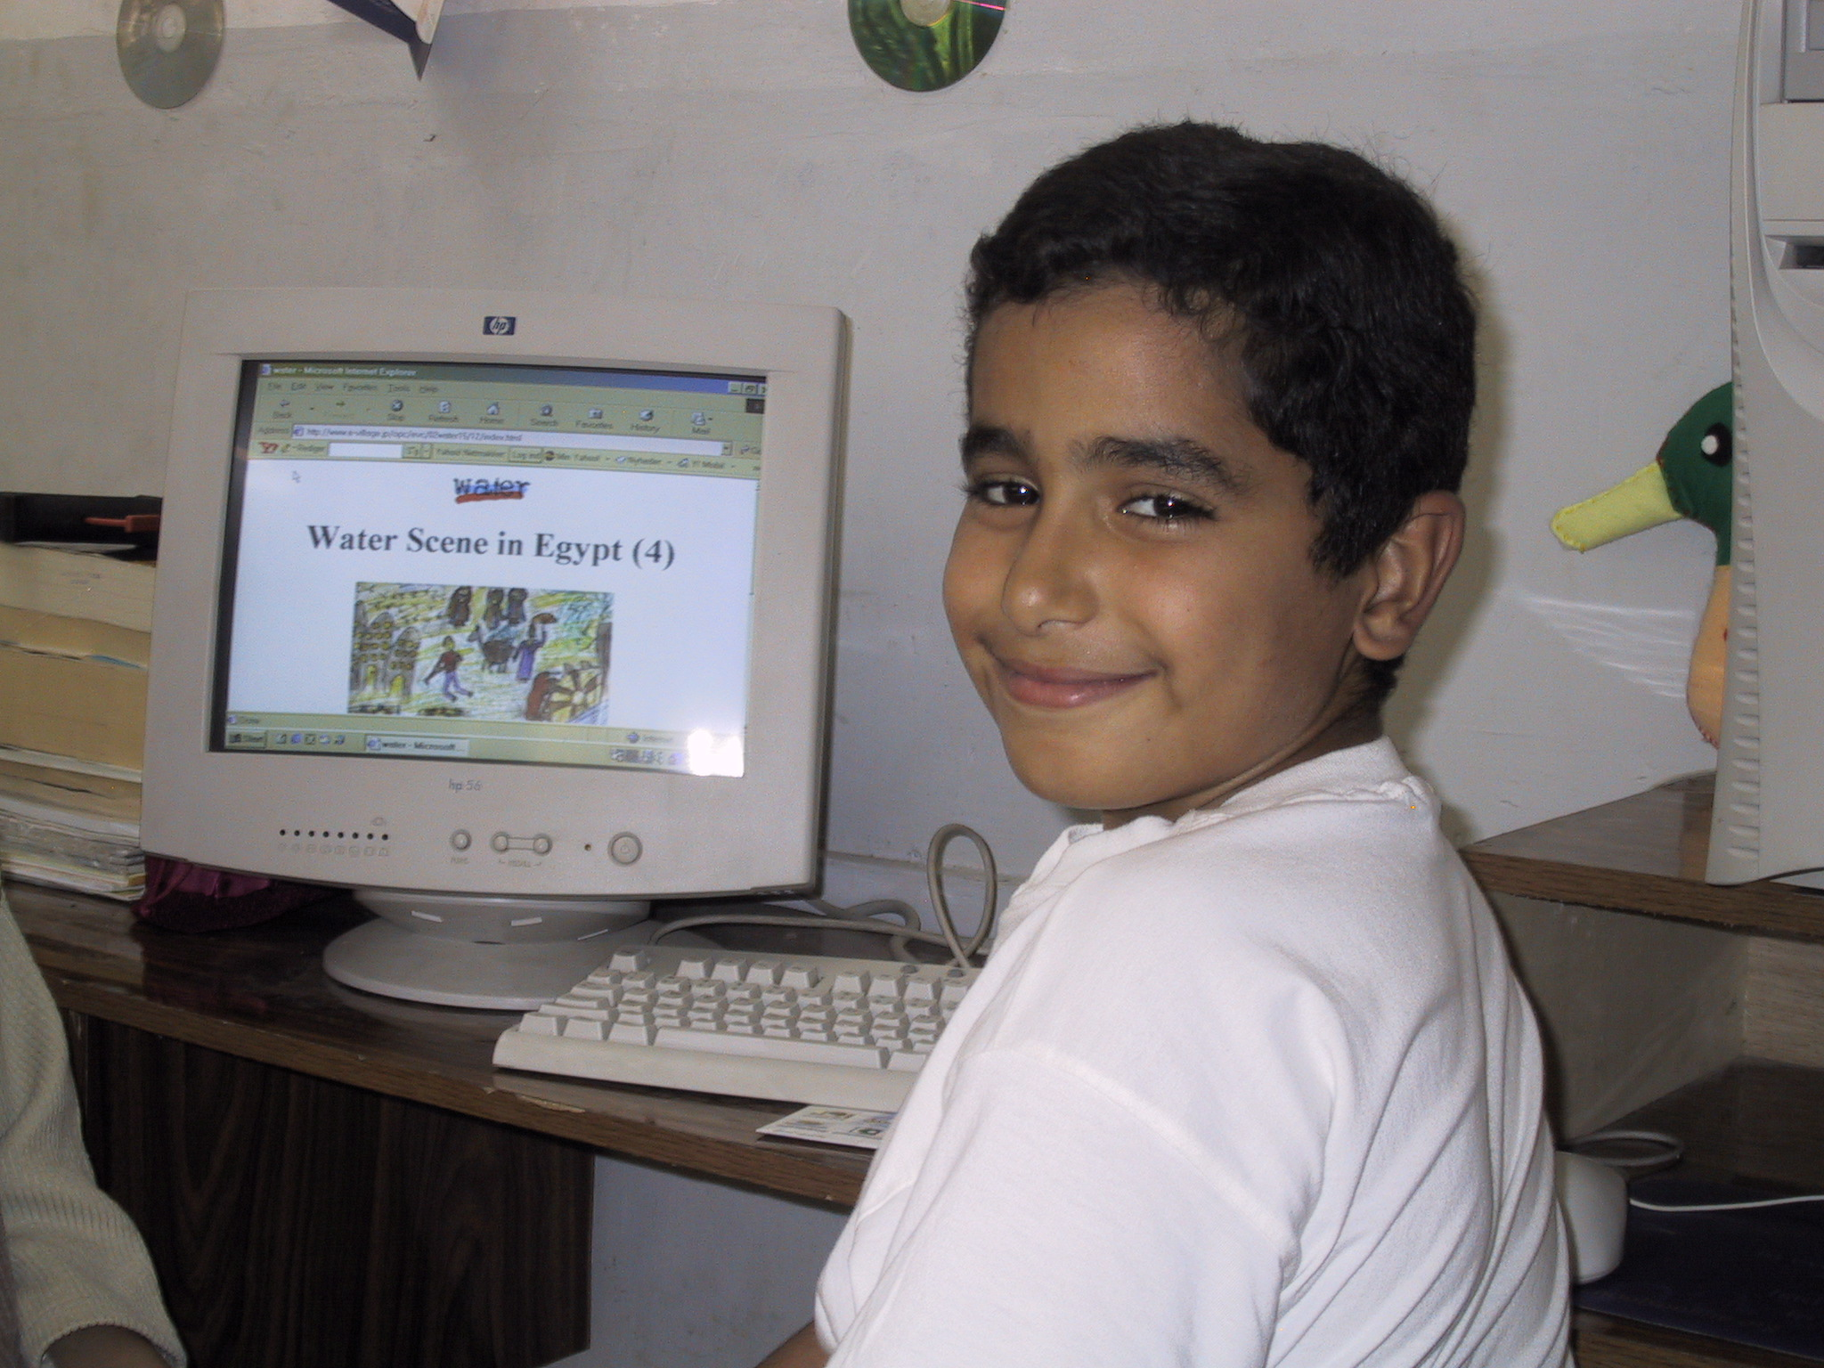
The new Digital Community Center Project in partnership with Hewlett Packard (HP) directly benefits the disadvantaged and underserved peoples of the Jordanian and Palestinian mixed community of Wahdat, with special attention accorded to women and youth, ethnic minorities, seniors and disabled persons.
Partnering with the Royal Jordanian Government and with UNRWA, the Digital Community Center extends outward into four selected local area schools, 2 Jordanian Ministry of Education Schools and 2 UNRWA Palestinian schools.
The provision of expertise and equipment through the Wahdat Digital Community Center (DCC) is designed to meet community needs in a culturally acceptable way to all community members, and to show tangible results in a short period, thus encouraging further and increasing participation in the Center and its activities throughout the community.
The DCC at Wahdat takes a leading role as a model in enhancing the life quality and life skills of:
- Community youth - in social, cultural, educational (life & vocational skills), sports, entertainment and organizational activities.

- Community adults - in educational (vocational skills and catch up education), in Small Enterprise and entrepreneurial training and guidance, in women’s and gender in development programs and as a springboard in promoting inter ethnic social activities (cultural, sports, entertainment).

- The Community’s 4 schools (2 Government and 2 UNRWA) - in:
- Education (computer/internet training and learning; computers as tools for education expansion)
- Regional and cultural history
- Inter-ethnic community and welfare projects.

- Community seniors and disabled - in sourcing and supplying services (welfare, public health and nutrition), in communal interaction and support (particularly with young people), in social events and education

The Digital Community Center is in the Wahdat low-income housing area in southern Amman. The district also incorporates the Wahdat Palestine Refugee Settlement. The Palestinian refugees in Wahdat are long term settled, though still under poor and underserved living and social conditions. The Wahdat Palestinian community have been granted Jordanian permanent residency status, with the possibilities of a sanctioned return to Palestine considered extremely thin for the foreseeable future.
The four local area schools, program equipped and program linked with Wahdat Digital Community Center
Jordan Ministry of Education Schools: Students Teachers
Sa’eed Al-Durra Boy’s School 334 42
Ashrafia Women’s School 637 41

UN Relief & Works Agency for Palestinian Refugees Schools
Students Teachers
UNRWA Amman Girls School at Wahdat 1,826 56
UNRWA Amman Boys School at Wahdat 1,700 52

Project Sustainability
Program design includes steps to secure eventual financial sustainability of the DCC. Including local and national government participation in the project contributes both to recognition and administrative sustainability. The parallel inclusion of all community groups in the decision-making and direction focus of the DCC project instills community ownership and social pride.

Financial sustainability builds both from the graduated introduction of progressive private individual and business group user fees, and from the capitalization on DCC based income generating activities. These include DCC centered business services, carried out by IT and entrepreneurship course graduates, in copying, printing, document preparation, business specific literature, letterhead, labeling and promotional material, fax and Amman area courier delivery services.
