
Project Proposal
Project Title: Trashcan Setup and Anti-Littering Campaign
Project Organizer: Green Channel

1. Project Summary

  - Description of Project
This project aims to stop littering habits in the public spheres and to enhance the waste disposal systems in Dhaka, in alliance with the Dhaka City Corporation (a government body). The major component of the project includes, setting up of trashcans in all major streets of the capital city (Dhaka) followed by an awareness campaign on anti-littering, amongst pedestrians and the general public.
The design of the trashcans is centered around three factors:
- Fixability – Each trashcan will be fixed to its position (via pole and chain) to prevent theft.
- Durability – Trashcans will be made up of durable material such as steel
- Convenience of Operation – Trashcans are designed in a way to make it easier for Dhaka City Corporation (DCC) to empty them on a regular basis.

Thirty-one trashcans have already been set up in the Gulshan Avenue and some of the roads leading up to it (Gulshan-Tejgaon Link Road, Gulshan-Badda Link Road, Gulshan-Mohakhali Link Road, Madani Avenue), as an experimental phase, during the period August – November 2011. The trashcans are being maintained under the authority of Green Channel and the disposal of trash is handled by the Dhaka City Corporation on a regular schedule. Now Green Channel plans to expand the project to the rest of North Dhaka, and then to South Dhaka, taking one step at a time to ensure that every part of the project is successfully and effectively carried out with sustainable and productive outcomes.

1.2 Location of Project: Dhaka City (Please see attached document regarding the phases of the project and the specific roads to be covered under each phase)

1.3 Overall cost: BDT 76,76,750 (USD 96,556.8)

1.4 Project Timeline: January 2013 – December 2014

2. Rationale of Project
Environmental pollution is one of the biggest challenges Bangladesh faces today. With the growth of industries, environmental issues have long been neglected in the country. The general education curriculum also does not address these issues with enough importance, and does not actively engage the youth into becoming environmentally friendly citizens. Green Channel acknowledges the urgency to protect the environment by building more efficient waste disposal systems and creating awareness amongst both the general public and the youth of the country through action oriented projects, general education and other creative means. The intention of this specific project is to reduce littering habits in Dhaka and maintain a green and clean atmosphere in the city.

2.1 Goals
  - Setup trashcans in all major streets of Dhaka
  - Develop the habit of using trashcans, among pedestrians in public spheres, for day-to-day general waste disposal
  - Raise awareness about the importance of being environmentally friendly among pedestrians and the general public
  - Create a greener and cleaner Bangladesh in the long run.

2.2 Project Management
This is a Green Channel initiative. Green Channel is a youth led, action oriented, not-for-profit organization, founded in 2011 that seeks to promote elements of a Green Economy in Bangladesh and to encourage the community around us in making environmentally and socially responsible choices in everyday life. Starting off as a simple environmental project in 2011, GC today is an organization (inspired by the ideals of United World College) with a special focus on reducing energy poverty (in Bangladesh) - the missing millennium goal.
We have a core group of about thirty members, with the heads of the organization supervising and working on research from abroad, while the Dhaka-based members co-ordinate the ground work. Outside the core group, Green Channel has a volunteer-base of over 500, who have worked with us previously, and will be delegated the task of raising awareness on site. After the awareness campaign, coordinators will continue to monitor the use and emptying of trash cans.

Project Profile on Global Giving: http://www.globalgiving.org/projects/green-channel/
Facebook Page: https://www.facebook.com/greenchannel2010
You tube Channel: http://www.youtube.com/user/greenchannel11?feature=results_main

3. Operation Plan

3.1 Spots and Numbers of Trashcans:(Please see attached document regarding the phases of the project and the specific roads to be covered under each phase)

  - Trashcan design:
The trashcans will be made out of steel, with a lid on top (hinged) to prevent overflow of trash and any unpleasant odor. They will also have a big enough opening on one (or more) sides to encourage passing pedestrians to use them. Each trashcan will be attached to a pole (existing or to be newly put up, if not available from beforehand) via a chain (hooked to the pole and the trashcan) that would be thick, and long enough (approximately 8 feet) for allowing a DCC officer to empty it. (Trash will be emptied by the DCC on a regular basis – an agreement has been signed between Green Channel and DCC regarding this alliance.
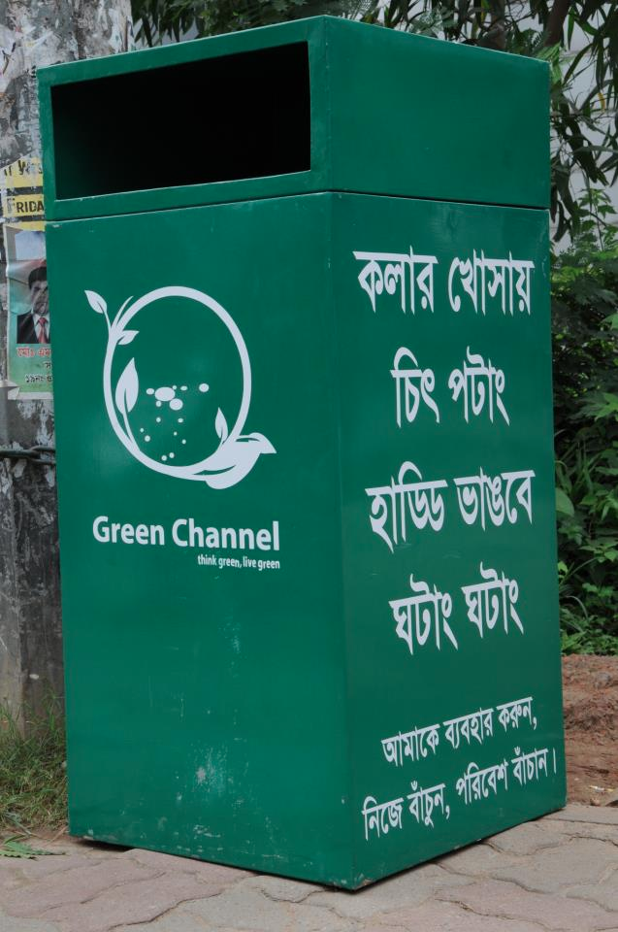
Picture: One of our trashcans in front of Trust bank (beside Grameen Phone Center) in Gulshan Avenue

3.3 Awareness-building through publicity
  - Ahsan Habib, the director of Unmad magazine has worked with us to create a cartoon character and dialogues to present a relatable, attractive image for the project. These cartoons will be published in established newspapers (for example, the Daily Star, Rising Stars, Unmad, etc.) to promote friendliness towards the environment among the public.
  - Press releases have been published about the project in Bangla and English national dailies (The Daily Star, Prothom Alo, etc.)
  - Our media partners, Radio Today and Shomoy TV, will be responsible for spreading awareness in relation to our project on radio and television. They have also covered us during the experimentation phase.
  - A publicity campaign will also be launched on the internet through social networking sites (Facebook, Twitter) and Global Giving, an international platform for community projects for the duration of the project.
  - Youtube videos, posters and banners in public places are some other possible options.

  - Awareness-building on site
An awareness campaign will be conducted under each phase involving volunteers speaking to passersby regarding littering and the problems it causes, as well as encouraging them to make use of the new trashcans. During this campaign, volunteers will be also picking up litter from the streets in order to provide a positive example and encouragement for the surrounding pedestrians. The trashcans themselves bear messages designed to encourage their use and attract attention.

  - Project Timeline
Phase 1 – 4: January 2013 – June 2013
Phase 5 – 7: July 2013 – November 2013
Phase 8 – 10: December 2013 – April 2014
Phase 11 – 14: May 2014 – September 2014
Phase 15 – 16: October 2014 – December 2014

*Details of phases are given in the attached document

4. Budget Details

1 USD = BDT 79.5050
Sl. no. | Item | Price (BDT) | Quantity | Total Cost (BDT)
1 | Trashcan (including painting main color) | 6500 | North Dhaka 83 roads * 5 trashcans (in each road) = 415 trashcans  South Dhaka 80 roads * 5 trashcans (in each road) = 400  Total: 815 Trashcans | 52,97,500
2 | Chains | 35 per feet | 8 feet per trashcan  So, 6520 feet for 815 trashcans | 2, 28,200
3 | Locks | 310 | 815 | 2,52,650
4 | Painting | Approximately 10,000 for 20 bins |  | 4,07,500
5 | Banners | 150 | 350 | 52, 500
6 | Pick up services | 1600 per day | 16 phases (3 days for each phase)  - 48 days | 76, 800
7 | T shirts | 180 (approx) | 400 in each phase  So (400 *16)  - 6400 | 11,52,000
8 | Gloves | 200 | 500 boxes | 1,00,000
9 | Photographer |  |  | Free (?)
10 | Certificates | 14 | 6400 | 89, 600
11 | Miscellaneous and tip (to helpers) |  |  | 20, 000
 |  |  | Total | 76,76,750  = USD 96,556.8
* Projected expenses are based on expenses from the experimentation phase
** The number of trashcans are an estimate at the moment (but it should not be too different)

We are an organization supported by Global Giving, which is a fundraising web site that gives social entrepreneurs and non-profits from anywhere in the world the opportunity to raise funds that are used to help underprivileged communities around us. In the past we have received funds from the Bill and Malinda Gates Foundation, Colorado College, Sheltech, Meridian, UWC Society of Bangladesh, Nitol Insurance and personal donations through Global Giving.
Website: http://www.globalgiving.org/projects/green-channel/

5. Deliverables

A project report will be submitted to DCC and all sponsors at the end of the project.

Details of Phases and Locations of Project Implementation

Dhaka City is split into 2 parts and 92 wards
North Dhaka (36 wards): wards 1 -23, 37-47, 54 and 55
South Dhaka (56 wards) : wards 24-36,48-53, 56-92

North Dhaka
Phase 1
Wards | Areas | Main Roads
19 | Gulshan  Banani  Karail | Gulshan Avenue  Kamal Ataturk Avenue  Gulshan-Badda Link Road  Gulshan-Baridhara Link Road  Gulshan-Tejgaon Link Road  International Airport Road
20 | Mohakhali | Mohakhali-Gulshan Link Road
37 | Tejgaon I/A | Shaheed Tajuddin Road

Phase 2
Wards | Areas | Main Roads
38 | West Nakhalpara  East Nakhalpara  Shahinbagh | Old Airport Road  International Airport Road(leading from Mohakhali)
39 | Tegaon | Pantha Path  Green Road

Phase 3
Wards | Areas | Main Roads
22 | Rampura | DIT Road
23 | Khilgaon  Choudhuripara
54 | Nayatola  Moghbazar | New Circular Road  Shaheed Tajuddin Road  New Eskaton Road  Kazi Nazrul Islam Avenue
55 | Nayatola

Phase 4
Wards | Areas | Main Roads
17 | Khlikhet  Bashundhara R/A  Nikunja Housing | International Airport Road  Pragati Sharani  Apollo Hospital road in Bashundhara R/A*
18 | Badda  Baridhara  Baridhara Embassy Zone | Madani Avenue(Gulshan-Baridhara Link Road)
21 | Dakhin Badda  Adarsha Nagar  DIT Project | DIT Road(Pragati Sharani)  Gulshan-Badda Link Road
*Roads inside Bashundhara R/A are not classified as main roads under the DCC map. None of the roads in Bashundhara R/A are not recognized by the DCC as main roads.
Phase 5
Wards | Areas | Main Roads
1 | Uttara Model Town | Dhaka Mymensingh Road(International Airport Road)  Rabindra Sharani  Shahjalal Sharani  Jashimuddin Road  Sonargaon Janapath  Gausul Azam Avenue  Alalul Avenue

Phase 6
Wards | Areas | Main Roads
16 | Kafrul  Taltala | Begum Rokeya Sharani  Bijoy Sharani  Old Airport Road  Mazar Road
40 | Sher-e-Bangla Nagar | Lake Road  Manik Mia Avenue  Begum Rokeya Sharani  Mirpur Road  Agargaon Road  Indira Road
41 | Sher-e-Bangla Nagar  Agargaon | Begum Rokeya Sharani
42 | Adabar | Ring Road
43 | Adabar
44 | Adabar | Asad Avenue  Sat-Masjid Road
45 | Mohammadpur  Lalmatia | Road 16  Sat-Masjid Road  Asad Avenue
46 | Mohammadpur
47 | West Dhanmondi

Phase 7
Wards | Areas | Main Roads
9 | Gabtoli | Dhaka-Aricha Highway(extending from Mirpur Road)
10 | Darus Salam | Mirpur Road  Mazar Road
11 | Kallayanpur  Darus Salam | Dar-Us-Salam Road
12 | Darus Salam
13 | Mirpur  Shewrapara  Pirerbagh  Paikpara  Monipur  Kazipara
14 | Mirpur  Kazipara  Senpara Parbata  Mirpur Section 14

Phase 8
Wards | Areas | Main Roads
6 | Rupnagar R/A  Mirpur Section 7  Mirpur Section 8 | Milk Vita Road  Begum Rokeya Sharani
7 | Mirpur Section 2 | Mazar Road
8 | Mirpur Section 1  Shah Ali
Phase 9
Wards | Areas | Main Roads
2 | Pallabi  Mirpur Section 12 | Begum Rokeya Sharani  Ceramic Avenue
3 | Mirpur Section 10  Rupnagar R/A (Extention) | Mazar Road
4 | Mirpur Section 18
5 | Mirpur Section 11
15 | Bhashantek | [no main roads here]
South Dhaka (56 wards) : wards 24-36,48-53, 56-92
Phase 10
Wards | Areas | Main Roads
24 | Khilgaon | Sayedabad Road  DIT Road
25 | Goran | [no main roads here]
26 | Rampura | [no main roads here]
34 | Shantibag | Sayedabad Road(Kamalapur Road)  Outer Circular Road
35 | Shantibag  Malibagh | New Circular Road
53 | Ramna  Shiddheshwari | Shaheed Captain Munsur Ali Sharani  Kazi Nazrul Islam Avenue

Phase 11
Wards | Areas | Main Roads
48 | Hazaribagh | [no main roads here]
49 | Dhanmondi | Mirpur Road  Sat-Masjid Road  Road 2  Road 16
50 | Kalabagan | Green Road  Sonargaon Road
51 | Kalabagan
52 | New Market | Azimpur Road(Mirpur Road ext.)  New Elephant Road  Hazaribagh Road
58 | Hazaribagh | [no main roads here]

Phase 12
Wards | Areas | Main Roads
32 | Mothijheel | DIT Avenue  DIT Extension Road  Toyenbee Circular Road  Fazle Rabbi Road
33 | Motijheel | Outer Circular Road  Station Road
36 | Paltan | Kakrail VIP Road  Shaheed Syed Nazrul Islam Sharani  Kakrail Road

Phase 13
Wards | Areas | Main Roads
56 | Shahbag | Zahir Raihan Sharani/ Shaheed Kamruzzaman Sharani  Bhashani Road  Hare Road  Kakrail Road
57 | Shahbag | Shahbag Road( New Elephant Road)  Nilkhet Road  Kazi Nazrul Islam Avenue  Kataban Road

Phase 14
Wards | Areas | Main Roads
59-66 | Azimpur  Lalbagh  Bakshi Bazar | Azimpur Road  Mitford Road  Zahir Raihan Sharani  Water Works Road
67-73 | Chakbazar  Kotwali  Bangshal | Zahir Raihan Sharani/ Shaheed Kamruzzaman Sharani  North South Road  Kazi Alauddin Road  Nawab Eusuf Road  Islampur Road  English Road  Buriganga Bridge no. 2  Nawabpur Road

Phase 15
Wards | Areas | Main Roads
74, 77-79 | Bangshal  Narinda  Lakshmi Bazar  Wari  Sutrapur  Gandaria | Khal Road  BK Dash Road  Nawabpur Road
80-83 | Sutrapur  Gandaria  Chandaria  Dayaganj | Keshab Benarjee Road  Pipe Road
87-90 | Shayampur  Postagola  Mir Hazaribag  Jurain | Dhaka-Naraynganj Road  Bangladesh-China Friendship Bridge

Phase 16
Wards | Areas | Main Roads
31, 75 | Kamalapur  South Kamalapur  Gopibagh  Tikatuli | Outer Circular Road  Hatkhba Road  Fazle Rabbi Road  Toyenbee Circular Road  Ashish Dipankar Road
27-30 | Golapbagh  Sabujbagh  Basabo | Basabo-Madartek Road  Ashish Dipankar Road  Kamalapur Manda Road
76 | Saidabad | Folder Street
84-86 | Jatrabari | Shahid Faruque Road  Dhaka Narayanganj Road  Demra Road

*Wards 91 and 92 consisting of areas Kamrangir Char and North Keraniganj are still under construction

