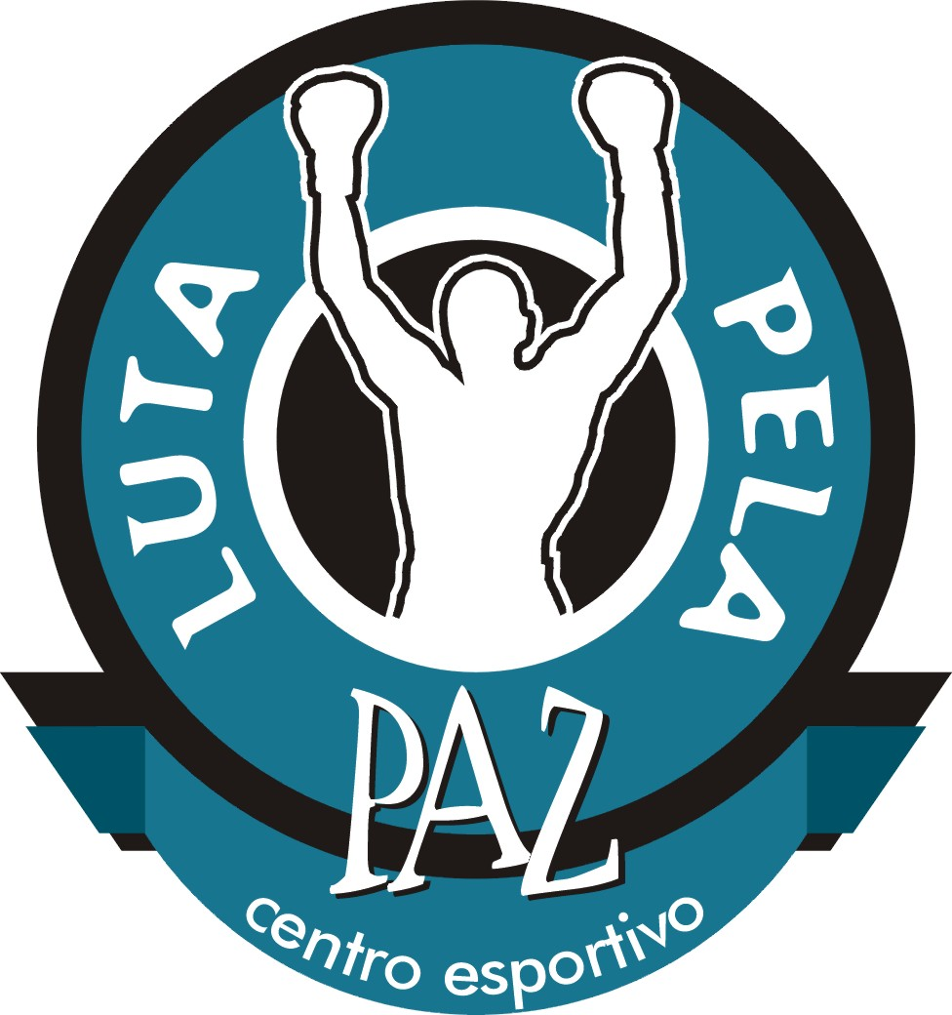

Fight for Peace Sports Centre
Alternatives for youth to crime, drug faction employment
and armed violence

Rio de Janeiro, Brazil, 2004

A Viva Rio project



Contacts

Luke Dowdney
Co-ordinator, Children in Armed Violence
Viva Rio
luke@vivario.org.br
Tel. (55)(21) 2555 3750 ext. 3236 / Cel. 92382812
Viva Rio

Name

Fight for Peace Sports Centre / Centro Esportivo Luta Pela Paz. www.lutapelapaz.org.br

Fight for Peace is a Viva Rio project. Viva Rio is a Brazilian non-profit non-governmental organisation that works toward social integration and aims to overcome violence and social exclusion within the city of Rio de Janeiro. www.vivario.org.br

Established

Fight for Peace was established in July 2000. Viva Rio was established in December 1993.

Country / Area

Fight for Peace is based in the Complexo da Maré, a complex of favelas in Rio de Janeiro, Brazil, that has over 120,000 residents. Viva Rio is based in Rio de Janeiro city and co-ordinates projects, campaigns and programmes in both Rio de Janeiro city and state.

Structure

Viva Rio was created in December 1993 by representatives of diverse sectors of civil society as a direct response to escalating violence within Rio de Janeiro. Focusing on youth, Viva Rio works toward social integration and aims to overcome violence and social exclusion within the city of Rio de Janeiro. Viva Rio co-ordinates peace campaigns and community based projects in the areas of Human Rights and Public Safety, Education, Sports, Community Development and the Environment through a network of local partners. In 2001, Viva Rio co-ordinated projects in over 500 low-income communities in 34 municipalities of Rio de Janeiro state and in co-operation with 433 partner organisations and agencies. Please see Annex 1 for a full summary of Viva Rio’s projects and a copy of Viva Rio’s financial report (‘Indicators for 2001’) also in annex.

Fight for Peace since 2000

Fight for Peace is based in Complexo da Maré, a favela where there has been a decade of territorial drug wars between two of Rio’s largest drug trafficking factions. Through their interest in boxing, Fight for Peace has maintained regular contact with youth most affected by violence and drug trafficking. Fight for Peace is open to boys and youths between 12 – 25 years of age and currently has 40 members. Fight for Peace’s successful methodology combines the following four interrelated elements known within the club as the ‘Four Point Plan’:

- Sport as a lifestyle: Dedication to sport offers the ability to change lives for the better and gives children and young people a sense of self-worth as well as a strong incentive to live a healthy and a positive life. Fight for Peace offers free boxing coaching to 70 club members, has a squad of successful amateur boxers and promotes federated amateur boxing shows within the community once a month. In 2003, the Fight for Peace boxing team had two amateur boxers ranked number one in the state by the Rio de Janeiro State Boxing Federation. Like any amateur boxing club in the UK, boxers are trained three nights a week, the club being open between 16:30 – 21:00 on Mondays, Wednesdays and Fridays. The club has two boxing trainers certified by the Rio de Janeiro State Boxing Federation.

- A culture of peace: On Tuesdays and Thursdays between 17:00 and 20:00, Citizenship Workshops are held by trained youth workers to instruct club members in citizenship and conflict resolution. Citizenship Workshops focus on topics such as sex education, family, employment, human rights, culture, violence etc.. Through instruction in citizenship and conflict resolution techniques, group workshops and family visits carried out by project staff, club members learn that they cannot instigate, participate or encourage violence in the community. This philosophy of non-violence is intrinsic to all aspects of Fight for Peace. The following club rules were chosen by club members during a Citizenship Workshop: Respect and help others; Be disciplined and punctual; e responsible; Train hard; Be responsible with the equipment; Be humble; Be honest; Behave peacefully outside of the ring; Receive guests to the club with respect and politeness. Although within boxing training club members must be disciplined and follow the commands of the coaches, citizenship classes offer a space within the project where members can discuss relevant themes to their lives and express themselves fully.

- Education for a future: Fight for Peace actively supports participants to return to school or education projects in order to enhance their life potential. Fight for Peace also employs a literacy teacher as a first step to getting children and adolescents back into school.

- Access to the work market: The final step in keeping young people out of crime and drug faction employment is offering concrete financial alternatives and prospects. Fight for Peace works with local businesses toward placing participants in paid part-time internships and jobs. This gives project participants access to the formal work market and important job skills for their future as well as money in their pockets in the present: an important combination to keeping young people away from drug faction employment.

The club opens its doors between 16:00-21:30 from Monday – Friday. As noted above, boxing training takes place on Monday, Wednesday and Friday and Citizenship classes on Tuesdays and Thursdays. Boxing shows within the community take place on Saturday evenings once a month and cultural outings three times per semester. Home visits are made by the projects youth worker and social co-ordinator throughout the year and meetings are held with project participants’ parents at the club three times a year.

Through this methodology, Fight for Peace offers young people access to sport, the necessary support to return to or stay in education and real financial alternatives to a life of crime. The project uses both a preventative strategy to stop children and youth entering drug trafficking, as well as reintegrating young people already involved in crime back into school or the formal work market. By combining access to competitive sport with the support provided by the project’s social workers, Fight for Peace’s Four Point Plan helps create both champions in and out of the ring. Through sport and education Fight for Peace helps young people tackle the problems they face daily living in a community where crime and armed drug faction employment are often the only real alternatives to a life of poverty and exclusion.

Project staff
The project is co-ordinated by a team of four staff members that includes:

Project Co-ordinator: Luke Dowdney was responsible for the creation and implementation of Fight for Peace, and is currently responsible for its development, co-ordination and overseeing boxing training. He has a Masters degree in Social Anthropology from the University of Edinburgh, his dissertation for which was researched in Recife, Brazil, and looked at violence in the lives of favela and street children. He has worked at Viva Rio since 1997 and as well as co-ordinating Fight for Peace he co-ordinates Viva Rio’s work on children in armed violence. This includes the recent completion of a research programme on armed child workers in Rio’s drug trafficking factions that was sponsored by Save The Children Sweden and the Ford Foundation and which was the subject of an international conference in Rio de Janeiro in September 2002. The result of this research will be published in book form in January 2003. Luke is also the 1995 light middleweight British Universities Lonsdale Champion and competed as an amateur boxer in Scotland, England, Nepal and Japan. Luke is a certified as a trainer by the Rio de Janeiro State Boxing Federation.

Social Co-ordinator: Leriana Del Giudice Figueiredo is responsible for citizenship and conflict resolution classes. Leriana has a masters degree in sociology and over five years experience in working with at risk youth in Rio de Janeiro’s favela communities. This includes a number of international youth exchange programmes carried out between Rio de Janeiro, England and Germany.

Youth Worker: Miriam Gonzaga dos Santos is the club’s full time youth worker. Miriam is from the community and has over 15 years experience working with local youth. Her last job was truancy officer for the local school and she has also held the position of Education Director in a nearby community centre. Miriam is responsible for offering support to project participants including home and school visits.

Assistant Trainer: Luis Otavio is the Club’s assistant trainer and is a certified trainer with the Rio de Janeiro Boxing Federation. Luis also runs his own boxing club in the favela of Dendê, Ilha de Govendor.

Fight for Peace is a year round project.

The Fight for Peace Mission

Fight for Peace’s mission is to offer real alternatives to crime and drug faction employment to youth via social inclusion through sports, education, the promotion of a culture of peace and access to the formal work market.

Violence in Brazil is a problem intrinsically linked to youth: in Rio de Janeiro gun related incidents are the primary cause of death for young people between fourteen and nineteen years of age (responsible for 59% of all deaths in this age group). Rio de Janeiro is not officially at war, yet firearms related death statistics for children and youth are worse than some areas that are in conflict. For example, in Israel/Palestine between Dec.1987-Nov.2001, 467 minors were killed in armed conflict. During the same period firearms within the municipality of Rio de Janeiro killed 3937 minors.

More recent statistics show that even with escalating conflict in Israel and the Palestinian occupied territories, more children and adolescents continue to die from small arms-related causes in the municipality of Rio de Janeiro than in the Israeli / Palestinian conflict. Amnesty International’s report, Killing the Future: Children in the Line of Fire calls for the UN Committee on the Rights of the Child to take into account that more than 250 Palestinian and 72 Israeli children were killed as a result of the conflict in the Palestinian occupied territories between September 2000 – August 2002, a 23 month period. The most recent data regarding firearm-related mortality rates in the municipality of Rio de Janeiro demonstrates that between November 1999 and December 2001, also a 23 month period, a total of 612 under eighteen year-olds were killed by small arms fire.

Child and youth involvement in the increasingly violent drug faction wars that dominate Rio de Janeiro’s favelas are responsible for such extremely high mortality rates. These children, some as young as 10 years old, are employed as armed soldiers, lookouts, drug sellers and carriers within these factions. Since its establishment in 2000, Fight for Peace has worked to confront this problem through focusing on the prevention of youth participation in crime, violence and drug trafficking. The project is based in Parque União, one of the fifteen favelas of Complexo da Maré, where there has been a decade of territorial drug wars between two of Rio’s largest drug trafficking factions and where openly armed children and adolescents patrol the streets and alleyways to defend the community from rival faction invasion or police raids. According to statistics from the Brazilian Ministry of Helath, the firearms related mortality rate of 15-17 year olds in the Complexo da Maré, where Fight for Peace is based, is over 150 per 100,000 inhabitants. This is a statistic rarely seen outside of areas in conflict or at war.

Funding Structure

Viva Rio is funded by the public sector (Federal, State and Municipal governments), the private sector (national private companies and multinational corporate organisations), foreign government development agencies (e.g. DFID of the UK government and DFAIT of the Canadian government), donor foundations (e.g. Ford Foundation), NGOs (e.g. Save the Children Sweden) and international agencies (e.g. UNESCO and UNICEF). Please see Annex 5 for a financial review of Viva Rio’s income and expenditure in 2001. A fully independent auditors report of Viva Rio is carried out annually by Franciso Carvalho Auditoras Independentes and this is available on request.

Since 2000 Fight for Peace has been funded by the following corporate businesses, donor organisations and foreign government agencies: BP Amoco; The International Newcomers Club; American Society Rio; British Embassy Brasilia; American Consulate Rio de Janeiro; Canadian Embassy Brasilia, Dreams Can Be. The project has also been funded by a number of private donors from the United States and the UK.

Evaluation and Research

Fight for Peace carries out ongoing evaluations of both project participants and the project itself. This is done using the following methods: group discussions with participants during citizenship classes; written questionnaires for participants and staff; parents meetings; staff meetings; and home visits of selected project participants. A data base of information regarding each project participant has also been compiled including the following information: name; age; documents; address; level of schooling; family income; family situation; further observations.

As Co-ordinator for Children in Armed Violence at Viva Rio, between November 2001 and August 2002, Luke Dowdney co-ordinated a study regarding the working functions of children and adolescents in the favela based drug factions of Rio de Janeiro. The study was financed by Save the Children Sweden and the Ford Foundation. Interviews were held with over three hundred people in fifteen favelas. This included twenty five children and adolescents currently working in an armed capacity within the drug trade who were interviewed whilst working. The study also analysed public health statistics (primarily firearms mortality rates within the city), youth crime statistics and police statistics (including the number and types of weapons seized by the police on Rio de Janeiro’s street from 1950-2001). In addition to discovering that firearms mortality rates in the municipality of Rio de Janeiro are above combat related deaths in many modern conflict zones, research results highlight striking similarities between the working functions of children employed by Rio’s drug factions and ‘child soldiers’ participating in armed conflicts that include: recruitment processes; age dynamics; children work within a hierarchically structured unit enforced by orders, rules and punishments; children are paid for a service and on call 24 hours a day; children are given firearms by adults; children are actively involved in armed confrontations with rival groups and the police; children survive in a kill or be killed reality; and children are increasingly being utilised as armed combatants.

In February 2003, Children of the Drug Trade: A Case Study of Children in Organised Armed Violence, was published. This book was written by Luke Dowdney and based on the above outlined research programme. The books conclusions identify a strong link between children and adolescents choosing to work for drug factions and a lack of cultural and educational alternatives, low self-esteem, social exclusion, a lack of perspectives and difficulty in accessing the formal work market. Through the methodology explained above, Fight for Peace offers children and adolescents access to sport which stimulates a feeling of self worth, the necessary support to return to or stay in school, and real financial alternatives to a life of crime or drug trafficking. The project uses this strategy to prevent youth involvement in drug trafficking and crime, as well as offering those already involved support to leave drug faction employment and start a new life.

Facts and Achievements

In August 2001, Fight for Peace held an outdoor boxing event in the community that attracted a crowd of over two thousand and was carried out in partnership with Viva Rio’s disarmament campaign, “Mothers Disarm Your Sons!”. Before the bouts were held guns were smashed with hammers in the ring and local Hip Hop stars and the internationally recognised musical youth group AfroReggae sang songs with a message of unity and the desire to end armed violence. The event was an excellent way to bring the project’s message of peace to the community as well as stimulating interest in amateur boxing as project participants had a chance to display their abilities publicly.

Since its establishment, the project has successfully returned twenty five boys to school, and found work placements for a further fourteen. 90% of club members are currently enrolled in education programs and / or working.

At the beginning of 2002, Fight for Peace project staff were contacted by family members of four adolescents in the community that had been arrested for armed robbery on a public bus within the city. The family and the boys claimed their innocence and as two of the four boys had frequented the Fight for Peace boxing club during 2001, the club contacted one of Viva Rio’s lawyers to give the boys free legal aid. Following legal representation at a judge’s hearing, the four boys were freed after 3 months in custody when charges were dropped. Three of the boys returned to the project immediately. All three are training regularly and thanks to the projects structure, have all returned to school. One of the boys has also been found a work placement at Halliburton in the city centre where he works as an office administrative assistant.

During 2002/2003/2004, Fight for Peace held monthly federated boxing competitions within the community and the project’s squad of young athletes participated in amateur boxing shows in Rio de Janeiro, São Paulo and Belém. The Fight for Peace Boxing Club is registered with the Rio de Janeiro State Boxing Federation, and members have been competing in amateur championships since 2001. In 2002, one of the club’s best athletes, 16-year-old Rivan Bispo de Santos, represented Rio de Janeiro State in the Brazilian Amateur Boxing Championships in the category of lightweight. A huge honour for a young athlete that only started competing in 2001.This has had a very positive effect on the entire program bringing attention to the club and creating a more palpable feeling of self-esteem among the members of the club. By the end of 2002 the Fight for Peace boxing team had two amateur boxers ranked number one in the state by the Rio de Janeiro State Boxing Federation. These boys are already showing the way for their peers to follow by becoming local heroes that achieve success and earn respect through their accomplishments in the ring and representing the belief that peace must prevail, rather than by picking up arms and joining the local drug faction.

Although there have been a number of individual successes over the last two and a half years, perhaps the most notable is that of Vitor. Vitor came to the project two years ago at the age of fifteen already in trouble with the police and with a troubled history: his father was in prison for armed robbery and his mother had effectively abandoned him when his father went to prison. Vitor was ten years old at the time and went to live with his grandmother. Vitor has other family members working for drug factions in other favela communities and as he was already involved in street crime outside of the community, it was seen by many as a logical progression for him to also join the local faction. Soon after Vitor joined the club his cousin was tortured and murdered due to his involvement in the local drug faction. In the same year, Vitor fathered two children and these events made him want to really change his life. He began to train harder at the club until he won a place on the amateur boxing team and he has been competing ever since. At the end of 2002, Vitor was ranked number three in his weight class by the Rio de Janeiro State Boxing Federation. Vitor began to participate more actively in the Citizenship Classes until he was nominated by the project’s co-ordinators to participate in a youth leadership course being held by another Brazilian NGO within Rio de Janeiro. Vitor passed the course and now holds the title of Fight for Peace project spokesperson. Vitor represents Fight for Peace at events, speeches and interviews with the press and has even been invited to São Paulo to speak on behalf of Fight for Peace and the problems young people face growing up in the favela. With the encouragement and support of the project ion 2002, at the age of seventeen, Vitor got a job training as a carpenter and he is now going back to school to finish his primary level education. As a prime example of the power of the Four Point Plan, Vitor has shown everyone what Fight for Peace can offer to those that dedicate themselves to sport and education as the path to a better life.

Plans for the future

Fight for Peace Sports and Education Centre 2004

In 2004 Fight for Peace will build on the work carried out since 2000 by amplifying both the social and sporting aspects of the programme:

Fight for Peace Sports and Education Centre: Fight for Peace is currently renting a shared and inadequate space within the residents association. Citizenship workshops are currently taking place in a corridor due to the residents association, where the club is housed, not correctly managing the building. Furthermore, boxing training is being negatively affected as other people are being allowed to use the space originally given to Fight for Peace. In order to overcome these problems and expand the project, Viva Rio will buy a plot of land in the community, constructing and equipping a building to create a sporting and educational facility with a total of 492m2. The building will include a reception area, a weights room, an area for cardiovascular, aerobic and gymnastic training, male and female changing rooms and a gym for capoeira, martial arts and boxing training. There will also be an educational centre, consisting of an equipped classroom for 30 students, a computer room (with 10 computers, printer etc.), toilet facilities and a staff office.

The construction programme will take an 8-10 month period. Construction is planned to begin in 2004 terminating within the same year. During this period Viva Rio has found another adequate space to rent in order to commence the project as described in this proposal by January 2004. Although this space is not ideal, it is sufficient for the commencement of the project outlined here until the centre is fully constructed.

Access to sports for 150 children and adolescents: Following construction of the Fight for Peace Sports and Education Centre, the project will be able to expand to include other sports and more access for local youth. A new headquarters in the community will offer permanent and guaranteed space to include other sports (including gymnastics, capoiera, judo), aerobics and dance classes and growth in access to the project from 40 to 150 children and adolescents of both sexes on a daily basis. Sports training for children and adolescents will take place during different sessions between 07:00 – 22:00 in order to offer maximum accessibility to the project.

Sporting events within the community: Fight for Peace will hold monthly sporting events within the community, an important step to attracting children and adolescents to the project, raising awareness about the projects objectives within the community and stimulating those already participating within the project to train harder.

Access to education and computer training: in addition to existing literacy classes and educational support, Fight for Peace will co-ordinate primary and secondary level classes within the centre for project participants and other community members. This will be achieved through partnership with Viva Rio and at no financial cost to the project. Since 1997 Viva Rio has co-ordinated fast track education classes for over 50,000 students in Rio de Janeiro state. The new headquarters will include the necessary classroom as well as a co-ordination office and a computer room (10 computers, a printer and a scanner are currently being donated to Fight for Peace by the Federal government’s FUST programme in 2003 to hold computer classes for project participants).

Amplified work placement scheme: Fight for Peace will invest further in partnerships with local businesses and the private sector to provide paid internships for selected participants on the programme. This will be put into practice by an active campaign by project co-ordination staff in 2003 to invite corporate businesses to join in a ‘Fight for Peace Work Placement Scheme’. Using their contacts in the private sector, Dreams Can Be are also planning a similar internship programme for participants of projects they support and Fight for Peace will be prioritised in this programme.

- Access for 200 people from the community to affordable sporting facilities: by equipping the new headquarters with state of the art gymnasium equipment, Fight for Peace will also open a sports academy within the favela that will offer affordable membership to a further 200 people in the community.

- Partial financial self-sustainability: by having a paid membership of 200 community residents, the Fight for Peace programme will have a regular income in order to meet 30% of costs to run the sports and social programme for 150 children and adolescents within the community (please see accompanying budget).

Market research carried out by project staff within the community verified sufficient demand for such a sporting facility. There currently exist only two sports gyms within the community that has over 120,000 residents. These gyms charge between U$7 – U$12 per month. Neither of them offer the same quality of equipment or service intended for the Fight for Peace Sports and Education Centre. In order that the Fight for Peace Sports and Education Centre is accessible to community residents, there will be an average monthly charge of U$10 (depending on services offered) with the aim of having 200 paying members. This will create an income of U$2000 per month, 30% of operational project costs.

Funding

The total cost of buying the land, completing construction and equipping the centre has been budgeted at a total of USD 170,000.

Monies raised so far include:

Scott Wood (individual donor) USD 16,667
Gery and Anne Juleff (individual donors) USD 5,000
Canadian Embassy Brasilia USD 16,667
British Embassy Brasiia USD 36,666
The Stuart and Hillary Williams Charitable Trust USD 25,000

The Laureus Sports for Good Foundation are supporting operational costs for the project at USD 50.000 per year between 2004 and 2006 from a grant written by Dreams Can be Foundation.

In order for the building to be operational by the end of 2004, we are seeking grants for a total of USD70,000 for the remainder of construction costs and materials to fully equip the building.

A break down of construction costs and architects plans for the construction programme are available on request.

Results

Stories like that of Vitor’s described above show the impact that this project can have for individuals that want to dedicate themselves to sport and education to better their lives. In addition to each of these individual successes that the new Fight for Peace Centre will facilitate, supporting this project will lead to the attainment of the following results:

- 150 at risk children and youth attended by Fight for Peace;
- Community sporting events held monthly;
- Educational and job orientated alternatives to crime and drug dealing offered to youths from the community;
- Strengthened local culture of peace and citizenship;
- Decrease in local child and youth participation and victimisation in crime, drug faction employment and armed violence;
- Affordable access to sporting facilities for a further 200 people in the community so that the community knows it is training hard to help its children by creating partial financial self-sustainability for the Fight for Peace programme.

Most importantly of all, by offering real alternatives to drug faction employment to children that have typically had few options, establishing the Fight for Peace Sports Centre will facilitate the creation of both sporting champions and life champions: young people that will show their peers and the world that through dedication to sport and education they are capable of bettering their own lives and the lives of those around them.

Shantytowns
published in September 2002
Brazilian Ministry of Health, DATASUS - RJ
Children in Organised Armed Violence: a study of children and adolescents involved in territorial drug faction disputes in Rio de Janeiro, Dowdney LT, ISER / Viva Rio, 2002.

