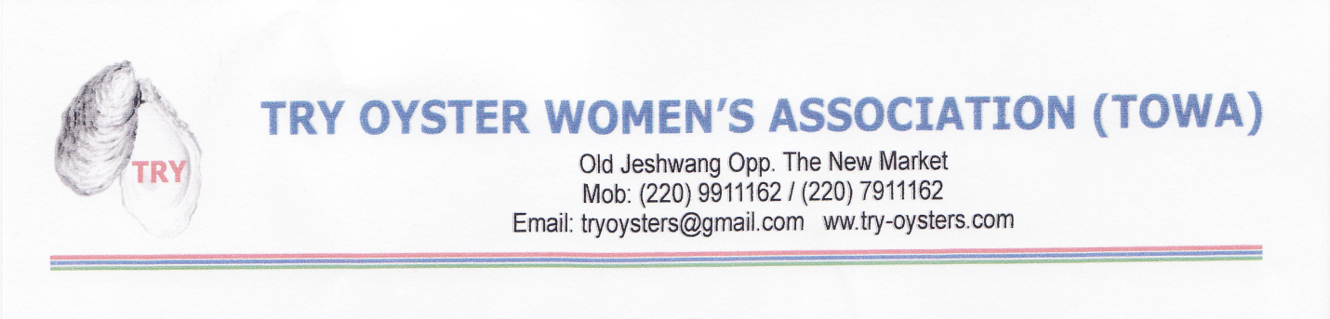

July 12, 2013
Global Giving Foundation
1023 15th Street, NW
12th Floor
Washington, DC 20005

Dear Global Giving,

The contributions made through your Global Giving site for the TRY Women Oyster Harvesters living in Northwest Africa The Gambia have been used towards the purchase of 100 eye protection goggles. The women oyster harvesters will use these goggles while roasting the oysters. The roasting process will cause eye irritation and the goggles will provide protection.

The oyster harvesting season officially closed for the 2013 season this July. We continue to expand and grow through educating the harvesters, creating awareness about our organization, and making known our vision for the future.

Here at TRY we thank you for assisting us so that others can learn about our organization and the hard work the women oyster’s harvesters perform and generously donate to our cause.

We are proud to be supported by Global Giving and will continue to work hard to help our local women oyster harvesters.

Thank you,

Sincerely,

Fatou Janha Mboob

