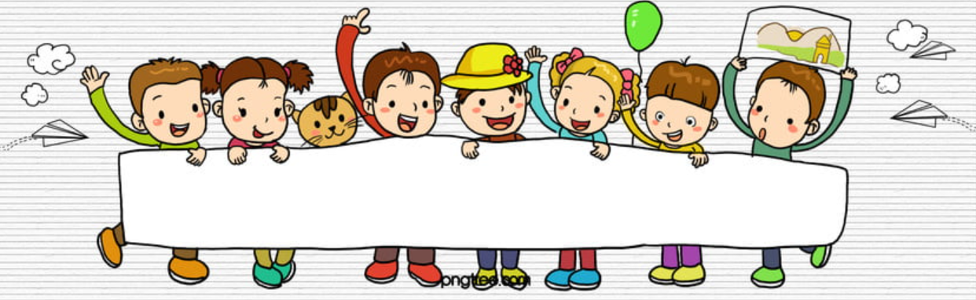 

**School Age Program**

**Living Skills**

**Dancing Time**

The group activities are as follows:

- **language time** (different topics are presented based

on various themes such as virtual trips [Underwater World in Langkawi, A’ Famosa Safari & Water Theme Park] and Taking Care of the Environment)

**- dancing time** (social interaction)

- **living skills** (teaching students to make sausage and

egg sandwich by using powerpoint slides and videos)

**Group Session**

**Language Time**

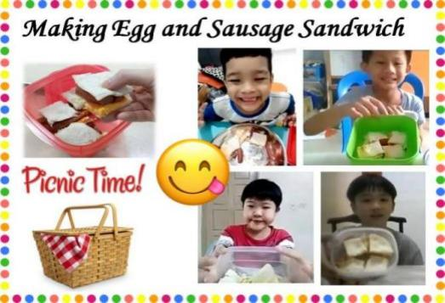

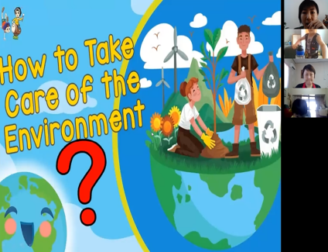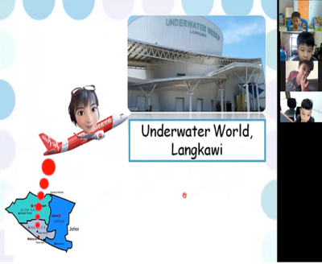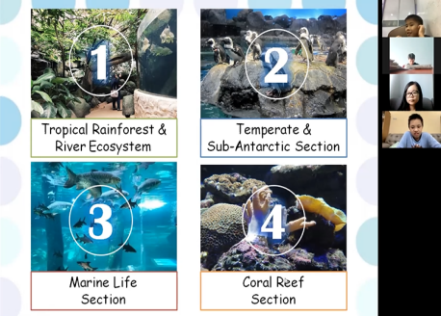 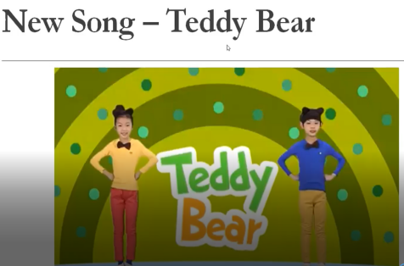

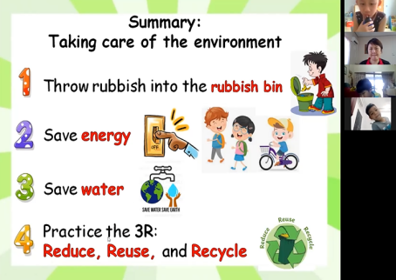 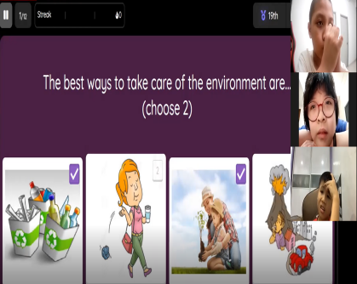 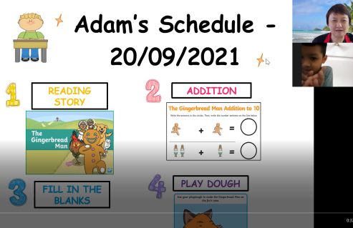

**Classwork**

**Session**