The Little Angel
By Nurul Syahirah - Deaf Blind Multihandicapped Teacher

Low vision is a condition caused by eye disease and cannot be corrected with regular eyeglasses or medical surgery. Children can have low vision due to birth defect or injury. They may face difficulties in learning and requires special instruction and need help in developing socializing skills.
Born on 1st of October 2012, doctor diagnosed her with Congenital Rubella and Glaucoma which caused her to have low vision and hearing impairment. She joined St. Nicholas’ Home in August 2019 and became teachers’ and classmates’ favourite student.
It was a challenge for her teachers to start working on developing her gross and fine motor sensory and cognitive skills as Sze Ling is a hyperactive child. Sze Ling able to communicate with teachers and her friends by using sign language and body gestures.
Being at St. Nicholas’ Home for the past 5 months, she has become familiar with her classroom and dormitory environment. Besides that, she also showed some improvement in her daily activities where she is able to threading beads and also fix screws and nuts. In addition, she loves to jump on the trampoline loves playing with her friends .

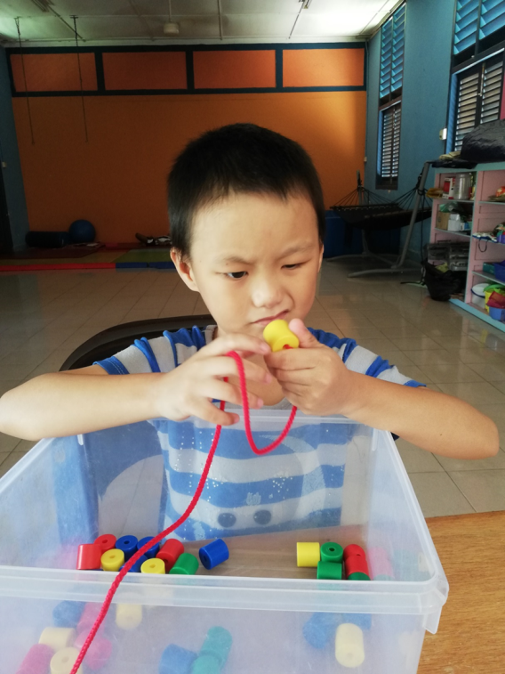
She is focusing on threading beads
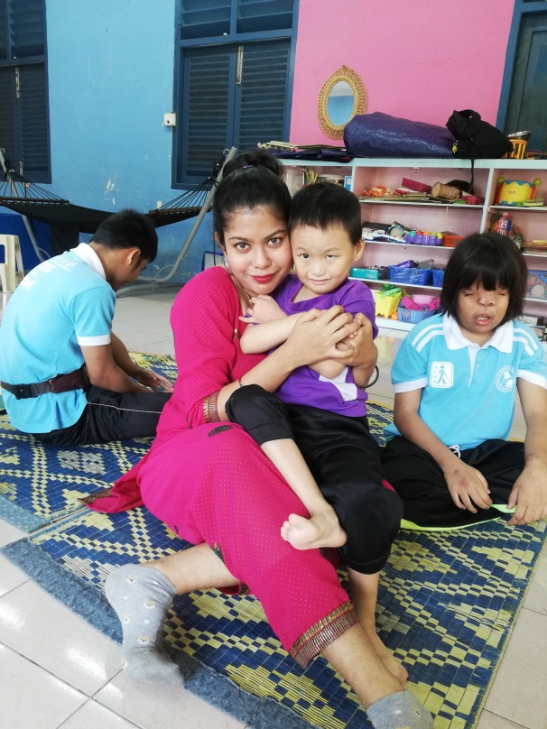
Sze Ling with her teacher during her classroom activity

Children like Sze Ling can achieve higher through your generous donation. Thus, continue your endless support to our home. Your small contribution can make huge difference.
“Children with special needs come into our lives , leaving footprints on our hearts, and we are never the same .”

