Ravin’s Journey of Discoveries
(By E.Stephanie Ann – DBMH Teacher)
Ravin (Name Changed) a 12 Years old boy, was born with visual and hearing impairment due to Congenital Rubella Syndrome. He stayed with his mother till the age of 7 before enrolling at St. Nicholas’ Home, Penang. In December 2018, his father passed away due to some health condition. Ravin’s mother went through a lot of struggles in raising him as a special need child.
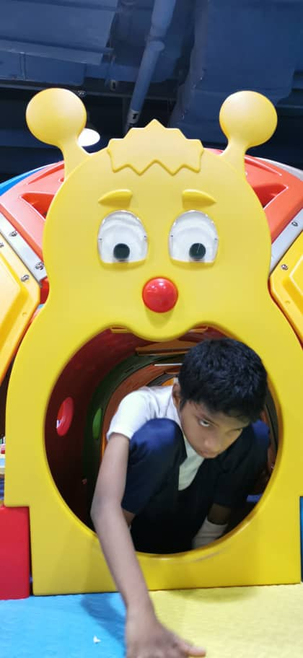
“Now, my son eats on his own and able to communicate with us using sign language and body gestures. As a mother, I’m happy to see my son’s progress upon being taught at the Deaf-Blind and Multi Handicapped Programme at St. Nicholas’s Home,” Ravin’s mother shared.

Exploring new environment by touch

Ravin who lived within the four walls of his home was reluctant to get engaged in outdoor activities. He did not have a proper exposure as how a normal child should have. It was a great challenge for his teachers to start working on developing his gross and fine motor sensory and cognitive skills as Ravin is a hyperactive child. In order to enhance his communication skills, we integrated sign language into his Individual Education Plan (IEP).
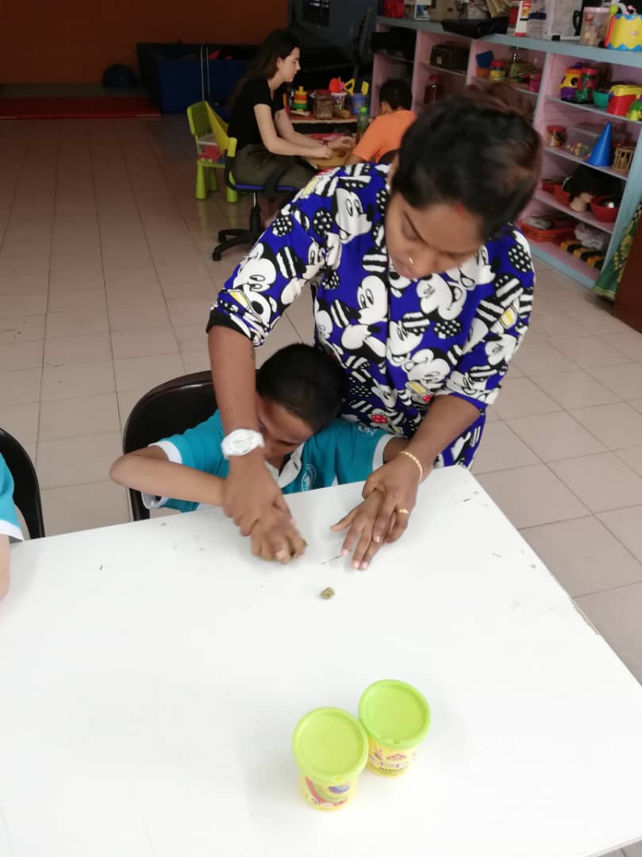
Within four month of joining St. Nicholas’ Home, Ravin gradually showed improvements in his daily activities. He is able to focus longer on activities especially his favorite ones such as jumping on the trampoline, playing with water and grains which gives different textures for him to feel. Besides that, Ravin loves playing and wrestling with his best friend Jimmy who is also deaf and blind since born.
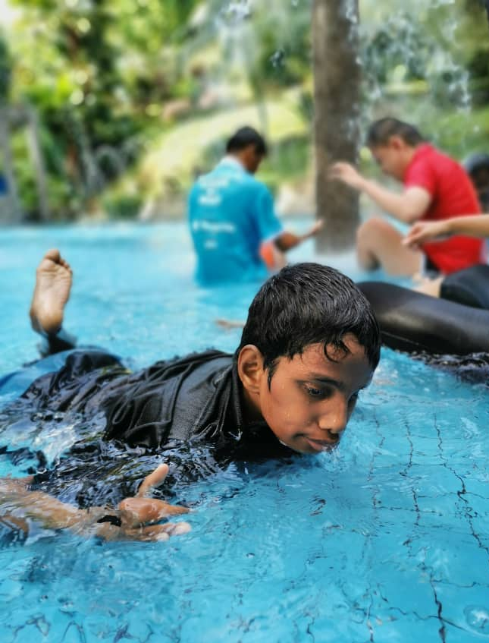

Swimming time
I can roll the Play-Doh
Currently, we are assisting Ravin to perform his daily activities with less help from the teachers. This is an early stage for him to learn things and we do believe by doing so, it will be helpful for him to be more independent in future.

