**LITTLE SLEEPING BEAUTY ROSY**

By Thivia Manikam - DBMH Teacher

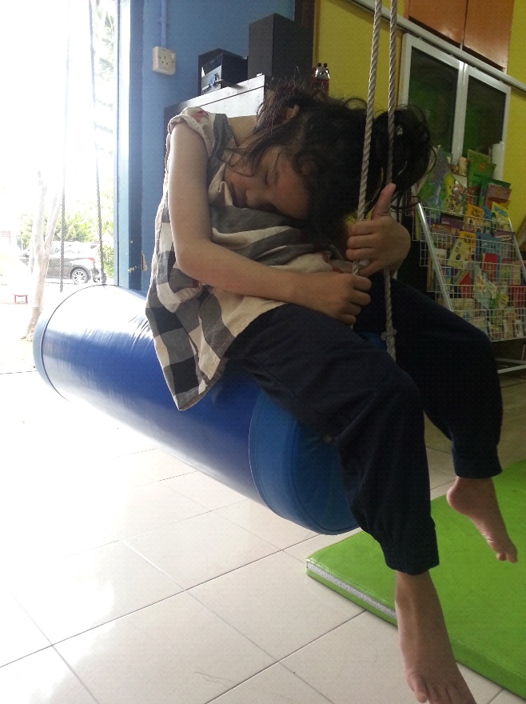

(She sleeps while playing on swings)

This cute little girl is an eight-year-old from Penang. She is the eldest child and has two siblings. Her father is an independent business man. And the mother is a primary school teacher. She was born with a condition known as glaucoma. It is an eye disease that is often associated with elevated intraocular pressure in which damage to the eye (optic) can lead to loss of vision and even blindness. She was born with no eye ball. Due to her poor condition, she needs assistance to manage her daily routine.

When Rosy arrived at our home, she could not stand and walk. Her father always brought her using a baby pram stroller. She was very dependent on the family especially her father. She also felt insecure and was afraid to walk independently.

In the beginning, she was too afraid to stand, as teacher we faced difficulties to make her stand independently without helping without holding onto anything. The teachers were constantly focused to make her physically fit before we could start her basic lesson plan. We also focused on her cognitive skills to make her improve herself such as matching similar and threading beads. She is a quick learner.

In addition, we are giving her several techniques during physiotherapy treatments to own. The physiotherapy treatments that we are enable providing her include stretching exercises to help the muscles be more elastic and toned. Correct posture treatment also is given to prevents fatigue because muscles are being used more efficiently. We always give her walking gait therapy to alternate sinuous movements of different segments of the body with least expenditure of energy. Manipulation therapy to treat musculoskeletal pain and disability; it is mostly kneading and manipulation of muscles, joint mobilization and joint manipulation. And we are also practicing hydrotherapy as a musculoskeletal disorders such as arthritis, ankylosing spondylitis, or spinal cord injuries and spasticity.

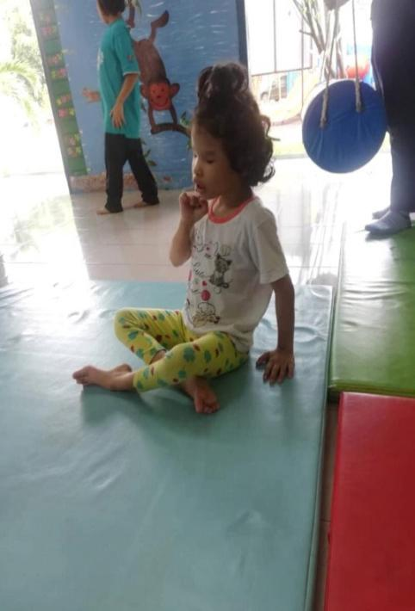

(Rosy sitting in the classroom after her break time)

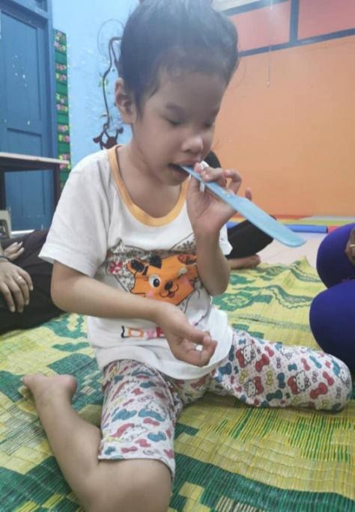

(Rosy in music class goes on)

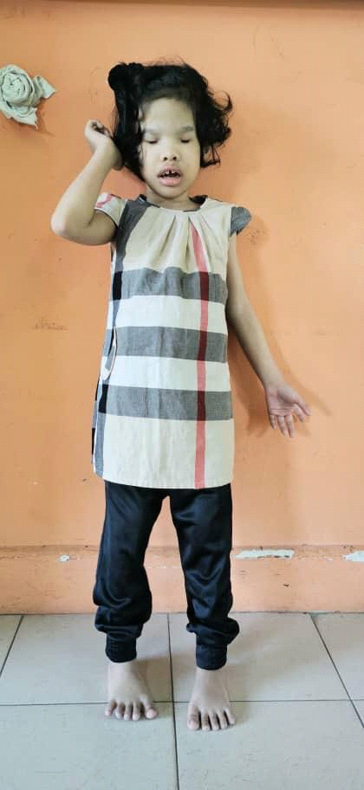

(Rosy is standing during lesson in class)

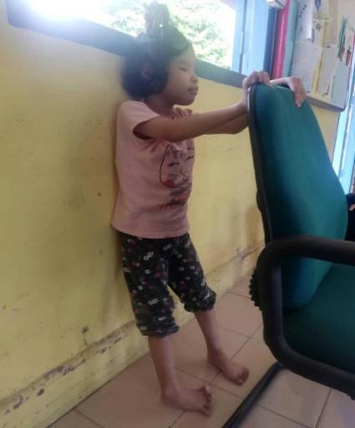

(Rosy is standing with the support of the chair)

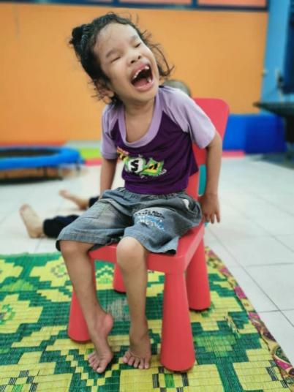

(Rosy happy sitting on the chair with happy face)

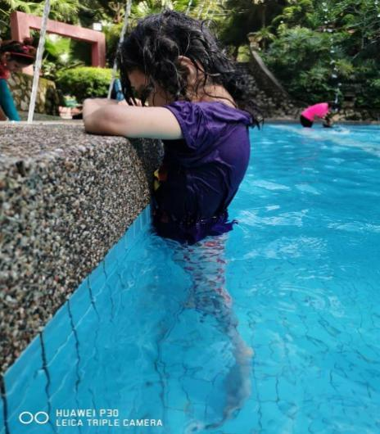

(Outdoor activity & Rosy always likes to play in water)

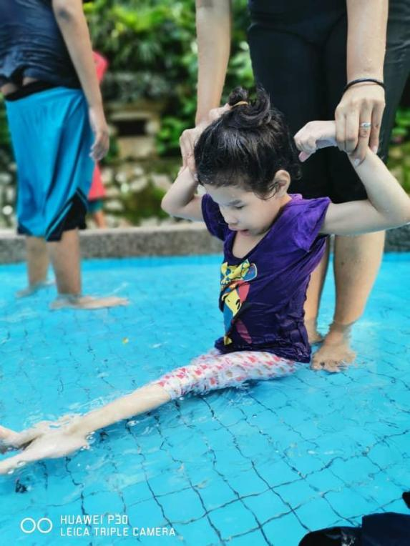

(Hydrotherapy session)

Rosy has made lots of progress in the past six months at St Nicholas Home. Nowadays, she is able to stand and sit by herself and needs little guidance. She is able to walk around the dining table without any assistance, use her hands forward and sideways, stand up and move from one position to another. However, the most significant improvement is that she is able to stand steadily and independently. We are planning to train her using mobility device so that she can lead an independent life in future. We are also very encouraged by her parents who have taken a step forward rosy development.

Your generous donations contribute towards the growth and self-confident our children an active role in her. Your kind support helps these children get a better future desire being physically challenged. We hope that you will continue to show your compassion for them.

**“GIVING IS NOT JUST ABOUT MAKE A DONATION, IT’S ABOUT MAKING A DIFFERENCE”**

Thank you for changing their future!