Kristina Acuma Achon Medical Clinic Project Proposal
Achon Uganda Children's Fund

April, 2011

Executive Summary
From 1987-2006, the people of northern Uganda were caught in a war between their government's military and rebels of the Lord’s Resistance Army. The LRA survived throughout this conflict by kidnapping an estimated 66,000 children and forcing them to become child soldiers. At its height, this bloody civil war displaced nearly 90% of the region’s population (1.8 million people) and lead to northern Uganda being called the world’s worst neglected humanitarian crisis. Although the LRA largely withdrew from the area in 2005-2006, the process of rebuilding northern Uganda has been a slow and arduous one. The poorest region in one of Africa's poorest countries, northern Uganda faces a lack of food and safe water, poor infrastructure and inadequate access to healthcare and education. These factors affect rural areas disproportionately: indicators of health, including mortality rates and prevalence of disease are significantly worse in rural villages.

Awake is one such rural village in northern Uganda. Residents here must travel over 5 km for even the most basic medical care. For the 22,000 residents in surrounding Orum County, the closest Regional Hospital is in Lira, some 65 km away along challenging roads. As such, people in this region suffer daily, and in some cases, die needlessly because they do not have access to routine, preventive health care or emergency medical attention.

One former resident of Awake Village, Julius Achon, knows firsthand the suffering caused by Uganda's civil war and the harsh realities of trying to survive in its aftermath. Julius was kidnapped by the LRA as a boy, yet was able to escape and, miraculously, went on to become a celebrated Ugandan runner and two-time Olympic athlete. Over the past six years Julius has dedicated his life to aiding the people of his home village.

Achon Uganda Children's Fund (AUCF) was officially incorporated in 2007 by Julius Achon and a board of directors in response to the dire situation faced by the residents of northern Uganda. AUCF has a strong track record of fundraising through private donors, and has utilized those funds to provide shelter, food, clothing, education, healthcare and guidance to a group of 31 orphaned children from Awake Village. In addition, AUCF has built a church for the community and provided food relief in times of famine. In 2009, AUCF received IRS 501(c)(3) designation and established a partnership with Love Mercy Uganda, an Australian organization dedicated to the same vision and goals as Julius Achon.

AUCF has undertaken a project to construct the Kristina Acuma Achon Medical Clinic, a non-profit, non-sectarian healthcare facility in Awake which represents the first level of interface between the formal health sector and the community. It will be staffed by medical professionals to provide affordable, basic care to treat and triage the sick and injured.

The clinic will be comprised of a main building with six diagnosis/treatment beds, a diagnostic laboratory, a supply storage room, and a covered veranda serving as a waiting area. A second building will contain separate living quarters for the permanent medical staff and traveling volunteers.

The clinic will be staffed by a full time clinic manager, a full time comprehensive nurse, a part-time physician or clinical officer, and additional support staff, augmented by visiting healthcare professionals from the US and Australia.

Within three months of opening, we expect to see and serve 40-50 patients per day from Orum County and other areas of the surrounding Otuke District. During visits from healthcare professionals who are able to perform specialized services, we expect to serve 60 - 100 patients per day from this region.

The budget to build and equip the clinic is approximately $125,250. The budget to operate the clinic for the first three years is approximately $57,600. These funds will be comprised of cash contributions and in-kind donations of equipment and infrastructure by partner organizations. AUCF has already established partnerships with other local and international organizations such as Crown Renewable Energy, Engeye Clinic, Lifewater International, Medical Teams International, Nike, Ugandan Ministry of Health and Welch Allyn, Inc.

We expect to open the clinic by January 1, 2012. AUCF will fund the clinic's operation for the first three years, after which our goal is for it to become financially self-sustaining.

Statement of Need
The approximately 22,000 residents of Orum County in northern Uganda live 50 to 80 km from the nearest hospital, Lira Regional Referral Hospital. This facility is government-run, and as such, provides medical treatment free of charge to a population in excess of 2 million. However, because it is the primary medical facility for several districts (and the only one consistently staffed by doctors), it is chronically over-crowded, under-staffed and lacking in sufficient inventories of medication. Its aging buildings and equipment are inadequate to meet the needs of the patients filling the floors and outdoor areas awaiting attention.

There are several government-run and private medical clinics in Orum County and the surrounding Otuke District, however, they too are often unable to provide the care that is needed for the district’s 84,000 residents. A recent survey of facilities between Lira and Awake village finds the following:

- Orum Health Center IV (5.2 km NW of Awake) is the primary level IV clinic in Otuke District, and refers critical patients to Lira Hospital. Run by the government and augmented by a partnership with Baylor College of Medicine and Children’s Hospital, Orum HC IV provides inpatient and outpatient care, HIV/AIDS testing, counseling and prevention of mother-to-child transmission, maternal and child health, TB screening and immunization. Like other government clinics, it is plagued by under-funding, over-crowding, insufficient staff, nonfunctional equipment and lack of sufficient medications. Of note, in November, 2010, the clinic had been without a medical doctor for several weeks due to illness, and his return date is uncertain.
- Aliwang Catholic Parish Clinic (8 km SW of Awake) was established 40 years ago by Italian missionaries and is run today by the Catholic church as a private clinic focused on pediatric and maternity care. The staff includes one RN, two midwives and support staff, and the clinic, comprised of two wards, holds 14 beds. Aliwang is a primary source of healthcare for pediatric and obstetric care for Otuke District. Despite the passion and dedication of the facility manager, and the size of the facilities, the clinic is unable to expand its services due to lack of funding.
- Anep Health Center II (4.3 km north of Awake) was constructed by the government in 2000, yet was never opened, and was in fact occupied by the LRA during the civil war. Construction has resumed in 2010, yet there is no official word about plans for the facility. Regardless, without a substantial change in the way government facilities are funded, staffed and supplied, this clinic alone cannot meet the needs of the residents in this county.

As a result, the vast majority of Orum residents are required to travel many kilometers to reach medical care of any kind, often find those facilities unstaffed and lacking in medications, and cannot afford or access the infrequent motorized transportation to Lira for the health care offered there. As such, every day, people in this region suffer and sometimes die simply because lack access to basic preventive care, medicine and emergency medical attention.

Although the Ugandan Ministry of Health (MOH) has set forth goals related to reducing maternal and child mortality, fertility, malnutrition, the burden of HIV/AIDS, tuberculosis, malaria and the disparities in healthcare within the country, these efforts do not seem to have reached the most needy - namely residents of rural villages in the north of the country. These residents routinely suffer from communicable diseases such as malaria, tuberculosis and HIV/AIDS, go without vaccinations, give birth without medical care, and lack education concerning hygiene, sanitation and family planning.

Of particular note is the disease burden posed by inadequate sanitation. From the Uganda MOH Health Sector Strategic Plan II:

"Over 75% of Uganda’s disease burden is considered to be preventable as it is primarily caused by poor personal and domestic hygiene and inadequate sanitation practices (failure to break the faecal-oral disease transmission routes). This vicious cycle that affects most Ugandans can be reversed, as has already been proven in several other countries, through a well-integrated and coordinated deployment of existing resources.”

Again, however, this deployment of resources does not seem to have reached rural northern Uganda. According to the Lira Ministry of Health Office Director, John Nelson Opio, “Otuke District realizes severe sanitation problems with 17% of the population practicing basic sanitation versus 62% in Lira. There is a need to focus on prevention and education as well as provide treatment. Health is made at home.”

Due to the lack of sufficient healthcare facilities in rural areas and the high vacancy rate of medical staff in existing facilities, the Ministry of Health highlights the need to augment the existing healthcare system in rural Uganda in its Health Sector Strategic Plan III 2010-2015. The HSSP III goals include increasing the proportion of the population living within 5 km of a health facility from 72% to 90% and the number of health facilities by 30% by 2015.

The Kristina Acuma Achon Medical Clinic will augment the current healthcare delivery system in northern Uganda by providing access to basic, affordable healthcare to a currently under-served area.

Project Description
The Kristina Acuma Achon Medical Clinic, named in honor of Julius Achon's mother who was killed by the LRA in 2004, will be a non-profit, non-sectarian healthcare facility in the village of Awake, Orum County, Otuke District, Uganda. The clinic will be designated a Health Centre II facility as defined by the Uganda Ministry of Health, representing the first level of interface between the formal health sector and the community. The clinic will provide primary medical care including triage and appropriate treatment, disease testing, inoculation, medication dispensing and education. Maternity services will be added in a second phase with the date yet to be determined.

Achon Uganda Children’s Fund will finance and manage the clinic’s creation, and will employ local Ugandans to do as much of the on-site work as possible, including construction and administration. At completion, it will be staffed by local medical personnel, augmented by visiting medical professionals from the US and Australia and managed by an on-site Clinic Manager who will report to the AUCF Board. Initially, its operations will be funded by a combination of AUCF payments and nominal patient payments, with the goal of self-sufficiency within three years.

Kristina Acuma Achon Medical Clinic Objectives
- The first objective is to build, furnish, and staff a fully-functional medical clinic in the village of Awake, Otuke District by January 1, 2012.
- The second objective is to treat, triage or refer every patient who comes to the clinic, and to keep appropriate records of each patient visit. By the end of the first year of operation, we will have a record of every patient that attended the clinic, with the following information: patient name, age, village, symptoms, diagnosis, treatment, payment and recommended follow-up.
- The third objective is to have the clinic operate self-sufficiently by the end of its third year of operation. At this point in time, KAAMC will operate independently of AUCF funding and oversight; it will be managed by local Ugandans and supported financially through a combination of nominal patient payments and a related income-generating project developed in concert with Love Mercy Uganda based in Sydney, Australia.

Methods
Clinic Description
The Kristina Acuma Achon Medical Clinic will be modeled after the Engeye Clinic located west of Masaka, Uganda opened in 2007. It will be comprised of a main clinic building which will include:
- three exam/treatment rooms
- a larger room which can be sub-divided into three additional exam/treatment areas
- a diagnostic laboratory room
- a locked supply storage room
- a covered veranda serving as a waiting area.
A second building will contain four separate living quarters with private living area, bedroom, kitchen, and shower for the three permanent medical staff and for traveling volunteers. Separate pit latrines will serve the clinic and living quarters.

The clinic will be furnished with a water collection system to harvest rainwater, and a bore-hole well will be drilled on the premises to augment water needs during the dry season. Solar panels will be installed to provide electricity sufficient to power a generator, lights, medical equipment and a refrigerator to store medications and a high-temperature incinerator will be installed on the premises to dispose of medical waste. Please see Appendix for Clinic Site Plan and Drawings.

The clinic will be equipped with basic medical supplies including:
- diagnostics – including diagnostic kits (e.g. malaria), temperature and blood pressure measuring devices, otoscopes, opthalmascopes, glucose test kits, urinalysis kits
- electronic vital signs monitoring devices - spot check (NIBP, SPO2 and Temperature), continuous (ECG, NIBP, SPO2, Temp.)
- treatment - IV kits, non-refrigerated medicines, syringes, first aid supplies and other necessary supplies such as scales, durable mobility devices (crutches, canes, etc)

The clinic will initially be open Monday through Friday from 9 am to 5 pm. The following staff will manage its daily operations:
- Medical Director will be responsible for medical oversight, finalizing diagnostic and treatment protocols, licensing, treating higher-acuity patients and nursing supervision. This physician or clinical officer will be involved in setting up the clinic operations, and will work part-time in the clinic once it is open.
- Enrolled Comprehensive Nurse will be responsible for patient diagnosis, triage, treatment and record-keeping. The nurse will work at the clinic full-time and will be provided living quarters on-site. We are assessing the ability to hire a back up nurse position for emergency situations.
- Clinic Manager will be responsible for site management, financial management, ordering of supplies and materials, supervision of caretaker and regular reporting to the AUCF board. The clinic manager will work at the clinic full-time and will be provided living quarters on-site.
- HIV / AIDs Counselor will be responsible for administering HIV/AIDs tests, counseling and referring patients for treatment, and providing general education concerning HIV/AIDS.
- Pharmacist will be responsible for tracking and preparing medications and vaccines, as well as patient record-keeping.
- Caretaker will be responsible for cleaning the clinic and dormitory, laundry and cooking for the medical staff and visiting volunteers.
- Volunteer medical staff will be hosted every other month for a duration of 2-4 weeks. We plan to establish partnerships with 2-3 hospitals / medical schools that allow their doctors, nurses, technicians and students to visit KAAMC on a yearly medical mission.

Note: AUCF board members have met with medical officials in Lira (Lira Ministry of Health) and have been assured that if paid an appropriate salary and provided housing (see above) that filling these positions is readily achievable; there are medical professionals without work in the Lira region today.

Clinic Services
The clinic will be a fully-functional Uganda Healthcare Level II facility providing basic triage, diagnostic and treatment services for the most common health issues facing rural Ugandans. Data from Engeye Clinic which treats a similar demographic indicate that the following diagnoses are the most common: Malaria, Respiratory Tract Infection, GERD / Dyspepsia / Peptic Ulcer Disease, Hypertension, Gastroenteritis / Diarrhea, Urinary Tract Infection, Sexually Transmitted Infections / Pelvic Inflammatory Disease, Allergy, Type II Diabetes, injury / trauma and maternity. Kristina Clinic staff will be trained and prepared to treat these and similar conditions (exception maternity which will occur at a later date).

Medicines, purchased monthly at the Joint Medical Store in Kampala, will include the following as an initial inventory (based upon Engeye Clinic recommendation):

Medication | Diagnosis | Medication | Diagnosis
Albendazole | Worm Infestation | Aminophylline | Asthma
Artemether | Malaria | Prednisone | Asthma
Quinine Sulfate | Malaria | Dexamethasone | Asthma
Lumefantrine | Malaria | Betamethasone | Eczema
Clindamycine | Malaria | Metoclopramide | Vomiting, Gastroenteritis
Ceftriaxone | Bacterial Pneumonia, Gonorrhea | Saline solution | Dehydration
Amoxicillin | Bacterial Pneumonia, Peptic Ulcer | Ciproflaxin | Dysentery, Gonorrhea
Magnesium Trisillicate | GERD | Diclofenac | Arthralgia
Omeprazole | GERD, Peptic Ulcer | Paracetamol | Arthralgia
Metronidazole | Peptic Ulcer, Trichomonas, Anerobes | Co-trimoxazole | UTI : Acute Cystitis, Pyelonephritis
Bendrofluazide | Hypertension | Ciprofloxacin | UTI : Acute Cystitis, Pyelonephritis
Atenolol | Hypertension | Doxycycline | Chlamydia
Nifdepine | Hypertension | Benzathine Penicillin | Syphillis
Spironolactone | Hypertension | Azithromycin | Chlamydia
Hydralazine | Hypertension | Cetirizine | Allergic Rhinitis
Salbutamol | Asthma | Chlorpheniramine | Allergic Rhinitis
Beclomethasone | Asthma | Glibenclimide | Diabetes Type II
 |  | Metformin | Diabetes Type II

The following table represents the recommended immunization schedule for children in Uganda according to the World Health Organization.

Vaccine |  | Schedule
BCG | Bacille Calmette-Guérin vaccine | birth
DTwPHibHep | Diphtheria and tetanus toxoid with whole cell pertussis, Hib and HepB vaccine | 6, 10, 14 weeks
HPV | Human Papillomavirus vaccine | 10-12 years; +4 weeks; +5 months; Part of country
Measles | Measles vaccine | 9 months
OPV | Oral polio vaccine | birth; 6, 10, 14 weeks
TT | Tetanus toxoid | 15-49 years; +4, +6 weeks; +1, +1 year
VitaminA | Vitamin A supplementation | 6 months; 1, 1.5, 2, 2.5, 3 years

Water, Hygiene, Sanitation & Education
Achon Uganda Children's Fund has established a partnership with Lifewater International in order to provide, through its WASH (Water, Sanitation & Hygiene) Program, safe water, adequate sanitation and education concerning effective hygiene for the local community. Lifewater International will drill a bore-hole well at the clinic site. In addition, certified field trainers from Lifewater's local in-country partner will then implement their Community Health Through Hygiene Lessons (Handwashing at Critical Times, Safe Fecal Disposal, Keeping Water Safe) to the clinic staff, and to community members who will become trainers.

Lifewater International and their in-country partners have been facilitating access to clean, safe water and educating populations in communities around the world in a participatory, culturally-appropriate way for over 25 years. They have had tremendous success in northern Uganda bringing WASH to the youth through soccer and to large communities through health workers, teachers and church workers.

HIV / AIDS
Kristina Clinic intends to partner with Aids Healthcare Foundation via its Uganda branch Uganda Cares (UC) to provide HIV testing, counseling and referral for treatment. Uganda Cares is one of Uganda's largest providers of AIDS treatment and its program has been identified by the World Health Organization and UNAIDS as a best practice model for antiretroviral therapy (ART).

Based upon the UC and Engeye model, Kristina Clinic would receive free, unlimited HIV diagnostic kits (finger-stick test) from Uganda Cares. In order to qualify, Kristina must employ a registered counselor and have a higher-level healthcare facility to refer to for treatment. The intent is to partner with the Soroti Uganda Cares location which is the closest to Kristina Clinic.

Dental Care
Dental care will be provided only when a dentist visits the clinic. Our goal is to arrange for a US or Australia-based dentist to visit the clinic two times per year in order to provide basic services.

Maternity, Obstetric & Newborn Care
During phase I of Kristina Clinic’s operation, pre-natal care, delivery, post-natal and newborn care will be referred to Aliwang Clinic or Orum Health Center IV. We intend to add pre-natal care, delivery, post-natal and newborn care in a second phase, with a time frame to be determined.

Chronic Disease Management
During phase I of Kristina Clinic’s operation, chronic disease management will be treated per established protocols and medications, if appropriate, or referred to Orum Health Center IV or Lira Regional Referral Hospital.

Project Timeline
June 2010: Purchase land
An 80 meter by 60 meter parcel of land has been purchased in Awake village to build KAAMC. The parcel of land is located centrally within the Awake community, and within walking distance of other community infrastructure including the trading center, church and school. A bore hole well was installed by Care International, located directly adjacent to the clinic site, in August 2008.

Jan. 2011: Hire in-country Project Manager
An in-country project manager has been hired, based in Lira. The project manager is responsible for the overall clinic construction co-ordination, oversight of construction personnel and materials and regular communication to the AUCF board. Fund dispersal will be managed by Jimmy Okullo, brother of Julius Achon, reporting to the AUCF board of directors. Jimmy Okullo has previously successfully managed the construction of a home in Lira as well as a church in Awake.

Jan. - Feb. 2011: Design buildings and site layout
The clinic design and construction is based upon the Engeye Clinic, using their original blue prints updated to the Awake site by our Lira-based architect. Design is now complete, including site plans and architectural drawings.

Jan. - June 2011: Obtain permitting
With final building and site design completed, necessary permits including NGO registration, Uganda bank account, MOH approval will be obtained.

Apr. – Sept. 2011: Construct bore hole well and latrine
In collaboration with Lifewater International, a bore-hole well and two latrines will be built on the clinic site. The well and latrine will provide water and toilet facilities during construction for the work staff. Once completed, the well and latrines will be used by patients and staff.

Apr. 2011 - Sept. 2011: Construct buildings and utilities
Construction of main clinic building and dormitory, water collection and storage system will take place. Clinic construction will use plans developed for Engeye Clinic and augmented as necessary by a Lira-based engineer. We will use local and Lira-based non-skilled and skilled labor for construction, and will use local materials, such as bricks and lumber, whenever possible.

Sept. - Nov. 2011: Purchase and install furnishings
We will procure clinic furnishings including beds, tables, storage cabinets, benches, chairs, curtains and linens locally or from Lira and Kampala.

Sept. - Nov. 2011: Acquire medical equipment and supplies
We will obtain medical equipment and supplies by donation or acquisition through partnerships (see Partners section). We will purchase medications from the Joint Medical Store based in Kampala, or obtain them through donations.

Oct. - Dec. 2011: Install solar power and incinerator
Solar power will be designed and installed by Crown Renewable Energy and incinerator will be sourced from Uganda-based Technology for Tomorrow (T4T)

Nov. - Dec. 2011: Hire staff
With the assistance of Uganda Ministry of Health Otuke, and Medical Teams International Lira, and Awake village leaders, AUCF board members will interview and hire a full-time nurse, part-time doctor or clinical officer, clinic administrator and caretaker, and create contracts for each.

Nov. - Dec. 2011: Establish diagnostic and treatment protocols
Based upon the established Engeye Clinic model, we will implement medical diagnostic and treatment protocols and a patient reporting plan (recording information about patients for follow up, metrics, and quality control).

Jan 1, 2012 Open clinic

Feb. - Mar. 2012: Set up volunteer / visiting personnel protocols

Partnerships/ Suppliers
AUCF has begun forming partnerships with other non-profits, NGOs and local businesses for the purpose of gaining expertise, sharing methods and resources, and soliciting in-kind donations.
- Engeye Clinic has been our primary model during the planning phase of the Kristina Clinic project. Founders Dr. Stephanie Van Dyke and John Kalule have provided extensive mentorship and guidance in planning the clinic, including its business model, physical attributes and diagnosis / treatment protocols. Founded in 2006 near Masaka, Uganda, Engeye Clinic sees approximately 15,000 patients per year in addition to operating a scholarship program for local children. It is a mature, successful organization that is operating with similar goals in within a similar demographic to that of the Kristina Clinic.
- Lifewater International and AUCF have entered into an agreement whereby Lifewater will build a deep borehole well on the clinic property and provide WASH education for the medical staff and community leaders. Lifewater International and their in-country partners have been facilitating access to clean, safe water and educating populations in communities around the world in a participatory, culturally-appropriate way for over 25 years. They have had tremendous success in northern Uganda bringing WASH to the youth through soccer and to large communities through health workers, teachers and church workers.
- Welch Allyn, Inc., former employer of two AUCF Board members, has committed to donating clinic equipment including bedside diagnostic devices, ECG machines and vital signs monitors for the care of higher-acuity patients. Further, several Welch Allyn clinical consultants (nurses) have committed to traveling to Kristina Clinic as volunteers.
- Medical Teams International has expressed interest in providing medical supplies to the clinic.
- Crown Renewable Energy will provide the design, construction and on-site installation of a solar panel array sufficient to provide electricity to the clinic and living quarters. The CEO and management team of Crown have expressed a commitment to using their resources and contacts within the industry to ensure the renewable power needs of the Kristina Clinic are met.
- Uganda Ministry of Health continues to work with AUCF in the areas of certification, guidance, medical professional recruitment assistance.
- Rotary Clubs: AUCF has established relationships within the Rotary Clubs of Seattle, Beaverton and San Luis Obispo, as well as Lira, Uganda. We hope to gain Seattle Rotary Service Foundation’s support of the project and to leverage that endorsement to encourage the other US-based clubs to augment the investment. Lira Rotary Club will act as the local host partner, providing oversight and accountability to the US-based Rotary organization.

Project Administration Staff
The following represents the staff that will administer the development of Kristina Clinic and provide oversight during its daily operations:

- Construction Project Manager will be responsible for the overall clinic construction co-ordination, oversight of construction personnel and materials and regular communication to the AUCF board.
- Achon Uganda Children's Fund Board of Directors will be responsible for fundraising, financial governance, stateside coordination & communication with local Construction Project Manager, hiring of clinical and administrative staff and implementing their contracts, organizing volunteer involvement and protocols, establishing partnerships with other NGOs and governmental organizations, and working with medical staff to establish diagnosis and treatment protocols. Once the clinic is running, AUCF Board will provide general oversight, and will be responsible for reporting and project outcomes.

Evaluation
Achon Uganda Children's Fund Board of Directors is responsible for evaluating whether the objectives of the Kristina Clinic project have been met, and evaluating the impact the project is having on the people it is meant to serve.

Objective 1: Clinic Construction
The AUCF Board will evaluate the progress of the project against the Project Timeline stated above on a quarterly basis starting at the end of Q2 2010. Project status will be reported to funding agencies and to private donors and supporters.

Objective 2: Treatment and Record-Keeping
During the first year of operation, AUCF Board will collect and examine the patient diagnosis and treatment records to ensure that appropriate record-keeping is being conducted. This review will be conducted on a quarterly basis. Our plan is to add a medical professional to the AUCF board with experience in medical administration and oversight.

After each year of operation, AUCF Board will collect and examine the patient records generated during that year. An annual report will be generated which details the number of patients seen by geographic area, age, gender, diagnosis and treatment. Recommendations will be made regarding changes to treatment, additional development projects, etc, based on the community's needs and our ability to meet those needs. The Annual Report will be disseminated to funding agencies, private donor and supporters as well as partner agencies.

Objective 3: Self-Sufficiency
At the end of the third year of operation, an audit will be performed by the AUCF Board to determine if Kristina Clinic is meeting its objective of operating independently of AUCF funding and oversight. The Board will assess if any requests for additional funding or for administrative intervention are being made to AUCF. The Board will perform an audit of the Clinic's financials, including expenses, patient payments and profits from the joint development project with Love Mercy Foundation. A report on this audit will be disseminated to funding agency, private donors and supporters.

Sustainability
Each patient will be charged a nominal charge per visit consistent with the charges established at Engeye Clinic. This nominal fee will be requested primarily to ensure that the patient values the service being provided, and increases the likelihood of the patient following the recommended treatment course. However, these fees will also be useful in defraying a portion of the clinic's operating expenses. As stated below in the Budget section, it is estimated that it will require approximately $1,500 per month to keep the Clinic operating. While this payment will initially be made by AUCF through private donations and grant funding, our goal is that it will, within three years, be financed through patient charges and a development project undertaken with Love Mercy Foundation.

Over the past three years, Achon Uganda Children's Fund and its sister organization Love Mercy Uganda have raised approximately $100,000 to construct a church and latrine in Awake village, provide financial support to 31 orphaned children for a period of three years, and begin to save for the medical clinic project. We expect to raise an additional $110,850 through donations, grants and partnerships to complete the medical clinic by January 1, 2012 and supplement its operations for the first three years. We believe that our demonstrated ability to raise funds and complete development projects over the past three years will continue to make AUCF attractive to donor organizations in the future. Orphanage Mosquito

Budget

Construction and Startup Expenses
Item | Estimate | Notes
Land purchase | $3500 | A 3-acre parcel of land in Awake village has been acquired for $3,500.
Construction of clinic, living quarters and latrines | $65750 | Detailed cost roll up completed 4/1/2011
Rain water collection system | $5000 | T4T Africa
Solar power for clinic and dormitory | $8000 | Crown Renewable Energy
High temperature incinerator | $4000 | T4T Africa
Bore hole well | $10000 | Donated by Lifewater Int'l
Clinic and dorm furnishings | $3000 | Beds, cabinets, tables, chairs, linens
Diagnostic Laboratory Equipment | $5000
Medical equipment and disposables | $5000 | EKG, patient monitor, BP, Oph/Oto/temp, supplies – purchased from or donated by Medical Teams Int'l, Welch Allyn and other partners
Medications | $5000 | Initial inventory of medicines and vaccines
Misc. travel, lodging, vehicle rental to complete construction | $7000
Clinic Construction Manager Salary | $4000 | To be employed full-time at $500/month through the planning and construction phase, estimated at 8 months.
Total Construction / Startup Expenses | $125250 | In-kind donations are expected to total $25,000

Monthly Personnel Expenses
Position | Hire Date | Hours | Monthly Salary
Clinic Site Operations Manager | 2 months prior to clinic opening | Full time | $350
Physician / Clinical Officer | 6 weeks prior to clinic opening; consultation prior | Part time | $350
Enrolled Comprehensive Nurse | 1 month prior to clinic opening | Full time | $350
Caretaker and cook | 1 week prior to clinic opening | Full time | $125
HIV / AIDS Counselor | 1 week prior to clinic opening | Part time | $100
Pharmacist | 1 week prior to clinic opening | Part time | $100
Total Monthly Personnel Expenses |  |  | $1375

Monthly Operating Expenses
Item | Notes | Estimate
Medications / Vaccines | Cost of medications and supplies to be partially offset by patient payment of $3000 SH (around $1.50) per visit | $150
Supplies |  | $75
Total Monthly Operational Expenses |  | $225

Total Cost Estimate for First Three Years
Construction and Startup Costs | $125250
Monthly Personnel Expenses for 36 months | $49500
Monthly Operating Expenses for 36 months | $8100
Kristina Clinic Funds Balance as of April, 2011 | $47000
Estimated In-kind Donations | $25000
Remaining Funds to be Raised for Clinic Completion and 3 Years Operation | $110,850

Organization Information
Achon Uganda Children's Fund (AUCF) was officially incorporated in 2007 in Oregon by Julius Achon and a board of directors in response to the dire situation faced by the residents of northern Uganda. AUCF has a strong track record of fundraising through private donors, and has utilized those funds to provide shelter, food, clothing, education, healthcare and guidance to a group of 22 orphaned children from Awake Village. In addition, AUCF has built a church for the community and provided food relief in times of famine. In 2009, AUCF received IRS 501(c)(3) designation and established a partnership with Love Mercy Uganda, an Australian based organization united through the vision and goals of Julius Achon.

The mission of the Achon Uganda Children's Fund is to improve quality of life in rural northern Uganda through access to health care and education, improvements to infrastructure and means of self-sufficiency. Each development project undertaken as a partnership between AUCF and native Ugandans will transition to a state of self-sustainability and independence from outside assistance.

The three-year goals of AUCF and Love Mercy Uganda are:
- To establish a medical clinic in Awake Village, Otuke County to provide life-saving healthcare to its residents and those of the surrounding community.
- To establish a system of health education outreach focusing on issues of sanitation, hygiene, and food preparation and storage.
- To build and staff a pre-school providing early-childhood education to the youngest residents of Otuke County and the surrounding community.
Achon Uganda Children's Fund is currently comprised of a four-member volunteer Board of Directors (see below), and a small group of dedicated volunteers. We are working to increase volunteer participation through active outreach, media exposure and Julius' speaking engagements.
- Julius Achon (Founder) was born in Awake village future site of Kristina Clinic, a former child soldier who escaped and went on to become a great Ugandan runner and two-time Olympian. Julius has dedicated his life to aiding the people of his village in the North and is a well known figure in Northern Uganda both as an athlete and a humanitarian through the Achon Uganda Children's Fund in the United States and Love Mercy Uganda in Australia.
- James Fee (Executive Director) retired in May 2009 after a 40 year career in the medical device industry. During his career, Jim held executive and senior management positions at Welch Allyn, Protocol Systems and Physio-Control. Jim also served on the board of directors of Acrymed, Inc. and Eastside Catholic HS, and for 20 years led an outreach program at Welch Allyn and Protocol Systems providing medical equipment for medical missions.
- Stephanie Musho (Director) has a master's degree in Biomedical Engineering, a keen interest in business development, and a varied background in marketing, product management and research & development in the healthcare, high-tech and athletic industries. Most recently, Stephanie served as Marketing Manager for Acute Care Monitoring and Systems for Welch Allyn in Beaverton, Oregon.
- Pastor Fred Carson is the Lead Pastor at True Life Fellowship in Beaverton, Oregon. Fred has provided the leadership and guidance that has transformed True Life Fellowship into a vibrant, motivated, family-oriented church. He has extensive experience with humanitarian projects in Africa, and has trained hundreds of ministry leaders overseas.

Achon Uganda Children's Fund has demonstrated the capability to effectively complete the Kristina Acuma Achon Clinic project. Our personal connection to the area and its residents and our intention to use local labor and materials affords us a significant level of local support. Julius Achon was born and raised in Awake Village, where his father and stepmother reside and where the clinic will be established. Julius is a well-known figure in northern Uganda both as an athlete and humanitarian and maintains a close connection with the people of Awake and Otuke District through regular visits and financial assistance. Julius' brother Jimmy, who will assist in overseeing the clinic construction, has served effectively in a similar position when he managed the construction of the Lira home for the orphan children. Jimmy today manages the orphan facility and its finances. Julius’ father Charles is a leader in the Awake community, lives next to the clinic site, and 84,000 will act as a liaison between the village and clinic construction team. The AUCF Board of Directors brings substantial experience in the medical device industry, strong project management, and a broad network of medical industry executives and healthcare professionals to provide both financial support and medical expertise.

Conclusion
In conclusion, the members of Achon Uganda Children's Fund are dedicated to its mission to improve quality of life in rural Northern Uganda through access to health care and education, improvements to infrastructure and means of self-sufficiency. We understand the people of Awake Village and Orum County are severely under-served with regard to medical care with the closest medical facility of any kind several miles away. As such, every day, people in this region suffer, and in some cases, die needlessly because they do not have access to routine, preventative health care or emergency medical attention. We are committed and determined to build the Kristina Acuma Achon Medical Clinic to provide primary medical care including triage and appropriate treatment, disease testing, inoculation, medication dispensing and education with a staff will be comprised of Ugandan medical professionals augmented by US and Australian based medical professionals. We are confident and have demonstrated expertise to raise the necessary funds to complete the project and the relationships to staff and maintain the clinic. With the hard work and efforts of our Team and the support of individuals and corporations we will be successful.

Appendix: Clinic Site Plan and Drawings
Kristina Acuma Achon Medical Clinic Compound
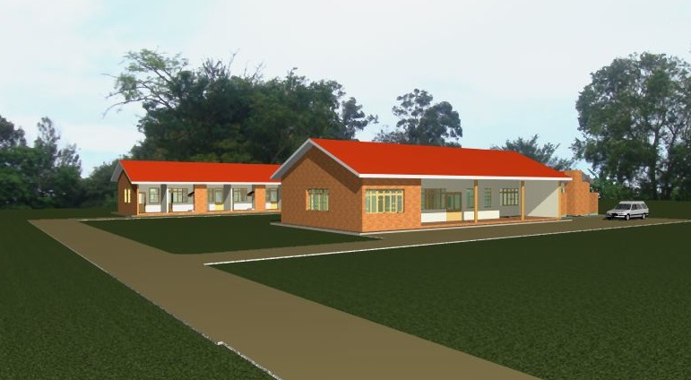

Main Clinic Building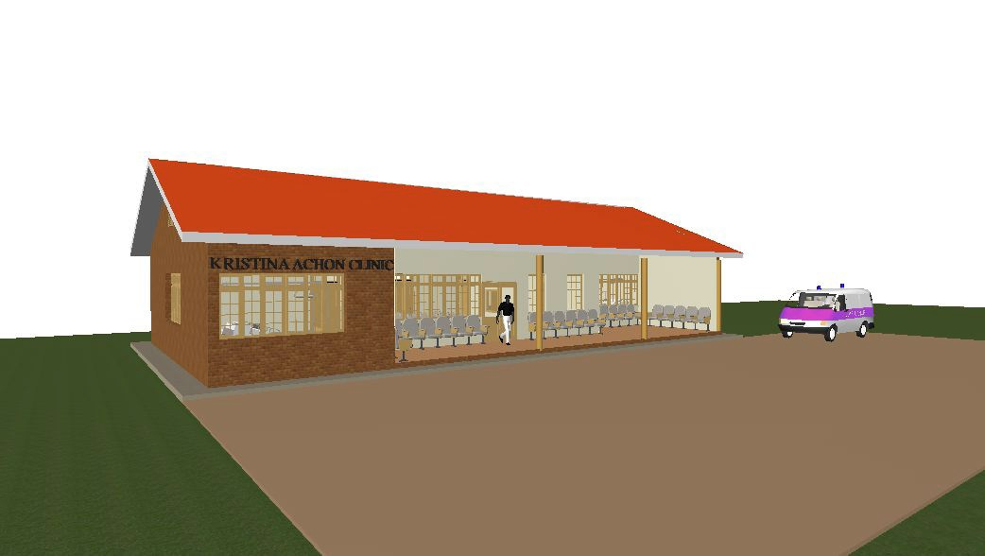
Living Quarters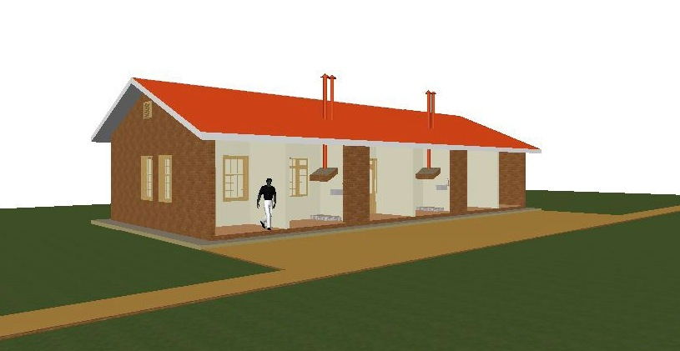
Latrine
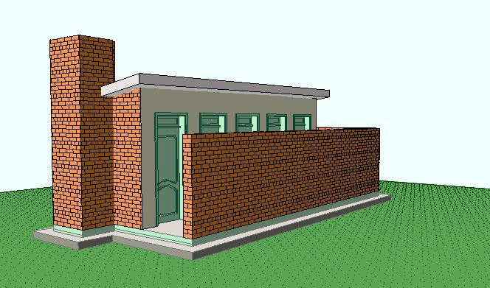

Clinic Site Plan

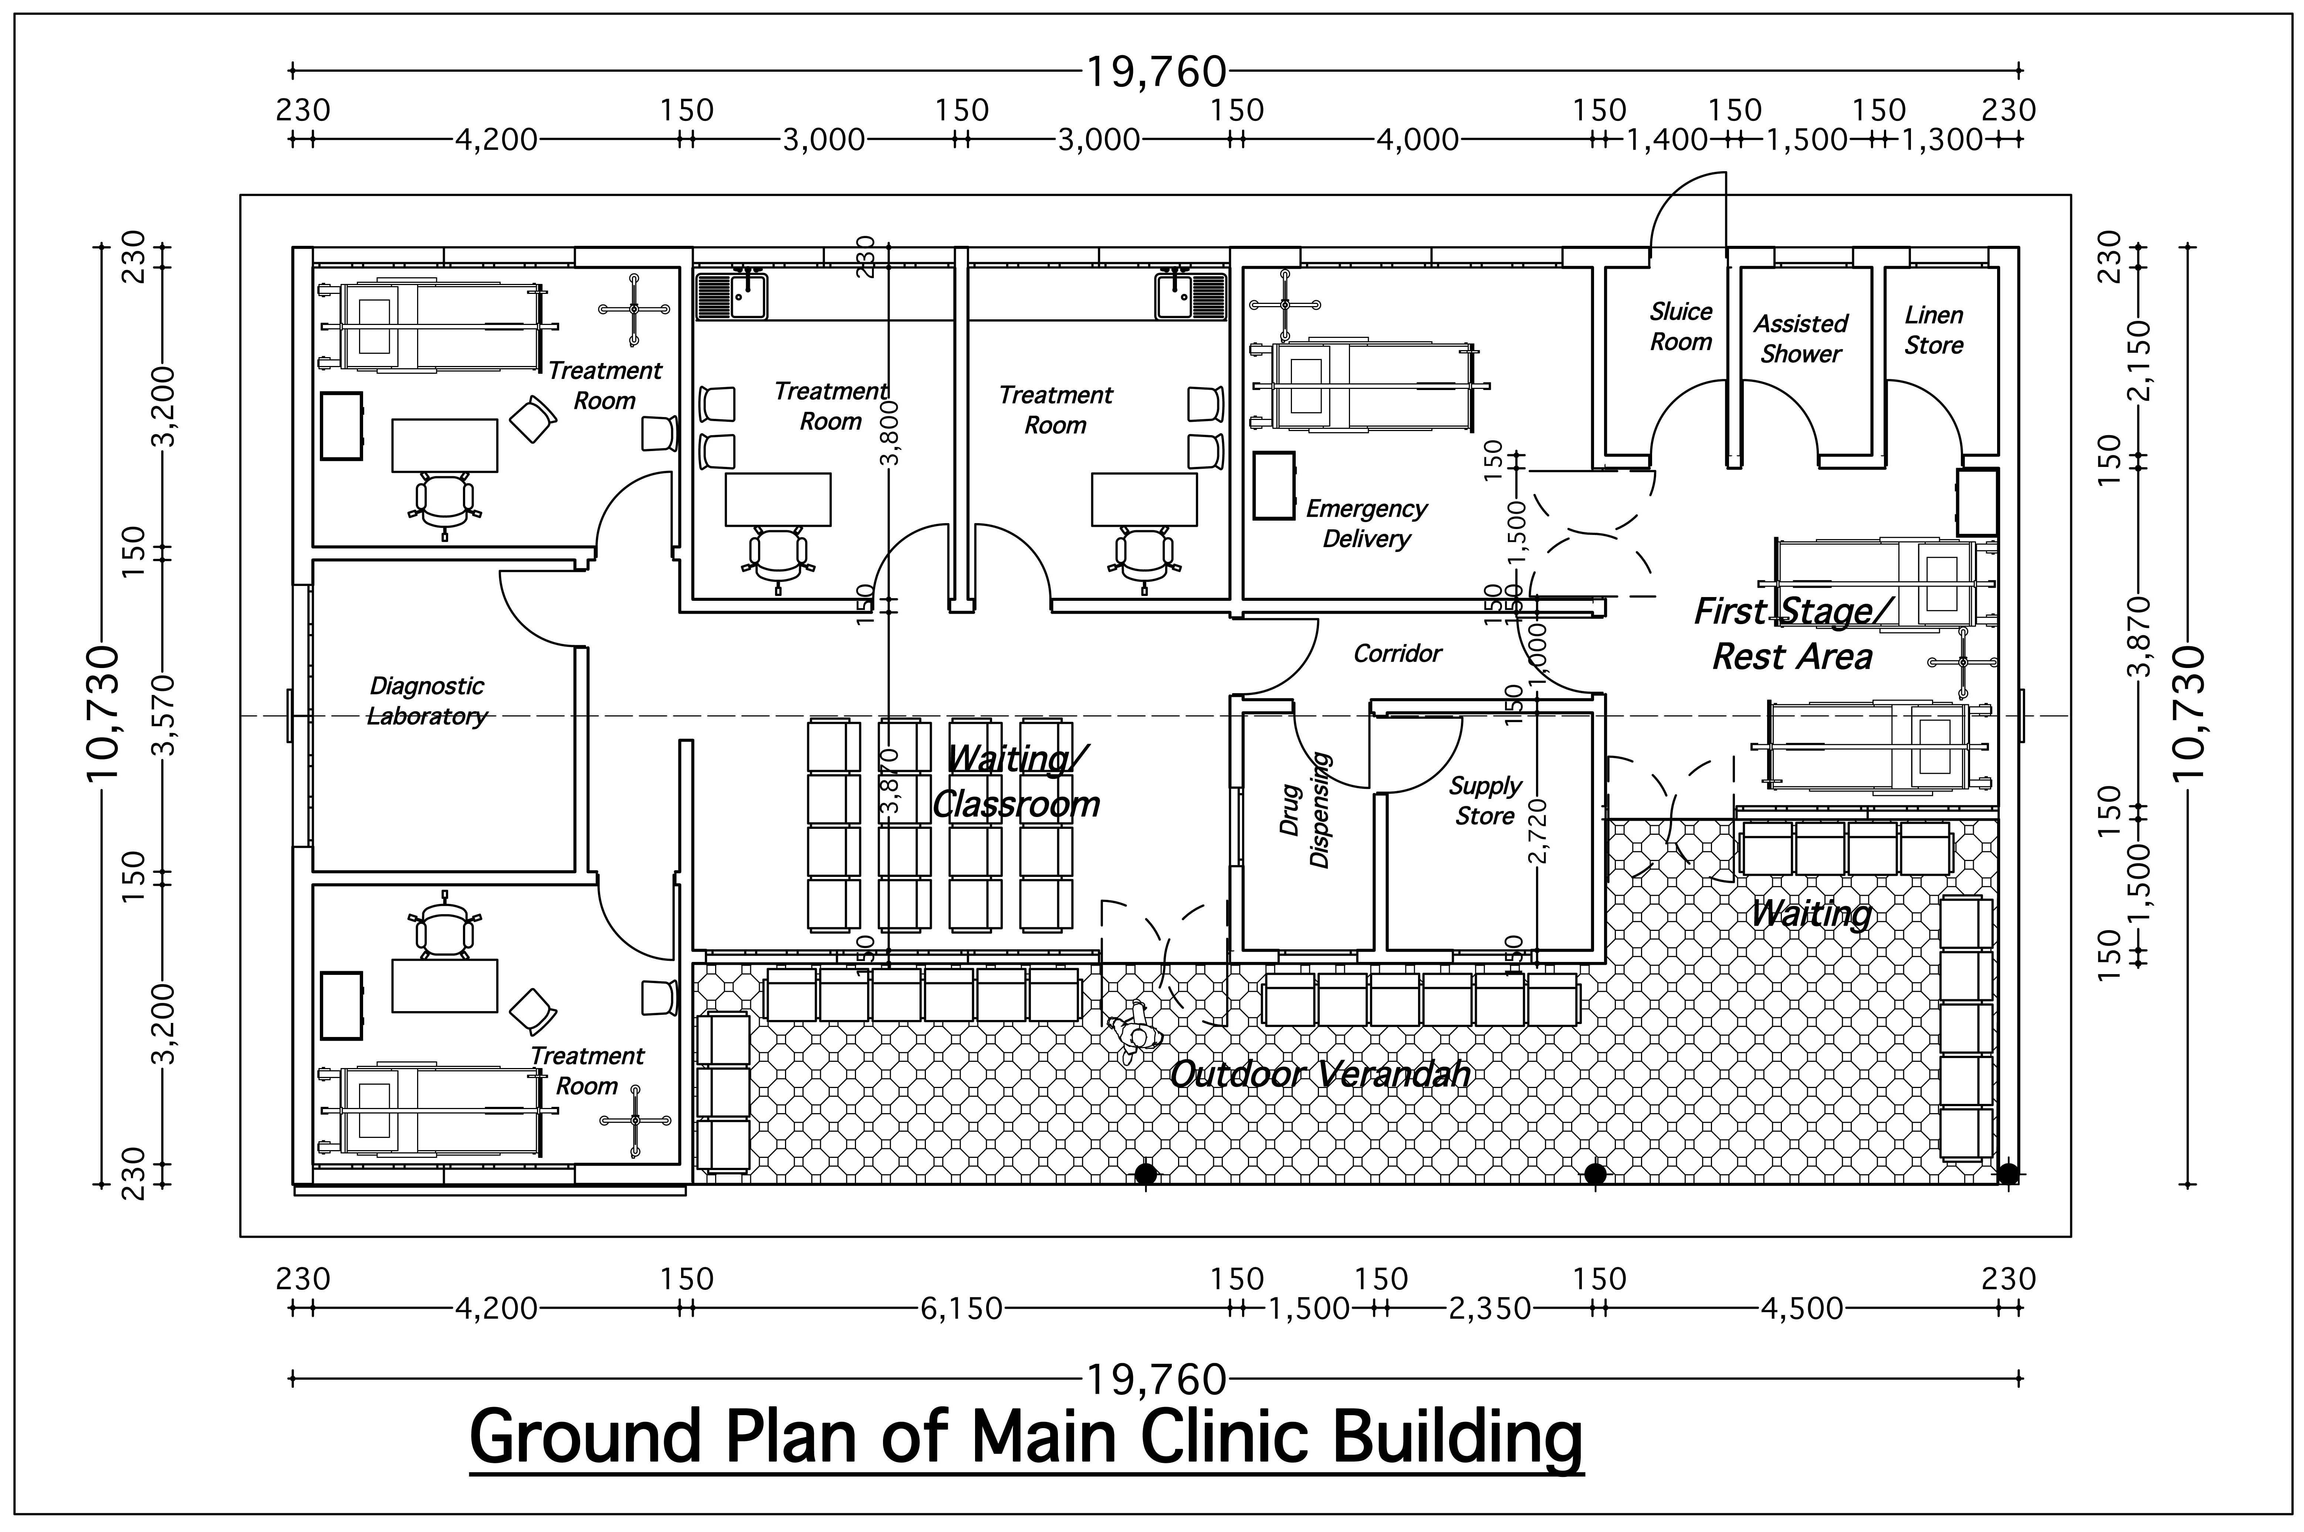 | 