From the Field: Catch up on the latest from PPI's programs
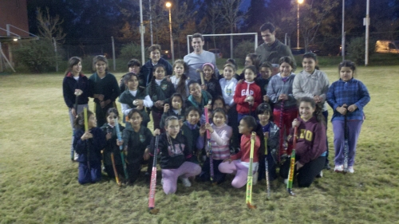
PPI Teams up with the Laureus Sport for Good Foundation in Latin America
Technical Assistance Director Brian Cognato traveled to Buenos Aires, Argentina to work with local Laureus staff and discuss their strengths and challenges.
Read more

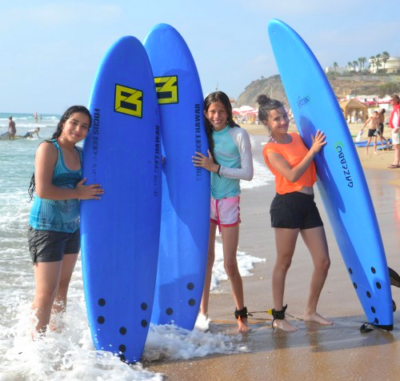
Participant Spotlight: Malak and Mayar Celebrate Romy’s Bat Mitzvah
In the beginning, it was an unlikely friendship; but it blossomed, and transcended all odds.
Read more

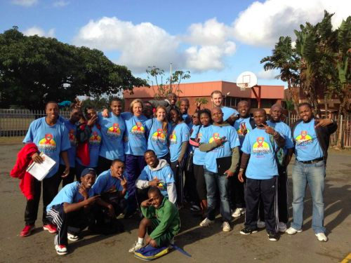
PeacePlayers – South Africa Builds Bridges to Bring Hope
PPI-SA staff were trained as facilitators for the award-winning Bridges for Hope curriculum, an HIV/AIDS prevention curricula that focuses on behavior-changing techniques rather than just giving information.
Read more

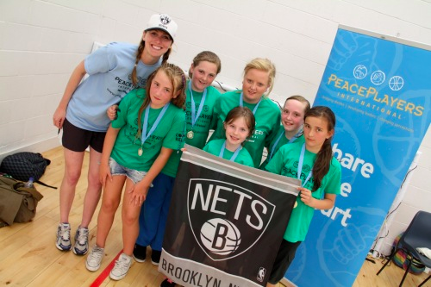
PPI- Northern Ireland Hosts Spring Jam 2012
“In my four and a half years at PeacePlayers, I’ve never seen a more impressive sight… To the untrained eye, they looked like the oldest of friends, but many of these boys and girls only met each other for the first time when they put their team shirt on.” –Project Coordinator Joanne Fitzpatrick
Read more

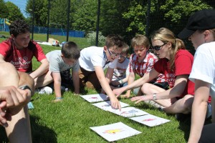

PPI in Action:
Leading the way in sport for peacebuilding

PPI-SA holds 22nd Semi-Annual City-Wide Tournament
The tournament hosted more than 800 participants from the primary school program, and the Brooklyn Nets were recognized at the tournament for their investment in PeacePlayers.
Read more

New Fellow Ashley Johnson Arrives in Cyprus
Ashley Johnson comes to PeacePlayers-Cyprus all the way from Colorado, where she graduated from Colorado College with an economics degree and also captained the basketball team. Ashley was previously stationed in Cameroon for two years with the Peace Corps. Read more

The Difference Between Teaching and Coaching
Check out this in-depth look at the PeacePlayers approach. Not only do we coach basketball skills, but we also teach participants life skills and how to become leaders. Read more!

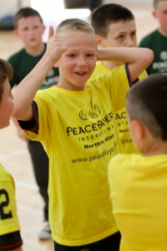

Scoreboard: PPI's Impact
By the numbers, so far this year:
- Percentage of Female Participants Worldwide: 52%
- Number of New Communities Served: 6
- What People Are Saying:
“I’ve never been inspired like this, and my attitude has changed for the better because of being around [PeacePlayers]. I’m proud of being a PPI product, and I know many more people will leave PeacePlayers as better people. You have changed my perceptions.”
Nombuso Dlamini, Former PPI-SA coach and office assistant
“Coexistence is more than just bringing two communities together to play basketball. It is also about these young ladies getting a chance off the basketball court to talk to one another about conflict issues.”
Edniesha Curry, PPI-ME basketball trainer

