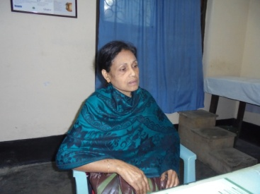
Picture of Asea (Not her real name)

