Report on

Food and Education for the Cambodian

Orphans and Destitute children

Dear Supporters and Friends,

The staff and children of the Cambodian Children’s House of Peace (CCHP) wish to thank you for your kind and generous help and support in keeping our children together and in sponsoring them so that we can provide food, shelter, clothing, medical/dental care and the most important thing is access to education for our 30 orphans and destitute children and youth at CCHP. We strongly believe that only education can help break the cycle of poverty. It is thanks to Friends like you that the founding and development of this children’s home was made possible.
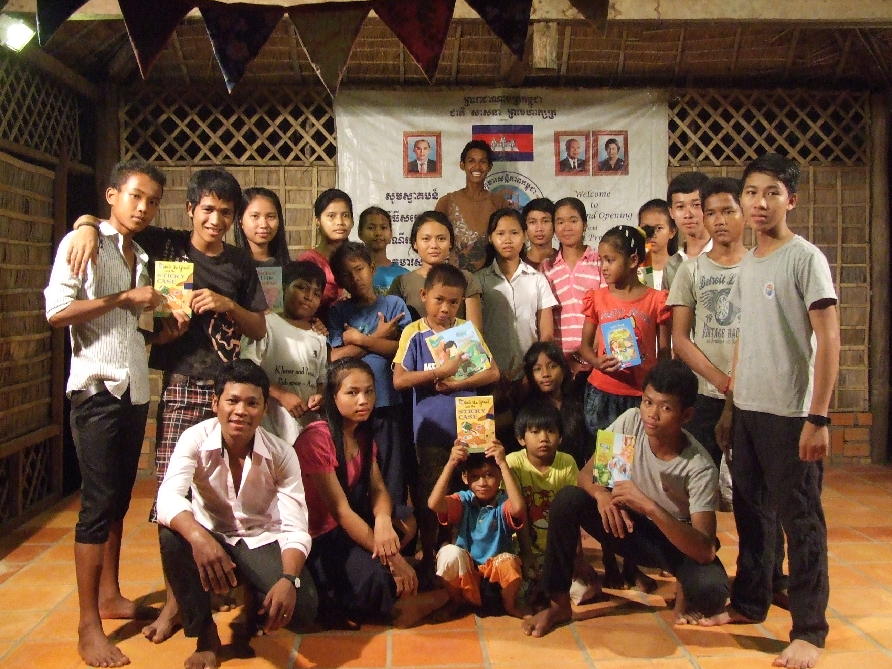
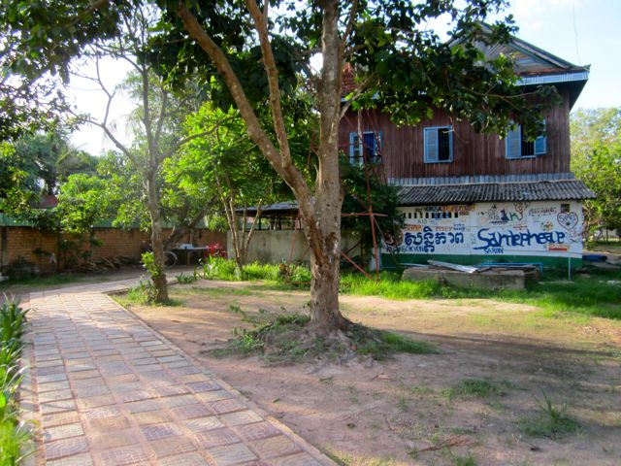

So far we have raised $24,891 through GlobalGiving from supporters and friends around the world to help support these destitute children and all of us can be very proud of its success in making a difference in the lives of these children and their families. Thank you so much for your thoughtful and faithful giving!

Recently we were very lucky to welcome a group of Singaporeans who helped us with painting a beautiful mural on the children’s home and helped build a new library for our classroom. It was a lot of fun for the kids to be able to assist and play with the group, especially on Sunday afternoon. The children’s home looks very nice now, and the energy of the painting reflects the energy of our own kids. We love it! Thank you!
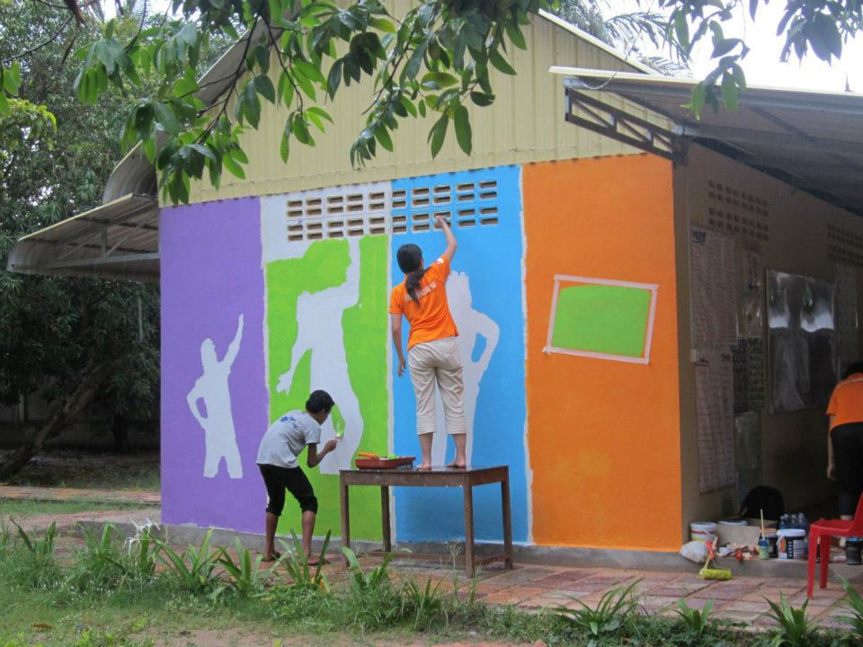
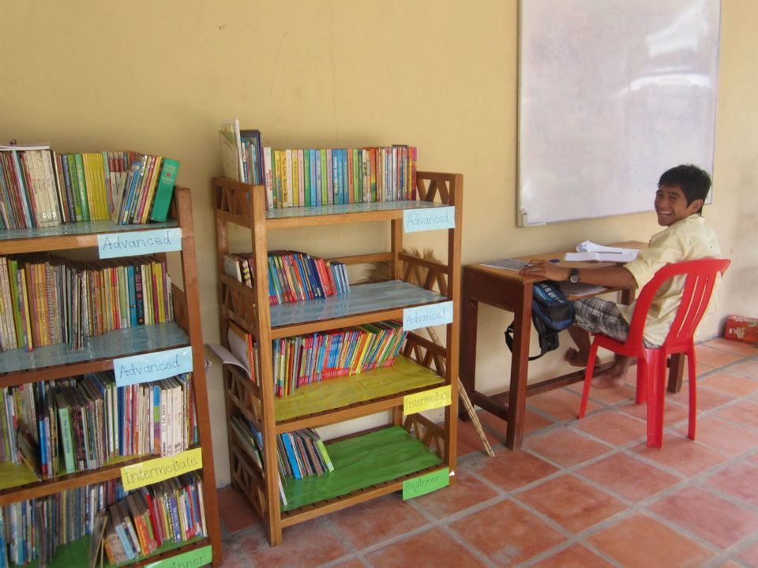

We have been working on our own organic home garden! We plowed the ground at the back yard, and created rows for home gardening. We just planted our first seeds, and we hope to see our first vegetable grow soon! You will always find one or two of our children wandering around the organic garden looking after the first sprouts.

We have also been slowly filling in our new the fish farming pond with water, and putting fertilizers in to create a sustainable environment (plankton) for fishes. The children have showed great interest in creating the fish pond and are using their creativity everyday to solve practical problems like this, and have put in place gutters and water collecting systems. Our goal with the fish farming pond and the organic garden is to give our children an opportunity to learn more about and interact with the environment.
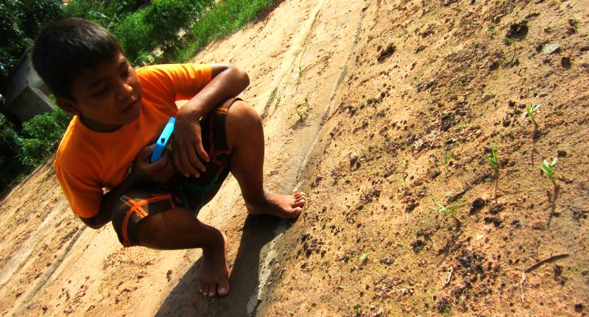
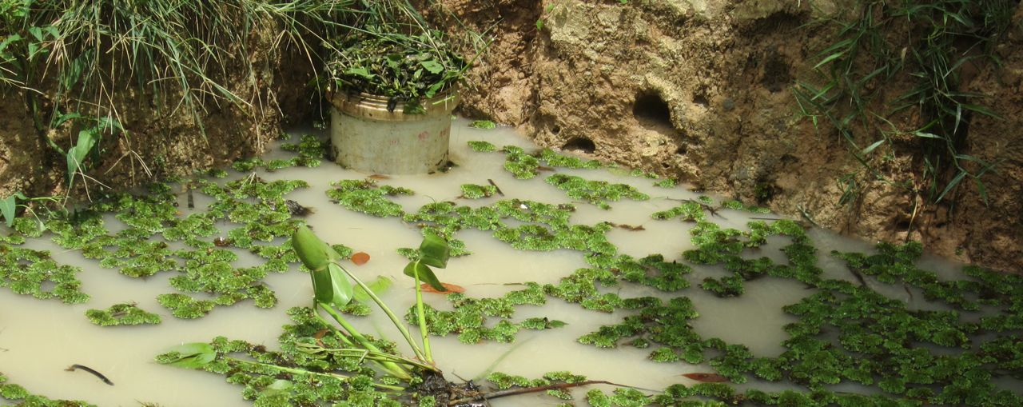

Sathya Hem
Project Leader
Cambodian Children’s House of Peace
Siem Reap, Cambodia

