Update from the Cambodia Children’s House of Peace

Greetings from the Cambodia Children’s House of Peace!

The start of 2013 has been a happy one for the children at CCHP. We are pleased to report to you on a number of successes that your kind donations have contributed to.

Exams
February was a busy month for our children, as they studied hard for their exams. We are pleased to tell you that all our children all passed their exams, with one of them scoring 100% in one English exam. We are pleased that the hard work of our children, teachers and volunteers is being effective.

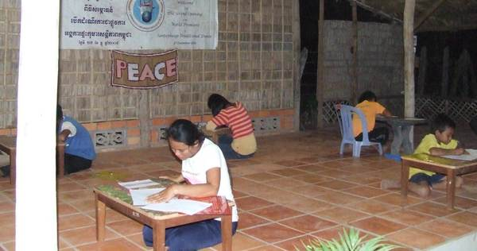

Cinema Outing
After the success in their exams, we decided to treat the children to an outing to the cinema. We watched a Cambodian production called “Have you ever loved me?”, featuring a local pop star. For all of them it was their first experience at a cinema and they were very excited and happy.

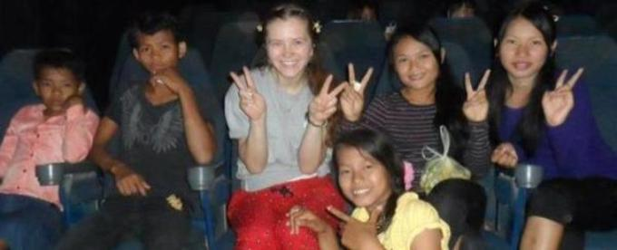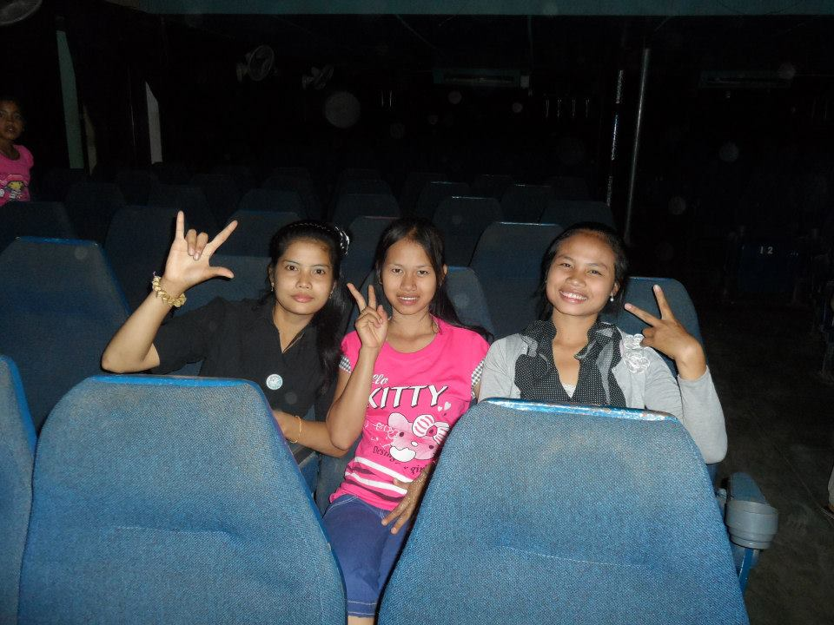

Improvements to our home
Our classroom was outdoors and we worried about our books with rainy season coming soon. With your kind contributions through Global Giving we have been able to build a new indoor classroom.

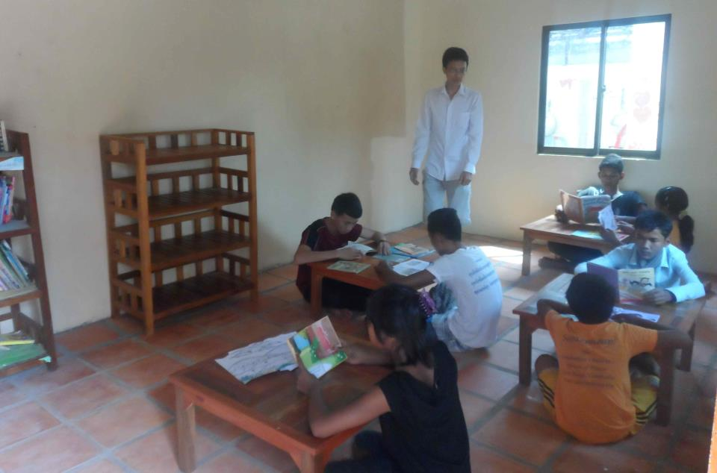

Our kitchen was old and traditional so our children were required to wash dishes on the floor and our shelving was in urgent need of repair. In February we received funds from one of our volunteers to build a new kitchen. This has made an amazing difference:

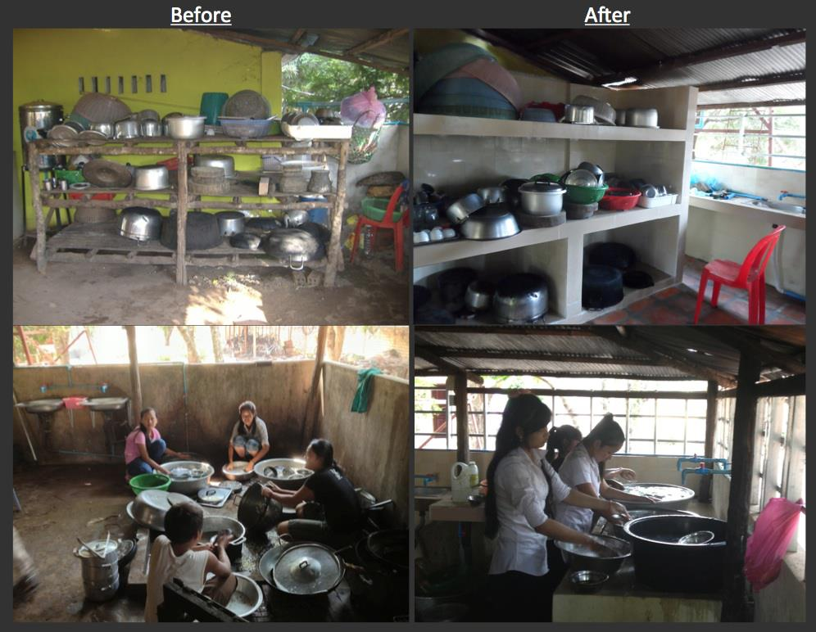

Financial Reports & Facebook
We have now published our Annual Report for 2012 and Budget for 2013 on our website (http://www.santepheap.org/index.php?page=newsletter-2), so you can better understand how your generous donations are spent.

Our Facebook page has been growing in popularity as we post regular photos and comments. Please “like” our page to enjoy these updates:
(http://www.facebook.com/santepheap.org).

Thank you!
On behalf of the children and staff of the Cambodian Children’s House of Peace, we would like to thank you very much for your generous support to Cambodian Children’s House of Peace – CCHP.

