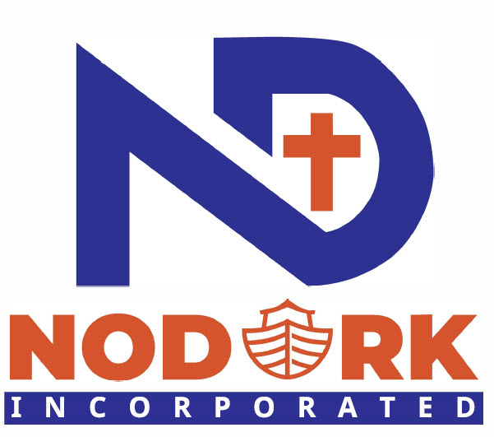

SUBJECT: JOIN PROJECT ‘BOMA’ - Secure The Land for $10K
Dear Supporter,
In Swahili, a BOMA is a secure homestead — a fenced, protected place with a number or huts/houses for different members of the family that is safe.
That is what we are building – a safe place for our flagship home, Destiny Hope Rescue Center in western Kenya. We are calling this microproject Project BOMA and our mission is to raise $10,000 to Secure The Land for our Flagship Home.
Phase 1 - What $10,000 USD Secures:
⚖️ Lawyer Fees ~ $1,500 — Title search, land transfer, legal protection so the Center owns it forever
🔒 Fence & Refurbished Container ~ $4,000 — Secure the boundary, install gate, have a caretaker to protect from encroachment
🌱 Site Clearing ~ $1,500 — Clear brush, level ground, make it buildable
💧 Water & Septic ~ $1,500 — Water access + septic tank prep
📋 Permits & Inspections ~ $1,500 — Legal approval to build
Why now? We cannot build the permanent home until the land is legally and physically secured. Your gift today supports unlocking Phase 2.
Be one of 100 Founders at $100 level to make BOMA – Secure The Land a reality!
THANK YOU! for building a safe home with us.
NODARK INC
Project BOMA: Secure the Land. Build the Future.

