

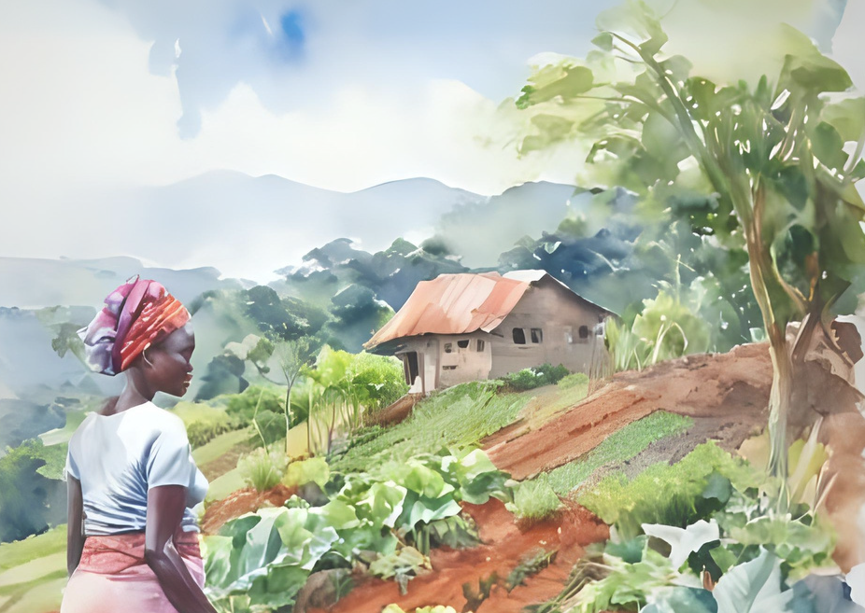




1000WG is able to scale and deepen impact through its Model Gardener Volunteer (MGV) program, which engages expert women gardeners to support program gardeners in their villages, while the RCRA team expands into new sub-counties.

Background
In Kasese District, part of the Tooro Region of Western Uganda, an estimated 85% of households make a living as subsistence farmers in the foothills of the Rwenzori Mountains, with high vulnerability to severe climate events. Soil erosion has led to steady degradation of the Rwenzori watershed and lower agricultural yields, making food insecurity one of the key challenges facing the district today. The Tooro Region ranks second in the country with the percentage of stunted children, 37.0%, compared to a national average of 24.4% (DHS, 2018, 2023).
Women-led Organic Gardens
A Cost Effective Approach for Sustained Food Security and Household Resilience, Western Uganda
In Kasese, Uganda where political conflict,
ethnic and socio-economic marginalization, and degraded natural resources contribute to widespread and persistent poverty, home vegetable gardens are a relatively low-cost and sustainable intervention to support nutrition and health.

1,000 Women’s Gardens
To address food insecurity, malnutrition, and increasing numbers of unwanted adolescent pregnancies, the Rwenzori Center for Research and Advocacy (RCRA) launched 1,000 Women’s Gardens for Health and Nutrition(1000WG) in 2021, supporting women-led organic vegetable gardens for home consumption and income generation.

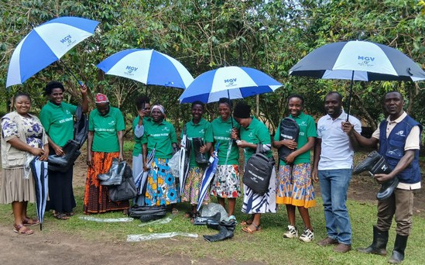
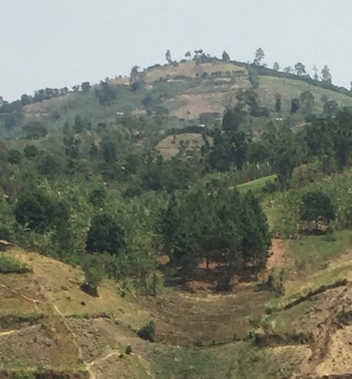
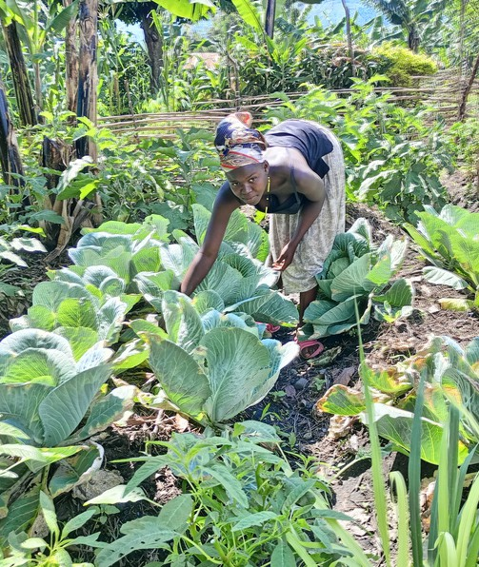
Image: MGV training with 1000WG team



Over the last four and half years, the 1000 WG team has trained almost 700 vulnerable women in organic vegetable gardening practices, including soil and water conservation, nursery establishment and transplanting, crop diversity, botanical pest management, flood management, and seed saving.

Contact: robinmarsh@berkeley.edu doreenkans90@gmail.com

Image: Steep terrain and erosion lead to flooding and crop loss during the rainy season

Image: Young mother tending her vegetable garden

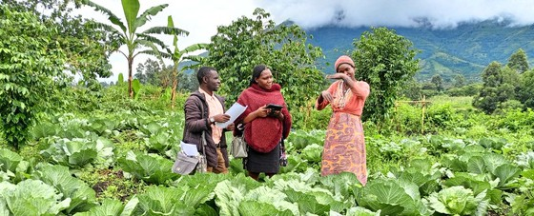
Methods
To assess the impacts of the 1000WG initiative, researchers from UC Berkeley and RCRA used a mixed methods randomized control study design to address the main research question:


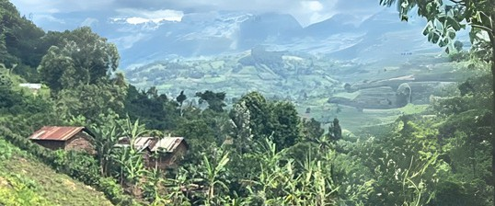

Image: RAs interviewing a respondent in her garden

(How) does having a woman-led organic vegetable garden with 1000WG training impact family nutrition, food security, income, and well-being?
The total sample size of 150 households
included 100 target and 50 control; each household was visited twice by teams of two local researchers, for a total of 300 visits.
85% of households have farms
less than 3 acres.

Key Results
Food Security
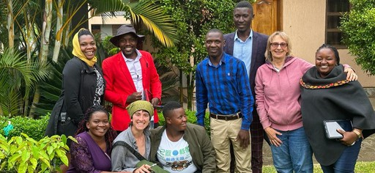
Regarding family nutrition and food security, the data show participation in 1000WG, as compared to the control group, results in marked improvements in vegetable consumption and number of meals eaten per day, fewer ‘lean’ months per year, and improved health status - primarily as a result of better nutrition. Further, data using the Food Insecurity Assessment Scale (HFIAS) tool show 65% of target households fall into ‘food secure’ or ‘mildly food insecure’ categories versus only 20% of control households.

Household Characteristics Respondents in the target and control groups have similar ages, education levels, and household size. More than 70% are married. Landholdings are small overall, with 40%
cultivating one acre or less and fewer than 15% farming more than three acres, underscoring land scarcity as a key production limitation.

Image: Research team at planning workshop
Researchers combined diverse variables to calculate composite household food security scores. The target and control score means of 8.51 and 5.65, respectively, are highly significantly different.
Food Security Composite Scores

1000 WG Area of Coverage

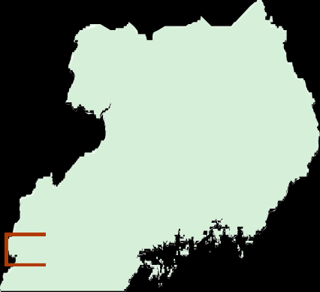

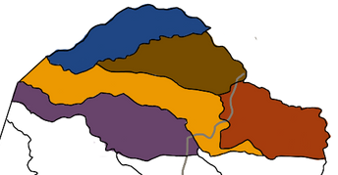






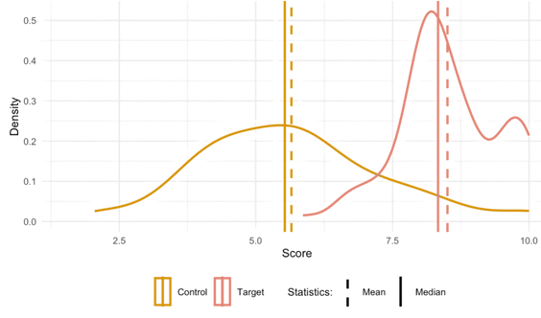
South Sudan
Kyabarungira
Bwesumbu

Kyabarungira
Maliba Bugoye
Kitswamba
Uganda
Lake
Victoria

Health Status
Among gardening households, nearly 90% reported improved health over the last 12 months, with better nutrition being the principal reason (92%). The other frequent reasons cited for health improvement were safe water, improved sanitation, and maternal/child health education. Nearly a quarter of target households also reported having more money to spend on health expenses.
Use of Garden Income, Target Group


Food School fees or supplies Saving for the future Personal items
Donations to church/others

Health/medicine Supplies for the garden

Organic Vegetable Gardens
1000WG and indirect beneficiaries or 'adopter'
Purchase farm animals

0 20 40 60 80
Percentage (%)

gardeners grow a wide diversity of crops. A high percentage of respondents stated they received training in mulching (95%), pest and disease control (78%), composting (77%), fencing (73%), seed saving (65%), and preparation of nursery beds/making raised beds (56%). The most frequent reported garden challenges are pest and diseases, followed by small garden size and lack of water.

Target Adopter
100
Fruit
Over 50% of gardeners save a portion of their
garden sales for future needs and emergencies, mostly in informal collective savings groups.

Community Gardens
1000WG team supports 44 community gardens (CGs) with groups typically of 7-10 members. CGs have played a pivotal role in small town centers where many women live in rented shacks and lack land for home gardening. In these cases, land for CGs is typically leased from landlords on a seasonal basis.
Garden Crops Grown, Target and Adopter

80
Percentage (%)
Spring onion
60
40
20
0
Eggplant
Dodo
African eggplant
Tomato
Cabbage
Sukumawiki

Income Generation
Target households used an average of 56% of harvested vegetables for household consumption, 24% for sale, and 20% as gifts to neighbors or donated to their church. 70% of gardening women sell a portion of their harvest.

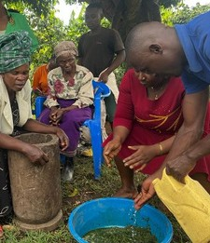
Image: Gardeners learned to make botanical pesticides from local materials.

100
Benefits of Community Gardening, Target Group

80
Pumpkin
Herbs

60
Percentage (%)

40

20

0
Time to socialize
More vegatables to sell
Share labor with other women
More vegatbles to eat

“Some members shared that they no longer have to beg their husbands for money and the additional income has reduced tension and increased love in their family.”

- Grand mother community gardener
Access to land for gardening

Image: Community gardeners in mulched cabbage beds

Women’s Empowerment
Women participating in 1000WG have gained self-confidence to take on new projects, a clearer vision of their future goals, and stronger feelings of pride in themselves and their abilities, all local components of women’s empowerment. The majority of women in 1000WG report positive impacts on domestic relationships with partners and other family members, reducing household tension from lack of food and income. For adolescent mothers, earning their own income reduces reliance on men for basic needs, freeing them from transactional sex that often results in unwanted pregnancies. Other benefits include socialization with other women, joy from collective work, and opportunities to share knowledge and brainstorm solutions to common challenges.
We’re acting as good examples of empowered women in this village because we have healthy children. They see the visible benefits and would like to join us.”

Conclusion
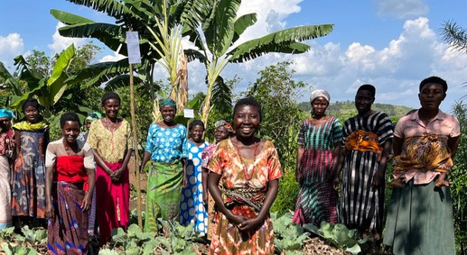
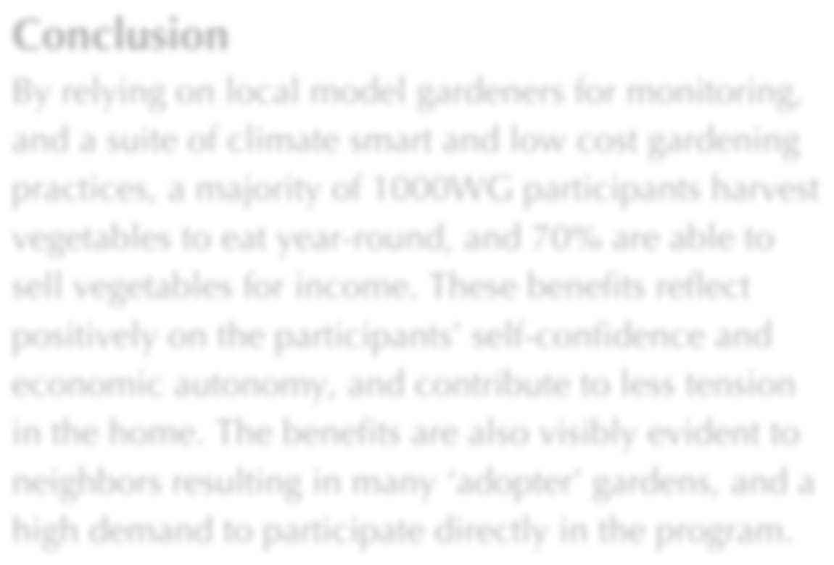
By relying on local model gardeners for monitoring, and a suite of climate smart and low cost gardening practices, a majority of 1000WG participants harvest vegetables to eat year-round, and 70% are able to sell vegetables for income. These benefits reflect positively on the participants’ self-confidence and economic autonomy, and contribute to less tension in the home. The benefits are also visibly evident to neighbors resulting in many ‘adopter’ gardens, and a high demand to participate directly in the program.

A remaining concern are the quarter or so program households who still struggle with food insecurity and low household resilience to adverse events.
It costs less than $40 USD per direct beneficiary when new and continuing gardeners are included.

Recommendations
These recommendations are intended for local governments and community-based organizations seeking sustained improvements in food security, nutrition, women’s empowerment, and resilience to climate change and other shocks for rural households.

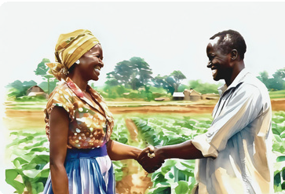
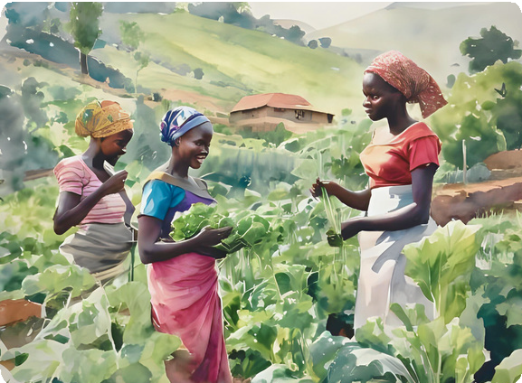
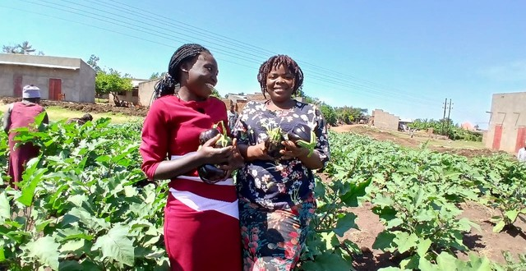
- Expand community gardens for landless women;
- Plan garden crops to sell during lean seasons in local markets;
- Promote income generating gardens for adolescent mothers and grandmothers;
- Create means to access land for garden size expansion;
- Invest in model gardeners for sustained benefits at low cost;
- Train local governments and community-based organiza- tions;
- Analyze cost-effectiveness of 1000WG compared to other rural development initiatives;
- Identify households in lower quartile of benefits for greater support.
-Young mother community gardener

Link to full report:

