My name is Itongwa Tony and in my Community in Goma, I met two talented children: Jeremy Wandjo and arlène Butunga.
Jeremy has a natural gift for music while Marlène is powerful in slam poetry, Despite their talents, both were at risk of losing their potential due to a lack of support and opportunities.
Like Jeremy and Marlène many vulnerable children have incredible, but they lack guidance resources and a safe environment to develop their abilities.
To respond to this reality, we created Circle of Future, a program dedicated to mentoring and supporting vulnerable but talented children, helping them discover, develop and believe in their gifts.
PROJECT TITLE: EMPOWERING VULNERABLE TALENTED CHILDREN IN GOMA TOWN (DR CONGO)
Summary: In Goma Town (DR CONGO) many talented Children from low-income and vulnerable families lack access to training, Mentor ship, and opportunities to develop their skills in arts, sciences and leadership. Without support, their potential remains untapped, limiting their future opportunities and increasing their risk of school dropout and social exclusion.

“Circle of Future” is a structured 6-month empowerment program designed to identity, train, mentor, and showcase 25 vulnerable yet talented children. Through professional training, continuous monitoring, and community engagement, this project will transform raw talent in to real educational and leadership opportunities.

With your support, we will provide access to quality mentorship, learning materials, and a safe environment where children can grow, build confidence, and become future leaders in their community.

PROBLEM | SOLUTION | LONG-TERM IMPACT
In Goma Town (DRC), children from economically disadvantaged families face significant barriers to personal development: Limited access to extracurricular programs lack of mentorship and career guidance financial constraints preventing skill development risk of early school dropout according to local community observations and school feedback many children demonstrate exceptional talent in arts, sciences and leadership but lack structured opportunities to nurture these abilities.  Without intervention, these children risk losing confidence and opportunities that could change the trajectory of their lives. Talent exists but opportunity does not. | Circle of Future provides a structured response through:  - Identification of 25 vulnerable but talented children in partnership with schools and community leaders.  - A 6-month training program including: Arts development (music, visual arts, performance, creative expression).  - STEM Introduction and innovation workshop leadership and public speaking training professional mentorship from local trainers and role models.  Continuous progress monitoring and evaluation a final public show case event celebrating the children’s achievements.  The program is designed not only to develop skills but also to strengthen self-esteem, discipline, team work, and long-term ambition.  ACTIVITIES AND TIME LINE (6moths)  Moth 1: Community outreach and awareness selection process Baseline assessment of each children’s skills program orientation.  Moth 2-5: Weekly structured training sessions mentorship meetings skills workshops, Monitoring and evaluation parental engagement meetings.  Moth 6: Final evaluation  Public talent show case event, certificate distribution, publication of impact report.  EXPECTED OUTCOMES  Direct impact: 25 vulnerable children receive structured skill development and 25 families indirectly supported increased motivation and school engagement. | Improved access to educational and professional opportunities increased youth leadership within the community creation of a network of empowered young role models.  MEASURABLE RESULTS  At least 80% of participants show measurable improvement in their identified talent area 90% program completion rate documented progress reports for each child.  Alumni participants will be trained to mentor future beneficiaries  The project will build a growing network of community-supported youth improvement.  Our goal is to create a sustainable cycle of opportunity where today’s beneficiaries become tomorrow’s mentors.  Investing in vulnerable children’s talent is not charty-it is long-term social transformation.  By nurturing their abilities today, we are building confident leaders, innovators, and creators who will positively impact their communities tomorrow.  Your support will not only fund a program.

DONATION OPTIONS
The total budget for this project is $50 000 designed to ensure the effective implementation of activities aimed at empowering vulnerable and talented children in Goma through education, training and mentorship
- Training materials: $ 10 000 and equipment | This budget line covers the purchase of education and creative materials such as school supplies materials such at school supplies sports equipment and artistic tools  Outcome: Children have the access to the necessary tools to learn, practice and develop their talents.
- Professional trainers and Mentors: $15 000 | This allocation is dedicated to hiring qualified trainers and mentors who will guide children in their education and talent development (academic, artistic and vocational skills)  Outcome: Children receive quality mentorship and structured guidance to improve their skills and confidence.
- Program coordination and Administration: $8 000 | These funds support project management, coordination, monitoring, reporting and communication activities.  Outcome: Efficient, transparent and well-organized implementation of the project.
- Talent Development Activities:  $12 000 | This includes workshops, training sessions, competitions and talent development programs (arts, sport and innovation activities)  Outcome: Children actively develop and show case their talents in a structured environment.
- Child support (Nutrition, transport, follow-up) : $5 000 | This budget supports vulnerable children with basic needs such as meals during activities, transportation and continuous follow-up.  Outcome: Improved participation and well-being of children throughout the program

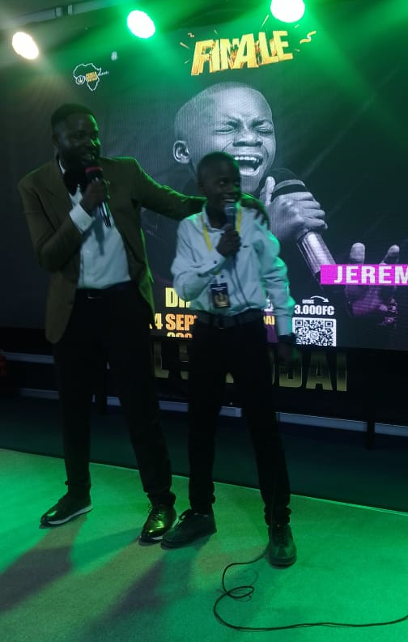
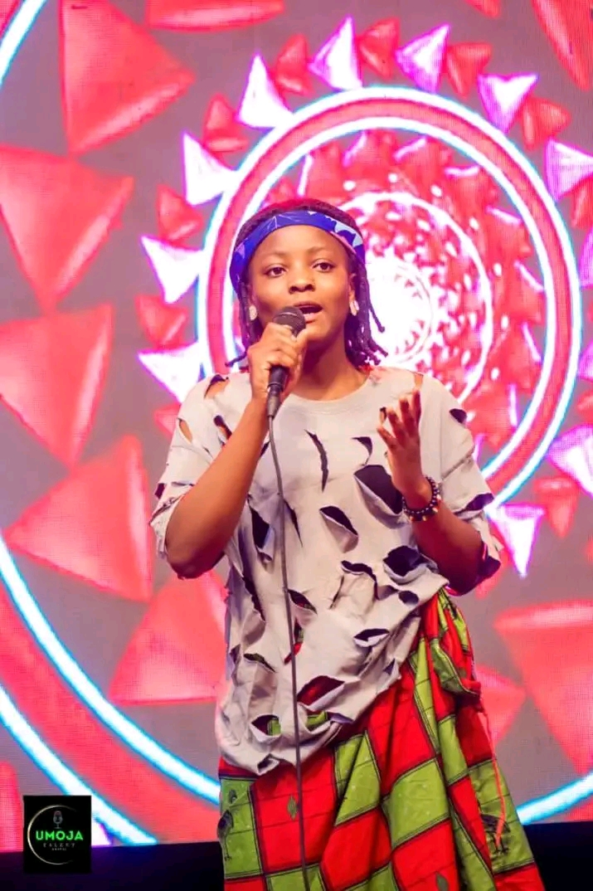
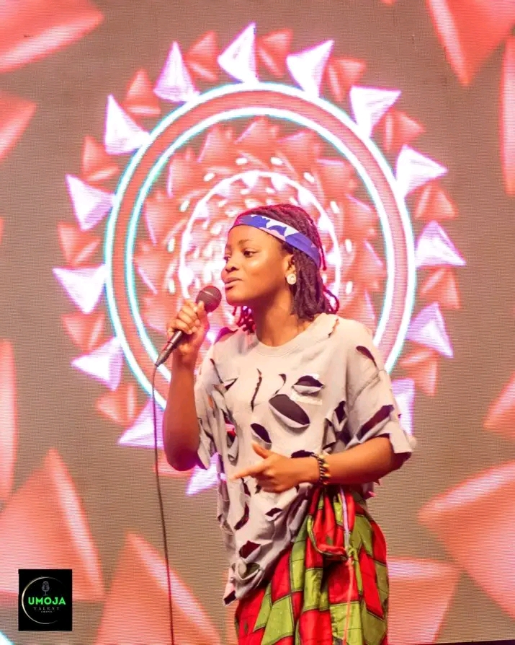
This budget is designed to ensure a holistic approach to empowering vulnerable and talent children in Goma. Each component plays acritical role in providing education, mentorship and essential support services, contributing, to the long-term development and well-being of the beneficiaries.

