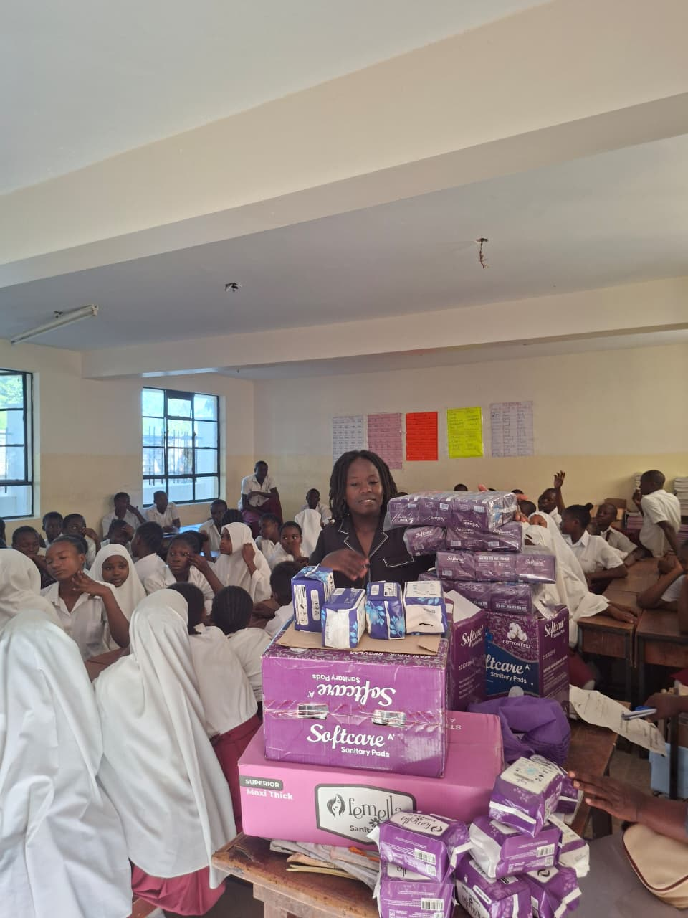
Figure 1. KESCO team presenting cartons of Dignity sanitary pads to the students.
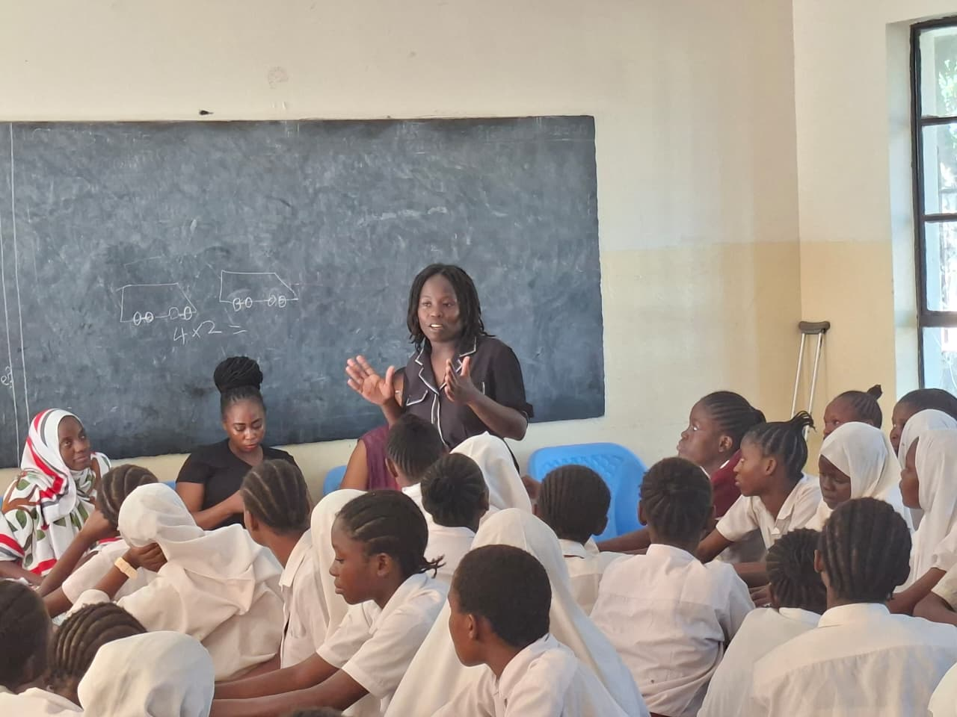
Figure 2. KESCO facilitator leading a menstrual health session at Bedzimba Primary School.

