KENYA SRH CARE CBO (KESCO)

QUARTERLY PROGRESS REPORT
Help 400 Vulnerable Girls Return to School
Mombasa County, Kenya

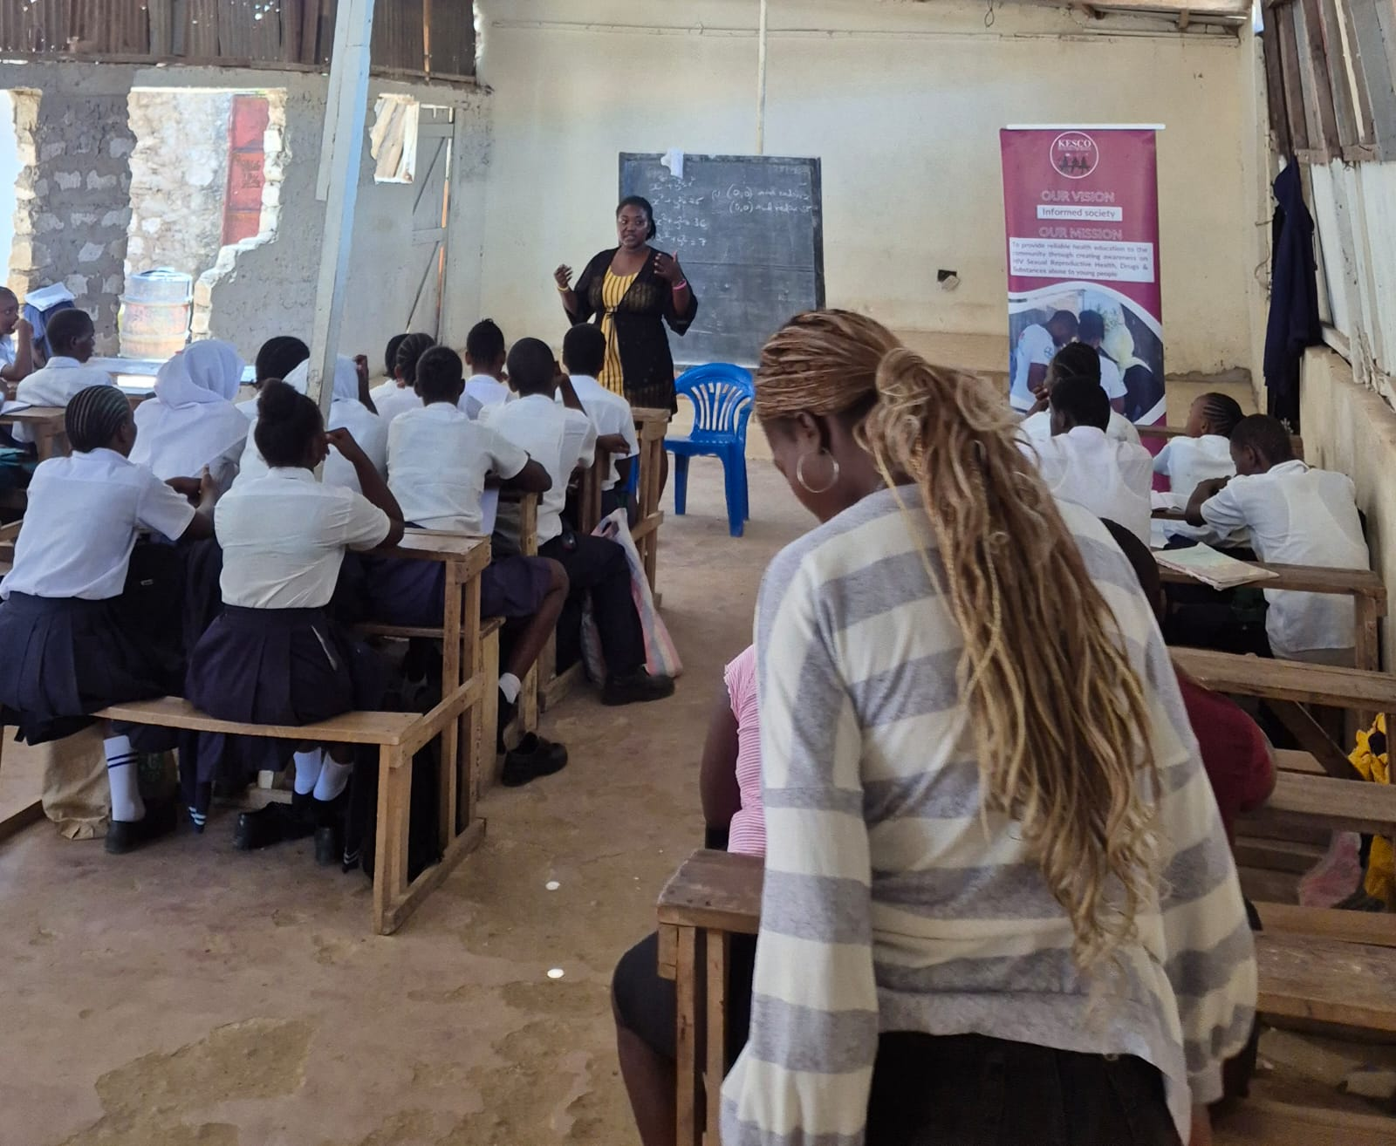
Learners participating in a KESCO life-skills session at Chaani Secondary School, Mombasa.

1. Executive Summary
During the reporting period, KESCO continued school-based engagement linked to the Help 400 Vulnerable Girls Return to School project, whose wider approach combines education support with life skills, menstrual health, mentorship, psychosocial support, protection, referrals and community engagement. Available activity evidence documents engagement across Bomu Primary & Secondary School, Fairways Primary School, Ahmed Shahame Mwidani Technical Training Institute and Chaani Secondary School.
Documented school and institutional activities included menstrual health education, reusable menstrual product sensitization, practical demonstrations, teacher engagement and life-skills development. Chaani Secondary School additionally hosted a KESCO life-skills session reaching 38 school-going learners.
The quarter shows the value of combining educational participation with wellbeing and life-skills support. It also highlights the need to keep project-specific beneficiary tracking separate from broader partner activity reach so that progress toward the 400-girl target can be reported accurately.

2. School and Institution Engagement
School / Institution | Date | Documented Activity | Documented Reach
Bomu Primary & Secondary School | 28 May 2026 | Menstrual health education & sensitization | 200 participants; 20 reusable products distributed
Fairways Primary School | 12–13 Jun 2026 | Menstrual health awareness & teacher engagement | 121 participants; follow-up with 11 teachers
Ahmed Shahame Mwidani Technical Training Institute | Jun & 14 Sep 2026 | Sensitization, practical demonstration & follow-up | 25 initial participants; 20 follow-up engagements
Chaani Secondary School | 17 Jul 2026 + life-skills activity | Menstrual health education and life-skills development | 25 menstrual-health participants; 38 learners in documented life-skills session

Evidence note: The figures above come from the available activity records. They should not be added together as unique GlobalGiving project beneficiaries because some records are partner-programme activity attendances and follow-up engagements.

3. What? So What? Now What?

WHAT? — What happened?
School and institutional engagement took place through menstrual health education, practical sensitization, teacher engagement and life-skills activities. At Bomu, 200 participants were reached during Menstrual Hygiene Day activities. Fairways engaged 121 participants during initial awareness activities and later recorded 11 teacher follow-up engagements. Ahmed Shahame Mwidani TTI reached 25 participants initially and 20 in follow-up. Chaani Secondary reached 25 participants through menstrual health education, while a separate KESCO life-skills session reached 38 learners.

SO WHAT? — What do the findings mean?
The activities demonstrate that barriers to girls' education are connected to wellbeing, confidence, menstrual health knowledge and supportive school environments. Teacher engagement at Fairways showed how school staff can extend menstrual health information to learners and families, while the Chaani life-skills session demonstrated the value of participatory learning that builds confidence, communication and decision-making.

NOW WHAT? — What should happen next?
KESCO should continue integrating life skills, menstrual health, mentorship and protection into school engagement while strengthening project-specific monitoring of enrolment, attendance, retention and support received. Future quarterly reports should clearly distinguish unique beneficiaries from activity attendances and partner-programme reach.

4. School-Level Progress and Learning

Bomu Primary & Secondary School
Menstrual Hygiene Day activities on 28 May 2026 combined menstrual health education, hygiene awareness and introduction to reusable menstrual products. The activity reached 200 participants and recorded 20 products distributed. The engagement demonstrates the value of combining awareness with practical menstrual-health support.

Fairways Primary School
Activities on 12–13 June 2026 engaged 121 participants, including male and female teachers and the school community. A follow-up on 7 September engaged 11 teachers. Teacher feedback highlighted their potential role as menstrual-health information champions who can extend accurate information to students, families and communities.

Ahmed Shahame Mwidani Technical Training Institute
An initial activity reached 25 participants and provided practical guidance on use, insertion, removal, cleaning and care; 25 products were distributed. A follow-up on 14 September engaged 20 participants and documented both initial discomfort and improved comfort among some users with repeated use, alongside concerns about product design.

Chaani Secondary School
On 17 July 2026, 25 adolescent girls received menstrual health education and practical reusable-product information, with 10 products distributed. In a separate documented KESCO life-skills activity, 38 school-going learners participated in an interactive session focused on confidence, communication, decision-making, personal development and wellbeing.

5. Key Learning and Challenges
- Education should accompany material or product support so that learners can make informed choices and manage practical challenges.
- Follow-up matters because user experiences and challenges often emerge only after initial sensitization.
- Teachers can multiply impact by reinforcing accurate menstrual-health information within schools, families and communities.
- Participatory life-skills sessions complement material education support by strengthening confidence, communication and decision-making.
- Project-specific monitoring needs to distinguish unique beneficiaries, activity attendances and follow-up engagements to avoid overstating progress.

6. Recommendations and Next Steps
- Maintain a consolidated GlobalGiving beneficiary register linked to school, support received and follow-up status.
- Track enrolment, attendance and retention for girls supported under the 400-girl project.
- Continue school-based life-skills, mentorship, menstrual-health and psychosocial-support activities.
- Strengthen teacher engagement and school-level follow-up.
- Document each activity with attendance records, approved photographs, participant feedback and school records where available.
- Report partner-programme reach separately from direct GlobalGiving project beneficiary results.

7. Conclusion
The reporting period demonstrates engagement across four documented education settings: Bomu Primary & Secondary School, Fairways Primary School, Ahmed Shahame Mwidani Technical Training Institute and Chaani Secondary School. Together, the activities show how education, menstrual health, teacher engagement and life skills can reinforce a more supportive environment for girls and young people.
The next quarter should build on this engagement while strengthening beneficiary-level monitoring so that KESCO can demonstrate not only activities delivered, but also progress in school participation, retention, wellbeing and confidence among girls directly supported by the GlobalGiving project.

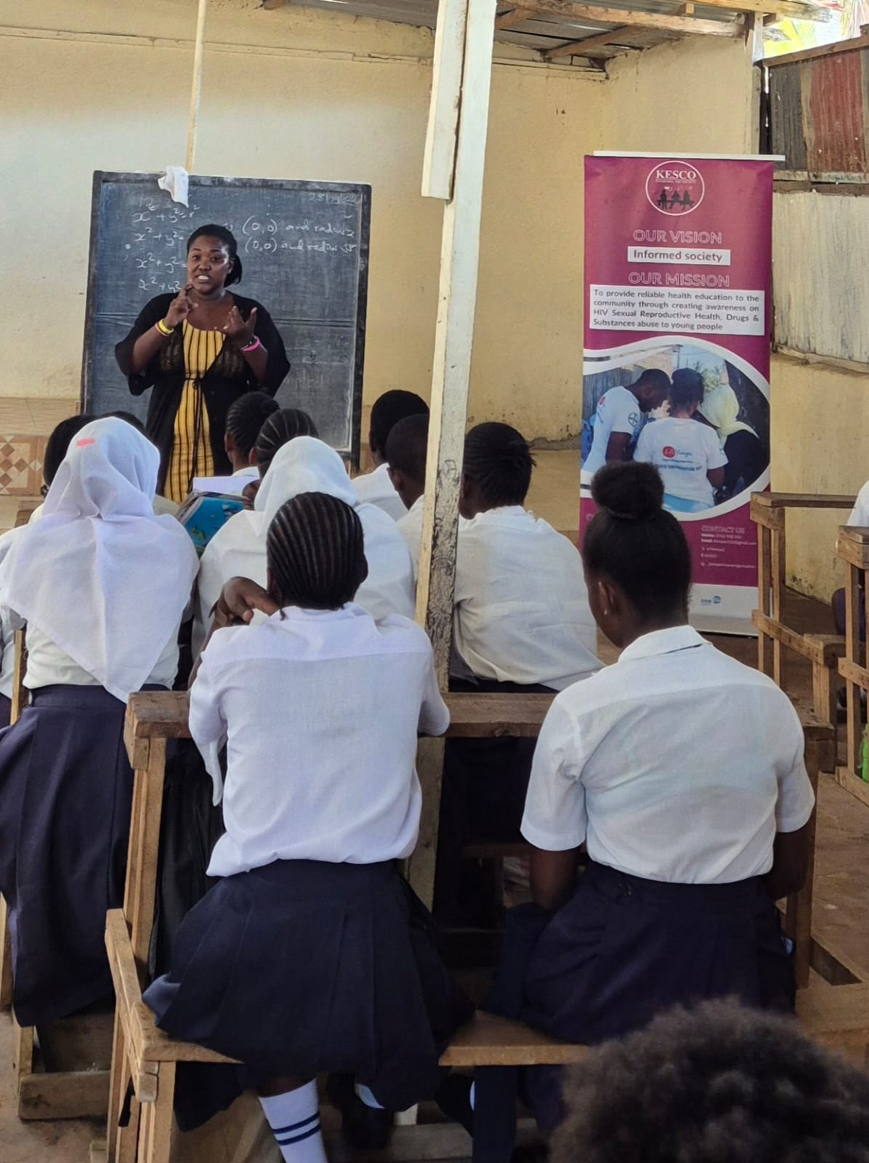
Chaani Secondary School — KESCO facilitator engaging learners during the life-skills training session.
Chaani Secondary School — learners participating in the KESCO life-skills session.

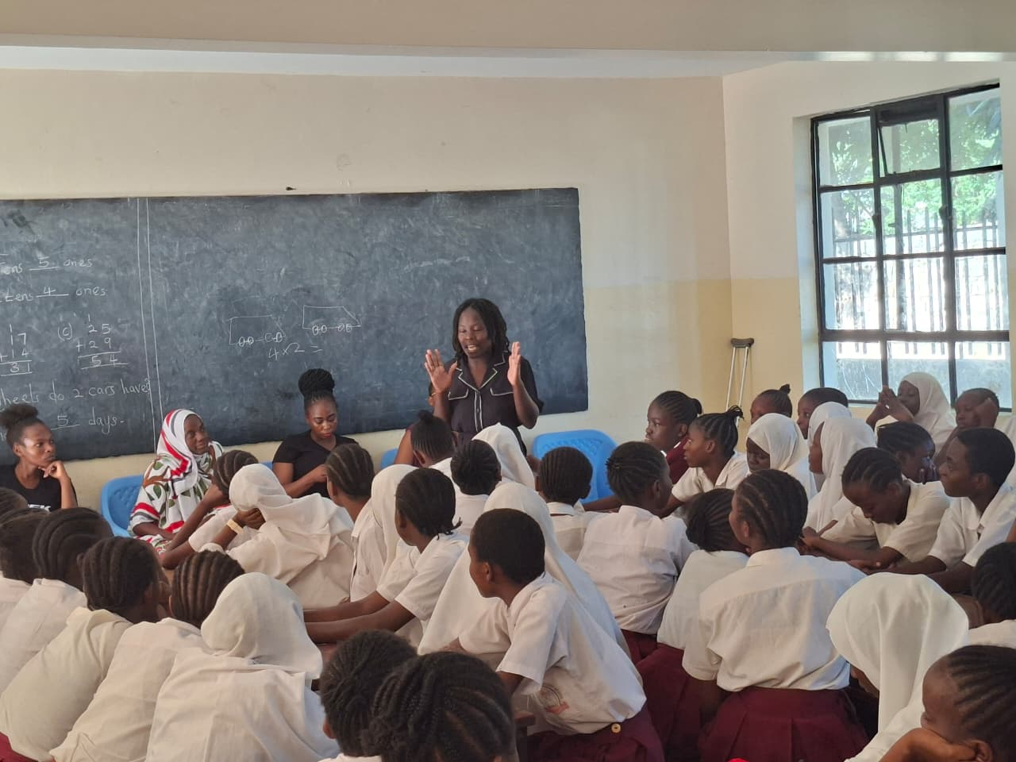
Additional school-based learner engagement documented during the reporting period.
Safeguarding: Photographs are included with confirmed consent for reporting and communication purposes.

