Storytelling Worksheet
Use this worksheet to outline the essential elements of your organization's work you’d like to fundraise for. This storytelling format mirrors GlobalGiving project pages, which you can view on GlobalGiving.org for inspiration.

Let’s Get Started!
- Get familiar with GlobalGiving’s project page format by finding three projects you would support if you were a donor. We encourage you to filter by “Location” and “Theme” to streamline your exploration. This first step aims to familiarize you with the project page format and help you understand what potential donors see when they visit GlobalGiving.

- Review the “Tell Your Story” content (page 2) to help you complete the Storytelling Worksheet (pages 3-5). We hope this worksheet will help you outline a project you hope to fundraise for soon. Ideally, the project you feature in the worksheet is the first project you wish to fundraise on GlobalGiving to save yourself some time and effort. However, you are not limited to one project once you're a GlobalGiving partner.

- Submit your completed worksheet USING THIS FORM by Friday, Feb. 27 to access GlobalGiving’s due diligence application.

Tell Your Story

Donors are more likely to support your work when they understand how you will channel their generosity to make a difference. Good storytelling is essential to your sustainable fundraising strategy because it keeps people giving!

Key Lessons

- Inspire connection through personal storytelling. The people closest to the problem community members and/or staff) are often the most influential storytellers. Here is a downloadable checklist to master the basics of nonprofit storytelling.

- Talk about impact in terms of transformation. Combine data, photographs, and individual stories to show rather than tell how things have changed because of your work.

- Portray your community with dignity and strength to inspire empathy and connection rather than pity. Choose photos that show the positive impact that you are making and leave out images of despair. We encourage you to review the GlobalGiving Community Photo Standards.

- Watch this 3-minute video to hear how GlobalGiving community leaders inspire donors through storytelling!

 Tell Our Story

Project Title:
Recommended 50 character maximum, start with a verb ; Transforming Huts into Homes
Summary: What will this project do?
The project aims to provide safe, permanent housing for families living below the poverty line who currently reside in temporary sheds or huts. It will construct durable, disaster-resilient homes with access to basic amenities, improving health, safety, and dignity. The initiative prioritizes vulnerable households, including women-headed families, older persons, persons with disabilities, and families with children, enabling them to achieve a secure and sustainable living environment.

Recommended 500 character maximum
Funding Amount/Goal: How much money do you hope to raise (in USD)?
26500 USD (5300 USD X5 Houses)

Challenge  What is the problem or need?  Many families living below the poverty line live in unsafe sheds and huts made of tin sheets, thatch, and other fragile materials. These shelters offer little protection from rain, wind, and extreme weather, exposing families to health and safety risks. Poor housing also limits access to sanitation, education, and livelihoods. Safe, permanent housing is urgently needed to protect vulnerable families and improve their dignity, well-being, and future opportunities.  Recommended 500 character maximum | Solution  How will this project solve the problem?  The project will construct safe, durable, and disaster-resilient homes for families living in temporary sheds and huts. Each house will provide secure shelter, improved sanitation, and a healthy living environment. Priority will be given to the most vulnerable households, including women-headed families, older persons, persons with disabilities, and families with children. The project will restore dignity, improve health and safety, and create a foundation for sustainable livelihoods and long-term well-being..  Recommended 500 character maximum | Long-Term Impact  How will this make a lasting impact in your community?  The project will create lasting change by providing vulnerable families with safe, permanent homes that improve health, security, and dignity. Stable housing will reduce disaster risks, support children's education, and enable families to invest in livelihoods rather than temporary repairs. Over time, the project will strengthen community resilience, reduce poverty, and help break the cycle of poor housing for future generations.  Recommended 500 character maximum
Donation Options: How can you illustrate the impact of a person’s donation? For the purpose of this exercise, we recommend outlining three donation options under $100.

Amount | Description
$ 50 | The project will identify vulnerable families, clean and prepare housing sites, and construct safe, permanent homes with basic sanitation. Community participation will promote ownership and ensure lasting benefits.
$ 5300 | Construct one safe, permanent house for a family living in extreme poverty, replacing an unsafe hut. The house will provide secure shelter, basic sanitation, dignity, and protection from weather and health risks.
$ 26500 | Construct five safe, permanent houses for families living below the poverty line, replacing unsafe huts. The homes will provide secure shelter, basic sanitation, dignity, and protection from weather and health risks.

Photo Gallery
Choose four images that show the impact of your work and draft clear captions. Choose high-resolution photos that are positive and empowering and show the community you serve with respect and dignity. Before sharing a photo, ask yourself this question: Would I want to be portrayed this way? Does this image instill hope? Upload photos to worksheet however makes the most sense - photos don’t have to fit perfectly in box!
PHOTO  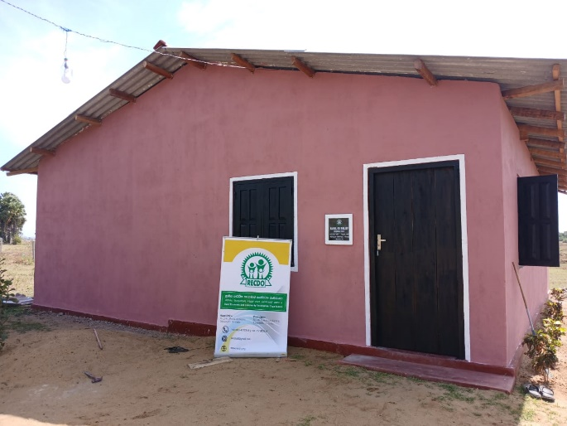 | PHOTO  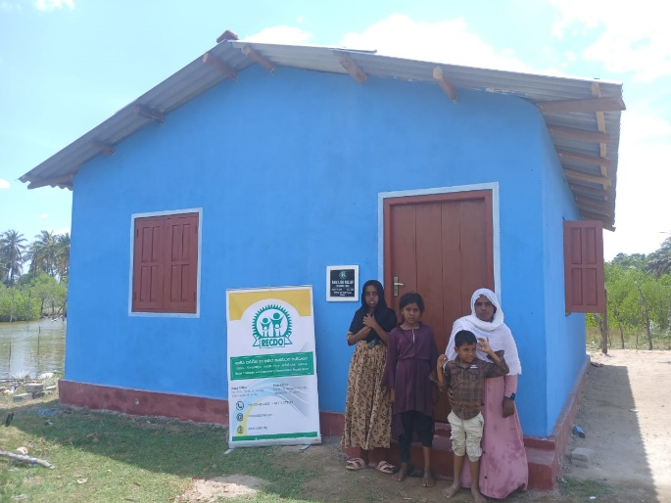
Model Houses for Families Living Below the Poverty Line – Handover | Model Houses for Families Living Below the Poverty Line – Handover
PHOTO  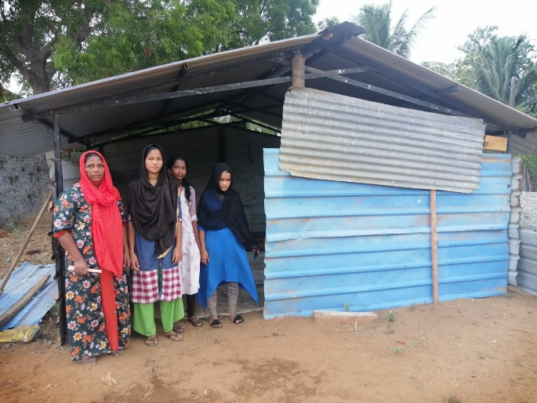 | PHOTO  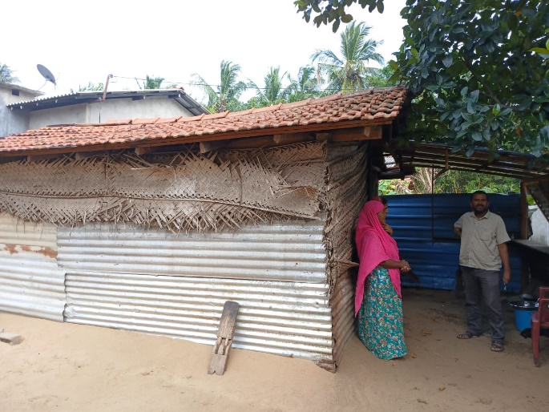
Current Living Conditions of Beneficiary Families | Current Living Conditions of Beneficiary Families

Dear Sir/Madam,
Funding Request: Transforming Huts into Homes – Providing Safe and Permanent Housing for Families Living Below the Poverty Line
We respectfully seek your valued partnership and financial support for the Transforming Huts into Homes initiative, a community-driven project designed to provide safe, permanent, and dignified housing for families living below the poverty line in Sri Lanka.
Despite ongoing development efforts, many vulnerable families continue to live in unsafe huts and temporary shelters made of tin sheets, thatch, mud, and other fragile materials. These inadequate living conditions expose families to severe weather, health risks, poor sanitation, and insecurity, while limiting children's education, livelihoods, and overall well-being. Women-headed households, older persons, persons with disabilities, and families with young children are among those most affected.
Through this initiative, the Rural Economic and Community Development Organization (RECDO) aims to:
- Construct safe, durable, and disaster-resilient model houses for families living in extreme poverty.
- Replace unsafe huts with permanent homes that provide security, dignity, and a healthy living environment.
- Improve access to basic sanitation and safe living conditions.
- Engage local communities and volunteers in housing construction and environmental improvement.
- Strengthen community resilience and help vulnerable families break the cycle of poverty through secure housing.
Your generous contribution will directly help vulnerable families move from unsafe shelters into permanent homes where they can live with safety, dignity, and hope. Secure housing provides a strong foundation for better health, children's education, improved livelihoods, and long-term community resilience.
We would be honoured to discuss this proposal further and explore opportunities for collaboration through GlobalGiving. Your support can make a lasting difference by transforming the lives of families who have endured years of inadequate housing and hardship.
Thank you for considering our request. We look forward to the opportunity to partner with you in building safer homes, stronger families, and more resilient communities.
Sincerely,
JM. Azhar
Chairman
Rural Economic and Community Development Organization (RECDO)
Contact: +94 77 707 3441
Email: recdosl@gmail.com
Website: www.recdo.org

Transforming Huts into Homes: Safe Housing for Families Living Below the Poverty Line
Project Summary
The project aims to construct five safe and permanent model houses for families living below the poverty line who currently reside in unsafe huts and temporary shelters. Through community participation, the initiative will provide secure housing, improve health and sanitation, reduce disaster risks, and restore dignity. The project will serve as a model for expanding affordable housing to other vulnerable families across Sri Lanka.
Goal
To improve the quality of life of vulnerable families by providing safe, permanent, and dignified housing.
Objectives
- Construct five model houses for the poorest families.
- Replace unsafe huts with permanent, disaster-resilient homes.
- Improve health, sanitation, and living conditions.
- Promote community participation and ownership.
- Strengthen long-term resilience and reduce poverty.
Target Beneficiaries
Direct Beneficiaries
- 5 families (approximately 25–30 people).
Priority Groups
- Women-headed households.
- Older persons.
- Persons with disabilities.
- Families with children.
- Extremely low-income households.
Indirect Beneficiaries
- Community members and neighbouring households.
- Local volunteers and youth groups.
Inputs
- Donor funding.
- Construction materials.
- Skilled labour and technical supervision.
- Community volunteers.
- Land preparation and site clearance.
- Project management and monitoring.
- Local stakeholder support.
Activities
- Select beneficiary families through a transparent assessment.
- Clean and prepare housing sites.
- Procure construction materials.
- Construct five permanent houses.
- Install basic sanitation facilities.
- Conduct regular quality monitoring.
- Organize house handover ceremonies.
- Document lessons learned and project results.
Outputs
- Five permanent model houses completed.
- Five vulnerable families relocated from unsafe huts.
- Five sanitation facilities established.
- Housing sites cleaned and improved.
- Community volunteers engaged in construction.
- Handover ceremony successfully completed.
Outcomes
Short-Term
- Families have safe and secure homes.
- Improved hygiene and sanitation.
- Reduced exposure to rain, heat, and disasters.
- Increased dignity and security.
Medium-Term
- Better health and well-being.
- Improved school attendance and learning environment for children.
- Reduced household maintenance costs.
- Greater community participation and resilience.
Long-Term Impact
- Reduced poverty and housing insecurity.
- Stronger, healthier families.
- Improved community resilience to disasters.
- Increased opportunities for education and livelihoods.
- A scalable model for future affordable housing initiatives.
Indicators
- 5 houses completed.
- 5 families permanently housed.
- 100% of beneficiary families report improved living conditions.
- Increased school attendance among beneficiary children.
- Reduced housing-related health and safety risks.
- High beneficiary satisfaction with housing quality.
Sustainability
Community participation throughout construction will strengthen ownership and maintenance. Beneficiary families will receive guidance on home care and sanitation. The five model houses will demonstrate an affordable, community-based housing approach that can be replicated with support from donors, government agencies, and local partners.
Expected Impact
The project will transform the lives of approximately 25–30 people by replacing unsafe huts with permanent homes, restoring dignity, improving health, strengthening resilience, and creating lasting opportunities for families to escape extreme poverty

