MUSHROOM PROMOTION PROGRAM
IN TOGO

The mushroom promotion in Togo draw its origin from the regional seminar on beekeeping and mushroom farming organized by Food and Agriculture Organization at Ho in Ghana in November 1996. The actual coordination of Association pour la Gestion Intégreé et Durable de l’Environnement (NGO AGIDE) was in a member of the Togolese team. Since its creation in 1998; AGIDE is the pioneer in the mushroom farming promotion in Togo. The program contains many projects donated by different organisations.

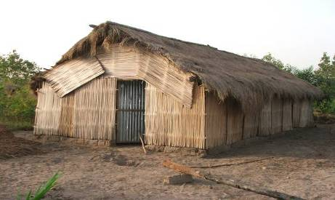

Photo N° 1: Mushroom growing room
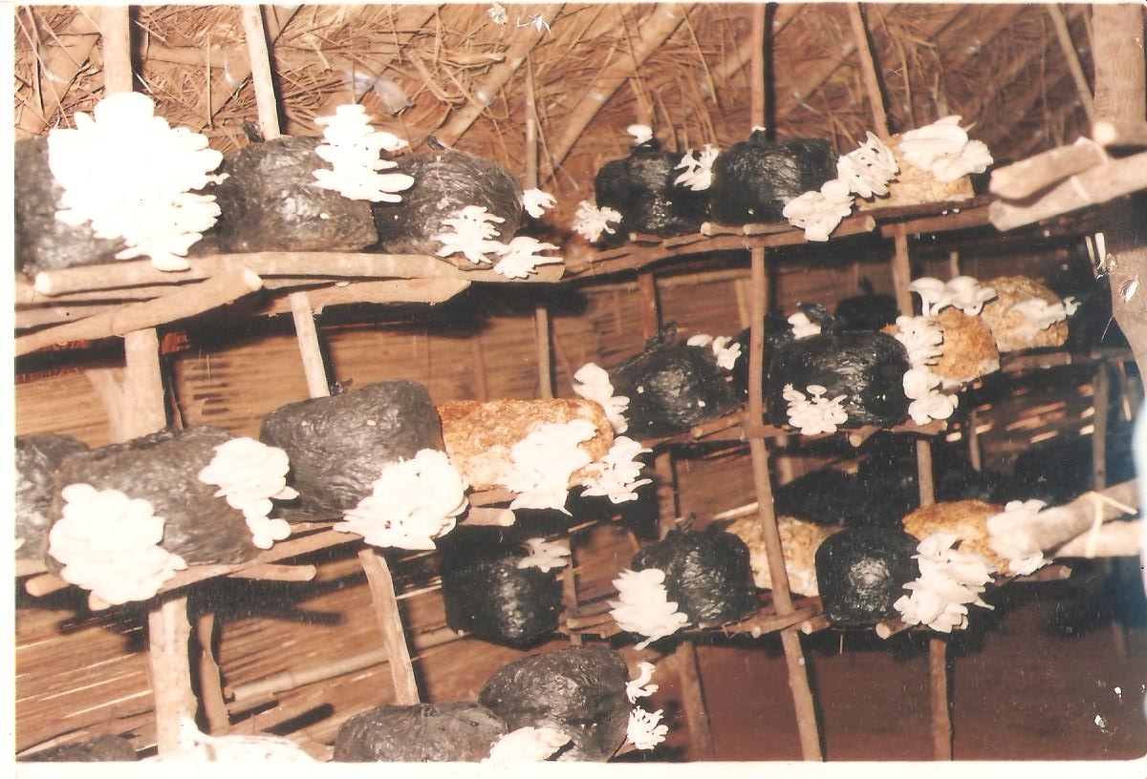

Photo N°2: Mushroom on the shelves

In 2001, the Resident Mission of World Bank in Togo had gave a small grant to AGIDE to lunch the promotion of this new activity in rural areas. In 2003, a second small grant had allowed AGIDE to train the national technicians of Institut de Conseil et d’Appui Technique Région Maritime (ICAT RM) and leaders of some NGO



Photo N° 1: The World Bank Resident representative is Giving a check to the AGIDE’s Coordinator

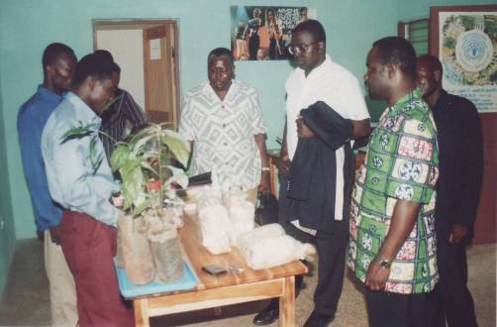

Photos N°2:The Coordinator of AGIDE is Explaining the mushroom farming steps to the World Bank staff

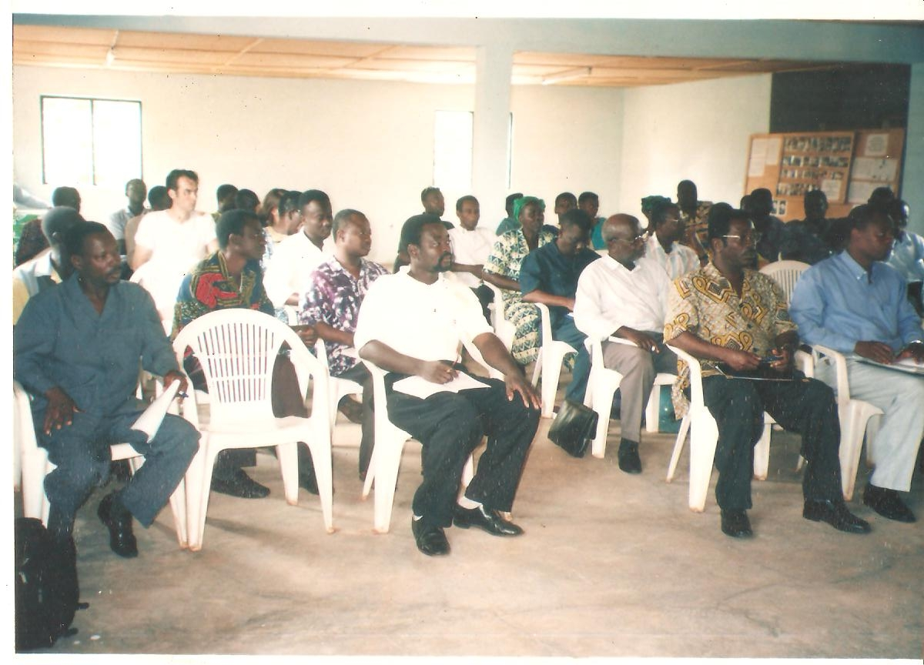

Photo N° 5: ICAT Technicians and NGO’s agents in seminar with on mushroom farming

In 2003 the Ministry of Environment has requested AGIDE to train famers living around the Missahoe Classified Forest in Kpalimé.

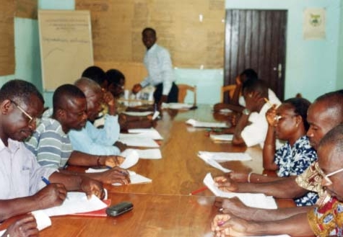

Photo N° 6: The Coordinator of AGIDE training farmers in Missahoe

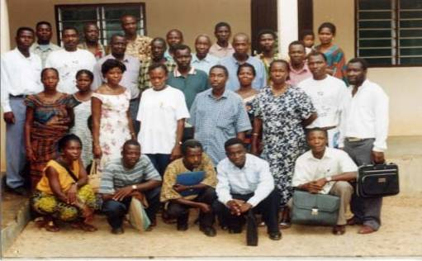
Photo N°7: Photo in group in Missahoe at the end of the training

By 2006, the Service de Coopération et d’Action Culturelle (SCAC) of France Embassy had suported AGIDE in mushroom promotion by offering a big grant. The grant had allowed rapid advancement of mushroom farming in the whole country.

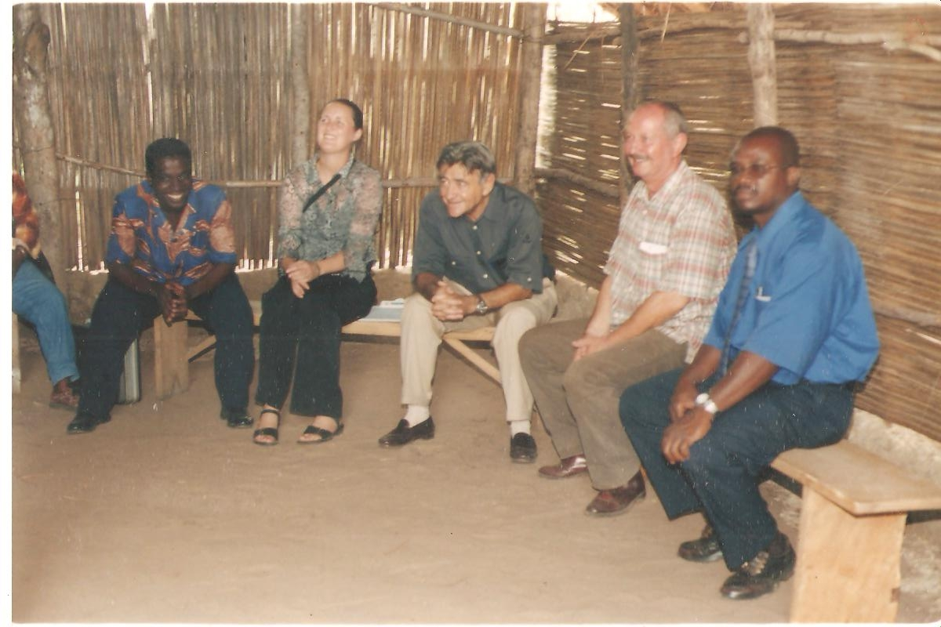
Photo N° 8: Visit of the Adviser of the SCAC of France Embassy during the mushroom cultivation project

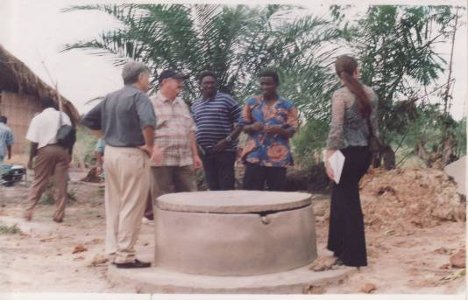

Photo N° 8: The SCAC of France Embassy visitors around a well on the mushroom cultivation project site

AGIDE Is on the forefront of many mushroom project in Togo. It is working in partnership with The Faculty of Science of the University of Lome in research and collecting local edible mushroom from Togo forests. In the Agronomic High School of of the University of Lome , AGIDE’ s Coordinator is in charge of training students on mushroom farming. He is in charge of the same course in the National Agricultural Training Instituted of Tove since 2004. AGIDE is Guest speaker in the USA Peace Corps on the program Natural Resources Management. He trains volunteers on mushroom cultivation since 2002.

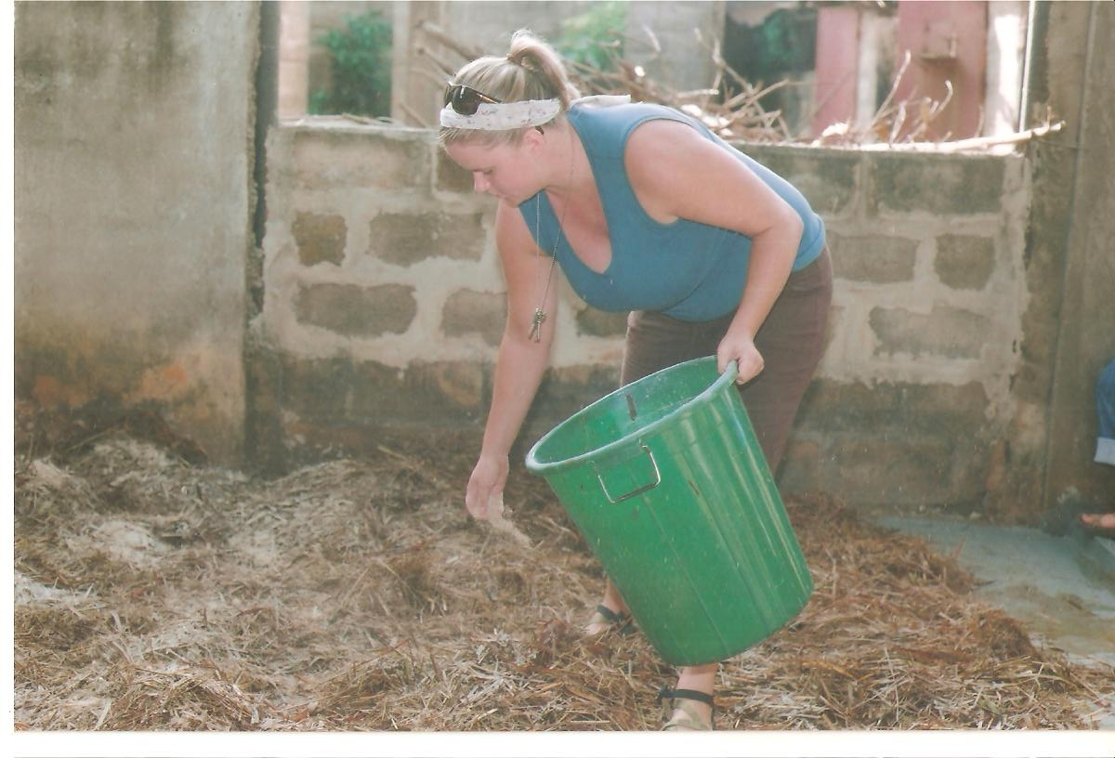
Photo N° 9: A peace corps volunteer learning the mushroom cultivation in NGO AGIDE’s headquarter

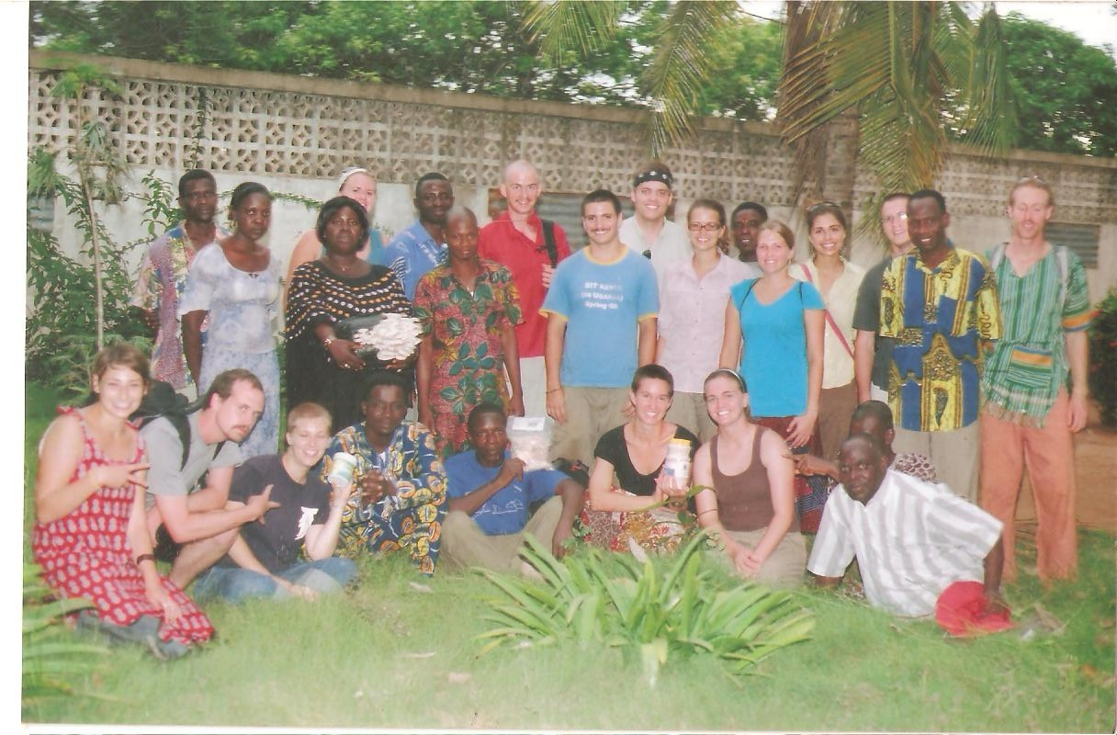
Photo N°10: photo in group of the Peace Corps volunteers at the end of the training in 2009

Since 2008, LOLONYO grouping started transforming mushrooms cultivated into CHAMPIMIX product. This product has shown a significant effect in helping malnourished children. That grouping combined the cultivated mushroom with local cereals and soya into flour for porridge. LOLONYO is composed of rural women cultivating mushroom.



This project “Combating Child malnutrition with mushroom in Togo” will not only help malnourished children but also allow LOLONYO to sell its product. The project will help them to improve their income.

Join us in this new revolution integrative food using mushrooms as keystone components in preventing malnutrition and diseases for children.

Your donations are well come!!!.

