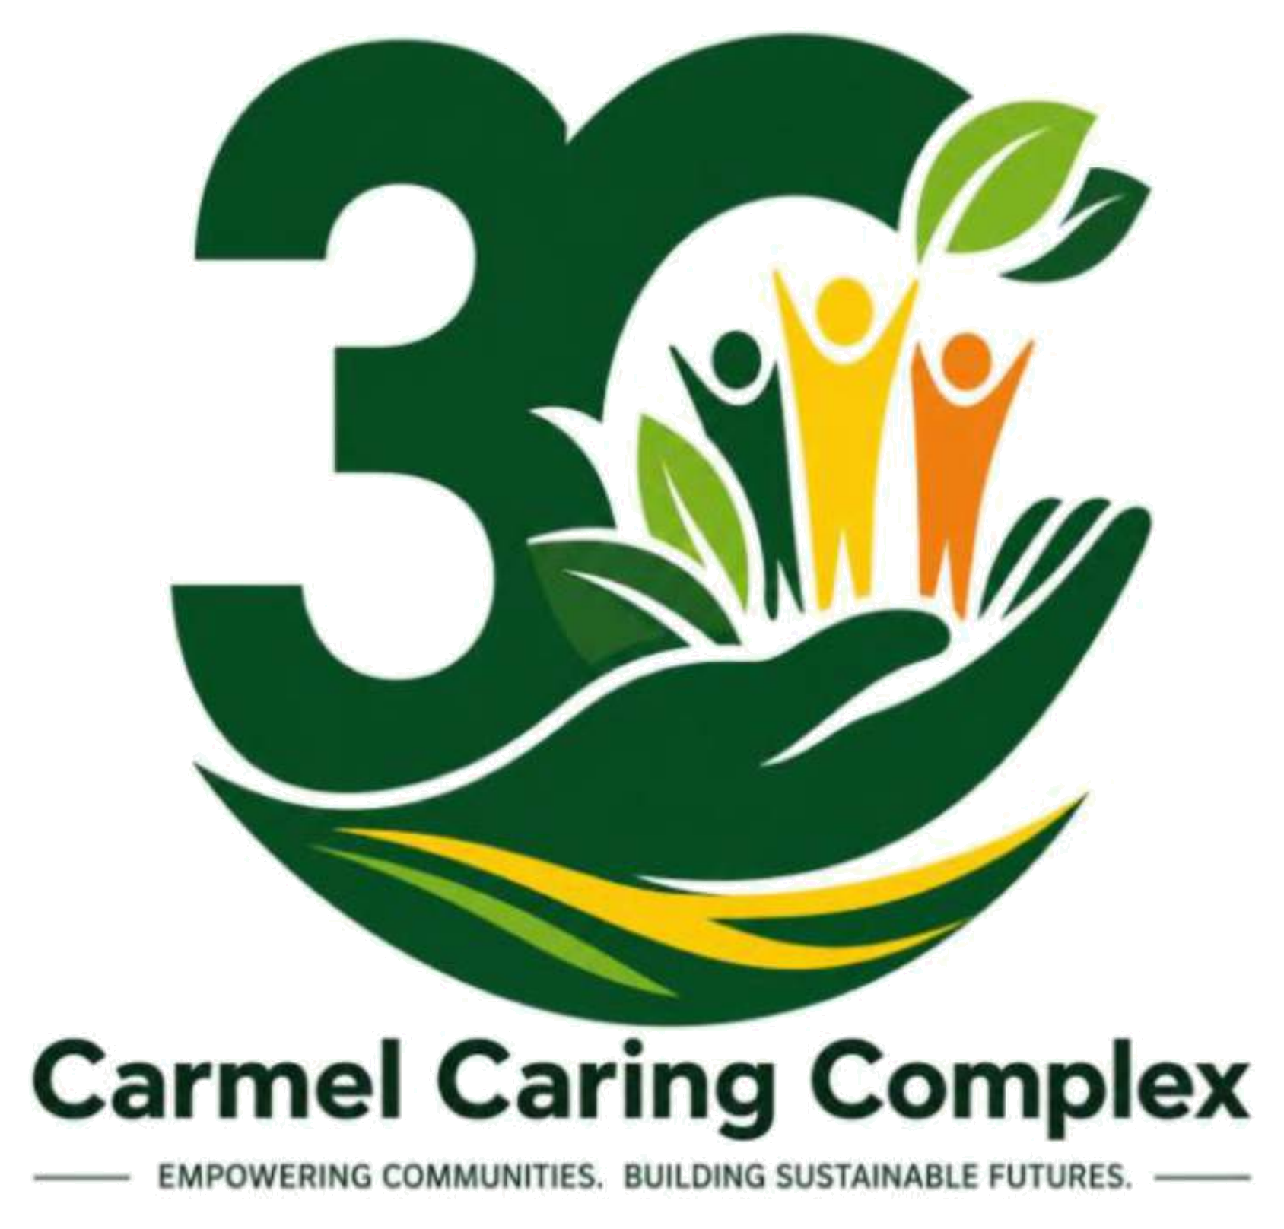
Carmel Caring Complex Ltd.
Building Resilient Communities. Empowering Local Solutions.
Help 1,000 Ugandan Farmers Grow Food & Plant Trees
Public Project Brief and Budget
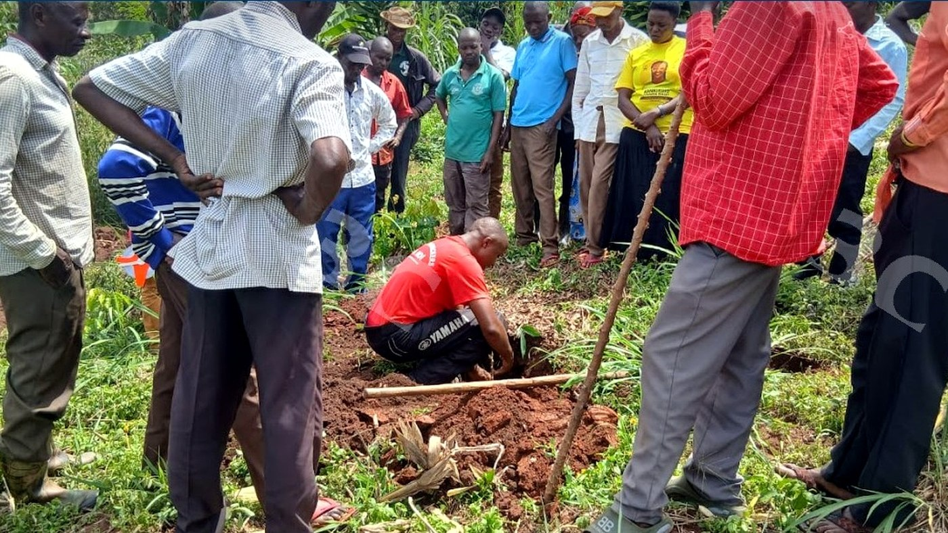
Community members take part in tree planting and restoration activities supported through Carmel Caring Complex Ltd.'s community-led climate and livelihood work.

Project at a Glance
Project title | Help 1,000 Ugandan Farmers Grow Food & Plant Trees
Lead organization | Carmel Caring Complex Ltd.
Country | Uganda
Primary focus | Sustainable agriculture, climate action, ecosystem restoration, and food security
People reached | 1,000 smallholder farmers and vulnerable households in the first public project phase
Funding target | USD 80,000
Public website | www.carmplex.org
LinkedIn | linkedin.com/company/carmel-caring-complex

1. Executive Summary
This project will help 1,000 Ugandan farmers and vulnerable households plant trees, grow food, restore land, and build climate-smart livelihoods. Carmel Caring Complex Ltd. will provide seedlings, practical farmer training, local giving and volunteer support, community-led planning, and follow-up so communities can strengthen food security, income, resilience, and lead change.
The project is implemented under the Empowering Change, Philanthropy Forward and Giving Back Together Initiative, Carmel Caring Complex Ltd.'s flagship community-led development and philanthropy initiative. It brings together tree planting, sustainable food growing, local giving, volunteer action, farmer learning, and community-led planning in one practical project that donors can understand and follow.
Core donor promise
A gift to this project helps farmers and vulnerable households grow food, plant trees, restore land, build livelihoods, and lead practical local solutions in Uganda.

2. The Problem This Project Responds To
Many smallholder farmers and vulnerable households in Uganda face food insecurity, declining soil fertility, land degradation, climate shocks, rising costs, and limited livelihood options. Droughts, floods, and changing weather reduce harvests and income. This project supports 1,000 farmers and vulnerable households with seedlings, tree planting, food growing, and climate-smart farming support.
The problem is not a lack of community knowledge or leadership. Communities already have experience, relationships, generosity, volunteer spirit, and practical ideas. The gap is that resources, tools, technical support, and decision-making support often remain too far from the people closest to the challenges.

3. What the Project Will Do
Carmel Caring Complex Ltd. will provide seedlings, train farmers in climate-smart farming, support tree planting, guide land restoration, and follow up with farmer groups. The project will strengthen local giving, volunteer action, and community-led planning so 1,000 farmers and vulnerable households grow more food, improve incomes, restore land, and lead lasting change. Community members will help choose priorities, care for trees, share learning, and track progress.

Main activities
- Conduct community listening and priority-setting sessions so project activities respond to real local needs.
- Provide tree seedlings, planting materials, nursery support, agroforestry guidance, and follow-up tree care.
- Train farmers and community groups in climate-smart farming, food growing, soil health, water conservation, and sustainable land use.
- Support women, youth, farmers, and vulnerable households with practical livelihood and resilience activities where resources allow.
- Strengthen local giving, volunteer participation, in-kind support, and shared community responsibility through the Carmel Caring Community Fund approach.
- Track activities, community feedback, photos, stories, and lessons so donors can see what was done, what changed, and what was learned.

4. Who Will Benefit
The first public project phase is designed to directly support 1,000 smallholder farmers and vulnerable households in Uganda. The wider community will benefit as trees grow, soils improve, families share practical farming knowledge, local leadership becomes stronger, and restored land supports future food production and resilience.
The project is especially relevant to farmers, women, youth, low-income households, community groups, and people whose livelihoods are affected by climate shocks, land degradation, food insecurity, and limited access to practical support.

5. Expected Long-Term Impact
Over time, this project will help 1,000 Ugandan farmers and vulnerable households improve food security, restore degraded land, increase household income, and build resilience to climate shocks. Tree planting, food growing, farmer training, local giving, volunteer action, and community-led planning will strengthen lasting local solutions and reduce dependence on short-term aid. It will also improve soil health, share practical skills, and strengthen community leadership.

Expected areas of change
Area | Expected change
Food security | Households gain practical support to grow more food and improve resilience.
Land restoration | Tree planting and soil care contribute to healthier local ecosystems.
Livelihood resilience | Farmers and households build skills that can support income and reduce vulnerability.
Community leadership | Community members help identify priorities, care for trees, volunteer, give locally, and track progress.
Learning and accountability | Progress is documented through activity records, community feedback, photos, stories, and donor reports.

6. Budget Summary: USD 80,000 Phase 1 Target
The USD 80,000 target is designed to support meaningful community activities, project coordination, learning, donor reporting, field logistics, and reasonable platform, transaction, banking, transfer, and contingency costs. Final spending will follow Carmel Caring Complex Ltd.'s financial controls, procurement procedures, GlobalGiving disbursement reports, local procurement realities, exchange conditions, and the actual net funds received.
Budget line | Purpose | Amount
Community listening, participatory planning, and local leadership | Community priority-setting, local planning, mobilization, leadership support, and community feedback processes | $8,000
Seedlings, tree planting, nurseries, and agroforestry support | Tree seedlings, nursery support, planting materials, agroforestry activities, restoration, and follow-up care | $18,000
Climate-smart agriculture training and farmer follow-up | Training, demonstrations, farmer engagement, learning materials, soil and water conservation, food security support, and field follow-up | $12,000
Women, youth, and community-led livelihood support | Practical support for livelihood priorities, enterprise activities, household resilience, and income opportunities | $10,000
Carmel Caring Community Fund, local giving, and volunteer mobilization | Community giving systems, volunteer engagement, in-kind support coordination, local philanthropy, and participatory support activities | $6,000
Monitoring, evaluation, accountability, research, and learning | Community feedback, surveys, outcome tracking, stories, photos, reports, donor updates, and learning reviews | $6,500
Project coordination, safeguarding, communications, and donor reporting | Field coordination, staff time, safeguarding, accountability, donor stewardship, administration, compliance, and reporting | $11,500
Platform, transaction, banking, transfer, contingency, and field logistics | Allowance for GlobalGiving and payment processing fees, financial transfer costs, banking, price variation, local logistics, and operational risk | $8,000
Total Phase 1 funding target | Gross fundraising target requested for the first public project phase | $80,000

7. Donation Use Examples
The examples below help donors understand how different gift levels support practical work. Actual implementation will follow local prices, procurement conditions, community priorities, and funds received.
Gift amount | Illustrative project support
$10 | Provides 10 tree seedlings for community-led restoration.
$25 | Provides 25 seedlings and planting guidance for 1 farmer.
$50 | Supports 2 farmers to attend practical climate-smart farming training.
$100 | Trains 5 farmers in tree care, food growing, and land restoration.
$250 | Provides 100 seedlings and simple tools for 1 community farmer group.
$500 | Supports 1 community tree planting and farmer learning day.
$1,000 | Supports 1 farmer group with seedlings, training, follow-up, and monitoring.
$2,500 | Supports 1 community cluster with tree planting, food growing, and livelihood activities.

8. Community Standards, Safety, and Consent
Carmel Caring Complex Ltd. is committed to photography, storytelling, fundraising, and reporting practices that uphold dignity, privacy, safety, and consent. People will be portrayed as leaders, contributors, farmers, volunteers, decision-makers, and partners in local solutions, not as passive victims.
- Use photos and stories that respect dignity and avoid shock, pity, harmful stereotypes, or private situations.
- Seek appropriate consent for fundraising and reporting use, especially where children or vulnerable groups are involved.
- Avoid publishing personal details that could put people at risk.
- Ensure photos, captions, and stories accurately reflect the project activity shown.
- Use community-centered language that shows shared leadership, resilience, and practical action.

9. Accountability, Learning, and Reporting
Carmel Caring Complex Ltd. will track project activities and share donor updates through GlobalGiving and other approved communication channels. Reporting will focus on what was done, what changed, what was learned, and what comes next.
- Track seedlings, farmer training, community planning sessions, field follow-up, livelihood activities, and participation.
- Collect community feedback and lessons to improve future action.
- Use approved photos and stories that are truthful, dignified, and connected to real activities.
- Report both achievements and challenges honestly so donors see transparency, learning, and accountability.
- Apply the principle: no stories without numbers and no numbers without stories.

10. About Carmel Caring Complex Ltd.
Carmel Caring Complex Ltd. is a community-led nonprofit organization based in Uganda and working across East Africa. Founded in 2018 and incorporated in 2019, the organization empowers children, youth, women, refugees, low-income households, smallholder farmers, and underserved communities to build sustainable livelihoods, improve health and education outcomes, and strengthen resilience against poverty, inequality, and climate change.
The organization works through integrated programs in community philanthropy, climate action, environmental restoration, health and wellbeing, education and skills development, sustainable livelihoods, humanitarian response, and research, learning, and innovation. Its approach is rooted in listening, community leadership, participation, accountability, local giving, partnerships, and evidence-informed action.
Contact and public links
Website: www.carmplex.org
LinkedIn: linkedin.com/company/carmel-caring-complex

11. Public Use Note
This public project document is prepared to help donors, partners, and GlobalGiving visitors understand the project purpose, activities, budget, expected impact, and accountability approach. It intentionally excludes internal working notes, private application details, passwords, meeting links, sensitive access information, and internal decision records.
Together, we build sustainable, empowered, and resilient communities.

