Storytelling Worksheet
Use this worksheet to outline the essential elements of your organization's work you’d like to fundraise for. This storytelling format mirrors GlobalGiving project pages, which you can view on GlobalGiving.org for inspiration.

Let’s Get Started!
- Get familiar with GlobalGiving’s project page format by finding three projects you would support if you were a donor. We encourage you to filter by “Location” and “Theme” to streamline your exploration. This first step aims to familiarize you with the project page format and help you understand what potential donors see when they visit GlobalGiving.

- Review the “Tell Your Story” content (page 2) to help you complete the Storytelling Worksheet (pages 3-5). We hope this worksheet will help you outline a project you hope to fundraise for soon. Ideally, the project you feature in the worksheet is the first project you wish to fundraise on GlobalGiving to save yourself some time and effort. However, you are not limited to one project once you're a GlobalGiving partner.

- Submit your completed worksheet USING THIS FORM by Friday, Feb. 27 to access GlobalGiving’s due diligence application.

Tell Your Story

Donors are more likely to support your work when they understand how you will channel their generosity to make a difference. Good storytelling is essential to your sustainable fundraising strategy because it keeps people giving!

Key Lessons

- Inspire connection through personal storytelling. The people closest to the problem community members and/or staff) are often the most influential storytellers. Here is a downloadable checklist to master the basics of nonprofit storytelling.

- Talk about impact in terms of transformation. Combine data, photographs, and individual stories to show rather than tell how things have changed because of your work.

- Portray your community with dignity and strength to inspire empathy and connection rather than pity. Choose photos that show the positive impact that you are making and leave out images of despair. We encourage you to review the GlobalGiving Community Photo Standards.

- Watch this 3-minute video to hear how GlobalGiving community leaders inspire donors through storytelling!

 Tell Our Story

Project Title:
Recommended 50 character maximum, start with a verb ; Children's Day 2026: Living with Personality
Summary: What will this project do?

RECDO annually organizes the Children's Day 2026: Living with Personality program for 150–200 children, providing a safe, inclusive, and inspiring environment to celebrate their potential. The project offers a full day of recreational games, team-building activities, personality development sessions, educational entertainment, and nutritious meals. Through these activities, children develop self-confidence, communication and social skills, teamwork, and positive values while enjoying a memorable day of fun, learning, and friendship. The program promotes children's well-being, encourages personal growth, and creates a joyful experience that motivates them to become confident, responsible, and active members of their communities
Recommended 500 character maximum
Funding Amount/Goal: How much money do you hope to raise (in USD)?
2000 USD

Challenge  What is the problem or need?  Many children, especially those from low-income and vulnerable families, have limited access to recreational, educational, and personal development opportunities outside of school. Financial hardship and social challenges often prevent them from participating in activities that build confidence, communication skills, teamwork, and self-esteem. As a result, they miss opportunities to develop important life skills and enjoy positive childhood experiences. There is a need for safe, inclusive programs that promote children's well-being, encourage personal growth, and provide joyful learning experiences where every child feels valued, supported, and inspired.  Recommended 500 character maximum | Solution  How will this project solve the problem?  The project will address this need by providing a full-day Children's Day program that combines recreation, learning, and personality development in a safe and supportive environment. Through interactive games, team-building activities, leadership and communication exercises, creative learning sessions, and nutritious meals, children will strengthen their confidence, social skills, teamwork, and positive values. The program also encourages inclusion, friendship, and active participation, giving every child the opportunity to learn, grow, and enjoy a memorable celebration that supports their personal development and overall well-being.  Recommended 500 character maximum | Long-Term Impact  How will this make a lasting impact in your community?  The Children's Day 2026: Living with Personality project will create a lasting impact by helping children develop confidence, positive values, communication skills, teamwork, and leadership from an early age. These life skills will support their academic success, personal growth, and future participation in their communities. The annual program also strengthens relationships among children, families, volunteers, and community members, fostering a culture that values child development and inclusion. By continuing this initiative each year, RECDO contributes to raising confident, responsible, and socially engaged young people who can make positive contributions to their communities in the future.  Recommended 500 character maximum
Donation Options: How can you illustrate the impact of a person’s donation? For the purpose of this exercise, we recommend outlining three donation options under $100.

Amount | Description
$ 1000 | The project funding will be used to provide lunch and refreshments for approximately 150–200 children and to purchase sports and recreational materials needed for the Children's Day activities. These resources will enable children to participate in fun, active, and inclusive games that promote teamwork, confidence, and social interaction while ensuring they enjoy a nutritious meal and a safe, memorable celebration. No funds will be used for gift items.
$ 1000 | The project funding will be used to provide lunch and refreshments for approximately 150–200 children, purchase sports and recreational materials, and support singing, dancing, and other entertainment activities during the Children's Day celebration. Gift items will also be provided to make the event more memorable and to recognize each child's participation. These activities will create a joyful, inclusive environment that promotes friendship, teamwork, confidence, and positive personal development while ensuring every child enjoys a meaningful and memorable Children's Day experience.

Photo Gallery
Choose four images that show the impact of your work and draft clear captions. Choose high-resolution photos that are positive and empowering and show the community you serve with respect and dignity. Before sharing a photo, ask yourself this question: Would I want to be portrayed this way? Does this image instill hope? Upload photos to worksheet however makes the most sense - photos don’t have to fit perfectly in box!
PHOTO  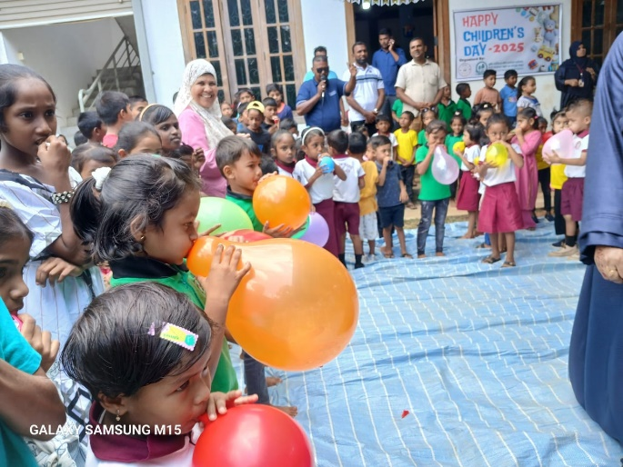 | PHOTO  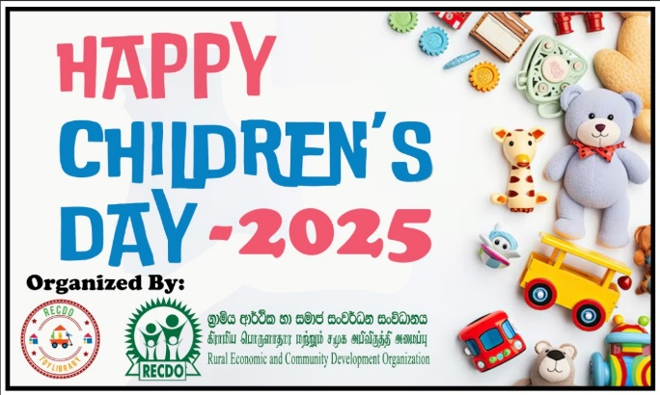
International Children day celebration -2025 | International Children day Banner -2025
PHOTO  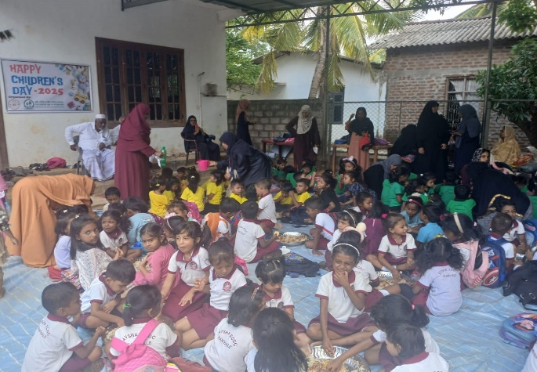 | PHOTO  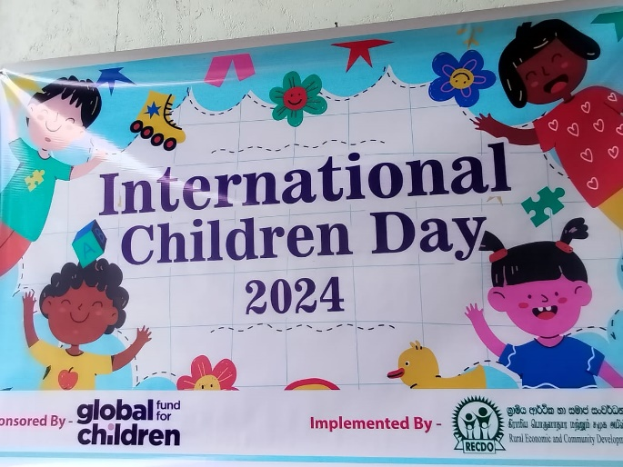
International Children day celebration -2025 Lunch for Kids | International Children day Banner -2024

Children's Day 2026: "Living with Personality" Project Outcomes
The "Living with Personality" project, implemented in celebration of Children's Day 2026, aimed to promote positive values, life skills, child protection, and personal development among children. The key outcomes of the project are:
- Improved self-confidence and self-esteem among participating children.
- Enhanced understanding of good values, respect, honesty, responsibility, and empathy.
- Strengthened communication, teamwork, and leadership skills.
- Increased awareness of child rights and child protection mechanisms.
- Better emotional well-being and positive coping strategies for everyday challenges.
- Improved relationships between children, parents, teachers, and community members.
- Greater participation of children in school and community activities.
- Increased awareness of personal hygiene, health, and safe behaviours.
- Encouraged creativity, critical thinking, and problem-solving through interactive activities.
- Reduced bullying and promoted a culture of inclusion, kindness, and mutual respect.
- Strengthened parental engagement in children's personal and social development.
- Developed action plans for children to continue practicing positive behaviours beyond the project.
- Established child-friendly learning environments that encourage participation and expression.
- Enhanced collaboration between schools, community organizations, and local stakeholders to support children's holistic development.
- Celebrated Children's Day by recognizing every child's potential to become responsible, confident, and compassionate citizens.
Expected Long-Term Impact
- Children demonstrate positive attitudes and responsible behaviour in daily life.
- Improved school attendance and participation.
- Safer and more inclusive school environments.
- Stronger family and community support for children's development.
- Increased resilience, leadership, and life skills among children, enabling them to contribute positively to their communities.
These outcomes contribute to the overall goal of nurturing confident, responsible, respectful, and resilient children who are equipped with the personality traits and life skills needed for a successful future.
1. Background
Children are the future of every nation, yet many children in rural and vulnerable communities in Sri Lanka face challenges that hinder their personal and social development. Economic hardship, limited access to life skills education, social pressures, bullying, digital influences, and reduced opportunities for positive engagement affect children's confidence, emotional well-being, leadership abilities, and character development.
While schools focus primarily on academic achievement, there is a growing need to strengthen children's personality, values, resilience, communication skills, emotional intelligence, and leadership qualities. Developing these competencies during childhood helps build responsible, compassionate, and confident citizens.
To commemorate Universal Children's Day 2026, the Rural Economic and Community Development Organization (RECDO) proposes the "Living with Personality" Project, a one-day child development programme that combines learning, inspiration, creativity, and celebration to empower children with essential life skills and positive values.

2. Problem Statement
Many children from disadvantaged communities experience:
- Low self-confidence and self-esteem.
- Limited opportunities for personality and leadership development.
- Poor communication and social skills.
- Bullying, discrimination, and peer pressure.
- Limited awareness of child rights and responsibilities.
- Weak emotional resilience and coping skills.
- Inadequate parental and community engagement in child development.
Without intervention, these challenges may affect children's education, mental well-being, relationships, and future opportunities.

3. Goal
To empower children to become confident, responsible, respectful, and resilient individuals through personality development, life skills education, and positive social engagement.

4. Objectives
The project aims to:
- Build children's self-confidence and self-esteem.
- Promote positive values including respect, honesty, kindness, empathy, responsibility, and discipline.
- Develop leadership, teamwork, communication, and problem-solving skills.
- Improve emotional intelligence and resilience.
- Increase awareness of child rights and child protection.
- Encourage creativity, innovation, and critical thinking.
- Strengthen collaboration among schools, parents, and communities in supporting children's holistic development.

5. Target Beneficiaries
- 150 – 200 Children in the area

6. Project Activities
- Children's Day opening ceremony.
- Team-building exercises.
- Creative arts, drawing, essay, and speech competitions.
- Mental health and emotional well-being activities.
- Recognition and awards for outstanding participation.

7. Expected Outcomes
- Improved self-confidence among participating children.
- Enhanced leadership and communication skills.
- Greater understanding of positive values and responsible behaviour.
- Increased awareness of child rights and child protection.
- Stronger emotional well-being and resilience.
- Reduced bullying and promotion of inclusion and respect.
- Increased participation of children in school leadership and community activities.
- Stronger collaboration between schools, families, and communities.

8. Sustainability
The project will establish a lasting impact by:
- Training teachers to continue personality development activities.
- Supporting school child clubs and leadership programmes.
- Encouraging parents to reinforce positive values at home.
- Developing children's action plans for continued personal growth.
- Integrating life skills activities into school programmes through local partnerships.

9. Expected Results
- 150 – 200 children equipped with practical life skills.
- Increased confidence and leadership among participants.
- Better school participation and social interaction.
- Greater awareness of child rights and personal responsibilities.
- Improved relationships between children, teachers, and parents.
- Strong community commitment to positive child development.

10. About RECDO
The Rural Economic and Community Development Organization (RECDO) is a registered non-governmental organization based in Kantale, Trincomalee District, Sri Lanka. RECDO works to improve the lives of vulnerable communities through education, child protection, women's empowerment, youth development, livelihoods, climate resilience, humanitarian assistance, and community development.
With extensive experience implementing community-based programmes in partnership with government institutions, schools, civil society organizations, and international development partners, RECDO is committed to creating inclusive, resilient, and empowered communities.

11. Conclusion
RECDO respectfully invites your organization to partner with us in implementing the Children's Day 2026: "Living with Personality" Project. Your support will help hundreds of children develop the confidence, values, and life skills needed to become responsible leaders and positive contributors to their families, schools, and communities.
Together, we can make Children's Day 2026 a meaningful investment in the future of Sri Lanka's children.

Dear Sir/Madam,
Request for Support – Children's Day 2026: "Living with Personality" Project
We respectfully seek your partnership and financial support to implement the Children's Day 2026: "Living with Personality" Project, a child development initiative organized by the Rural Economic and Community Development Organization (RECDO) in collaboration with schools and community stakeholders in Sri Lanka.
Children are the foundation of a peaceful and prosperous society. However, many children from vulnerable and low-income communities face challenges that affect their personal growth, self-confidence, emotional well-being, and leadership potential. Limited opportunities for life skills education and positive social engagement often hinder their ability to become responsible and resilient citizens.
To commemorate Universal Children's Day 2026, RECDO proposes the "Living with Personality" Project, which aims to nurture children's character, values, leadership, and life skills through interactive learning and participatory activities.
Project Objectives
- Build self-confidence and positive self-esteem among children.
- Promote good values, respect, responsibility, honesty, kindness, and empathy.
- Strengthen communication, teamwork, leadership, and decision-making skills.
- Improve emotional well-being and resilience through life skills education.
- Raise awareness of child rights, child protection, and safeguarding.
- Encourage creativity, critical thinking, and positive behaviour.
- Foster stronger relationships among children, parents, teachers, and communities.
- Promote inclusion, diversity, and respect for all children.
Key Activities
- Children's Day celebration and personality development programme.
- Team-building games and creative learning activities.
- Art, essay, speech, and talent competitions.
- Recognition and awards for outstanding participation.
Expected Outcomes
- Increased self-confidence and leadership skills among participating children.
- Improved communication and interpersonal relationships.
- Greater awareness of positive values, child rights, and responsibilities.
- Enhanced emotional well-being and resilience.
- Reduced bullying and promotion of kindness and mutual respect.
- Increased participation of children in school and community activities.
- Stronger collaboration between families, schools, and community organizations in supporting child development.
Your generous support will enable us to provide a meaningful and memorable Children's Day experience for hundreds of vulnerable children. Your contribution will help create an environment where every child feels valued, respected, and empowered to reach their full potential.
We would be honoured to discuss this proposal further and explore opportunities for collaboration. Together, we can inspire the next generation to become confident, compassionate, and responsible leaders.
Thank you for considering our request. We look forward to partnering with your esteemed organization to make Children's Day 2026 a life-changing experience for children.
Yours faithfully,
JM. Azhar
Chairman
Rural Economic and Community Development Organization (RECDO)
Contact: +94 77 707 3441
Email: recdosl@gmail.com
Website: www.recdo.org

