ADULT CARDIAC SURGERY MISSION (Emphasis: Aortic Surgery)
DAR ES SALAAM, TANZANIA AFRICA

First Day: October 9th, 2026 (Friday)
Last Day: October 17th, 2026 (Saturday)




We take great pleasure in announcing the seventh mission to JKCI (The Jakaya Kikwete Cardiac Institute), Dar es Salaam, Tanzania Africa.

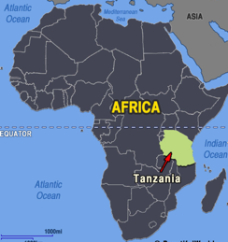

The Republic of Tanzania was formed as a sovereign state in 1964 through the union of the separate states of Tanganyika and Zanzibar. Mainland Tanganyika covers more than 99 percent of the combined territories’ total area. It is bound by 7 countries through its borders and is South of the Equator. Dodoma, since 1974 the designated official capital of Tanzania, is centrally located on the mainland. Dar es Salaam, however, remains the seat of most government administration, as well as being the largest city and port in the country. It has Africa’s highest mountain, Kilimanjaro (19,340 feet), and the world’s second deepest lake, Lake Tanganyika (4,710 feet deep). Most Tanzanians are of Bantu descent. A third of the population are Christians and slightly more are Muslim. The two principal languages are Swahili and English. The economy is largely agrarian.

Climate
It varies it is equatorial, so there is no Winter or Summer, but in January, can be hot and humid.

Cardiac Surgery Status in Dar Es-Salam

JKCI is the only cardiac institute in the country, attracting patients from some surrounding countries. It is affiliated with the University where students rotate through the specialties.

They have 128 beds, including 15 ICU beds (combined pediatric and adult), 3 OR theaters, a pediatric and adult cardiac ward for pre- and post-operative patients (a new pediatric ward with 50 beds is in development). There is a busy cardiac catheter laboratory and an outpatient clinic (open 6 days a week). The institute is funded publicly.

The need for cardiac surgery development remains dire. Some complex cases are sent out to other more established programs such as India.

OUR MISSION: ADULT CARDIAC SURGERY (Aortic Surgery)
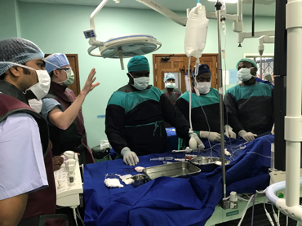

CardioStart’s role will be to help further develop their comprehensive adult cardiac surgery program with focus on aortic surgery.

Our team will work with the local team to further establish the essential features required for cardiac surgery and help set the necessary benchmarks for the Hospital to retain a position as a regional tertiary referral center. Part of this mission will be to assist development of complex case management, and our team will be expected to teach on relevant topics.

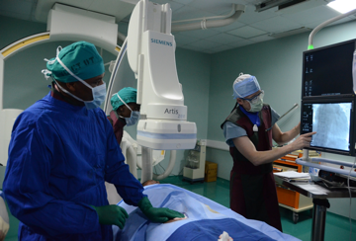

The angio-catheter suite is functioning well and has accomplished several hundred procedures with the visiting US charity team (led by Dr. Peter O’Brien, Virginia). Although JKCI does do some coronary revascularization they want more training in advanced techniques. Their personal experience with valve surgery is limited due to the difficulty obtaining valves locally.

The choice of heart cases will follow according to the discretion of the heart surgeons and will likely be adult acquired with focus on aortic surgery – all subject to team review and recommendation.

Pediatric Nursing:
A small number of nurses will attend the mission to provide education in the new pediatric ICU suite.

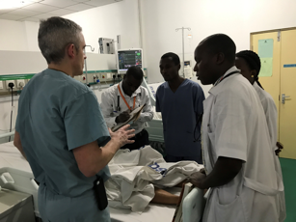

Visiting cardiac surgery team Structure:

- 2 CV Surgeons
- 1-2 scrub techs
- 1-2 Cardiac anesthesiologists
- 1 CV Intensivist
- 2-3 Perfusionists
- 6 CV ICU nurses (2 pediatric)
- 1 coordinator / data collection

Airfare:
Airfare costs will be self-funded by each volunteer. Popular flight corridors are Delta or United from Dulles to Zurich or Amsterdam. Then to Nairobi or Kilimanjaro and on to Dar es Salaam. Others have taken routes through London. An excellent alternative is to fly directly from the US to Istanbul (Turkey) and from Istanbul to Dar es Salaam. In selecting your airfare, first select the most convenient international embarkation point from your home state, as domestic travel from the point of origin can be negotiated separately and sometimes, much cheaper.

Lodging:
This will be provided by our hosts. Volunteers should expect that they may be asked to agree to same-sex room sharing to help reduce the costs incurred. CardioStart will assure minimum standards to ensure volunteer safety and comfort, but we will try to be sensitive to the financial burden borne by the local officials.

Meals:
Breakfast will be freely provided by the hotel. During the day, meals will be available and provided for by the hospital. Evening meals/snacks, etc. are available in the hotel or local restaurants, at volunteer’s own expense. They are generally of a high standard and inexpensive.

Security:
As of October 31, 2025, Tanzania is listed as Level 3 (reconsider travel due to unrest, crime, terrorism targeting gay and lesbian individuals. Unrest from demonstrations which are unpredictable and not authorized by government. on the website Travel.State.Gov. The most affected areas are in Mtwara Region. The hospital and surrounding areas are safe according to mission teams that have already visited. Further advisories will be given to those who apply to join this mission. Volunteers will be picked up at the airport, and safely escorted by bus from the hotel during the week. Register on Smart Traveler Enrollment Program (STEP)

Medical issues:
Volunteers are expected to contact their primary care physician or local travel clinic to investigate immunization status. We recommend that all volunteer activity is carried out applying full HIV precautionary measures as used in your own hospital.

You should have a routine check before travel of your HIV and Hepatitis a/b/c status. Vaccinations must include:
- current Yellow Fever if you are traveling from a previously known yellow fever location
- Tetanus protection (within 10 years) with certification.
Volunteers will be advised to take malaria prophylaxis just before the mission and those with serious medical conditions should obtain consultation and approval from their doctor prior to the mission. Please see the CDC website for international travel guidelines.

Applying to join the team:
Simply contact us soon by going into our website and registering your interest at www.cardiostart.org.

If accepted, you will then receive a Selection Letter listing all the required credentialing documents. There is a $50 (USD) registration fee to be paid on the website as a “donation”. Selection will be on a “first come – first served” basis and according to positions needed for the team.

All pre-mission information will be sent by e-mail. Therefore, we request you give us your personal e-mail address (not employment address) so that you can receive electronically derived information and attachments about the mission. (Volunteers using hospital or company web servers sometimes find that their institution’s spam filters block attachments and group mailings). You must make sure your passport has more than six months before expiration and your documentation and medical credentials are ready to scan and send us.

Clinical help. How we can prepare:
We need help with Cardio/Vascular/Thoracic OR instruments, ICU disposables, central lines, oxygenators for heart surgery bypass, and general medical equipment and disposables to donate to the Hospital.

If you hear of any equipment to donate, please contact our office. (Info@cardiostart.org).

Please ALWAYS obtain written consent from your department Head, when receiving donations. We can provide a disclaimer to the donating institution and tax information.

Travel/touring:
Coastal, jungle trips and other adventures are worth considering.

CardioStart mission leaders cannot directly help you make internal tourist travel arrangements, but you can usually obtain cheap travel packages during the week you arrive. Any tour arrangements should be made for the time after the mission ends. This time is considered a personal vacation and is not part of the mission; therefore, CardioStart assumes no responsibility.

Tanzania has large national jungle parks and game reserves spread throughout the country.

Collectively they contain an abundant diversity of fauna, (buffaloes, roan antelopes, chimpanzees, crocodiles, hippopotamus, hyenas, giant forest hogs, lions, and leopards, as well as fascinating and diverse flora.
The beautiful island of Zanzibar (birthplace of Freddie Mercury of Queen) https://freddiemercurymuseum.com/the-museum/ just off the mainland is well worth a visit at the ending weekend and can be reached for $35 USD on a 90-minute ferry journey.

Mission Director: Miro Peev, MD FACS FACC

