Storytelling Worksheet
Use this worksheet to outline the essential elements of your organization's work you’d like to fundraise for. This storytelling format mirrors GlobalGiving project pages, which you can view on GlobalGiving.org for inspiration.

Let’s Get Started!
- Get familiar with GlobalGiving’s project page format by finding three projects you would support if you were a donor. We encourage you to filter by “Location” and “Theme” to streamline your exploration. This first step aims to familiarize you with the project page format and help you understand what potential donors see when they visit GlobalGiving.

- Review the “Tell Your Story” content (page 2) to help you complete the Storytelling Worksheet (pages 3-5). We hope this worksheet will help you outline a project you hope to fundraise for soon. Ideally, the project you feature in the worksheet is the first project you wish to fundraise on GlobalGiving to save yourself some time and effort. However, you are not limited to one project once you're a GlobalGiving partner.

- Submit your completed worksheet USING THIS FORM by Friday, Feb. 27 to access GlobalGiving’s due diligence application.

Tell Your Story

Donors are more likely to support your work when they understand how you will channel their generosity to make a difference. Good storytelling is essential to your sustainable fundraising strategy because it keeps people giving!

Key Lessons

- Inspire connection through personal storytelling. The people closest to the problem community members and/or staff) are often the most influential storytellers. Here is a downloadable checklist to master the basics of nonprofit storytelling.

- Talk about impact in terms of transformation. Combine data, photographs, and individual stories to show rather than tell how things have changed because of your work.

- Portray your community with dignity and strength to inspire empathy and connection rather than pity. Choose photos that show the positive impact that you are making and leave out images of despair. We encourage you to review the GlobalGiving Community Photo Standards.

- Watch this 3-minute video to hear how GlobalGiving community leaders inspire donors through storytelling!

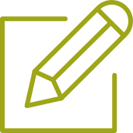 Tell Our Story

Project Title:
Recommended 50 character maximum, start with a verb ; ENHANCE: Menstrual Dignity & Education
Summary: What will this project do?

Menstrual health remains neglected in Trincomalee due to stigma, limited access to affordable menstrual products, inadequate sanitation, and weak local implementation of national policies. RECDO will strengthen community-led engagement with local authorities to integrate menstrual health into planning, budgeting, and accountability systems. The project empowers women, youth, schools, and health stakeholders to improve menstrual health governance and create a scalable model for inclusive public-health action.
Recommended 500 character maximum
Funding Amount/Goal: How much money do you hope to raise (in USD)?
40000 USD

Challenge  What is the problem or need?  The project addresses limited menstrual health awareness, poor access to affordable menstrual products, inadequate sanitation, and weak local policy implementation in Trincomalee. Stigma and cultural taboos hinder women’s and girls’ health, dignity, education, and inclusion. By strengthening community engagement and local governance, the project will integrate menstrual health into local planning, budgeting, and accountability, making it a recognised public health and development priority.  Recommended 500 character maximum | Solution  How will this project solve the problem?  The project will empower women, youth, teachers, and local officials through menstrual health and governance training, establish Community Health Forums to strengthen dialogue and accountability, and implement the “Speak Health–Period Pride” campaign to reduce stigma and promote policy change. By partnering with schools, health units, and local authorities, the project will improve community participation, service delivery, budgeting, and implementation of menstrual health initiatives.  Recommended 500 character maximum | Long-Term Impact  How will this make a lasting impact in your community?  The project will create lasting impact by strengthening Community Health Forums and partnerships with local authorities, schools, and health services. It will equip women, youth, and community leaders to advocate for menstrual health, influence local planning and budgets, and reduce stigma. By integrating menstrual health into local policies and accountability systems, the project will improve health, gender equality, school attendance, and access to essential services beyond the project period.  Recommended 500 character maximum
Donation Options: How can you illustrate the impact of a person’s donation? For the purpose of this exercise, we recommend outlining three donation options under $100.

Amount | Description
$ 10000 | Empowerment and Capacity Building:  Train 200 community facilitators (women, youth, and school teachers) and 30 local officials on menstrual health governance, gender analysis, and participatory planning. Workshops will equip participants to generate evidence on service gaps and advocate for responsive budgets.
$ 10000 | Institutionalizing Community Health Forums (CHFs):  Establish six CHFs linked to Divisional Secretariats and MOH offices that serve as formal dialogue spaces for citizens and authorities. These forums will use community scorecards to track school and clinic hygiene standards and publicly present findings in quarterly review meetings with local councils.
$ 20000 | Advocacy and Public Engagement:  Implement a district-wide “Speak Health -Period Pride” campaign to challenge stigma and amplify grass-roots voices through radio, social media, street theatre, and youth-led digital content. Advocacy briefs will be shared with provincial and national authorities, informing MHM policy roll-out.

Photo Gallery
Choose four images that show the impact of your work and draft clear captions. Choose high-resolution photos that are positive and empowering and show the community you serve with respect and dignity. Before sharing a photo, ask yourself this question: Would I want to be portrayed this way? Does this image instill hope? Upload photos to worksheet however makes the most sense - photos don’t have to fit perfectly in box!
PHOTO  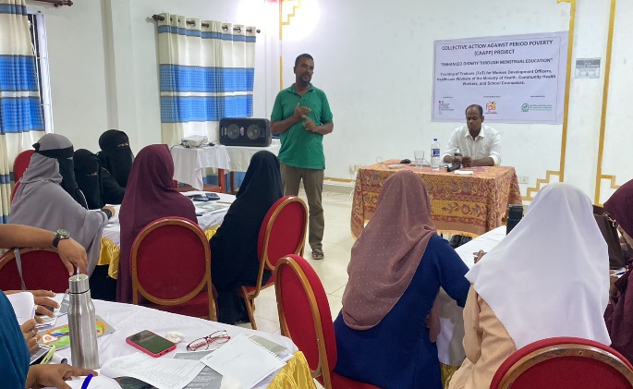 | PHOTO  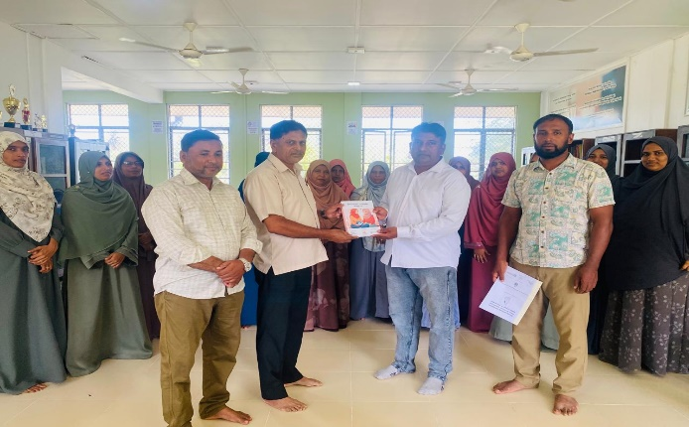
Training of Trainers (ToT) on Menstrual Health and Hygiene for WDOs, PHMs, and School Teachers | Launch of the Menstrual Hygiene Guidebook
PHOTO  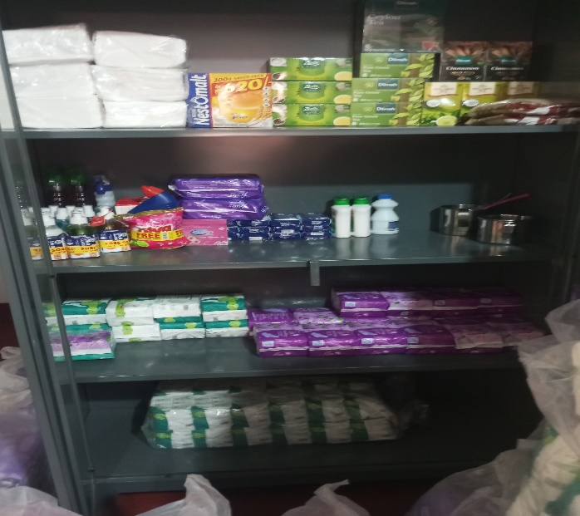 | PHOTO  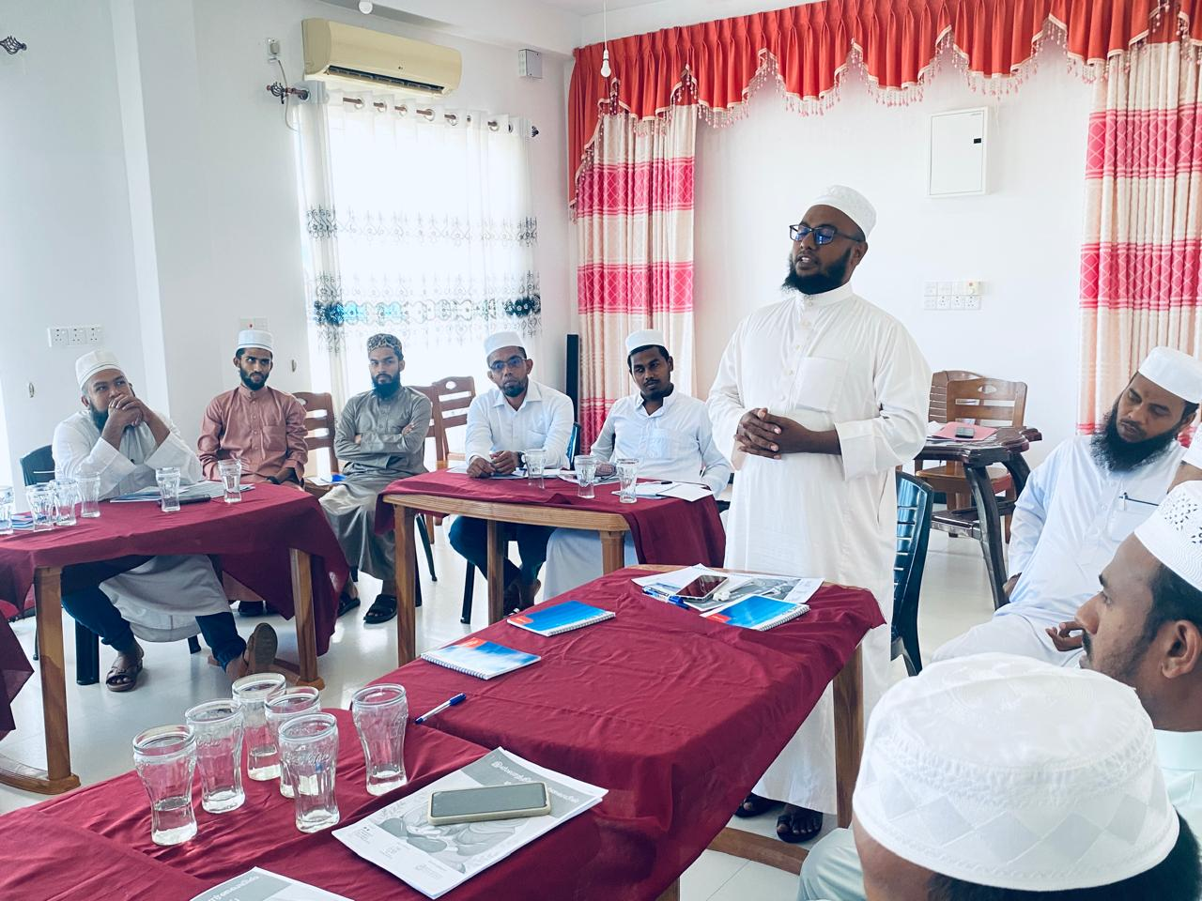
Establishment of School Menstrual Hygiene and Nutrition Units | Menstrual Hygiene Awareness Program for Male Community Leaders

1. What is the problem or need the project is designed to address
Menstrual health remains a neglected public-health issue in Sri Lanka, particularly in rural districts such as Trincomalee, where inadequate access to affordable menstrual products, poor sanitation infrastructure, and entrenched stigma restrict women’s and girls’ full participation in education, employment, and civic life. Although national policies such as the National Reproductive Health Strategy (2023–2027) recognise menstrual hygiene as a determinant of health, local implementation is fragmented and under-resourced.
RECDO’s prior baseline surveys reveal that only 47 percent of schoolgirls in selected Grama Niladari Divisions use hygienic menstrual materials consistently; 32 percent of women face irregular waste-disposal facilities; and cultural taboos persist, with many girls missing school during menstruation. Community consultations also highlight weak coordination between local authorities, schools, and health units, leaving menstrual hygiene absent from local health budgets and council planning.
The lack of participatory mechanisms for women and youth to voice needs in health governance perpetuates inequities. This project addresses that systemic gap by institutionalising community-driven engagement with government to integrate menstrual hygiene into local-health policy, resource allocation, and accountability frameworks transforming it from a private matter into a recognised public-health and rights issue.
2.Why is this the right time to implement the project?

Post-crisis recovery in Sri Lanka has generated renewed national attention on equitable access to essential services, with the Ministry of Health and the Ministry of Women and Child Affairs jointly developing a Menstrual Health Management (MHM) policy framework in 2024. Yet district-level implementation remains weak, especially in the Eastern Province. The current decentralisation drive and the 2026 local-council reform agenda offer a unique policy window for embedding community-led health initiatives into local-governance systems.
At the same time, public discourse on gender equality and cost-of-living pressures has intensified demand for affordable menstrual products and better sanitation in schools. Trincomalee’s multi-ethnic context makes it a priority area for inclusive interventions that model participatory, inter-communal approaches to women’s health governance.
Building upon RECDO’s tested community platforms and trained volunteers, this project will seize the momentum to pilot structured citizen-government engagement mechanisms ensuring local implementation of national MHM commitments and generating scalable lessons for other districts. Timely Commonwealth Foundation support will institutionalise these processes before policy attention wanes.

3.How does the problem impact women, men and marginalised groups differently?

Menstruation primarily affects women and adolescent girls, yet the burden of silence, stigma, and inadequate facilities also shapes family and community wellbeing. In Trincomalee, poor women, girls with disabilities, and plantation or coastal communities face the most acute challenges due to cost barriers, cultural restrictions, and geographic isolation. The absence of privacy and disposal facilities in schools and workplaces leads to absenteeism, declining academic performance, and reduced productivity.
Men, meanwhile, often remain excluded from menstrual-health conversations, reinforcing social taboos and limiting shared responsibility within households and institutions. This gendered information gap perpetuates discrimination and normalises neglect of women’s health needs in governance forums.
By prioritising inclusive community dialogue and male engagement, the project ensures that men and boys become allies in breaking stigma, while women and girls gain the confidence and institutional channels to demand equitable access. Intersectional analysis and gender-disaggregated monitoring will guide all activities, ensuring representation of marginalised groups, including persons with disabilities and ethnic minorities, in decision-making processes.

4.How have you identified the problem?

- Please mention research or other resource materials that support identification and relevance of the problem. This research could have been undertaken by your organisation or by other organisations and may include government data. Please provide links to resource materials when available.
- Were the project target groups involved in the identification of the problem or have they been otherwise consulted, and if so, how?

Problem identification was grounded in RECDO’s 2022–2024 community-health projects and participatory assessments across 22 Grama Niladari Divisions in Trincomalee. Data were collected through focus-group discussions with school girls, women’s rural development societies, and local health officers. The findings were corroborated by the Family Planning Association of Sri Lanka’s district reports and the Ministry of Health’s 2023 Reproductive Health Survey, which highlight that menstrual hygiene services remain largely uncoordinated at the local level.
RECDO’s experience under the FPA-supported “Community Health and Empowerment for Women and Girls” project (2022–2023) revealed strong community demand for policy engagement on menstrual health but limited awareness of avenues to influence decision-making. Consultations with school administrators and Medical Officer of Health (MOH) units confirmed the need for a structured platform for citizen-government dialogue.
International evidence on community engagement in health governance supports this approach as highlighted by recent research on participatory health planning in Sri Lanka (World Journal of Advanced Research and Reviews, 2025) which emphasises that locally anchored dialogues enhance equity and sustainability in public-health responses .

5.What changes (outcomes) do you expect to see as a result of your project?

Please include information on any specific expected changes. These could include changes to knowledge, capacity, attitude, or behaviour of target groups as well as changes to legislation, policies, or practices as a result of the project.

By project completion, RECDO expects tangible progress toward participatory, gender-responsive local-health governance in Trincomalee.
- Outcome 1: Women and adolescent girls from 20 target communities actively engage in planning, monitoring, and advocating for menstrual-health services through functional Community Health Forums and scorecards.
- Outcome 2: Local health authorities and councils integrate menstrual health indicators and budget lines into annual plans, demonstrating institutional responsiveness.
- Outcome 3: Increased public awareness and reduction of stigma on menstrual health through male engagement and community campaigns.
- Outcome 4: Enhanced policy dialogue between civil society and government, contributing to provincial and national MHM policy implementation.
These changes will reflect greater citizen participation, accountability, and health equity — core principles of the Commonwealth Foundation’s Health Justice agenda .

5.How will the project address the problem?

- What are the main outputs the project will deliver to achieve the planned outcomes?
- If the project is part of an ongoing larger project or programme, please focus on what the project will deliver with the requested support
- Who are you going to work with? Please include information on your key target groups.

The project adopts a rights-based, participatory-governance approach built on three interconnected strategies:
1. Empowerment and Capacity Building:
Train 200 community facilitators (women, youth, and school teachers) and 30 local officials on menstrual health governance, gender analysis, and participatory planning. Workshops will equip participants to generate evidence on service gaps and advocate for responsive budgets.
2. Institutionalizing Community Health Forums (CHFs):
Establish six CHFs linked to Divisional Secretariats and MOH offices that serve as formal dialogue spaces for citizens and authorities. These forums will use community scorecards to track school and clinic hygiene standards and publicly present findings in quarterly review meetings with local councils.
3. Advocacy and Public Engagement:
Implement a district-wide “Speak Health -Period Pride” campaign to challenge stigma and amplify grass-roots voices through radio, social media, street theatre, and youth-led digital content. Advocacy briefs will be shared with provincial and national authorities, informing MHM policy roll-out.
The project will partner with local schools, WRDSs, health units, and youth clubs. Participatory monitoring will combine qualitative (scorecards, focus groups) and quantitative (indicator tracking) methods aligned with the Foundation’s Results-Based Management framework .
Through this multi-stakeholder model, the initiative translates grass-roots voices into policy influence while improving service delivery, accountability, and gender equity in local health systems.

6.What are the main challenges (risks) envisaged in implementing the project and how will they be addressed?

Cultural resistance and stigma: Mitigated through inclusive male engagement and religious leader dialogues.
Institutional turnover: Maintain cross-party relations and MoUs with health offices to ensure continuity.
Resource constraints: Leverage in-kind contributions (school venues, volunteers) and link with provincial health programs.
Community fatigue: Use creative arts and peer-learning events to sustain interest.
A risk matrix will be reviewed bi-annually with partners and local officials to update mitigation strategies.

7.How will you incorporate gender considerations into your project?

Gender equality is central to the project logic. It addresses menstrual health as a gender-justice issue linked to the right to health, education, and dignity. Gender analysis informs all stages—from needs assessment to indicator design. The project allocates dedicated budget lines for women’s leadership training and child-care support during meetings. Sex-disaggregated data and intersectional analysis (covering ethnicity, age, and disability) will guide decision-making. By actively engaging men and boys as allies, the project aims to shift harmful social norms while strengthening women’s agency to influence policy and resource allocation. This approach reflects the Commonwealth Foundation’s cross-cutting gender principle

Empowering Women and Girls through the ENHANC
Dear Sir/Madam,
Funding Request: Empowering Women and Girls through the ENHANCE – Menstrual Dignity & Education Initiative
We respectfully seek your valued partnership and financial support for the ENHANCE: Menstrual Dignity & Education project, an initiative designed to improve the health, dignity, education, and well-being of women and adolescent girls from vulnerable communities in Sri Lanka.
Despite significant progress in education and healthcare, many girls continue to face barriers caused by menstrual poverty, limited access to menstrual hygiene products, inadequate sanitation facilities, and persistent social stigma. These challenges contribute to school absenteeism, reduced self-confidence, health risks, and gender inequality.
Through the ENHANCE project, the Rural Economic and Community Development Organization (RECDO) aims to:
- Improve access to affordable and sustainable menstrual hygiene products.
- Deliver comprehensive menstrual health and hygiene education for adolescent girls, boys, parents, teachers, and community members.
- Strengthen school and community sanitation facilities that support menstrual dignity.
- Reduce stigma and discrimination through community awareness and advocacy.
- Build the capacity of local leaders, youth groups, schools, and health stakeholders to sustain menstrual health initiatives beyond the project period.
Your generous contribution will directly enable vulnerable women and girls to remain healthy, attend school with confidence, and participate fully in community life. It will also help create lasting social change by promoting gender equality, dignity, and inclusive community development.
We would be honoured to discuss this proposal further and explore opportunities for collaboration. Your support can make a meaningful and lasting difference in the lives of thousands of women and girls.
Thank you for considering our request. We look forward to the opportunity to partner with you in advancing menstrual dignity and educational empowerment.
Sincerely,
JM. Azhar
Chairman
Rural Economic and Community Development Organization (RECDO)
Contact: +94 77 707 3441
Email: recdosl@gmail.com
Website: www.recdo.org

