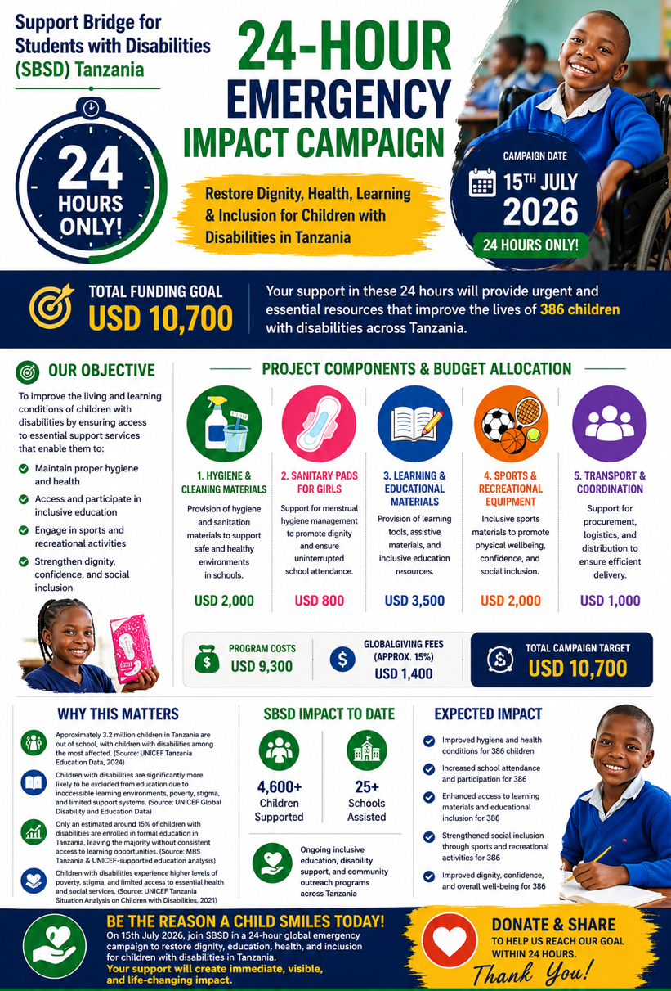

SBSD 24-HOUR EMERGENCY IMPACT CAMPAIGN

Project Title: Restore Dignity, Health, Learning & Inclusion for Children with Disabilities in Tanzania

1. Organization Information
Organization: Support Bridge for Students with Disabilities (SBSD) Tanzania
Country: Tanzania
Focus Area: Inclusive Education, Disability Support, Child Protection, Community Development
SBSD Tanzania works to improve the lives of children with disabilities by promoting access to education, health, dignity, and social inclusion through community-based interventions.

2. Project Title
SBSD 24-Hour Emergency Impact Campaign

3. Campaign Date
15th July 2026 (24 Hours Only)

4. Total Funding Goal
USD 10,700

5. Executive Summary
The SBSD 24-hour emergency campaign is a high-impact, time-sensitive fundraising initiative designed to support children with disabilities in Tanzania who face severe barriers in accessing hygiene materials, education, and inclusive opportunities.
Within 24 hours, SBSD aims to raise funds to deliver immediate, practical support that restores dignity, improves health conditions, enhances learning outcomes, and promotes inclusion through education and recreational activities.
This campaign directly responds to urgent gaps affecting vulnerable children and ensures rapid, measurable impact within a short implementation period.

6. Problem Statement
Children with disabilities in Tanzania face multiple challenges, including:
- Lack of access to basic hygiene and sanitation materials
- Limited access to learning and assistive educational resources
- Exclusion from sports and recreational activities
- Stigma, discrimination, and social isolation
- High risk of school absenteeism and dropout
These challenges negatively impact their dignity, health, education, and long-term development.

7. Project Objective
The main objective is to improve the living and learning conditions of children with disabilities by ensuring access to essential support services that enable:
- Improved hygiene and health
- Inclusive education participation
- Engagement in sports and recreation
- Enhanced dignity, confidence, and social inclusion

8. Target Group
- 386 children with disabilities in Tanzania
- Including 62 girls requiring menstrual hygiene support
- Schools and community-based learning environments

9. Project Activities and Budget Allocation

1. Hygiene & Cleaning Materials – USD 2,000
Provision of hygiene and sanitation materials to support safe and healthy environments in schools.

2. Sanitary Pads for Girls – USD 800
Support for menstrual hygiene management to promote dignity and school attendance.

3. Learning & Educational Materials – USD 3,500
Provision of learning tools, assistive materials, and inclusive education resources.

4. Sports & Recreational Equipment – USD 2,000
Inclusive sports materials to promote physical wellbeing, confidence, and social inclusion.

5. Transport & Coordination – USD 1,000
Support for procurement, logistics, and distribution to ensure efficient delivery.

10. Budget Summary
- Program Costs: USD 9,300
- GlobalGiving Fees (Approx. 15%): USD 1,400
- Total Campaign Target: USD 10,700

11. Expected Outcomes
This campaign will directly result in:
- Improved hygiene and health for 386 children
- Increased school attendance and participation
- Enhanced access to learning materials and education
- Improved confidence through sports and recreation
- Strengthened dignity and social inclusion

12. Impact Statement
This is a rapid-response intervention designed to create immediate and visible impact within a short timeframe. The campaign ensures that vulnerable children with disabilities receive essential support that directly improves their daily lives and educational opportunities.

13. Monitoring and Accountability
SBSD will ensure:
- Transparent procurement and distribution
- Documentation of beneficiaries reached
- Activity and impact reporting
- Financial accountability and reporting to donors

14. Conclusion
The SBSD 24-Hour Emergency Impact Campaign is a focused, high-impact initiative designed to deliver urgent support to children with disabilities in Tanzania. With timely funding, SBSD will restore dignity, improve health, strengthen education access, and promote inclusion for the most vulnerable children.

