About Us:
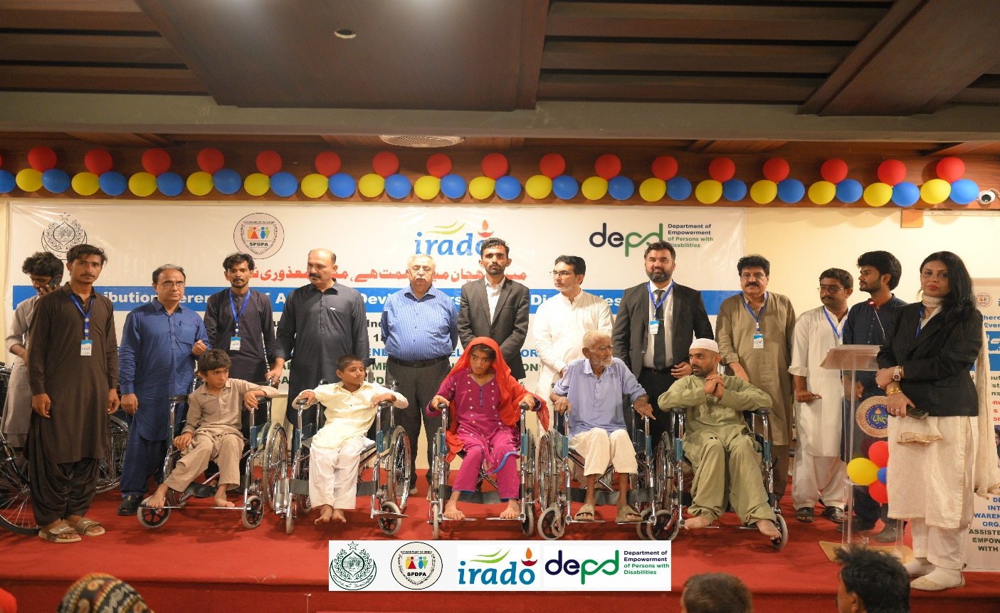

Integrated Rural Awareness & Development Organization (IRADO) is a not-for-profit, non-governmental humanitarian organization established in October 2009. The Organization is registered under the Societies Act 1860 of Pakistan. IRADO aims to strive for reinforcing the socio-economic status of deprived communities in the disaster-prone Zone of Sindh.
Since its inception, IRADO has worked for the empowerment of the downtrodden poorest. IRADO assists communities to achieve socioeconomic status and thereby improve the lives of marginalized families through an integrated rural development approach, mobilizing communities and enhancing their capacities to improve their living standards.
IRADO holds vast experience as an effective organization in implementing sustainable development projects. The Organization has completed multiple small, medium, and large-scale projects in collaboration with national, international, and philanthropic partners. The majority of its funding comes from consistence local as well international partners, the long-standing presence and rich experience of IRADO demonstrate the organization's commitment and ability to engage with various stakeholders and contribute to addressing rural development challenges. Its expansion from desert to other areas in Sindh is another strength that adds value to remain relevant and efficient.
One of organization's key strengths is its focus and productive engagement of its beneficiaries which consists of vulnerable groups, including women, youth, children, orphans, widows, and differently able persons from the rural and far-flung areas of rural as well of urban areas of Sindh. While operating with an inclusive approach ensuring the onboarding of all stakeholders and relevant government departments,

the emphasis demonstrates the organization's commitment to social equity and inclusion in its development interventions. Additionally, the IRADO program prioritization with a comprehensive and integrated approach to rural development, while addressing various aspects of rural life, including the availability of drinking water, sanitation, hygiene, food security, nutrition, livelihoods, emergencies, disaster risk reduction, education, women's and youth empowerment, sustainable community engagement, climate change, and good governance make IRADO unique among all players.
IRADO’s prime thematic area prioritizes humanitarian Assistance at all stages and for all walks of life. IRADO steps forward to wrestle with social issues by involving like-minded organizations and alliances.

Vision:
“To empower youth, women, and children, fostering a socially aware, economically independent, and politically engaged community, while promoting equality, justice, and access to rights for all, free from discrimination.”

Mission:

"To foster pro-poor, multi-sectoral partnerships, empower communities with a

gender-balanced approach, and build sustainable capacity for long-term development."

Objectives:

- Mobilize and engage marginalized communities, particularly youth and women, in integrated rural development initiatives focused on climate resilience, livelihoods, and social equity.
- Enhance the leadership capacities and technical skills of indigenous women and youth, empowering them to actively participate in community-driven development processes.
- Promote access to quality education and primary healthcare, with a focus on women and girls, through community-based advocacy and development programs.
- Support environmental sustainability and climate change adaptation, while reducing disaster risks through community-based environmental management initiatives.
- Raise awareness and mobilize communities for sustainable development, advocating for the protection of rights and empowerment of marginalized groups.
- Develop strategic partnerships and linkages with local institutions, networks, and stakeholders to share resources, expertise, and drive collaborative, sustainable development.

Organizational Values:

- Equity: Championing equal access to opportunities for all, ensuring that marginalized communities, especially women and youth, can fully engage and thrive in the development process, free from discrimination.
- Empowerment: Strengthening the capacity of marginalized groups, particularly youth and women, by equipping them with the skills, resources, and confidence to advocate for their rights and drive their own sustainable development.
- Inclusion: Actively involving marginalized communities, especially women and youth, in decision-making processes, ensuring their voices are heard and their needs addressed in social, economic, and environmental development.
- Sustainability: Committing to development practices that not only address immediate needs but also build long-term resilience, preserving resources for future generations and promoting climate-adaptive solutions for vulnerable communities.
- Partnership: Building strategic alliances with local communities, civil society organizations, and institutions to mobilize collective resources, share expertise, and collaborate on impactful, community-driven solutions.
Transparency: Upholding the highest standards of transparency and accountability, ensuring
that our operations and processes are open, inclusive, and responsive to the needs of the
communities we serve..

Thematic Areas:

- Persons with Disabilities (PWDs) Inclusion: Disability inclusion is one of the prime themes of IRADO. The organization is committed to promoting the rights, dignity, and equal opportunities of persons with disabilities, ensuring their full participation in social, educational, economic, and community life without discrimination.
IRADO works to remove barriers faced by persons with disabilities through awareness raising, advocacy, capacity building, and community engagement. The organization promotes inclusive development approaches that ensure accessibility and equal access to services and opportunities.
Guided by the principle of “Leave No One Behind,” IRADO integrates disability inclusion across its programs and encourages the active participation and leadership of persons with disabilities in decision-making processes, contributing to more inclusive and equitable communities.
- Community Mobilization: Empowering rural communities, particularly women and youth, through training and leadership development, making
- them active and capacitated partners in sustainable rural development and climate adaptation efforts.
- Rights and Protection: Focused on the most vulnerable, including women, youth, and minorities, IRADO works to educate, raise awareness, and equip these groups to advocate for their constitutional rights, ensuring their voices are heard and their rights are exercised in decision-making processes.
- Sustainable Livelihood Support: Promoting sustainable agricultural practices, providing skill-building opportunities for youth, and supporting small and medium enterprises. IRADO emphasizes the protection of natural resources and fosters volunteerism to enhance community development and well-being.
- Social Services: Facilitating access to quality education, primary healthcare, clean water, and sanitation services, particularly in remote areas, to improve the overall living standards of marginalized communities.
- Climate Change & Disaster Preparedness: Educating and empowering communities to understand and mitigate climate change impacts, enhance disaster preparedness, and actively participate in local environmental protection initiatives, contributing to effective emergency response and long-term climate resilience.
- Thari women into the textile
- Thari women possess exceptional skills in traditional crafts such as embroidery, carpet weaving (qaleen weaving), and other forms of handmade artistry, reflecting the rich cultural heritage of Tharparkar. Their intricate embroidery, characterized by vibrant patterns and meticulous needlework, and their expertise in crafting handwoven carpets, are not only artistic treasures but also potential avenues for economic empowerment. However, despite their talent, these women face significant challenges in accessing formal markets and industrial opportunities due to cultural barriers, limited resources, and inadequate infrastructure. Integrating Thari women into the textile industry, particularly in sectors aligned with their craftsmanship, can provide sustainable livelihoods, preserve their cultural art forms, and contribute to the broader socio-economic development of the region.
Agriculture is very important to Pakistan's economy and community. It is the largest sector, employing over 42% of the workforce and contributing around 24% to the country's GDP, cotton contributes nearly 10 per cent in the agriculture GDP and a source of 60 per cent foreign exchange earnings. The value addition through cotton is 8.2 per cent in agriculture and 2 per cent in the GDP.
Integrated Rural Awareness & Development Organization (IRADO) one core theme is Cotton sustainability programs aim to address the environmental, social, and economic challenges associated with cotton production while ensuring the long-term viability of cotton-growing communities. IRADO done these all through 20 farmers groups/organizations, in Umerkot, TM khan, Badin and Matiari District of Sindh.

Environmental Protection and Restoration:
- Sustainable Agriculture Practices: Promoting the adoption of environmentally friendly farming techniques such as reduced tillage, crop rotation, integrated pest management, and the use of organic fertilizers to minimize the environmental impact of cotton cultivation.
- Water Management: Implementing water-efficient irrigation systems, promoting rainwater harvesting techniques, and encouraging farmers to use

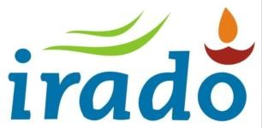
water judiciously to conserve this precious resource.
- Biodiversity Conservation: Preserving and enhancing biodiversity within cotton-growing regions by protecting natural habitats, promoting agroforestry practices, and minimizing the use of harmful chemicals that can harm local ecosystems.
- Soil Health: Supporting soil conservation practices such as cover cropping, mulching, and composting to improve soil fertility, structure, and resilience, thereby enhancing the long-term productivity of cotton farms.

Social and Economic Development:

- Fair Labor Practices: Ensuring fair wages, safe working conditions, and the prohibition of child labor in cotton production to uphold human rights and improve the livelihoods of cotton farming communities.
- Community Empowerment: Investing in education, healthcare, and infrastructure projects to enhance the well-being and resilience of cotton- growing communities, fostering economic diversification and reducing dependency on cotton farming.
- Gender Equality: Promoting gender equality and women's empowerment within cotton communities by providing access to education, training, and resources for women farmers, and ensuring their participation in decision-making processes.
- Capacity Building: Offering training programs, technical assistance, and access to innovative technologies to help cotton farmers improve their agricultural practices, increase yields, and adapt to changing environmental conditions and market dynamics.

Market Access and Supply Chain Transparency:

- Market Linkages: Facilitating direct relationships between cotton producers and buyers committed to sustainability, fair trade, and ethical sourcing, thereby providing market access and premium prices for sustainably produced cotton.
- Consumer Awareness: Raising awareness among consumers about the importance of supporting sustainable cotton production and encouraging responsible purchasing decisions through marketing campaigns, labeling initiatives, and product certifications.

Research and Innovation:

- Research Funding: Investing in scientific research and innovation to develop new technologies, practices, and solutions that improve the sustainability and resilience of cotton farming systems, address emerging challenges such as climate change and pest resistance, and enhance the overall efficiency and productivity of cotton production.
- Knowledge Sharing: Facilitating knowledge exchange and collaboration among stakeholders, including farmers, researchers, policymakers, CSOs, and industry partners, to share best practices, lessons learned, and innovative approaches for advancing cotton sustainability.

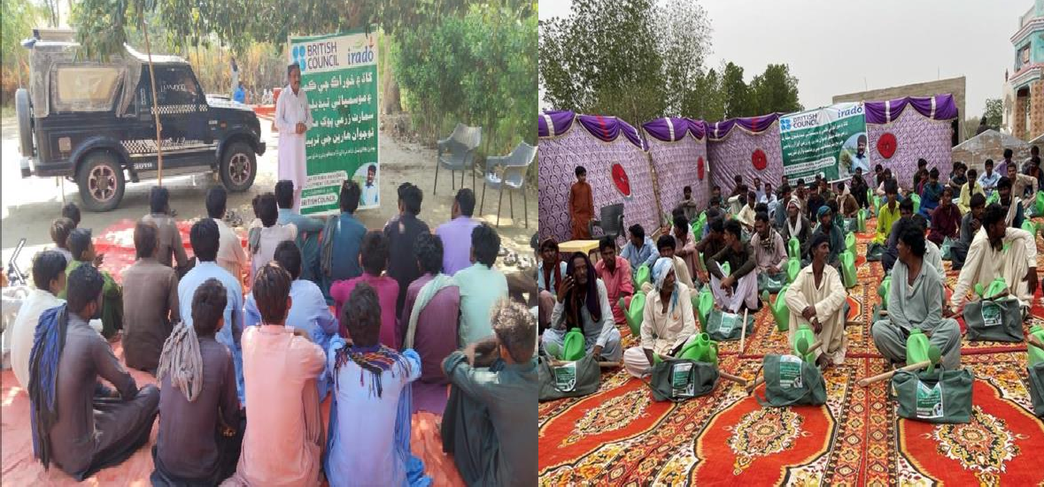

Trainings of farmers and Agri Tools distribution

Organogram:
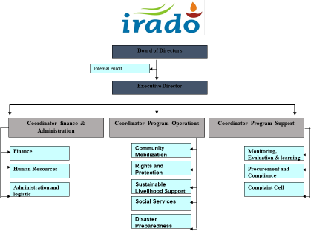
Renewable Energy:

IRADO, in collaboration with Shaan Tech, has made a significant contribution to energy access by distributing 500 solar lights across key villages in District Dadu and District Tharparkar. The initiative has illuminated communities in Manchar Lake Shah Hassan, Bhako, Adhegam, and Oan in Tharparkar. This project not only addresses the pressing need for reliable lighting but also supports sustainable energy practices, improving the quality of life for residents and fostering environmental stewardship in these remote.regions.
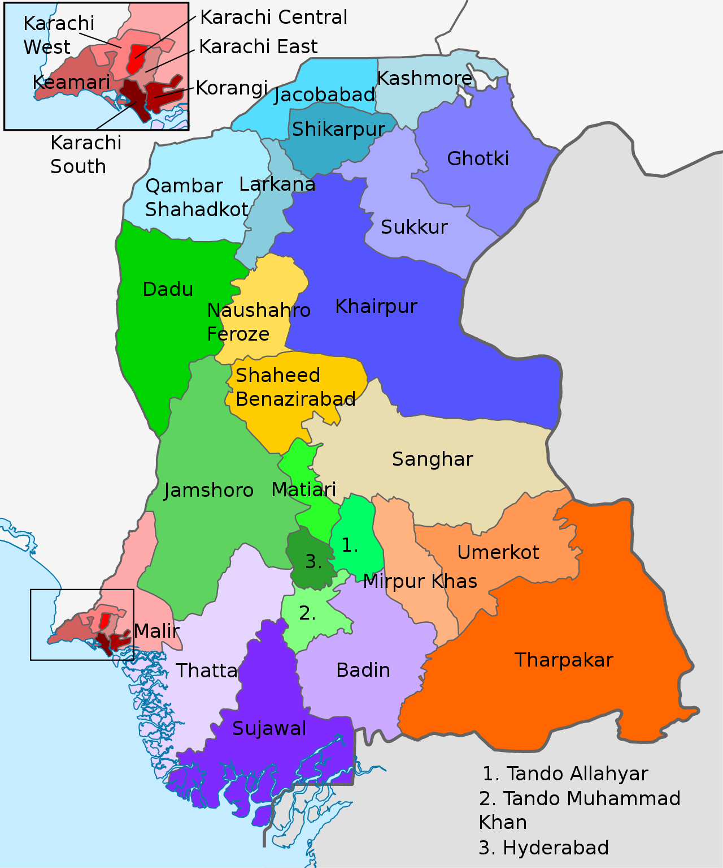

Sindh with its poor socio-economic indicators is vulnerable among other provinces of Pakistan, the geographical settings and various other anthropogenic features make it more vulnerable. Unplanned urbanization, the increasing trend of population, and a decrease in livelihood opportunities are causing a rise in poverty. the impact of climate change is also adding risks to the living and livelihood of the communities. Poverty and food insecurity are widespread in the IRADO areas. IRADOs Program districts include Tharparkar, Umerkot, Mirpurkhas, Sanghar, Matiari, Tando Allahyar, Tando Mohammad Khan, Badin,Sujawal, Thatta, Hyderabad, Jamshoro, Dadu. These are the districts affected badly due to the economic rescissions, COVID-19,

and recent flood events. The situation in the districts is aggravating with every passing day. With these and many other problems, IRADO employs a comprehensive integrated approach that addressed the issues of rural and semi- urban vicinities and comes up with an appropriate model with evidence at the community level. For IRADO it is important to promote the adaptive activities that exist at the community level, innovate some effective measures and pilot those, reduce the risk factors, promote some community-led models, and create income opportunities at the community level. Making the way for those to be replicable and to be up-scaled is the IRADOs strategy.

Prime Beneficiaries:

The Children, women & men from poor and hardcore poor families, landless, religion-ethnic minorities, disaster victims, and disabled people of these geographically isolated areas are the primary stakeholders of IRADO. The potential tertiary stakeholders are networks and alliances of NGOs, Civil Society Organizations, local administration, local government bodies, concerned ministries and relevant departments, International Agencies, academicians, and philanthropy.

Partners and Networks:

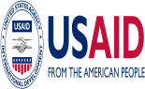
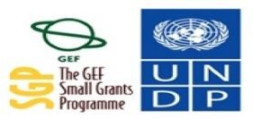
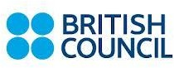
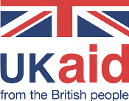
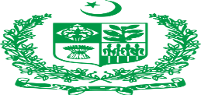
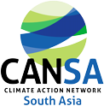
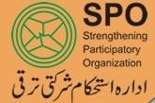
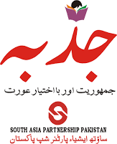
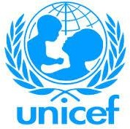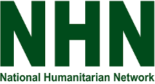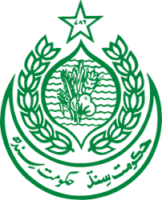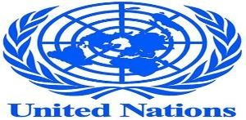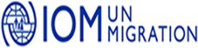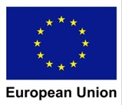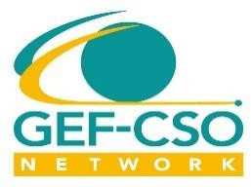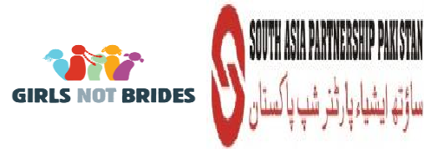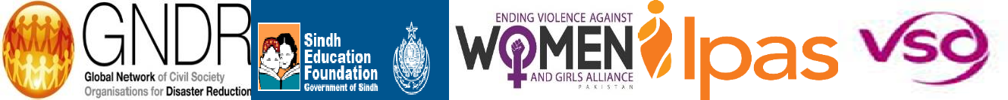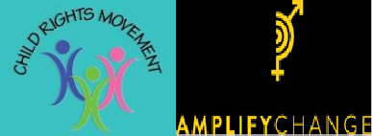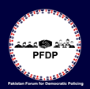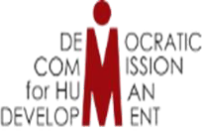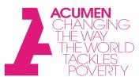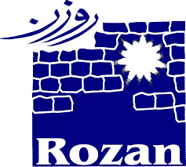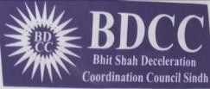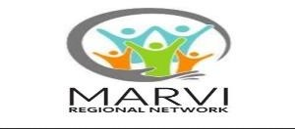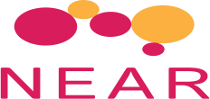
+

Partners
Alliance and Networks | - NHN: National Humanitarian Network.  http://nhnpakistan.org  - GEF CSO Network  - SUCSA Network  - NEAR Network  - GNDR  - Girl’s Not Bride’s  - CANSA: Climate Action Network South Asia  - GWP: Global water Partnership  - Child Rights Movement (CRM)  - Ending Violence Against Women and Girls (EVAW/G) Alliance – Sindh Chapter  - Acumen Fellowship 2018  - PNF: Pakistan NGOs Forum  - Bhit Shah Declaration Coordinating Council (BDCC)  - REAT NETWORK Pakistan  - South Asia Partnership -PAK  - Global Education Alliance  - Active Citizen Network Pakistan  - Accountability learning Group-Oxfam GB- Sindh  - Active member of LAPA network on climate  change

Projects:

Name of Project | Brief Description of the Project/Thematic  Focus | Location | Donor | Total project budget  (PKR/ USD) | Duration
Grant in (One Time) Provision of Assistive Devices | Provision of Assistive Devices for Differently abled Children and persons with disabilities | TM khan | DEPD, Sindh Government | 5M PKR | 3 Month
Dewatering & Site Improvement Activities | Disaster resilience, risk reduction, mitigation and Response | Umerkot | Internatio nal Organizati on for Migration (IOM) | 4M PKR | 3 Month
Youth Engagement for climate Smart Agriculture for  food Security | Agriculture, Livestock and natural resource Management | Umerkot | British Council | 11,392 | 6 Month
Management of Operational and Logistical arrangements of Ipas Program activities under Humanitarian R  esponse-Sindh Province | Disaster resilience, risk reduction, mitigation and Response | Sindh | Ipas | 16,034 | 1 Month
Emergency Response | Disaster resilience, risk reduction, mitigation and Response | Mirpurkha s, Dadu, Jamshoro  , Umerkot | SAP-PK,  Acumen Fellows and Philanthro py | 8,439 | 2 Month
Culture Promotion for  Peace | Eco Tourism | Sindh | Govt Of Sindh | 4,219 | 5 Month
Improve Socio- Economic Conditions of Indigenous Fisher Community living at  Mancher Lake | Livelihood & Value Chain | Dadu | USAID  Ambassa dor Fund Program | 27,426 | 7Month
To maximize Rain Water harvesting usag  e for domestic | WASH | Tharparka r | UN-ONE- EDM | 28,270 | 12 Months
WASH | WASH | Tharparka r | UNICEF | 8,439 | 01 Months

Provision of Livelihood Assistance | Livelihood & Value Chain | Tharparka r | UNDP GEF SGP | 32,489 | 03 Month
Vulture Safe zone | Livelihood & Value Chain | Tharparka r | WWF | 13,924 | 12 Month
(To Ensure Electrification through Solar- Powered LED in Rural Areas of Nagarparkar District Tharparkar) | Renewable Energy | Tharparka r | Usaid and Shaan Tech.  PVT | 44,304 | 10 Month
Active Citizen  Program | Local Governance | Sindh | British  Council | 4,219 | 36 Month
Impact of climate change  on world | Environment/Climate Change/Green Skills | Sindh | IIRE | 169 | 01 Month
HBW survey  (Women Empowerment) | Gender Equity & Equality | Sindh | SAP-PK | 84 | 01 Month
WASH | Environment/Climate Change/Green Skills | Sindh | SAP-PK | Supplies were provided by partner  in kind | 05 Month
Pro-women Legislation and Implementation of women laws | Local Governance | Sindh | GEP-  Aurat Foundatio n, Asia Foundatio n and | 570 | 2 Month
Drinking Water Provision | WASH | Tharparka r | Philanthro pist | 2,110 | 6 Month
GBV | Gender | Sindh | Rozen | 127 | 2 Month
FAFE | Local Governance | Sindh | DCHD | 68 | 1 Month
My Police for me | Local Governance | Sindh | Rozan | 422 | 2 Years
Women Participation in  local Bodies election | Local Governance | Sindh | SAP-PK | 633 | 1 Month

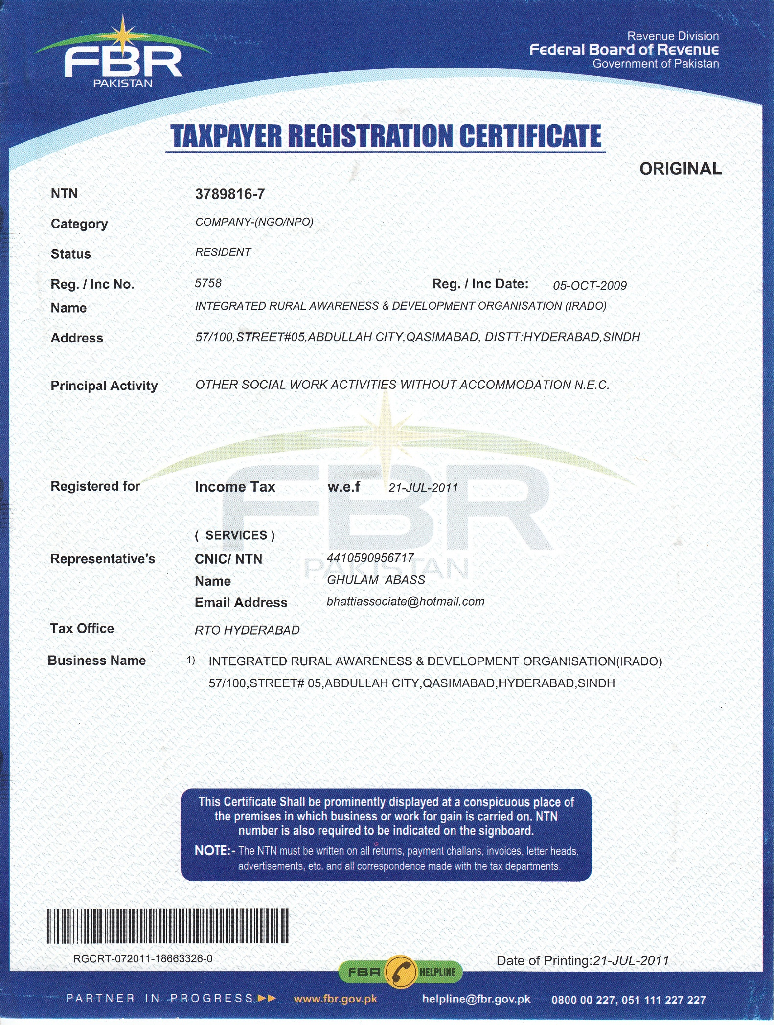

Contact Us

House # 57/100, Street 05 Abdullah City Nasim Nagar Chowck, Qasimabad.
Hyderabad Sindh, Pakistan.71000. Cell #.+923453789946 Social Media: https://www.facebook.com/irado54/
Email:irado54@yahoo.com

