Storytelling Worksheet
Use this worksheet to outline the essential elements of your organization's work you’d like to fundraise for. This storytelling format mirrors GlobalGiving project pages, which you can view on GlobalGiving.org for inspiration.

Let’s Get Started!
- Get familiar with GlobalGiving’s project page format by finding three projects you would support if you were a donor. We encourage you to filter by “Location” and “Theme” to streamline your exploration. This first step aims to familiarize you with the project page format and help you understand what potential donors see when they visit GlobalGiving.

- Review the “Tell Your Story” content (page 2) to help you complete the Storytelling Worksheet (pages 3-5). We hope this worksheet will help you outline a project you hope to fundraise for soon. Ideally, the project you feature in the worksheet is the first project you wish to fundraise on GlobalGiving to save yourself some time and effort. However, you are not limited to one project once you're a GlobalGiving partner.

- Submit your completed worksheet USING THIS FORM by Friday, Feb. 27 to access GlobalGiving’s due diligence application.

Tell Your Story

Donors are more likely to support your work when they understand how you will channel their generosity to make a difference. Good storytelling is essential to your sustainable fundraising strategy because it keeps people giving!

Key Lessons

- Inspire connection through personal storytelling. The people closest to the problem community members and/or staff) are often the most influential storytellers. Here is a downloadable checklist to master the basics of nonprofit storytelling.

- Talk about impact in terms of transformation. Combine data, photographs, and individual stories to show rather than tell how things have changed because of your work.

- Portray your community with dignity and strength to inspire empathy and connection rather than pity. Choose photos that show the positive impact that you are making and leave out images of despair. We encourage you to review the GlobalGiving Community Photo Standards.

- Watch this 3-minute video to hear how GlobalGiving community leaders inspire donors through storytelling!

 Tell Our Story

Project Title:
Recommended 50 character maximum, start with a verb : Promoting Gender Equality and Women’s Political Participation
Summary: What will this project do?

Challenges to Women’s Political Participation in Rural Communities
Women in rural communities face multiple barriers that limit their engagement in political and leadership roles. Key challenges include:
- Economic Hardship: Women-headed households often struggle with financial instability, which limits their capacity to engage in political activities.
- Limited Political Interest: Many women lack awareness or motivation to participate in politics due to social and cultural constraints.
- Low Political Awareness: Knowledge about political systems, processes, and rights is often limited among rural women.
- Low Participation in Local Governance: Women’s involvement in rural development societies, committees, or local councils is minimal.
- Family Responsibilities: Household burdens and lack of family support restrict women from participating in political activities.
- Hesitation to Contest Elections: Women are often reluctant to stand for elections due to societal pressures or lack of confidence.
- Gender Bias in Political Parties: Discrimination within political parties discourages women from active participation.
- Cultural and Social Norms: Traditional expectations and restrictive norms limit women’s mobility and engagement.
- Fear of Political Processes: Concerns about safety, criticism, or political backlash prevent women from active involvement.
- Absence of Support Structures: Lack of women’s organizations or mentoring networks hinders their political empowerment.
- Male-Dominated Political Spaces: Politics in rural areas is often controlled by men, making it difficult for women to access decision-making platforms.
- Resistance to Change: Prevailing attitudes in the community often undervalue women’s leadership and decision-making abilities.
- Limited Access to Information: Women often do not receive sufficient information about political rights, elections, or governance processes.
- Economic Barriers: Poverty and limited resources further restrict women from participating in political campaigns or leadership roles.
- Gender Inequality: Systemic discrimination between men and women persists in social, economic, and political spheres.
- Severe Hardships: Ongoing economic and social challenges exacerbate the difficulties women face in entering politics.
Women who are economically disadvantaged, especially those living in rural areas, face multiple social, economic, and political challenges. They often have low awareness of their rights and limited access to leadership opportunities. These women, particularly heads of households, face restrictions in participating in community decision-making and political activities. Due to these social and cultural barriers, they are often unable to raise their voices or claim their rights effectively.
Women’s participation in political and leadership roles is therefore very low. Even when opportunities exist, societal norms and family responsibilities prevent them from taking part. Those who attempt to engage often face discouragement or lack of support from family and community. As a result, women are unable to gain representation in local governance structures, decision-making committees, or political platforms.
In situations where women are active, their contributions are often undervalued or ignored. Women may participate in decision-making processes, but their inputs are frequently overlooked. This systemic neglect and social pressure further reinforce gender inequality, leaving women economically and politically marginalized.

Recommended 500 character maximum
Funding Amount/Goal: How much money do you hope to raise (in USD)?
100000 USD
Challenge  What is the problem or need?  Promoting Women’s Political Participation and Gender Equality in Trincomalee, Sri Lanka  In Sri Lanka, women make up nearly 42% of the population, yet their representation in political decision-making remains alarmingly low, at only 4–7%. This stark gap highlights a critical challenge: despite their numbers, women are largely absent from the political arena, which limits their influence on policies that affect their lives and communities.  The barriers to women’s political participation are numerous and complex. Many women face social and cultural restrictions, family and household responsibilities, and economic hardships that prevent them from engaging in political activities. Additionally, political environments are often male-dominated, competitive, and at times unsafe, making it particularly difficult and even risky for women to step into leadership roles. These factors contribute to a persistent gender gap in political representation, especially in rural and marginalized areas.  Recognizing this urgent challenge, our initiative in Trincomalee, Eastern Province, focuses on raising awareness, building capacity, and empowering women to participate actively in politics. Through community education, leadership training, and advocacy programs, we aim to:  - Increase awareness among women about their political rights and opportunities  - Encourage and support women to participate in local governance and elections  - Foster gender equality by challenging social norms that limit women’s voices  - Promote safe and inclusive political environments for women leaders  By addressing these barriers, we aim to strengthen women’s political representation and leadership, contributing to a more equitable and inclusive democracy in Trincomalee and beyond.  Recommended 500 character maximum | Solution  How will this project solve the problem?  1. Women actively participate in leadership and decision-making roles. They are being empowered through awareness programs and training, which helps them gain confidence and take on responsibilities in their communities.  2. Preventing Gender-Based Violence and Discrimination in Political Participation  3. Women are being empowered to take leadership and decision-making roles, and they are also being encouraged to participate in community development activities.  4.“On International Women’s Day, we celebrate women who are being empowered to take on leadership roles. As a result, they are gaining confidence and actively participating in decision-making processes, shaping a more inclusive and equitable society.”  By implementing these activities, we aim to address and reduce the challenges faced by women in political and leadership roles. Empowering women through awareness programs, training, and community engagement will strengthen their confidence, increase their participation in decision-making, and promote safer, more inclusive political and leadership environments.  Recommended 500 character maximum | Long-Term Impact  How will this make a lasting impact in your community?  The implementation of these activities is expected to produce significant and sustainable long-term benefits for women and the wider community in Trincomalee:  1.. Increased Political Representation: By empowering women through leadership training, awareness programs, and community engagement, more women will participate in local governance, councils, and political processes. This will gradually close the gender gap in political representation.  2..Enhanced Leadership Capacity: Women will develop stronger decision-making, advocacy, and leadership skills, enabling them to take on influential roles not only in politics but also in social and economic development initiatives.  3..Cultural and Social Transformation: Raising awareness and preventing gender-based violence and discrimination in political spaces will challenge traditional norms and biases. Over time, this will foster more inclusive, equitable, and supportive environments for women in both public and private spheres.  4..Community Development and Participation: Empowered women will actively contribute to community planning and development, improving the quality of life, services, and governance in their local areas. Their participation will strengthen accountability, transparency, and responsiveness in decision-making processes.  5..Sustainable Gender Equality: The project will lay the foundation for long-term gender equality by creating a pipeline of confident, skilled, and politically engaged women leaders. This will inspire younger generations, encourage more women to step forward, and gradually transform the political and social landscape to be more inclusive.  6..Reduction of Gender-Based Barriers and Violence: Through awareness campaigns and advocacy, the project will reduce instances of gender-based discrimination and create safer spaces for women to participate in leadership and political roles.  Overall, these interventions will empower women, strengthen democratic participation, and promote a culture of gender equality, creating a lasting positive impact in Trincomalee and the Eastern Province.  Recommended 500 character maximum
Donation Options: How can you illustrate the impact of a person’s donation? For the purpose of this exercise, we recommend outlining three donation options under $100.

Amount | Description
25000 USD | Women actively participate in leadership and decision-making roles. They are being empowered through awareness programs and training, which helps them gain confidence and take on responsibilities in their communities (10 Programs)
25000 USD | Preventing Gender-Based Violence and Discrimination in Political Participation (10 Programs)
25000 USD | Women are being empowered to take leadership and decision-making roles, and they are also being encouraged to participate in community development activities. (10 Programs)
5000 USD | .“On International Women’s Day, we celebrate women who are being empowered to take on leadership roles. As a result, they are gaining confidence and actively participating in decision-making processes, shaping a more inclusive and equitable society.”
20000USD | Admin and Staff

Photo Gallery
Choose four images that show the impact of your work and draft clear captions. Choose high-resolution photos that are positive and empowering and show the community you serve with respect and dignity. Before sharing a photo, ask yourself this question: Would I want to be portrayed this way? Does this image instill hope? Upload photos to worksheet however makes the most sense - photos don’t have to fit perfectly in box!
PHOTO  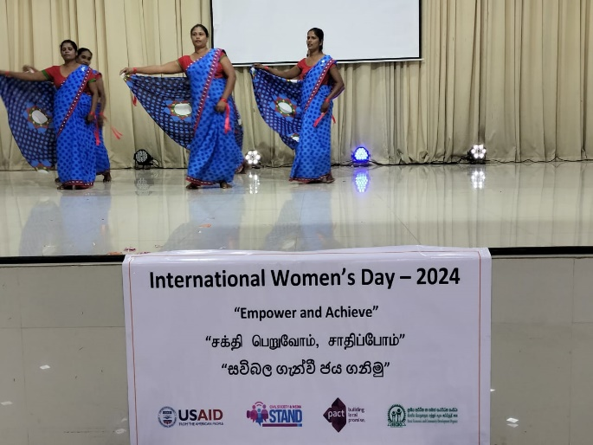 | PHOTO  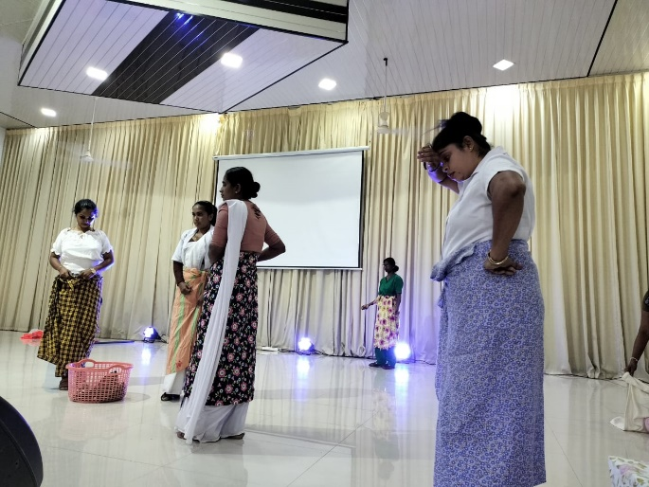
Exploitation and Harassment: Female performers are sometimes subjected to sexual harassment, coercion, or exploitation by organizers, directors, or audience members. | Social Stigma and Discrimination: Female performers are sometimes socially marginalized or judged for their work, which discourages them from participating in political activities, voting, or leadership roles.
PHOTO  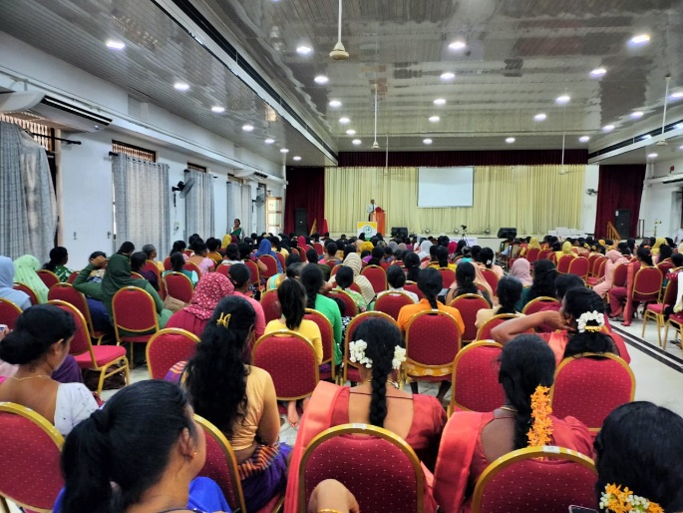 | PHOTO  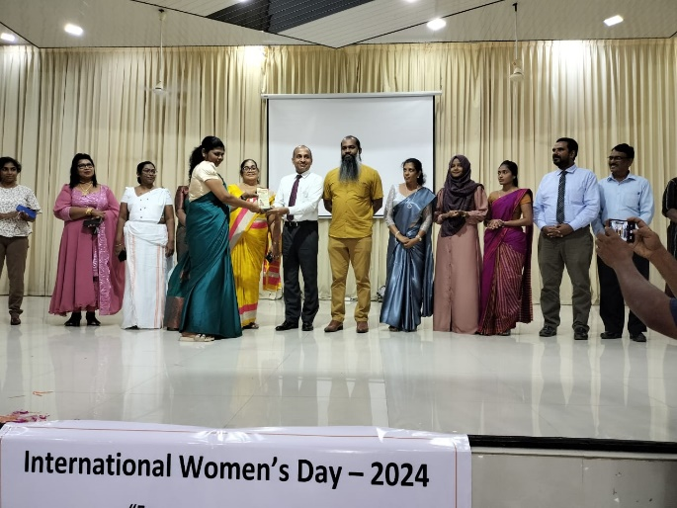
There were local celebrations and events marking International Women’s Day in Trincomalee | Encouraging Participation: Recognizing skilled women motivates more women to actively engage in politics and leadership roles.

Subject: Partnership Request to Enhance Women’s Political Participation Awareness Programs

Dear Sir/Madam,

I hope this message finds you well. I am writing on behalf of the Rural Economic and Community Development Organization (RECDO), an organization dedicated to empowering women and increasing their participation in political processes at the grassroots level. Our mission includes promoting gender equality, gender justice, and youth development. Through ongoing awareness programs conducted in villages, we strive to enhance women’s active involvement in local governance and decision-making.
We have successfully implemented projects focused on the development of women’s political participation, supported by funders such as PACT World, The Asia Foundation, and CDRI. Building on this experience, we are eager to collaborate with your esteemed organization to expand the reach and impact of our initiatives through resource sharing, technical support, and coordinated advocacy.
We had submitted a proposal to PACT International, which was approved and ready for funding. Unfortunately, due to the suspension of USAID funds, we were unable to move forward and lost this valuable opportunity. We kindly request your support in raising funds to continue this critical work, as we aim to bring more women to the forefront of political participation and strengthen their leadership at the community level.
Thank you for considering our request. We would be happy to provide additional details, recommendations, or documentation to facilitate partnership discussions.
Looking forward to your positive response.

Sincerely,
JM. Azhar
Chairman
Rural Economic and Community Development Organization
Contact: +94777073441
Email: recdosl@gmail.com
www.recdo.org

