Storytelling Worksheet
Use this worksheet to outline the essential elements of your organization's work you’d like to fundraise for. This storytelling format mirrors GlobalGiving project pages, which you can view on GlobalGiving.org for inspiration.

Let’s Get Started!
- Get familiar with GlobalGiving’s project page format by finding three projects you would support if you were a donor. We encourage you to filter by “Location” and “Theme” to streamline your exploration. This first step aims to familiarize you with the project page format and help you understand what potential donors see when they visit GlobalGiving.

- Review the “Tell Your Story” content (page 2) to help you complete the Storytelling Worksheet (pages 3-5). We hope this worksheet will help you outline a project you hope to fundraise for soon. Ideally, the project you feature in the worksheet is the first project you wish to fundraise on GlobalGiving to save yourself some time and effort. However, you are not limited to one project once you're a GlobalGiving partner.

- Submit your completed worksheet USING THIS FORM by Friday, Feb. 27 to access GlobalGiving’s due diligence application.

Tell Your Story

Donors are more likely to support your work when they understand how you will channel their generosity to make a difference. Good storytelling is essential to your sustainable fundraising strategy because it keeps people giving!

Key Lessons

- Inspire connection through personal storytelling. The people closest to the problem community members and/or staff) are often the most influential storytellers. Here is a downloadable checklist to master the basics of nonprofit storytelling.

- Talk about impact in terms of transformation. Combine data, photographs, and individual stories to show rather than tell how things have changed because of your work.

- Portray your community with dignity and strength to inspire empathy and connection rather than pity. Choose photos that show the positive impact that you are making and leave out images of despair. We encourage you to review the GlobalGiving Community Photo Standards.

- Watch this 3-minute video to hear how GlobalGiving community leaders inspire donors through storytelling!

 Tell Our Story

Project Title:
Recommended 50 character maximum, start with a verb Children Play With TOYS
Summary: What will this project do?
We are currently operating a Toy Library for children who are unable to afford toys at home. Through this initiative, children from low-income families are able to visit the Toy Library and engage in meaningful play activities in a safe and supportive environment.
Unfortunately, many of our toys are now damaged or broken due to long-term use, and we do not have sufficient funds to replace them. The Toy Library plays a vital role in developing children’s knowledge, creativity, social interaction, and activity-based skills. It supports early childhood development by enhancing cognitive abilities, motor skills, teamwork, and problem-solving skills.
We have witnessed significant improvement in many children who regularly attend the Toy Library, as they continue to develop their skills and confidence through structured play activities.

Recommended 500 character maximum
Funding Amount/Goal: How much money do you hope to raise (in USD)?
5000 USD

Challenge  What is the problem or need?  At present, we are facing serious challenges due to the shortage of toys in our Toy Library. Most of the existing toys are damaged or broken after long-term use. Additionally, many of the toys have become very familiar to the children, and they are no longer stimulating or engaging enough to support their creativity and learning.  The children need innovative and new toys that can encourage imagination, problem-solving, creativity, and skill development. The lack of updated and functional toys has become our main challenge, directly affecting the quality of activities and the overall development opportunities we provide to the children.  Recommended 500 character maximum | Solution  How will this project solve the problem?  This project will address the current shortage and poor condition of toys in our Toy Library by providing new, innovative, and developmentally appropriate toys for children from economically vulnerable families. By replacing broken and outdated toys, the project will restore the quality and effectiveness of our Toy Library activities.  The introduction of new and educational toys will stimulate children’s creativity, imagination, and curiosity. It will enhance their cognitive development, motor skills, social interaction, teamwork, and problem-solving abilities. New and engaging materials will also increase children’s motivation to participate regularly in structured play activities.  Furthermore, this project will ensure that children who are unable to afford toys at home continue to have access to a safe, supportive, and enriching environment where they can learn through play. By strengthening the Toy Library, the project will directly contribute to improving children’s knowledge, confidence, and overall skill development.  Recommended 500 character maximum | Long-Term Impact  How will this make a lasting impact in your community?  This project will create a lasting impact in our community by strengthening early childhood development among children from economically vulnerable families. By providing new and innovative toys through our Toy Library, children will continue to benefit from structured play that supports their cognitive, social, emotional, and physical development.  Access to quality play materials will help children improve their creativity, problem-solving abilities, communication skills, and teamwork. These skills are essential not only for their academic success but also for their future personal and professional lives.  In the long term, the Toy Library will serve as a safe and supportive learning space for generations of children in our community. It will reduce inequality by giving underprivileged children the same opportunities for learning and development as others who can afford educational toys at home.  By investing in children today, this project contributes to building a more confident, skilled, and capable future generation, creating sustainable positive change within the entire community.  Recommended 500 character maximum
Donation Options: How can you illustrate the impact of a person’s donation? For the purpose of this exercise, we recommend outlining three donation options under $100.

Amount | Description
$ 1500 | Buying TOYS and Play Equipment
$ 2000 | Electric car and Other Electric vehicle for Children Play and Play Cycle also
$ 1500 | TV and CD Player and Sounds Boxes and OUT door Game and Play Huts.

Photo Gallery
Choose four images that show the impact of your work and draft clear captions. Choose high-resolution photos that are positive and empowering and show the community you serve with respect and dignity. Before sharing a photo, ask yourself this question: Would I want to be portrayed this way? Does this image instill hope? Upload photos to worksheet however makes the most sense - photos don’t have to fit perfectly in box!
PHOTO  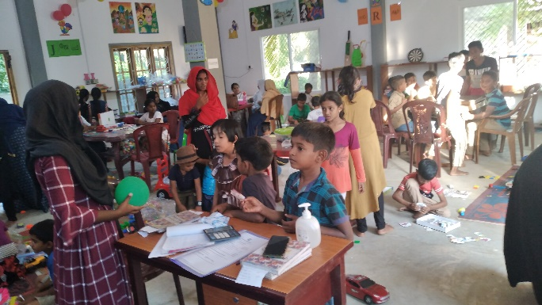 | PHOTO  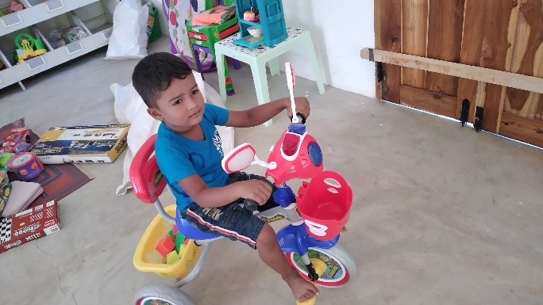
Caption Inside of Our TOY library Children are playing and Being with TOY Librarian. this is very poor children | Caption Using Food tricycle this child can’t buy a food Tricycle its his dream now he is playing with very happy.
PHOTO  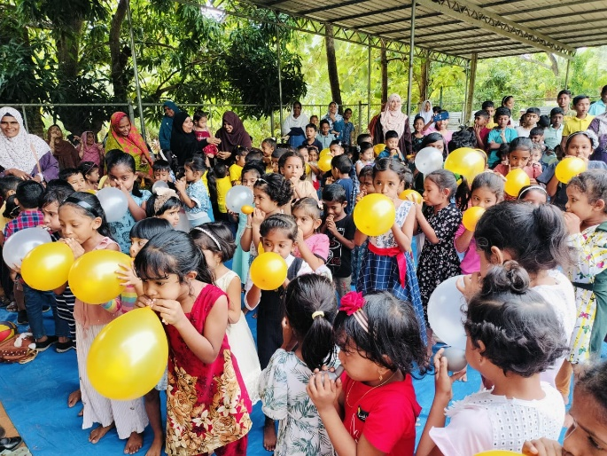 | PHOTO  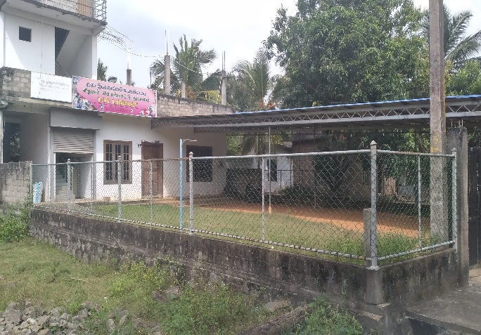
Caption; This is International Children day celebration for 2024 children are being and playing with happy | Caption: This is Our TOY library

Subject: Request for Support and Partnership for Toy Library
Dear Madam,
I am writing to introduce the Toy Library located at 17/1 Peraru, Kantale, which has been proudly run by the Rural Economic and Community Development Organization for over 10 years. Our Toy Library serves the local children by providing a safe and engaging environment with a variety of indoor and outdoor games and play equipment.
The Toy Library plays a significant role in the community by fostering creativity, learning, and social interaction among children. We are eager to expand our services and improve our facilities and believe that partnering with your organization would be mutually beneficial.
We kindly request your support or partnership to help us continue and enhance this valuable community service. Your assistance could be in the form of resources, equipment, funding, or expertise to help us better serve the children of Kantale.
We would be grateful for the opportunity to discuss this further and explore how we can collaborate for the benefit of our community. Thank you for considering our request. We look forward to your positive response.
Sincerely,
JM. Azhar
Chairman
Rural Economic and Community Development Organization
Contact: +94777073441
Email: recdosl@gmail.com
www.recdo.org

