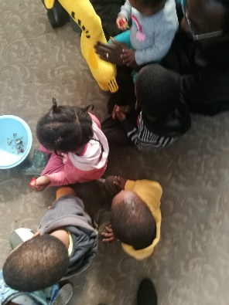
GLOBAL GIVING REPORT FIKELELA CHILD AND YOUTH CARE CENTRE JUNE – AUGUST 2023
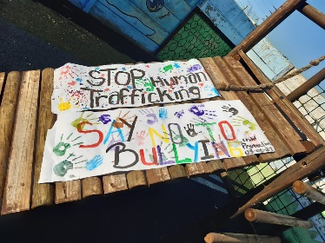
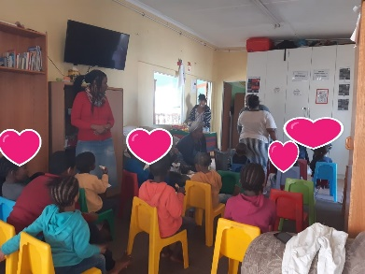
Children are such treasures and such amazing gifts and at the same time the ones who are so vulnerable and hurt so easily.
At Fikelela we ensure that a therapeutic environment is present every day, it is important not only for the children but for us as adults as well.
The spontaneity of the children makes it easy to engage with them. We do have one or two who we struggle with and they are then dealt with by using the star and talking flower.
The naughty corner does not seem to work for them so we will have to revisit the behaviour of these two young ones.
When the children don’t attend school especially with their school breaks Jerry forms part of their program. We tackle the importance of your body, being proud of who you are, making friends, sharing is caring how do we do that in our facility, longing to engage with their family , may we call, can we call.
We seem to hear more often the child who has been at the facility the longest
The talking flower works wonderfully for these sessions as they listen to the stories and feelings of others in the group. We have managed to form a support group for the older children between the ages of 7 – 10 and we see the fruits of this group as they engage and participate. They are enjoying being treated in a special way as the older children.
Thank you for your valuable donation which enables us to care and love our children daily.

Bev

