SPHOORTI FOUNDATION
Caring for Children, Changing Lives | www.sphoorti.org
🙏 AN URGENT APPEAL FOR YOUR COMPASSION 🙏
Save Little Bhavya
A 10-Year-Old Girl Battles a Life-Threatening Brain Condition

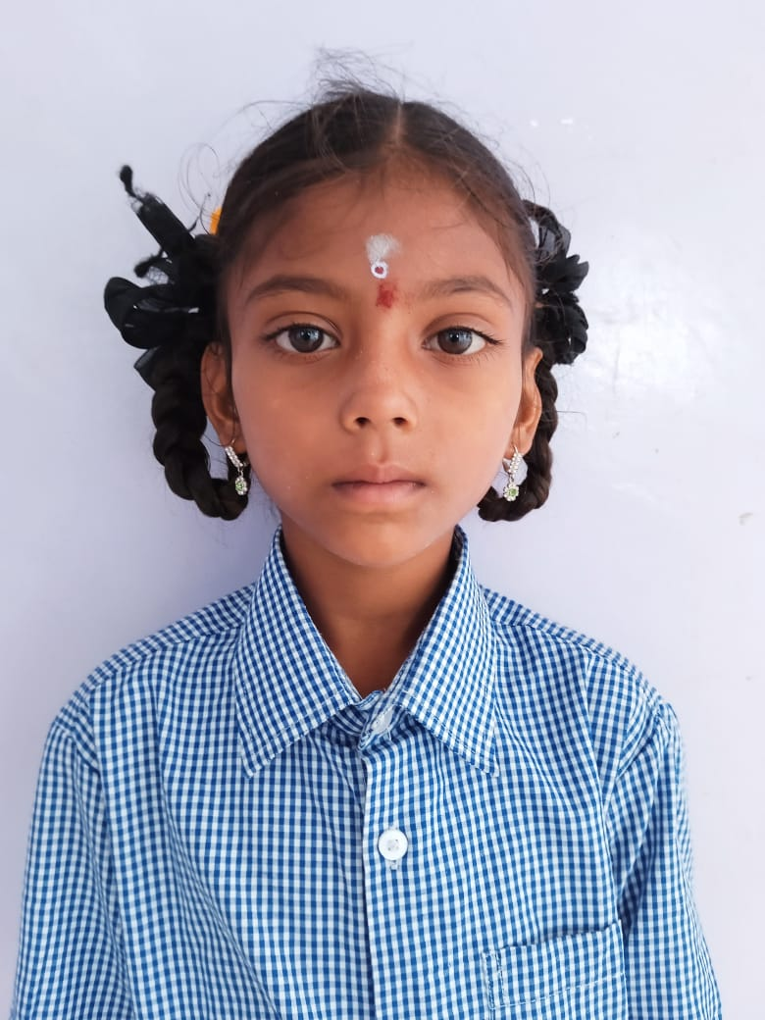
B. Bhavya Sree | Age 10 | Class IV
She enters the room with a smile that lights up everything around her. Bhavya — a bright-eyed, 10-year-old girl in Class IV — loves to dance, laughs with abandon, and brings joy to everyone she meets. But today, that smile is fighting for its life.

Bhavya is currently admitted at Yashoda Super Speciality Hospital, Somajiguda, Hyderabad, battling a devastating medical condition: Acute Febrile Illness, Meningitis, and a Cerebellar Abscess. Her doctors have advised an urgent and complex brain surgery — a VP Shunt and Biopsy of Posterior Fossa Mass Decompression — without which her life is at grave risk.

Medical Details

Child's Name | B. Bhavya Sree
Age / Gender | 10 Years / Female
Hospital | Yashoda Super Speciality Hospital, Somajiguda
Treating Doctor | Dr. Suresh Kumar Panuganti, Sr. Consultant Pediatrician
Surgeon | Dr. Ravi Suman Reddy, Neuro & Spine Surgeon
Diagnosis | Acute Febrile Illness, Meningitis, Cerebellar Abscess
Surgery Required | VP Shunt & Biopsy of Posterior Fossa Mass Decompression
Surgery Cost (Est.) | ₹ 4,50,000
Further Medical Mgmt | ₹ 7,00,000 (approx.)
Total Estimated Cost | ₹ 11,50,000

A Child With No Safety Net

Bhavya has no one to fall back on. Her father passed away several years ago, leaving a void that no child should ever face. Her mother suffers from severe mental instability and is unable to care for her. Relatives, though willing, are themselves mired in poverty and cannot afford even their own daily needs — let alone the lakhs required to save Bhavya's life.

This little girl — who should be playing, dancing, and dreaming — now lies in a hospital bed, dependent entirely on the kindness of strangers. She has no savings, no insurance, no family wealth. She has only us.

"Every child deserves a chance at life. Please be that chance for Bhavya."

Who is Bhavya?

Behind the diagnosis and the hospital ID is a real little girl full of life and light. Bhavya is a Class IV student who loves to dance — her eyes sparkle whenever music plays. She is known among her friends and teachers as someone who always carries a smile, no matter what. She is jovial, loving, and full of the energy that every child of her age deserves.

Bhavya should not be defined by her illness. She should be defined by her dance, her laughter, and the future she deserves — a future that only YOUR support can make possible.

⚠ URGENT — TIME IS CRITICAL ⚠

Surgery must not be delayed. Every day without treatment puts Bhavya's life in greater danger.

Total Funds Required: ₹ 11,50,000
Your contribution — however small — brings her one step closer to survival.

How You Can Help

Sphoorti Foundation is coordinating Bhavya's treatment and fundraising appeal. All contributions will go directly toward her surgery and post-operative care. You may contribute via:

📧 Contact: info@sphoorti.org
🌐 Website: www.sphoorti.org
📍 Sphoorti Foundation, Dundigal, Medchal District, Hyderabad
🏛 80G Tax Exemption Available for Donors

Please share this appeal widely.
A share costs nothing — but it could save everything.

Sphoorti Foundation | Est. 2005 | www.sphoorti.org | info@sphoorti.org
Caring for Children in Need — Because Every Child Deserves a Future

