Employability Programme for Youth in Slums

Unemployment is one of the major problems faced by youth in India. Saath has been working with the urban slum poor since 2005 . While working with them Saath noticed that there are many youngsters who have dropped out of schools to earn livelihood. But they don’t have enough skills, so to resolve this issue Saath started employability programs, not only in Gujarat but also in Jharkhand, kalyan and Bihar.

Objectives of the Programme:

- To train disadvantaged youth, aged 18-30 years, between 180 - 300 hours and ensure they are placed and try to support of them in relevant jobs with assurance of minimum wages and opportunity for career advancement

- To introduce minimum three innovations that would directly impact retention, skill enhancement, and program sustainability

Report Duration: June 2018 – August 2018
Various Activities conducted during this quarter

- Advance Hair Cutting Workshop @ Behrampura

Theory lecture about hair conducted and demonstrated 6 types of haircut like Straight cut, U cut, Deep U cut, V cut, Step cut and Layers cut

- A 3 Day Business Enterprise

A 3 Day Beauty & Wellness workshop organized by our Alumni group of Juhapura. As part of a recent alumni network building exercise, Saath is facilitating formation of groups by conducting various session on Journey of Participants after the training program, importance of building groups, benefits of group etc. Through this activity, a group of 6 alumni students came together to host the 3 day B & W workshop. Enterprise in Juhapura right before EID. The group made a net income of Rs.3,000/- .All the enterprise building components like marketing, drawing a rate card for all the various services, venue, mechanism of profit sharing, token system, material procurement etc. were taken up by the girls themselves.

- 14 Day Color Work Training for Women @ Behrampura – in association with Asian Paints

Through rigorous mobilization and 2community meeting, Saath initiated a batch of Color Work in association with Asian Paints as part of the Non-Traditional Livelihood Program.
A total of 28 women of age group 18-35 years enrolled themselves in the program. An expert from Asian Paints was assigned to conduct this express 14 day Training at Behrampura Centre.
24 women cleared the exams and are now eligible to be part of Asian Paints women painters’ squad or work independently as women painters.

- Business Development & Cost Analysis & Return on Investment session with Beautypreneur program participants
As part of the entrepreneurship program with Beuaty & Wellness entrepreneurs, with support of Godrej, we conducted a 3 day session with BPs where-in information sharing on current market trends, analysis of trends, utilisation of client database , costing and return on investment through the program was discussed.
- Retail Management & Tally Training Program
Total of 20 students are undergoing the training for Tally course at the above mentioned two centre. During the training, pre and post counselling is taken up. This mainly helps in facilitating Placement after the completion of training.

- Exposure Visit with Women @ Work program participants
An exposure visit to Science city was organized with Women @ work program adolescent girls. Over 43 Girls participated. The visit provided a very good platform to understand various science concepts, experience the theories first hand and broaden their horizon. Girls were accompanied by STEM Trainer, Life skills facilitator and W @ W program manager.

Success Stories

Story 1
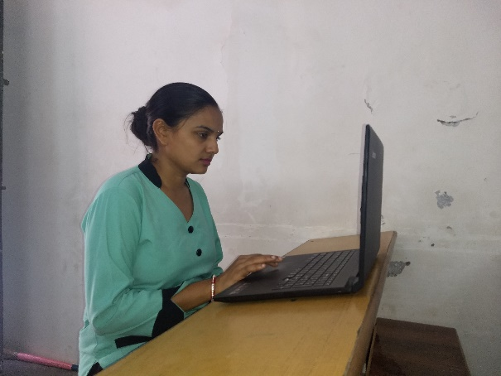
Name: Parmar Sneha Dilipbhai (Name Changed)
Age: 27
Education: 10th Fail
Course: Retail management
Centre: Meghaninagar
Marital Status: Married

Sneha’s family has 3 members. Her husband doesn’t work at the moment. He used to work as a daily wager in a factory where he would earn between RS 250 – 300 daily. He is working towards getting a job as a driving instructor. Her son is in the 1st grade. There was no income in the household.
Sneha wasn’t a 10th pass and didn’t know how to operate a computer which has become a necessity for a job today. So, she used to work a maid and a nanny in other households, earning about RS 8,000 – 10,000 monthly. A mobiliser approached her and told her about this course where she could learn how to operate a computer. She also thought that without knowing how to use a computer she wouldn’t be able to get a respectable job.
Self-confidence, communication skills, dressing sense, English speaking and multi-tasking are few of the skills she developed during the course. After her counselling she went for an interview at the Eva Women’s hospital and works there with a salary of RS 5,500 monthly.
Presently she has a respectable job and even though she has a lower income she feels proud and respected when she tells everyone of her job.

Story 2
Name: Jyoti Kewat (Name Changed)
Age:16
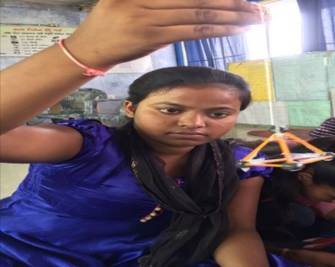
Address: 22- Killol nagar, Rajendra Park, Odhav
Jyoti lives in Killol Nagar area of Odhav. She is 15 years old & is studying in Matruchhaya School.
Team of Women @Work met her during mobilization in a nearby area. She had failed in class 10th Science & Math exam and had lost all her confidence and motivation. The members of W@ W undertook home visits and counselling sessions of her parents, in order to seek permission to allow Jyoti to enrol in the STEM program.
During STEM training, she was curious to learn different scientific & mathematical terms. She made number of models like Abacus, electromagnet, Surface tension in fluids, Newton’s Laws, but among them all she really likes models of surface tension in fluids. With the help of life skill sessions, she has now regained her lost confidence, decision making power & Time management skills have also sharpened. She now has clarity about her goal.
She is motivated enough to re-enrol in class 10 and clear her previous examination.

Story 3
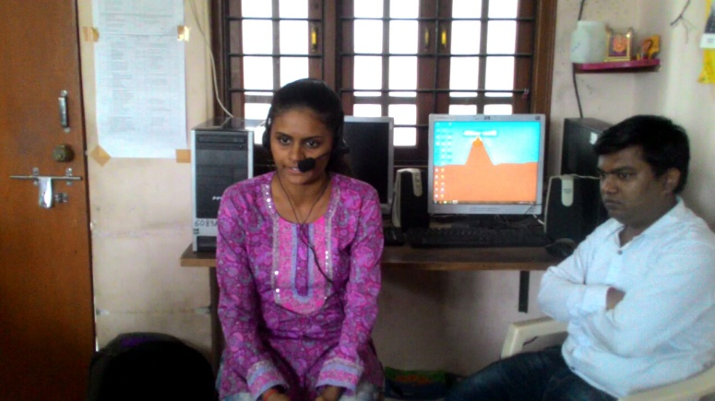
Name: Chauhan Manisha Anilbhai (Name Changed)
Address: Fafad seth’s Chawl, Akota Gam, Vadodara
Contact No.:7623005813
Center Name : Akshar Chowk Center
Course Name: Retail Management (Skill to Succeed)
Batch Duration: 25/6/2018 to 24/8/2018
Manisha comes from lower income family residing in the slum area of Akota Gam. She completed has completed her training successfully. Through this training she was able to work on her computer skills, basic English and communication, job readiness and on her knowledge on back end office work. Post the 2 months training she got an interview call from E- Plus Foundation. She now works as a part time computer operator and earns an income of Rs. 3,000/-. She is thoroughly thrilled with this sudden opportunity to grow and secure a job.

