Request for Support: Acquisition of Two Patient Monitors

- Background and Current Burden
Our health facility serves a growing population that relies on us for primary and emergency healthcare services. On average, the outpatient department attends to dozens of patients daily while the maternity unit cares for pregnant mothers during antenatal visits, deliveries, and postnatal monitoring. The facility also handles emergency cases, including severe malaria, pneumonia, trauma, hypertensive crises, and obstetric complications.

Many of these patients need close, continuous monitoring of vital signs to quickly detect any deterioration. However, the facility currently faces a significant challenge due to the limited number of functional patient monitoring devices. This shortfall forces healthcare workers to depend on manual monitoring methods, such as repeated blood pressure checks, pulse counting, and visual observation. Manual monitoring is necessary but has its limitations, especially in situations where: Multiple critical patients need observation at once. Staff are occupied with emergencies or deliveries. Patients require ongoing tracking of oxygen saturation and pulse rate, which isn't reliably done by hand. This challenge puts both patients and healthcare workers at risk, particularly during busy shifts, emergencies, or night duty when staffing is lower

- A Story Illustrating the Need A recent case at the facility clearly showed the need for patient monitoring equipment.

“A young mother who had just delivered began to show early signs of postpartum complications hours after giving birth. Initially, her condition seemed stable. However, during the night shift, she started to complain of dizziness and weakness. The midwife on duty had to manually check her blood pressure and pulse repeatedly while also attending to another mother in labor and responding to other patients in the ward. Without a patient monitor to continuously track her vital signs, subtle changes in her oxygen saturation and pulse rate went unnoticed. As the situation progressed, the mother’s condition worsened, and she needed urgent stabilization and referral to a higher-level facility. Thankfully, she survived. However, the incident highlighted how continuous monitoring could have led to earlier detection of her deteriorating condition, allowing for faster intervention and potentially preventing an emergency. Such situations are common in resource-limited settings where healthcare providers must manage multiple patients with limited equipment.”

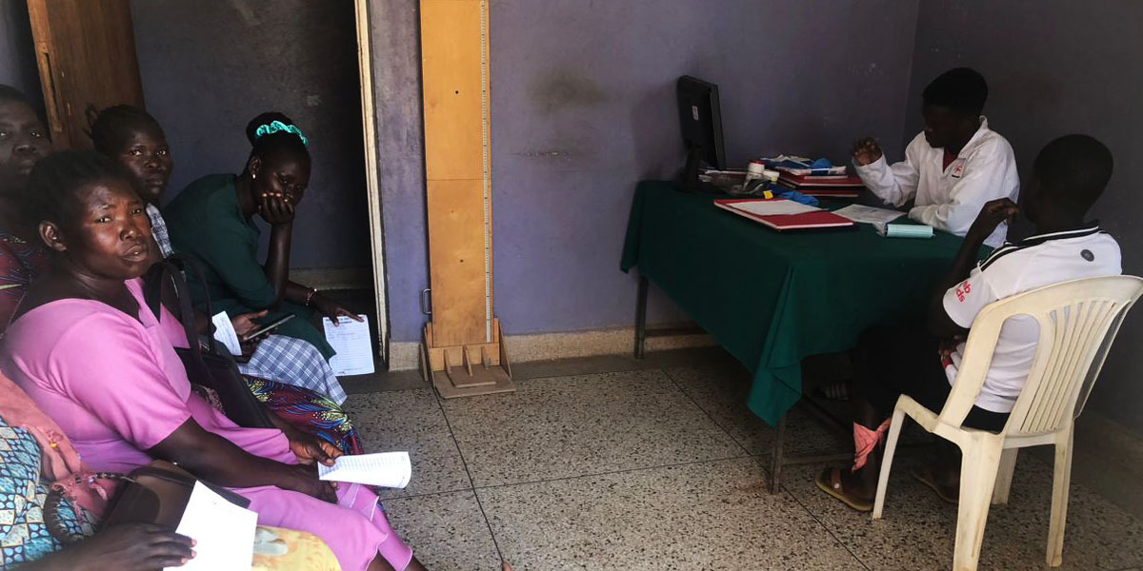

Patient monitors are vital tools in modern healthcare because they provide real-time tracking of critical vital signs, including: Blood pressure, Pulse rate, Oxygen saturation (SpO₂), Respiratory rate, Body temperature (depending on model). These parameters help clinicians swiftly identify signs of distress, such as hypoxia, shock, cardiac instability, or respiratory failure, enabling immediate medical action. Without these monitors, healthcare workers must rely on intermittent assessments, risking the chance of missing early warning signs of deterioration.

The Two Patient Monitors Will Support the Facility Acquiring two patient monitors will significantly enhance service delivery in several ways:

- Improved patient safety: Continuous monitoring allows healthcare workers to catch life-threatening changes early, reducing the risk of complications and deaths.
- Enhanced maternal care: The maternity ward will see substantial benefits, especially for mothers with complications such as postpartum hemorrhage, preeclampsia, or infection.
- Better emergency response: Patients with severe malaria, pneumonia, trauma, or shock can be stabilized and monitored more efficiently before being referred.
- Support for high-risk patients: Children with severe infections, elderly patients, and critically ill individuals need careful monitoring, which these devices will provide.
- Reduced workload on healthcare staff: Patient monitors lessen the need for constant manual vital sign checks, allowing staff to concentrate on other vital aspects of patient care.
- Strengthened quality of care: Accurate and continuous monitoring improves decision-making and overall treatment outcomes.

5. Expected Impact

- With the addition of two patient monitors, the facility will be able to:
    - Improve monitoring of critical and high-risk patients.
    - Strengthen maternal and emergency care services.
    - Enhance timely detection of complications. - Improve patient outcomes and survival rates.
    - Increase confidence among patients and healthcare workers in the quality of care provided.

6. Conclusion

Patient monitors are not just equipment; they are lifesaving tools that enable healthcare workers to provide safe, responsive, and high-quality care. As the patient load continues to grow, the need for reliable monitoring equipment becomes even more critical. The acquisition of two patient monitors will greatly enhance the facility’s ability to care for critically ill patients, support maternal health services, and ensure that patients receive timely and effective care. We therefore humbly request support to acquire these essential devices to improve healthcare delivery and protect the lives of the community members we serve every day.

