NEW APPLE JUNIOR SCHOOL – MAYANGAYANGA SITE- MUKONO DISTRICT
School Infrastructure Development Project Proposal
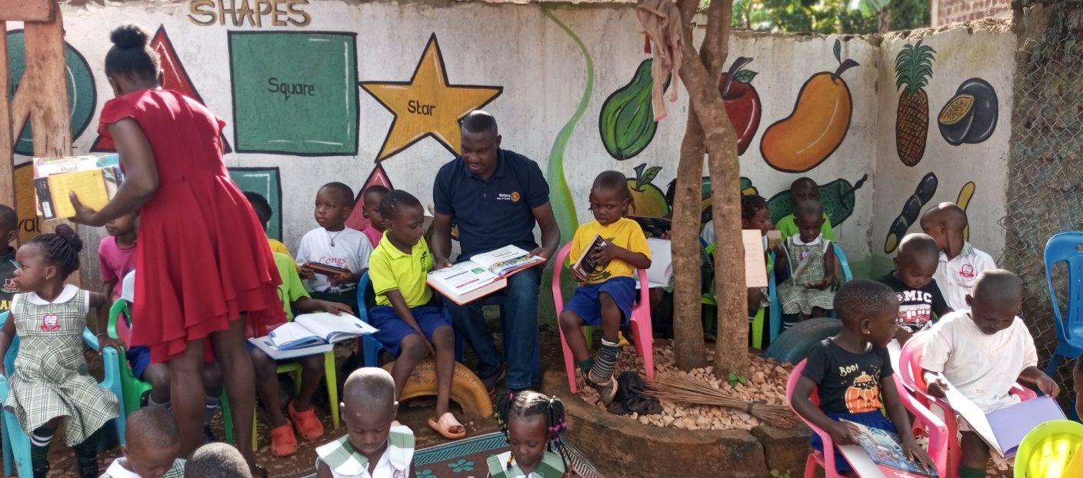



THE ANDTEX TRAINING AND CARE ORGANISATION
P.O.BOX 152305 Mukono (U)
Tel: +256 774997722 / 0703 807141 E-MAIL: tatacoug@gmail.com Web: /https://tatcoug.org

EXECUTIVE SUMMARY
School infrastructure development project for New Apple Junior School –Nabibuga is a project long waited for in the area. TATCO Uganda is the leading organization in implementing this project from just a proposal to the final stage of classroom occupancy. This proposal highlights our desire to expand our ECD and primary education services to another identified vulnerable community of Nabibuga village of Mayangayanga in Mukono District as annex to the current ECD center in Bukerere called Apple Junior school which was founded in 2022 on a leased space as a model Early Childhood Development center (ECD) to support the growth and education of vulnerable children in the community of Bukerere and the surrounding areas in Mukono district.
TATCO Uganda’s main concern is the realization of sustainable development in which the children, teachers and the community are involved in positive activities that will ensure socio-economic welfare in the entire locality and ensure proper learning environment by providing habitable accommodation. It is also in a way of assisting Government attain the Millennium Development Goal (MDG) by providing ablution facilities at the school.
TATCO Uganda has furthermore managed to hold four (4) successful meetings with the community Heads to reach an understanding of our vision and goals. We made sure that there is community ownership of the project. There is a need to involve everyone and have to participate fully on the project implementation. The local community and leadership have been very supportive and are doing their part where the land to which we hope to extend the new school facilities in Nabibuga Village was provided, they are willing to support in molding some bricks, providing other materials like stones, collection of water, site clearance, security and labour and on top of it bringing their children to study in the school.
In order to realize the goals, TATCO Uganda has agreed to assist in mobilizing resources to build over 10 classrooms, Administration block, Canteen, Library, Toilets and play ground work which can be done in about four phases. The construction cost for the entire project will require over USD$66,000.
TATCO Uganda’s main objective is to create community capacity to provide education, health infrastructure, and with a particular outreach to the most vulnerable in communities.
ABOUT TATCO UGANDA
We are THE ANDTEX TRAINING AND CARE ORGANISATION (TATCO Uganda) is a charity organization that was formed in 2013 with its first registration as a CBO at the district in the office of Community Development Officer – Mukono and Buikwe District respectively and also incorporated as a company by guarantee under the Uganda Registration Service Bureau (URSB) No. 80034347804994 to carry out community Transformation and development activities towards improving mindset and wellbeing of Vulnerable Children, Youths and Women having its registered office at Bukerere- Goma Division in Mukono District
Our MISSION: To strengthen communities with literate, skilled and economically empowered people through Education, Training and Entrepreneurship support,
Our Vision: A community where people have good mindset for a better living.
Our Goal: To train the local persons into skilled persons, improve their standards of living and create awareness to the community about religious, social and economic aspects.
BACKGROUND OF THE CURRENT SCHOOL (ECD CENTER)
Apple Junior School – Bukerere was started in 2022 by TATCO Uganda under the directorship of Ms. Namiiro Susan as a model ECD center and where children from vulnerable families within the area can get access to quality and affordable ECD programs. The school has managed to stand for years and has impacted over 400 children since its formation. Serving vulnerable children from the age 3-8 years and our target is to at least impact directly over 500 children per year in our ECD and learning centers.
Basing on this, we plan to extend our children support services to another vulnerable community by building a new and permanent school which will support children of ages 3-12 i.e Nursery children and primary going children with classes from Nursery to Primary Seven which will increase on the number and ages of children impacted with the early childhood development and education services, so New Apple Junior School will be setup in Nabibuga Village, in Mukono District just over 12 Kilometers from Bukerere our current operation area.
This new intended children development and learning facility is aimed at increasing our impact and get close to the real people in communities where early learning and child development services are not easily accessible.
We have managed to secure a piece of land which can accommodate both Nursery and primary classroom blocks, administration block, library, canteen, toilet facilities and a play ground in Nabibuga another rural community after Bukerere in Mukono district where we can permanently setup a well structured and designed school/center to also act as model children safe apace and learning center in the area.
SCHOOL MOTTO
Ever Forward
MISSION OF THE SCHOOL
To produce a Holistic citizen who can use the head, heart and hands.

PROJECT RATIONALE
Developments do not come to these remote parts of Mayangayanga villages easily. The major constraint for children and parents is that the most nearby primary schools are between the walking distances of 7 and 10 kms or 2 and 4 hours respectively and those nearby do not have clear ECD programs nor give quality education services and do not favour the vulnerable. TATCO Uganda has taken the initiative to change this situation and is now approaching organizations/ other stake holders in order to improve the conditions for children in our communities.
TATCO Uganda’s strategy is to construct permanent structures consisting 10 classes for the New Apple Junior School in Nabibuga village Mukono district for boys and girls of age from 3 to 12 years respectively. Implementation will include construction, provision of teaching materials, such as text books for all subjects, clean and safe drinking water, play materials, there will be four (4) phases of the construction project.
The classrooms will be used as shelters while teaching the pupils to provide a favorable learning environment for both school children and teachers. TATCO Uganda executive mobilized parents and local community members to make bricks for the buildings and contribute other locally available materials towards this project.
This project will also provide the community in appreciating the importance of sending their children to school. TATCO Uganda being former head/ leader of this initiative should motivate the young boys and girls to emulate and believe that nothing is impossible if they work hard.
PROBLEM STATEMENT
In Nabibuga village and the surrounding villages of Mayangayanga in Mukono, there is insufficient education efforts and institutional development for the people in the villages living more interior to understand and benefit from educational achievement. Typically, these local people such as orphaned children enter First Grade at age seven without prior exposure to classroom-based teaching, without basic skills, such as counting and writing, typical among other Ugandan children, and without an understanding of English, which is the medium for instructions. They are set up for failure from the beginning; not surprisingly, many drop-out before the end of Primary School, and almost half do not pass the Primary 7 exams, which are critical to entering Secondary School. Consequently, as compared to other communities throughout Uganda, the Mayangayanga citizens have far less children succeeding at all levels in school due to the fact that there is well structured infant school offering better development and education support. In collaboration with the community and some stake holders, we managed to get land where we can setup a school for the young children education so now we are in need of permanent classrooms for the children to study.
THE OBJECTIVES
To construct 10 classrooms, toilets, administration block, library and canteen for New Apple Junior School in Nabibuga with an expected population of 350 pupils per term to provide good learning environment hence quality education and performance.

STRATEGIES OF IMPLEMENTATION
The project was proposed by a series of discussion with the local communities, teachers and Director review of baseline data, and also minutes of TATCO Uganda meetings.
Phase 1
Construction of a 3 classroom block for nursery section, administration block and toilet with its needed furniture as recommended first.
Phase 2:
Construction of more 4 classroom block lower primary section.
Phase 3:
Construction of more 3 classroom block for upper primary, library, a canteen and working on the play ground area.

Deliverable
Directors of TATCO Uganda will deliver both technical and financial reports periodically to the funding agency. This will include details of the class attendance by learners and teachers, lessons taught, materials purchased, challenges faced, achievements realized, money spent and the community support.
PROJECT BENEFICIARIES
The school facilities aim to give services to over 350 Nursery and primary school pupils of Mayangayanga community.
MONITORING AND EVALUATION
A variety of formal and informal Monitoring and Evaluation mechanisms will be central to ensuring the appropriate delivery of effective and sustainable services. These will include: Multi Indicator Cluster Surveys, class performance surveys, class attendance data, girl-boy retention data and exit surveys.
PROJECT SUSTAINABILITY
TATCO Uganda will continue to work with the Local Community and school on this capacity while also working closely with other local NGOs working on education programmes in the area. TATCO Uganda will develop a Memorandum of Understanding with the school and funding donors which will clarify each partners’ roles and responsibilities both short and long term. In this way sustainable structures for primary school education delivery will be developed at the school.
TATCO Uganda will work with local communities to develop the capacity of individuals to play an active role in governance and delivery of ECD programs and education in the school. Parents Teachers Association (PTA) will be formed to ensure the school’s future sustainability. TATCO Uganda annual sustainability assessment will be used to review the capacity of both local communities and school to take on further aspects of supporting the school after the donor phase. TATCO Uganda will continue to provide its technical support and facilitation.
Collaboration
TATCO Uganda will collaborate and network with the local community, community leaders, Development partners and Government of Uganda.
Community Contribution
The local Community will contribute labor, water and security to the project in progress needed.
TATCO Uganda Capacity
TATCO Uganda has the required capacity necessary to design interventions and at the same time give momentum to the program’s management. The organization constantly plans before engaging in project activities and other interventions. It’s recognition by the local communities and authorities have further placed us in a strategic footing to replicate ourselves in the affairs of the school. We have a policy of noninterference in the school administration and our role is to assist where possible. Our budget proposal is based on materials donated by Friends of school, own sources as well as personal cash donations.
PROPOSED BUDGET FOR THE WHOLE SCHOOL CONTRUCTION PROJECT
PHASE | PARTICULARS | AMOUNT (USD$)
Phase 1 | Construction of the four (3) classroom block, administration block and toilet including its furniture | $26,000
Phase 2 | Construction of a 4 classroom block for lower primary including its furniture | $18,000
Phase 3 | Construction of School 3 classroom block for upper primary, Library and canteen including its furniture | $20,000
Phase 4 | Leveling and working on the school play ground area | $2,000
 | TOTAL | $66,000
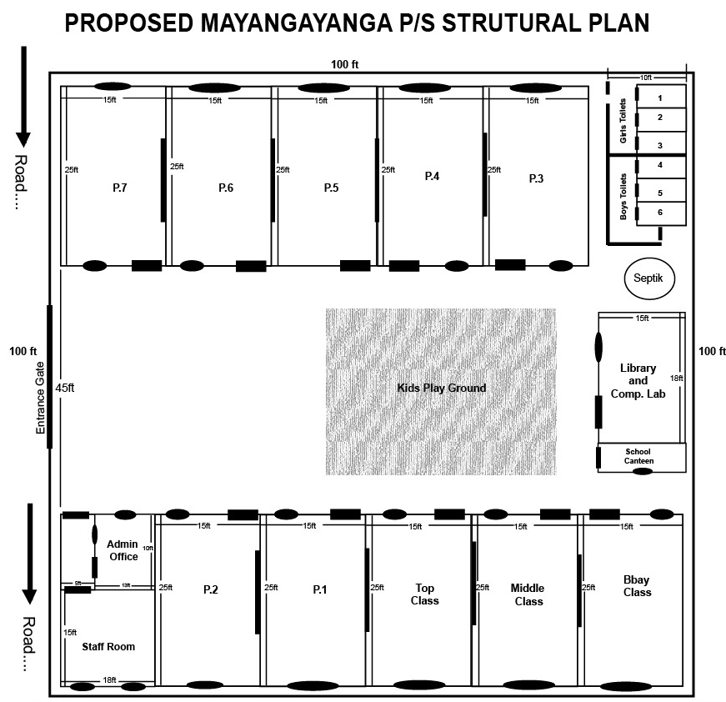
This Budget estimate is proposed based on current market prices of commodities and Dollar rate.

