EmpowerHer Farms: Helping Young Mothers Rise Through Farming
Tagline: Where hope grows, families thrive.
Goal: $25,000
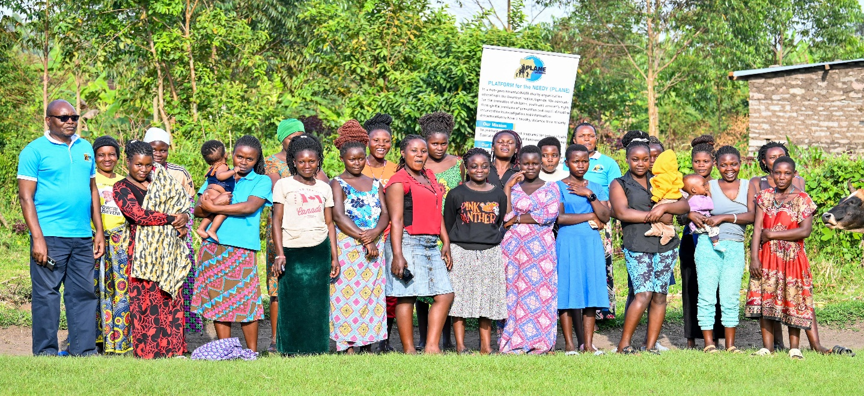
SUMMARY
In western Uganda, young mothers often struggle with poverty because of child marriage, teenage pregnancy, and leaving school early. EmpowerHer Farms helps 60 young mothers learn practical skills like goat rearing, zero-grazing dairy, and poultry farming. We also provide them with essential start-up resources, including goats, chicks, feed, and other farm supplies.
To boost their nutrition and their long-term stability, the project now includes a community fruit and vegetable garden. This creates a complete farm-to-table and farm-to-market approach. Animal manure naturally enriches the garden, and garden waste is used to feed the animals. This closed-loop system helps increase productivity and reduce costs.
By helping young mothers and vulnerable girls build steady sources of food and income, this project strengthens families, improves children’s health, and lays the foundation for long-term economic independence.

CHALLENGE
Almost 7 out of 10 girls in this area do not finish primary school, and 64% of teenage mothers cannot go back to school. With limited education and few job options, young mothers struggle to feed their children and earn a steady income. Many also face exploitation, domestic violence, and deeper poverty.
Adolescent girls, who are often affected by early marriage, early pregnancy, or gender-based violence, do not have safe spaces or practical skills. This leaves them at high risk of repeating the same cycle.
Without ways to earn a steady income, young mothers and girls have little chance of building independent, stable futures.

OUR SOLUTION
PLANE Uganda offers practical agricultural training that helps young mothers start earning money quickly and work toward long-term financial stability.
Animal Farming Training Includes:
- Goat rearing
- Zero-grazing dairy farming
- Poultry farming
- Basic farm management & entrepreneurship
Each participant gets start-up animals, feed, veterinary support, and ongoing guidance.
Fruit & Vegetable Farming (NEW)
The community garden improves nutrition and creates more ways for young mothers and adolescent girls to earn income.
- Animal manure becomes organic fertilizer.
- Garden waste becomes animal feed.
- This closed-loop system helps lower costs and makes the project more sustainable.
The garden is also a safe place for mentorship, where young mothers train adolescent girls, many of whom are recovering from early marriage or violence. This helps them build confidence, learn new skills, and find hope for a better future.
Support Beyond Farming
Participants also receive:
- Counseling
- Mentorship
- Goal-setting and business planning
These extra services help build confidence, resilience, and long-term success.

LONG-TERM IMPACT
This project will change the lives of 60 young mothers by helping them earn a steady income, improve their families’ nutrition, and keep their children in school. The garden also improves food security and provides income year-round.
By including vulnerable adolescent girls, the project helps prevent early marriage, teaches important skills, and builds strong support networks across generations.
As these young mothers grow their farms, they become role models who show that girls can overcome challenges and build independent, dignified lives. They will have a positive impact on families and communities for generations to come.
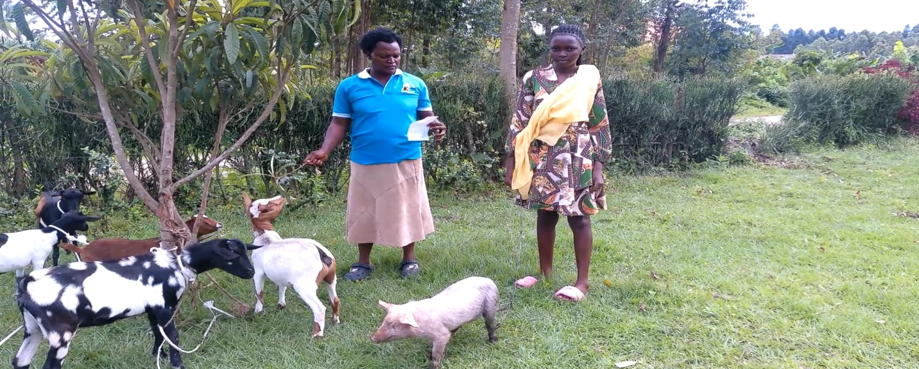
COST BREAKDOWN
Donation Amount | What It Provides | Impact
$10 | Seeds for one girl's garden plot | Provides nutritious vegetables for food and income.
$20 | Gardening tools (hoe + gloves) | Helps a girl or young mother farm safely and effectively.
$25 | One month of poultry feed | Supports healthy growth and egg production.
$30 | Seedlings + compost starter kit | Powers an early harvest for food or market.
$50 | One agricultural training session | Builds confidence and hands-on skills.
$75 | Safety kit (boots, gloves, apron) | Protects participants during daily farm work.
$100 | Business and financial literacy training | Helps mothers start and grow small farm businesses.
$130 | One goat for a young mother | Provides milk, manure, and sustainable income.
$250 | Irrigation equipment | Enables year-round vegetable production.
$300 | Seeds + tools + organic fertilizer for 10 girls | Powers a full season of crops and income.
$800 | Seeds for all 60 mothers/girls | Launches the entire community garden.
$1,000 | Dairy heifer (shared by 3 mothers) | Provides daily milk and long-term income.
$1,000 | Poultry house for 15 mothers | Supports large-scale group poultry farming.
$1,200 | Garden fencing | Protects crops from animals and theft.
$1,500 | 100–130 chicks for 15 mothers | Starts a community poultry enterprise.
$3,000 | Feeds & medicine for six months | Ensures healthy goats, chicks, and cows.
$3,500 | Full training program for 60 mothers | Covers farming, entrepreneurship, and garden skills.
$5,000 | Complete community garden infrastructure | Irrigation, tools, composting, and mentorship space.

VIDEO LINK: https://www.youtube.com/watch?v=jRpVzIPh9ZM
WEBSITE LINK: https://platformfortheneedyuganda.org/

