Installation Photographs of STEAM shalas in Mumbai and Bangalore
The transformation of the STEAM Shala is clearly reflected through the before and after installation photographs, showcasing a significant enhancement in the overall classroom environment. As part of the intervention, refurbishment activities were carried out to improve the physical condition of the classrooms, making them more vibrant, safe, and conducive to effective learning.

The upgraded classrooms have been converted into fully functional STEAM Shala, equipped with a comprehensive STEAM Digital Program. This includes the installation of a 55-inch Smart TV, integrated with digital learning content that is aligned with the curriculum for students from Grades 1 to 5. The digital content enables an interactive and engaging learning experience, helping students better understand concepts across Science, Technology, Engineering, Arts, and Mathematics.

Additionally, the classrooms have been distinctly branded as STEAM Shala with Majorly supported donor branding, enhancing the identity and visibility of the initiative within the school premises. This transformation not only improves the infrastructure but also creates an inspiring and technology-enabled learning space that encourages curiosity, creativity, and active participation among students.

The before-and-after visuals effectively highlight the positive impact of the project, demonstrating a shift from traditional classroom settings to modern, digitally enabled learning environments.

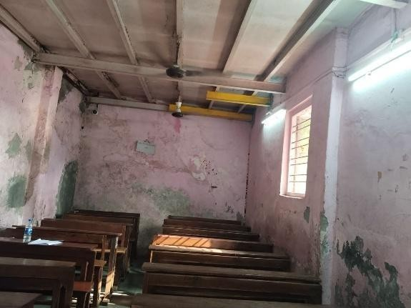
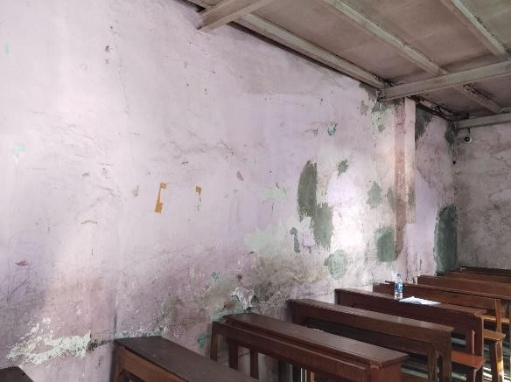
1. Sarswati Vidya Niketan, Ghatkopar

Photograph of the Classroom before Lab Installation
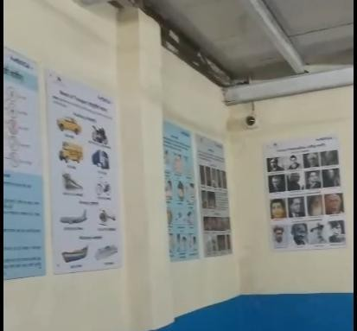
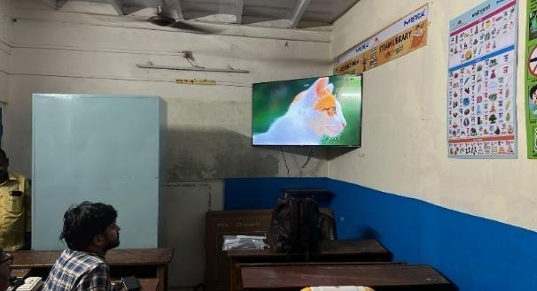

Photograph of the Classroom after Lab Installation

2. Janata Vidyalay, Patalganga
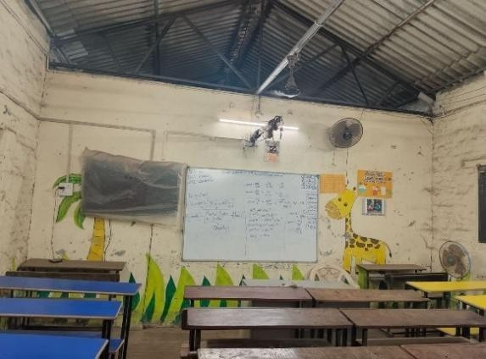
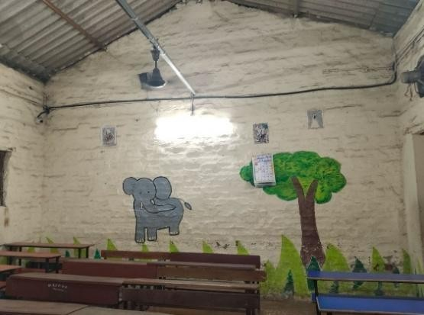

Photograph of the Classroom before Lab Installation
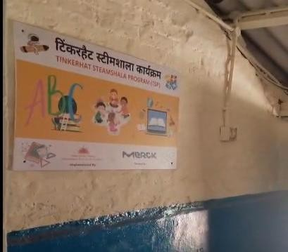
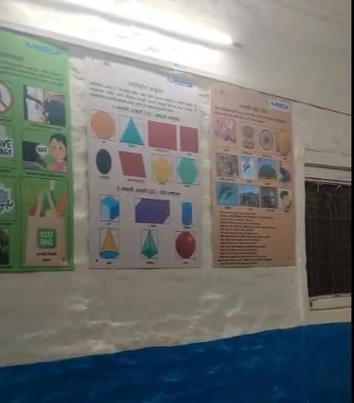
Photograph of the Classroom after lab Installation

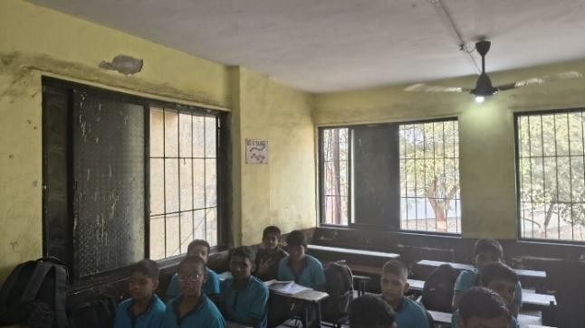
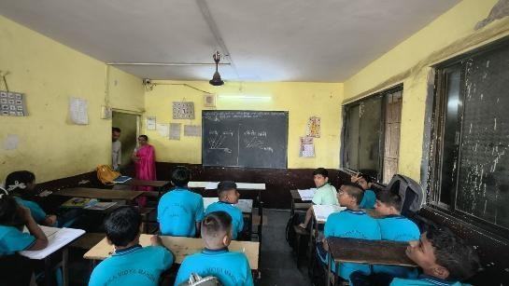
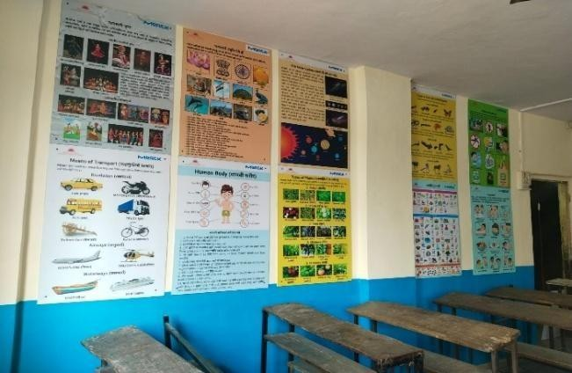
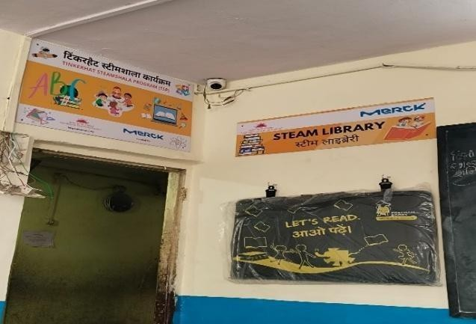
3.Dwaraka Vidya mandir, Nandivali
Photograph of the Classroom before lab Installation
Photograph of the Classroom after Lab Installation

4. Utkarsh Bal mandir, Vikhroli
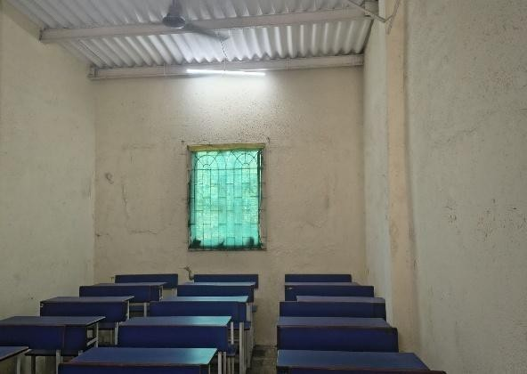
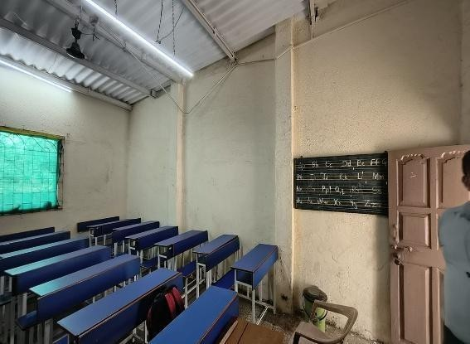
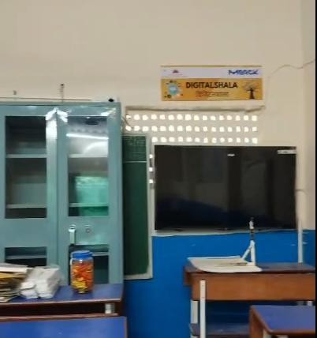
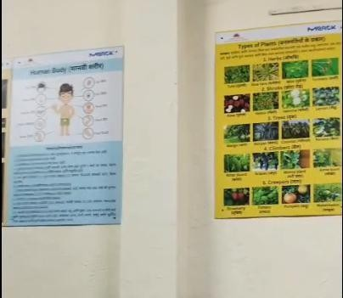
Photograph of the Classroom before lab Installation
Photograph of the Classroom after Lab Installation

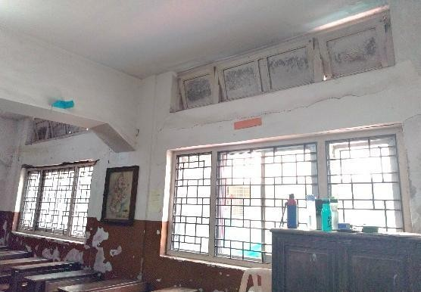
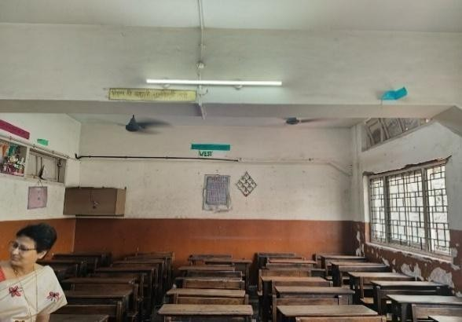
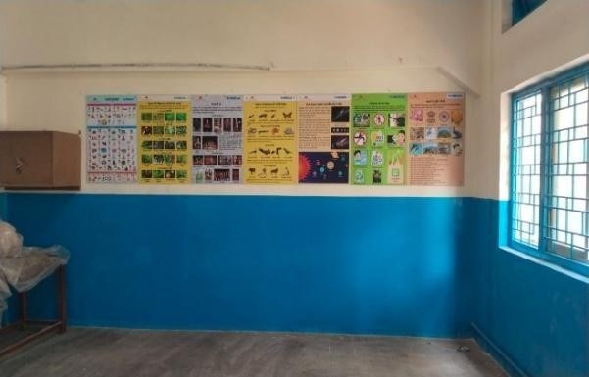
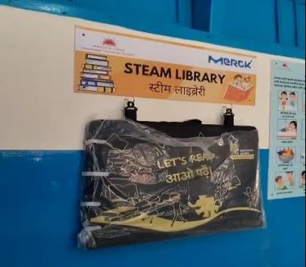
5.Dr. KMS Shirodkar Highschool, Parel
Photograph of the Classroom before lab Installation
Photograph of the Classroom after Lab Installation

6. Shivai Vidya Mandir, Nahur
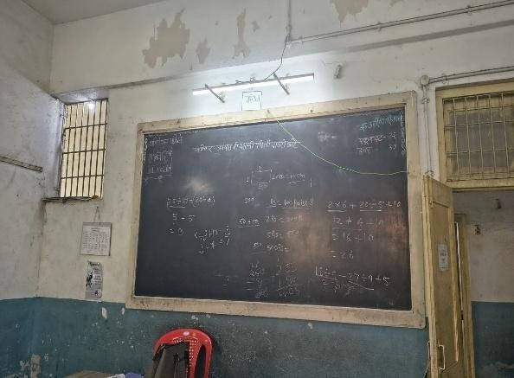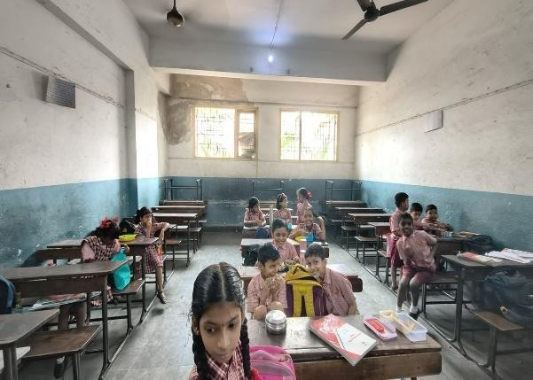
Photograph of the Classroom before lab Installation
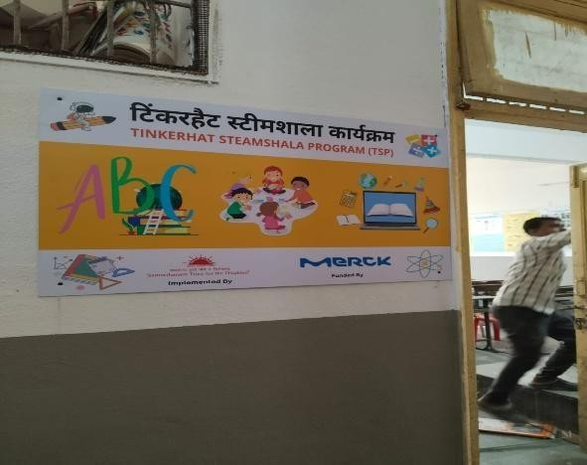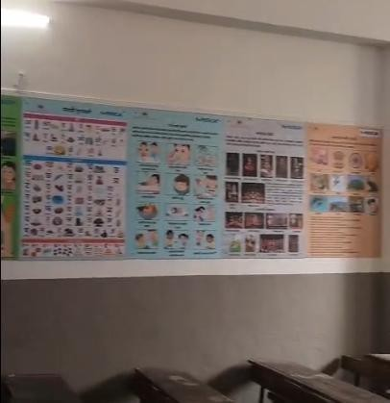

Photograph of the Classroom after lab Installation
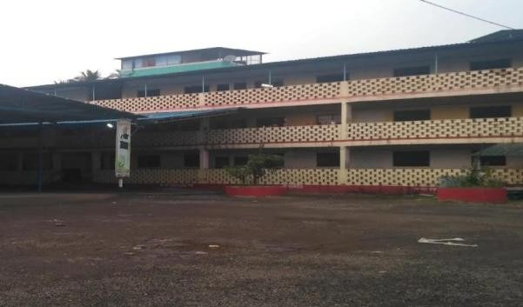
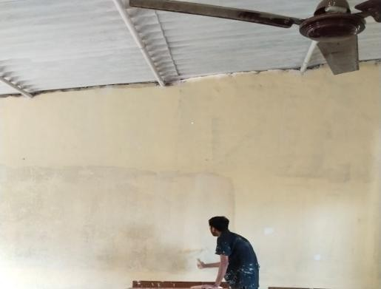
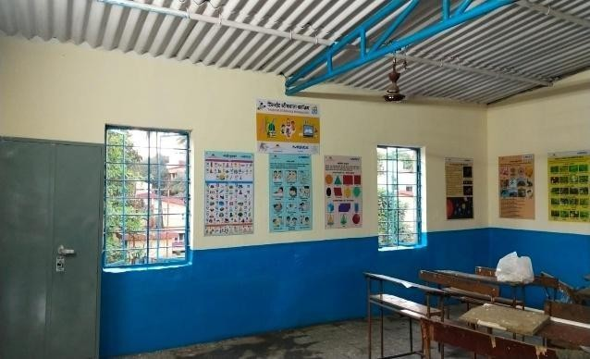
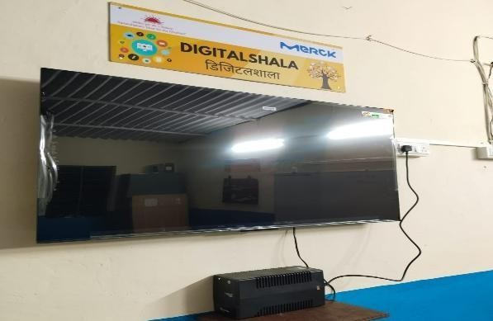
7. Janata Vidyalay,Patalganga
Photograph of the Classroom before Lab Installation
Photograph of the Classroom after lab Installation

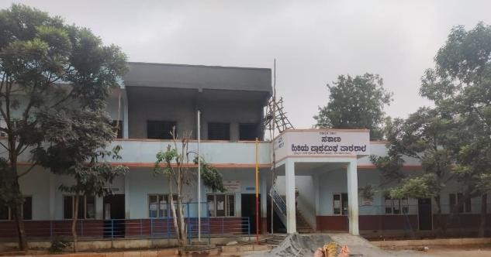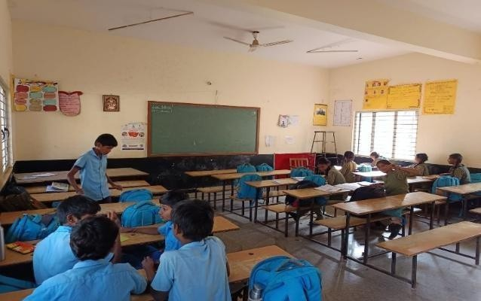
8. Government Higher Primary School, Hennagara
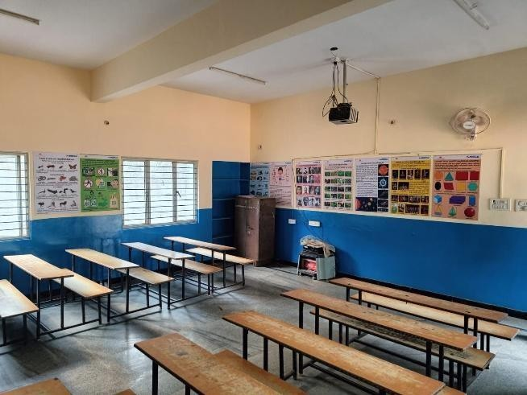
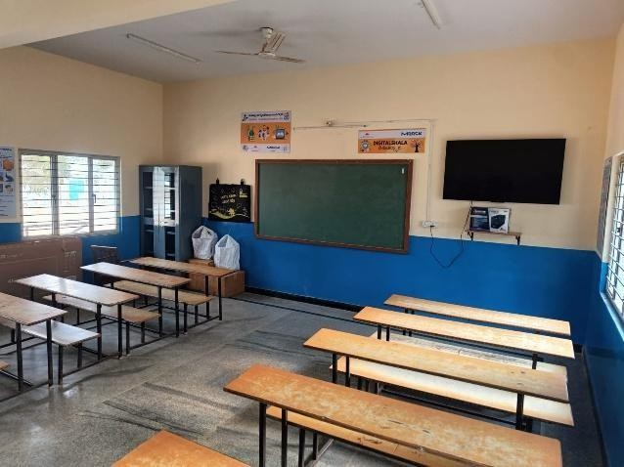
Photograph of the Classroom before lab Installation

Photograph of the Classroom after lab Installation

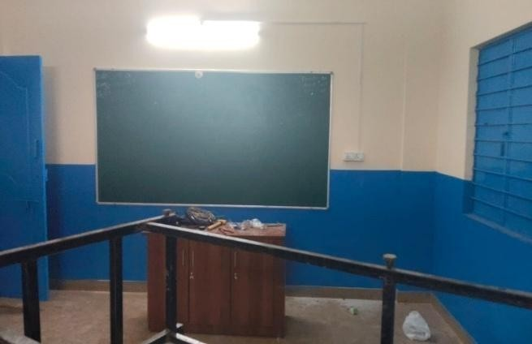
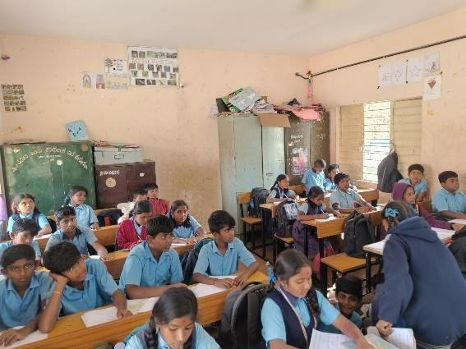
9. Government Higher Primary School, Huskur
Photograph of the Classroom before lab Installation

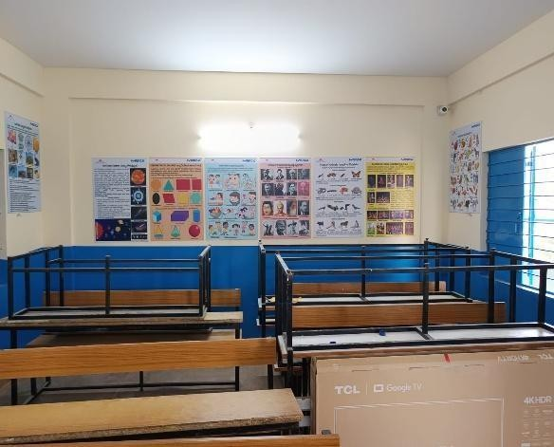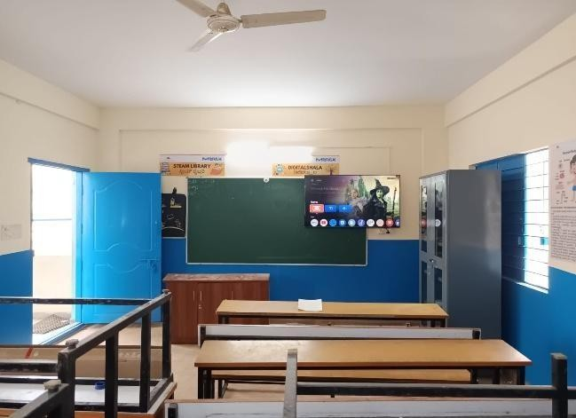
Photograph of the Classroom after lab Installation

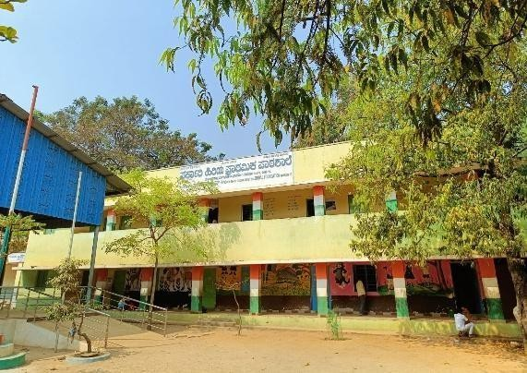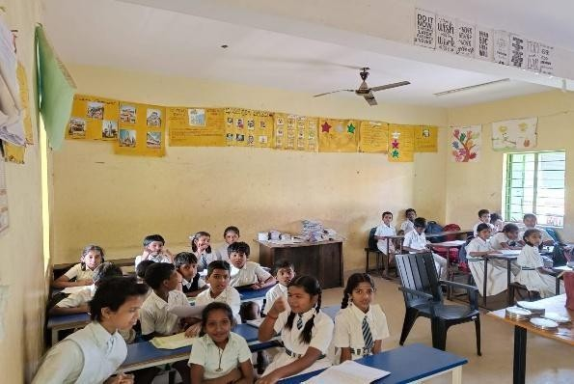
Photograph of the Classroom before lab Installation
10. Government Higher Primary School, Chikkabidarakallu
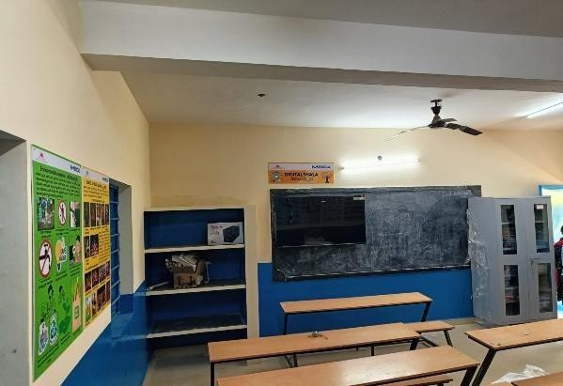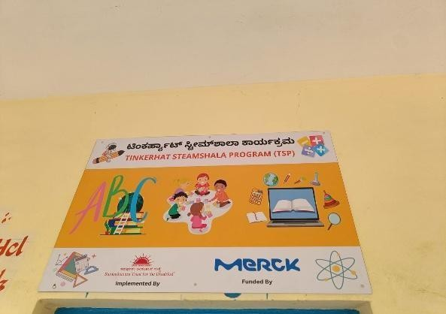
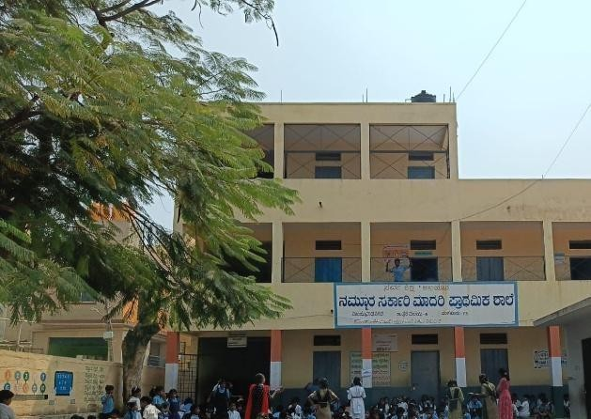
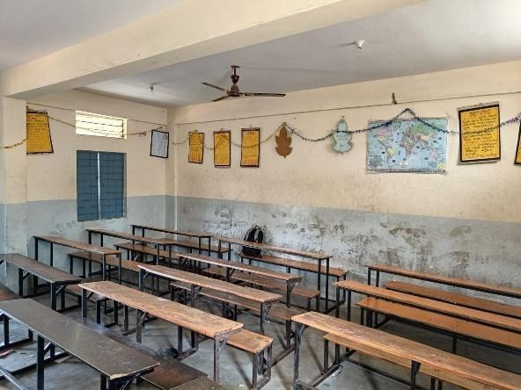
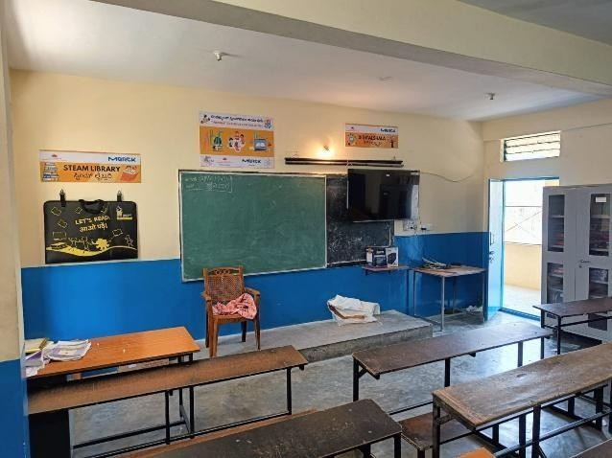
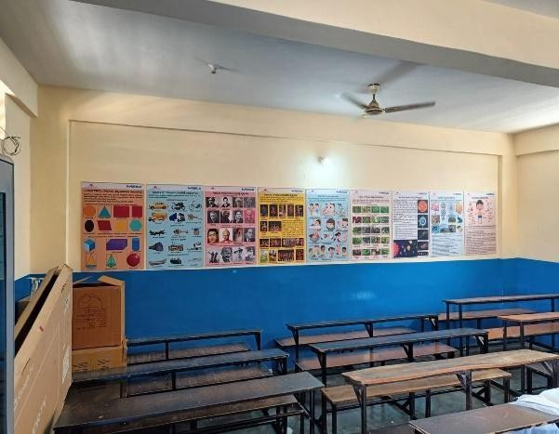
Photograph of the Classroom after lab Installation
11. Government Higher Primary School, Manjunathnagar
Photograph of the Classroom before lab Installation
Photograph of the Classroom after lab Installation

12. Government Higher Primary School, Doddabidarakallu
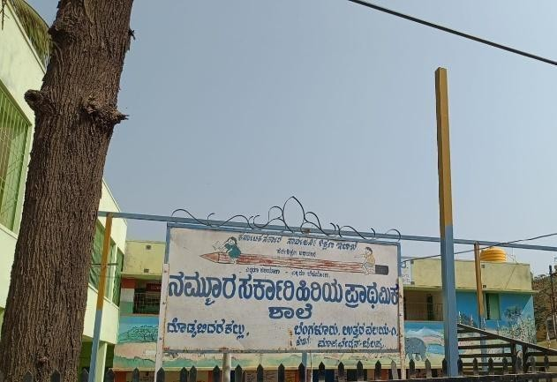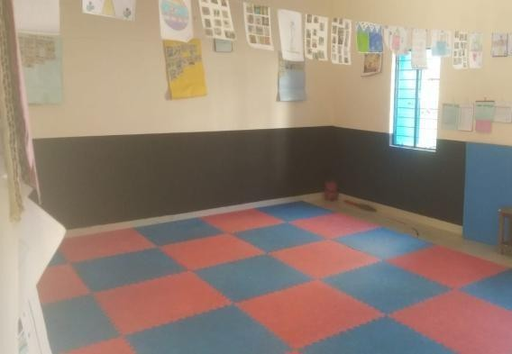
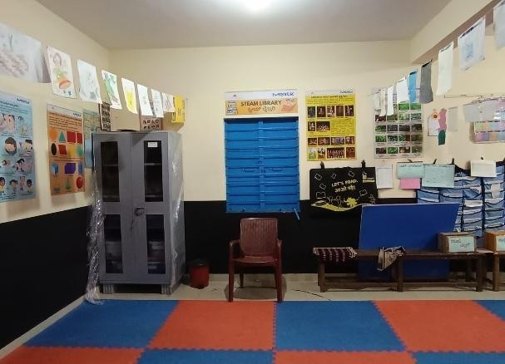
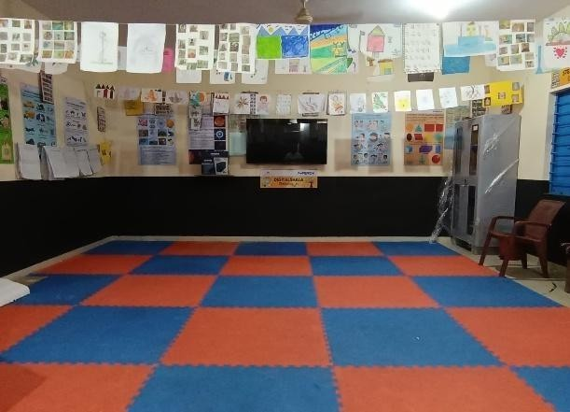
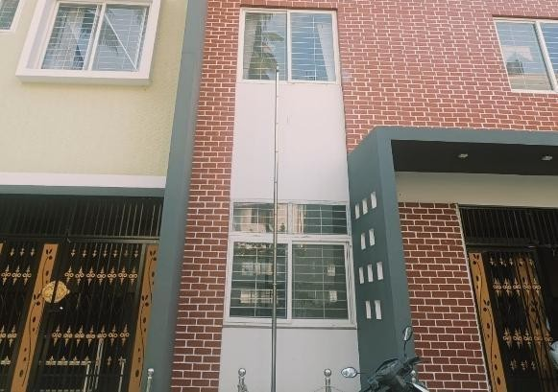
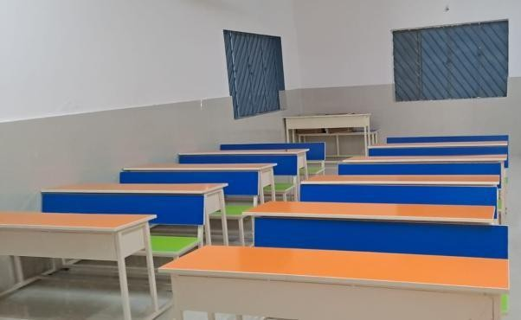
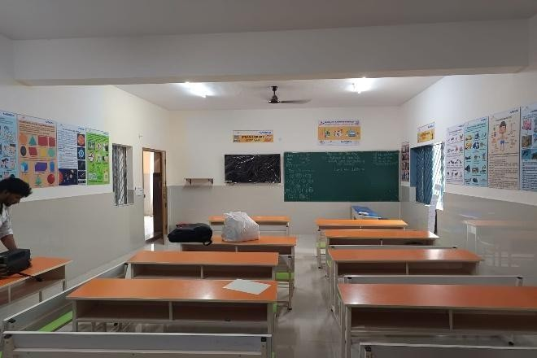
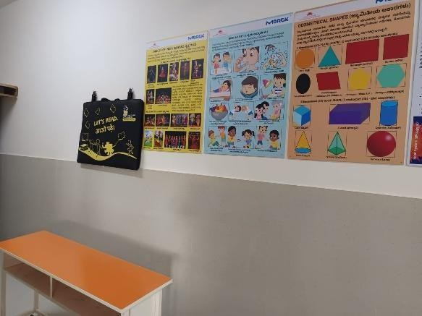
Photograph of the Classroom before lab Installation
Photograph of the Classroom after lab Installation
13. Government Higher Primary School, Kurubarahalli
Photograph of the Classroom before lab Installation
Photograph of the Classroom after lab Installation

14. Government Higher Primary School, Sarjapura
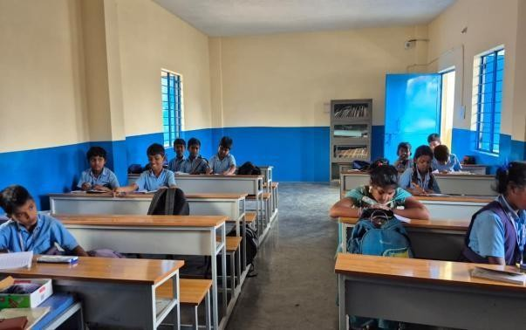
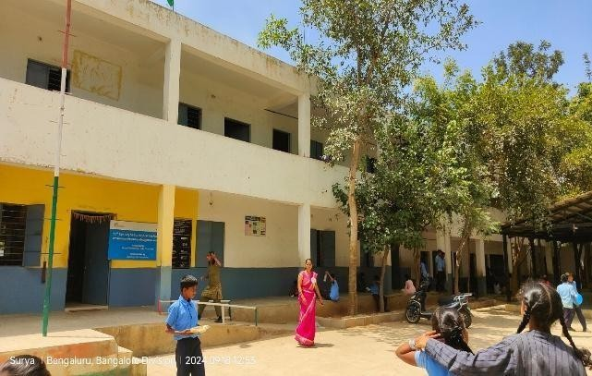
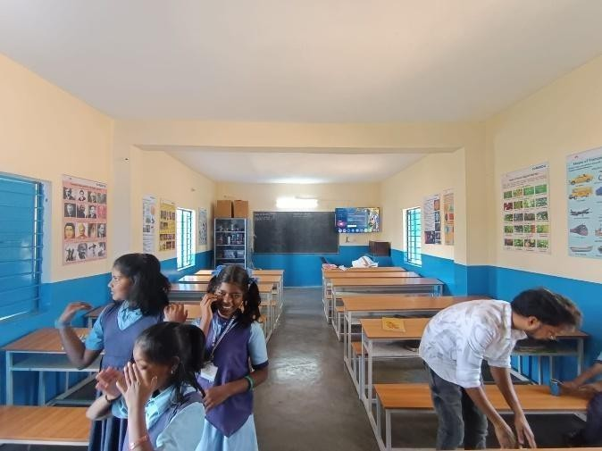
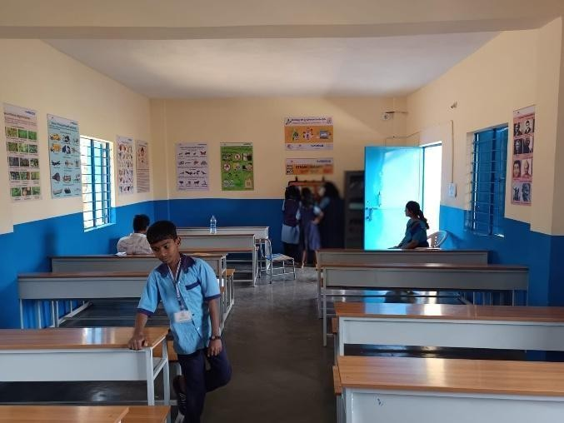
Photograph of the Classroom before lab Installation
Photograph of the Classroom after lab Installation

Teachers training on STEAM lab:
Teachers’ training sessions were conducted in Bengaluru and Mumbai schools during February–March 2026 under the STEAM Shala initiative. A total of 86 teachers from 10 schools participated in interactive, hands-on sessions led by qualified trainers, focusing on innovative teaching methods and STEAM tools. The training was delivered in regional languages and English, received positive feedback, and remaining sessions will be conducted after the summer vacation. For detailed information refer teachers training of STEAM lab report.

Inauguration of STEAM lab:
The inauguration activity was successfully conducted at Government Higher Primary School, Hennagara, Bengaluru, on 6th March 2026. The event marked an important milestone in the project and was graced by the presence of several distinguished guests, including representatives from key stakeholder groups. Their participation added significance to the occasion and reflected strong support for the initiative. For detailed information refer Inauguration of STEAM lab report.

Medical screening camp and assessment for the Disability Students in Schools:
Need assessment activities were conducted across 14 government and aided schools in Bengaluru and Mumbai under the STEAM Lab Program to identify students requiring specialized support. In Bengaluru, 34 students from 7 schools were identified and referred for further evaluation, with five students undergoing detailed assessments at specialized centres such as Mobility India and Corti Hearing Clinic, accompanied by the program team and parents. In Mumbai, assessments were completed across all supported schools, with no students identified with disabilities in the current locations. The overall disability assessment process was completed by February 2026, and based on the findings, identified students will be supported with appropriate assistive devices to enhance their learning outcomes. Additionally, eye screening camps were conducted in three government schools in March 2026 to detect vision-related issues, and spectacles were distributed to identified students during the STEAM Lab inauguration at Government Higher Primary School, Hennagara, ensuring timely support for improved vision and academic participation. For detailed information refer assessment and screen camp report.

Music Classes in 7 School Bangalore:
Music classes were conducted across 7 schools in Bengaluru during February and March 2026, with 8 structured one-hour sessions per school. Led by a trained music teacher and supported by a program coordinator, the sessions introduced students to the basics of music, including swaras and taalas. For detailed information refer Music classes closure report.

Few Photographs of Usage of STEAM shala in Schools by Students and Teachers

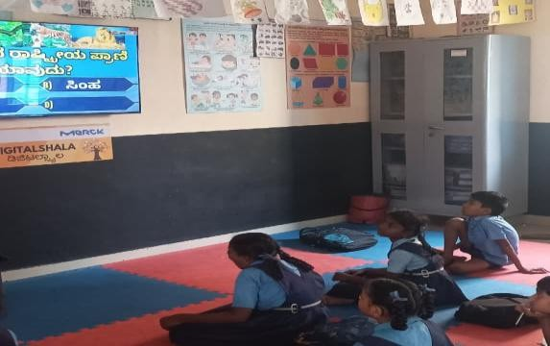
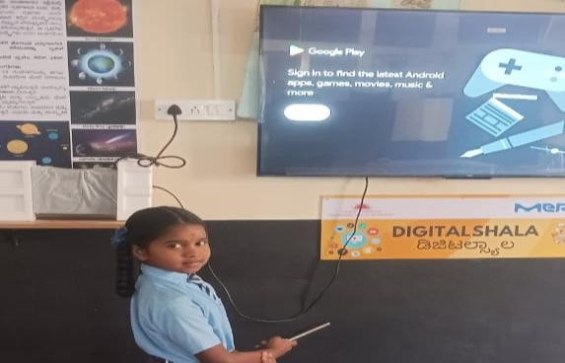
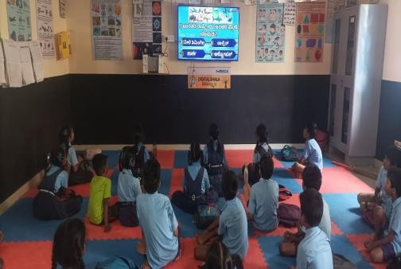
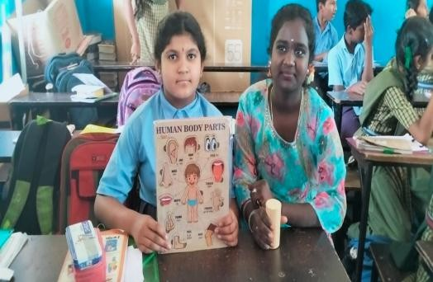

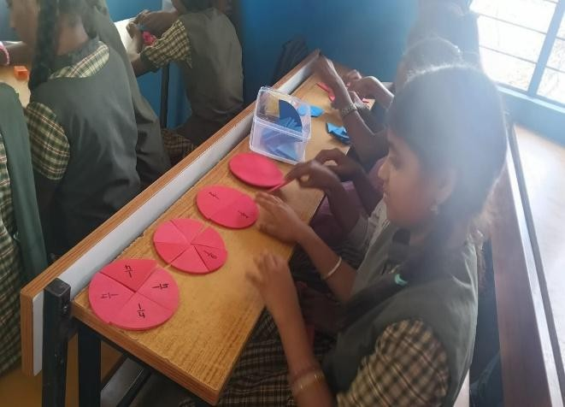
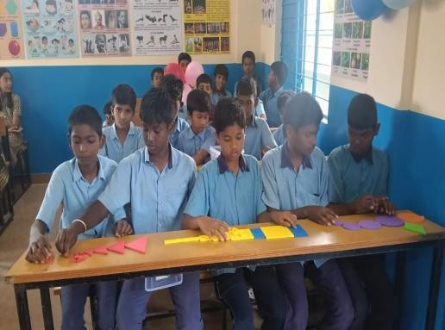

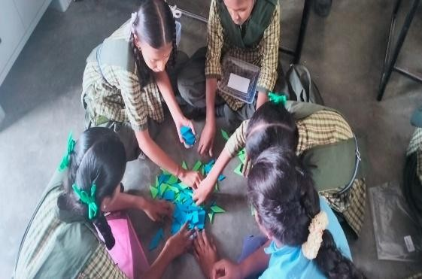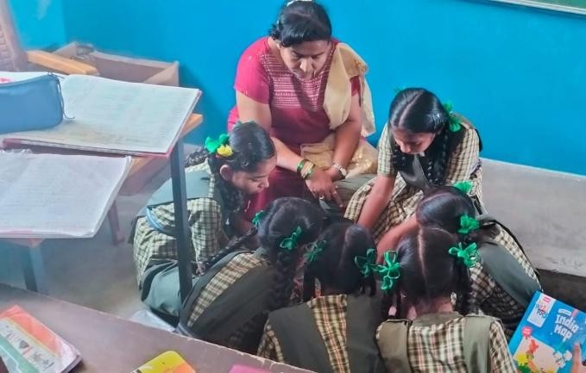
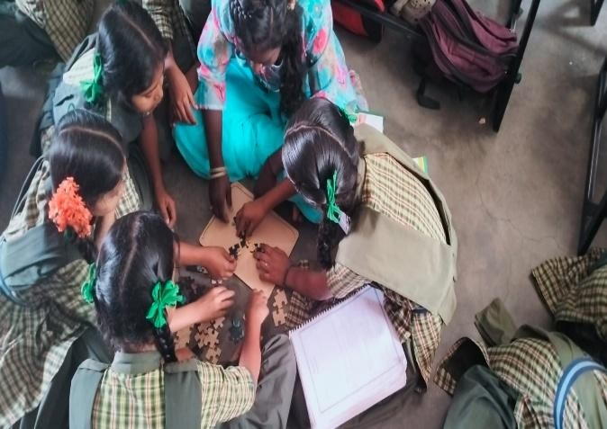
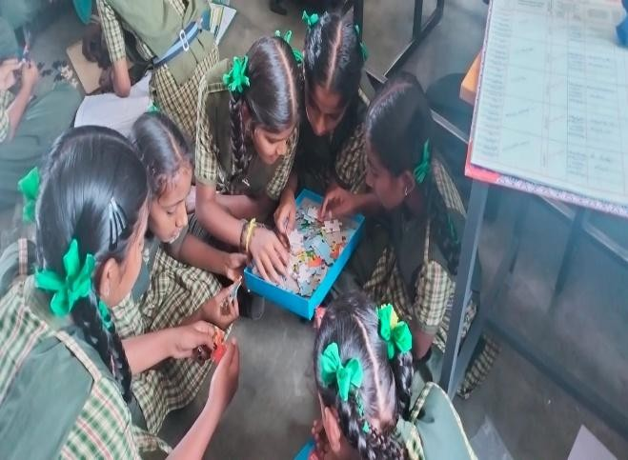

Overall Impact of STEAM shala in Schools and Feedback from Students and Teachers

- Students showed increased curiosity, confidence, and willingness to try new ideas during STEAM sessions.
- Teachers began using more hands-on, activity-based strategies that made learning enjoyable
and relatable.
- Classrooms shifted from textbook-focused teaching to more exploratory, creative, and collaborative environments.
- Teachers across subjects started working together, creating integrated lesson experiences for students.
- Students developed stronger skills in teamwork, communication, design, and
problem-solving.
- Technology became a natural part of day-to-day learning, not an isolated activity.
- The school environment became more inclusive, allowing different types of learners to shine.
- The STEAM Shala became a space where students felt safe to experiment, make mistakes, and innovate—turning learning into an experience rather than a task.
- Teachers rediscovered joy and creativity in teaching, often describing STEAM sessions as
refreshing and inspiring.
- Students began approaching problems with a design-thinking mindset, exploring multiple solutions instead of waiting for the “right answer.”

