GLOBALGIVING PROJECT STATUS REPORT
**Project Title: Dignity and safety for 50 girls in Modakeke
**Project ID: #74764
**Organization: EDEN-EDUCARE Foundation
**Prepared By: Jesujobi Adebimpe, Founder and Executive Director

Executive Summary
This report provides a detailed update on our ongoing efforts to deliver essential personal hygiene items and protective wear to girls in Modakeke under Project #74764. Our core mission remains focused on restoring confidence, improving health outcomes, and ensuring safety for the vulnerable young girls in this community. Through the generous backing of our GlobalGiving donors, we have successfully procured and begun distributing a critical baseline of health and dignity supplies.

Procurement and Inventory Breakdown
During this reporting period, our procurement team focused on sourcing high-quality, body-safe personal hygiene and care products. The specific inventory successfully acquired consists of the following:

Undergarments: We purchased 18 pieces of cotton panties to ensure the girls have clean, breathable protective wear. These items can be verified in the accompanying files
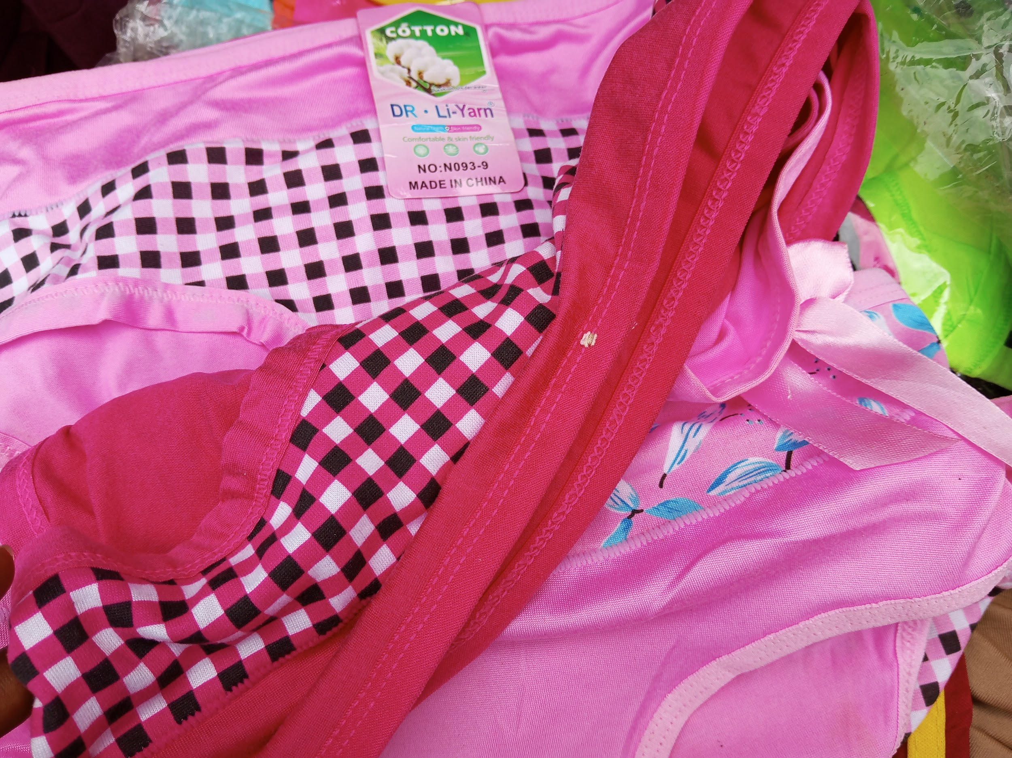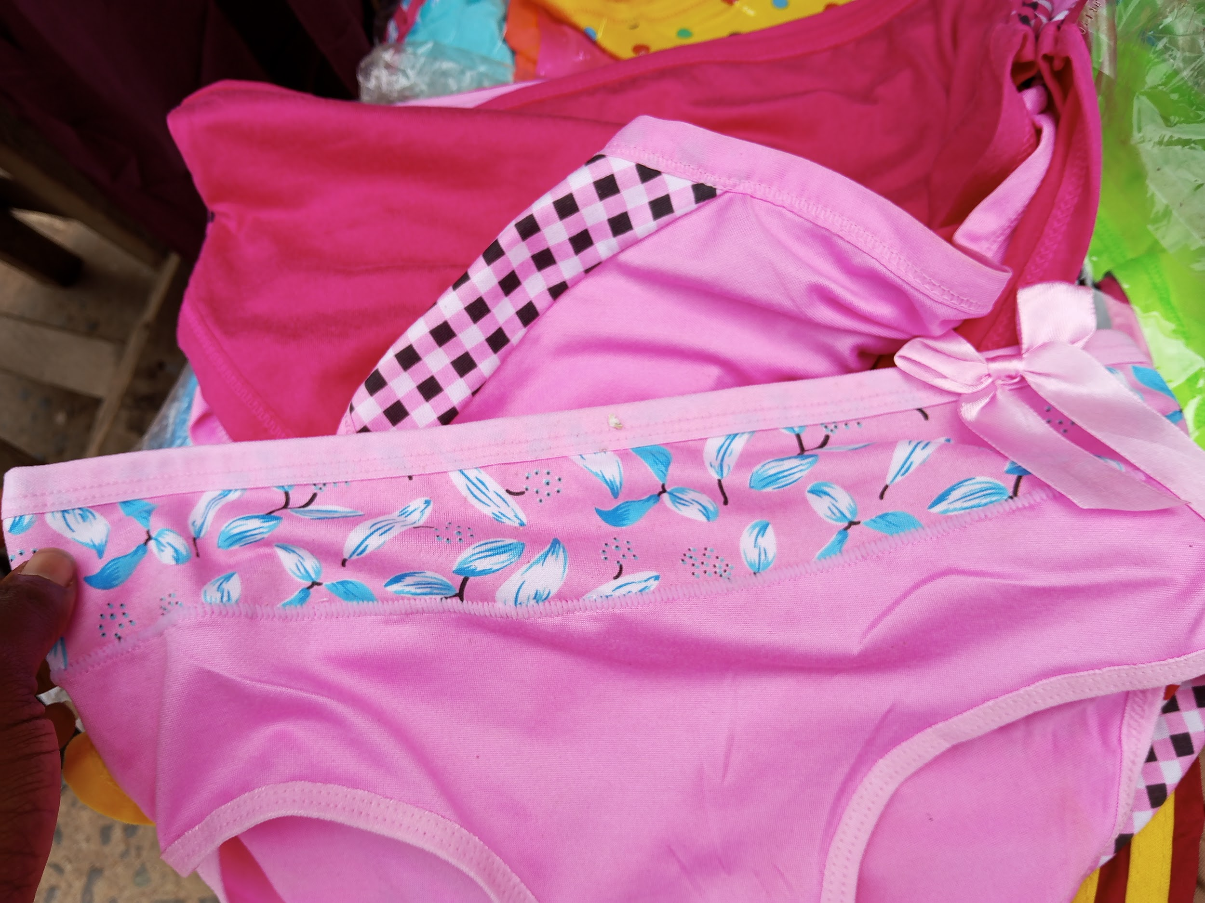

* **Menstrual Hygiene Management:** We secured premium Softcare sanitary pads explicitly designated or 15 girls. Visual confirmation of the sanitary pad stock and distribution packages can be referenced in files
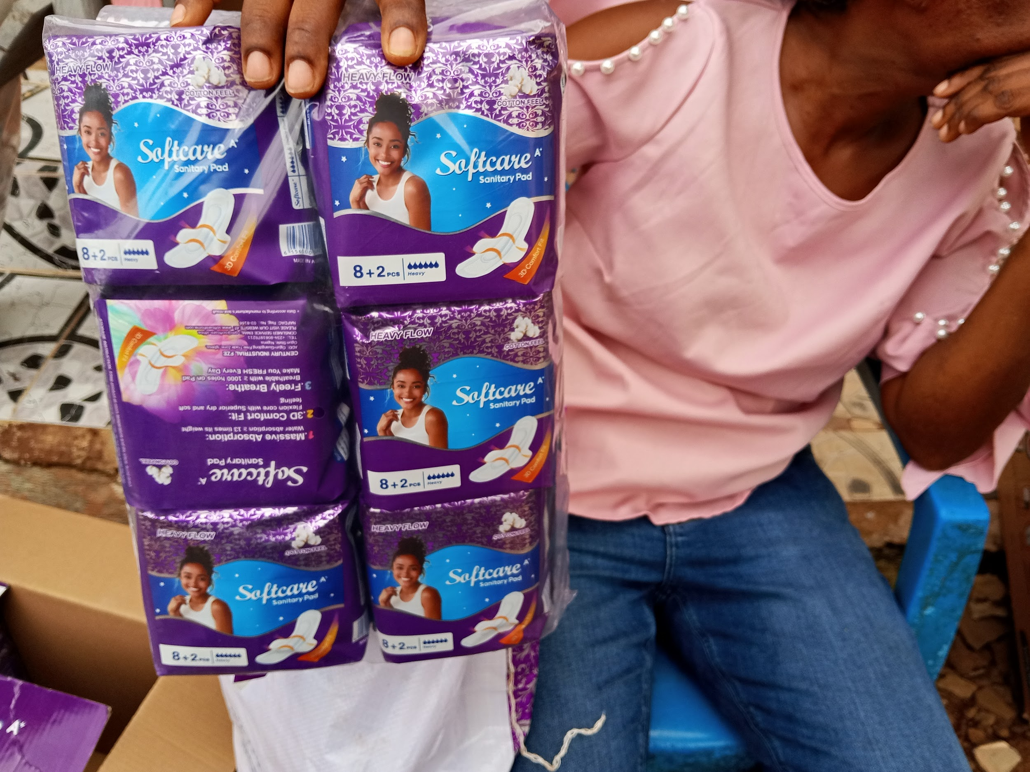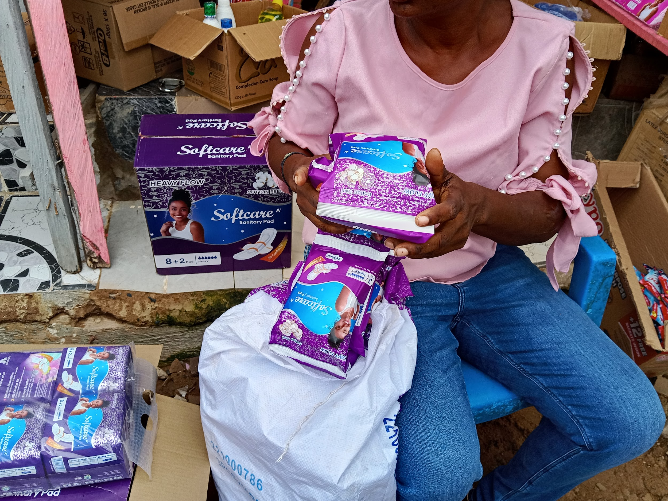

Personal Hygiene and Skincare:To promote everyday safety and cleanliness, we procured multi-packs of specialized bathing soaps (including Sanitol Medicated and Antiseptic Soap as seen held and Tura Germicidal Medicated Soap as shown in file
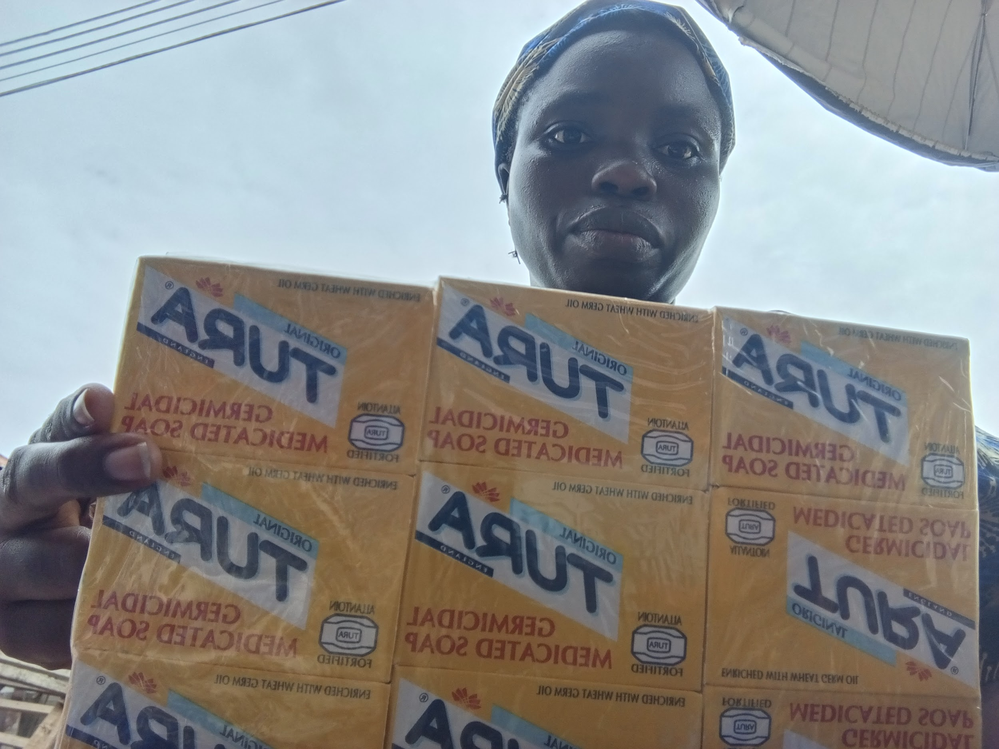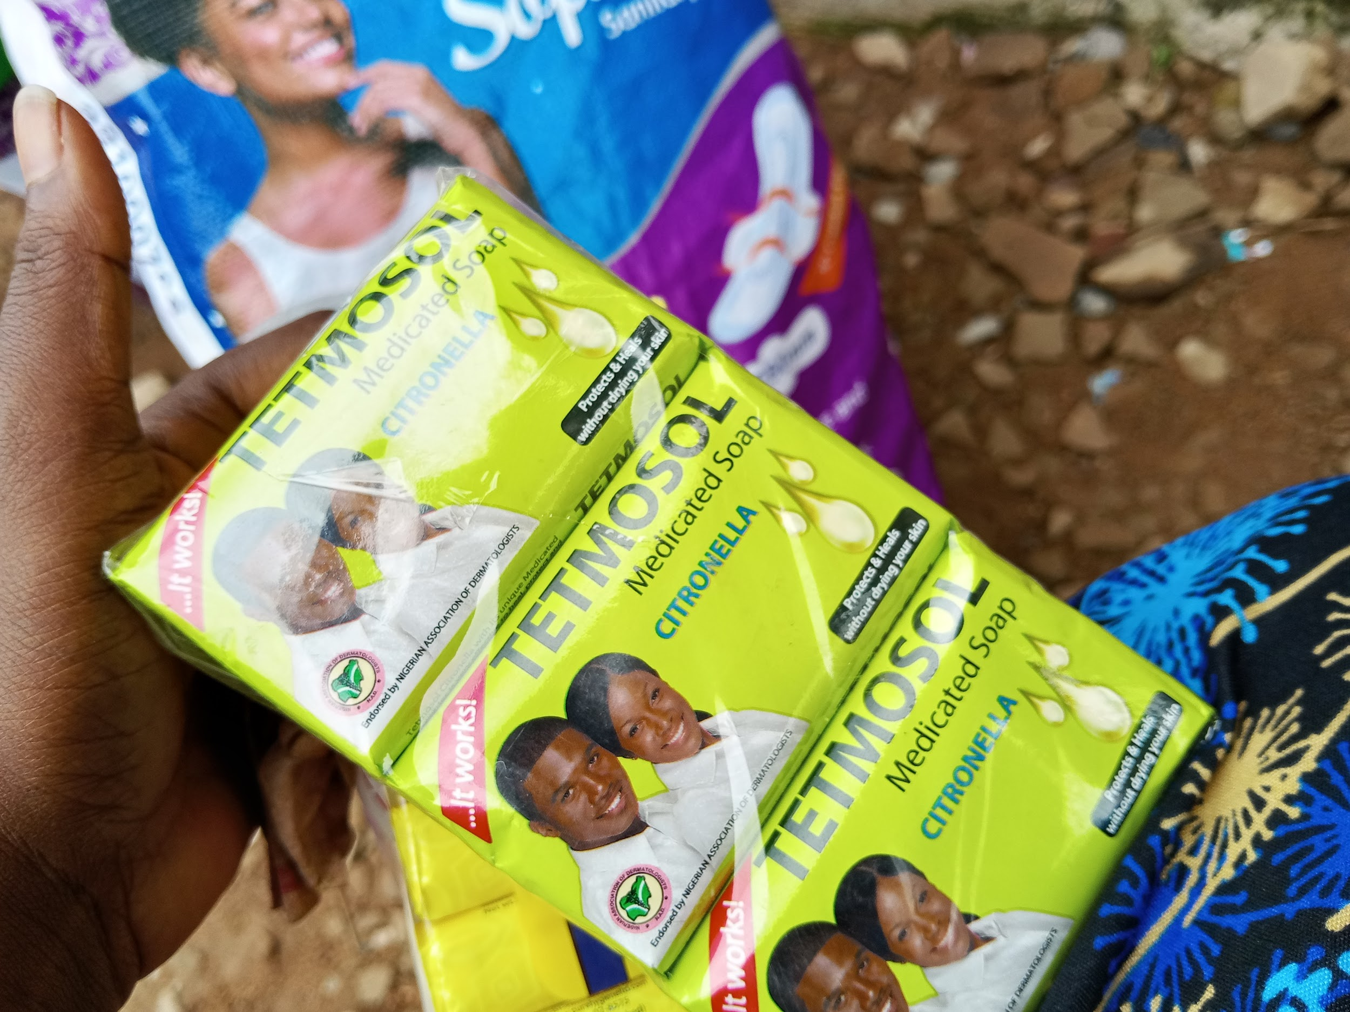

Oral Health Care: A supply of family-sized toothpastes from leading dental care brands (including Oral-B, Crestal, and Colgate) was acquired to support daily oral hygiene habits. These items are systematically laid out for inspection in pictures 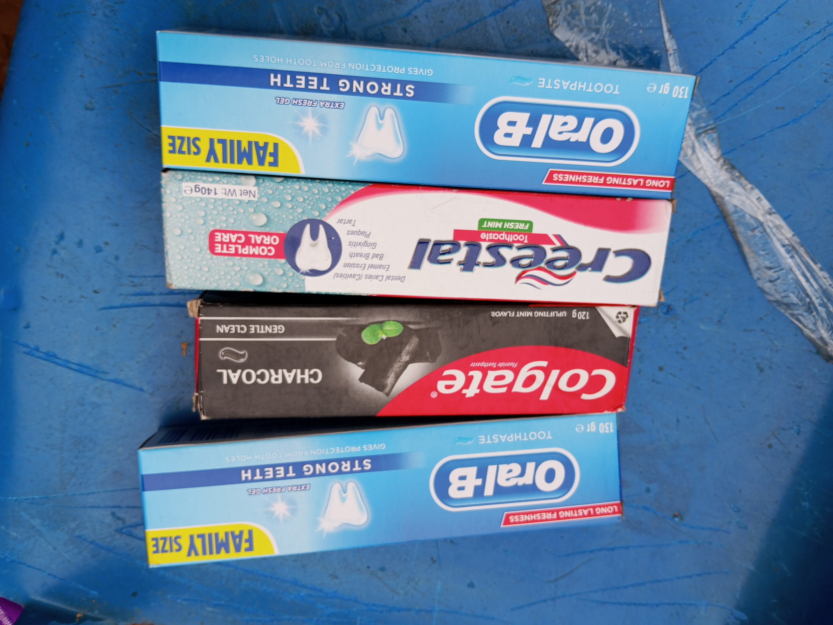

Project Impact & Next Steps
Providing these fundamental items directly impacts the health, self-esteem, and daily safety of the girls, mitigating the risks associated with poor menstrual hygiene management and inadequate access to basic toiletries.
As we look toward the next phase of implementation, the EDEN-EDUCARE Foundation is committed to scaling our distribution. We aim to bridge the remaining gap to ensure that we fully meet our target of supporting 50 girls in the Modakeke community with consistent, long-term dignity kits.
We extend our deepest gratitude to the GlobalGiving community for standing with us to make dignity and safety an accessible reality for these young girls.
A hearty thank you to our donors who have chosen to support us in every way..
Thank you! Thank you so much!
We are here because of you.
Ubuntu!

