GET NOAH!
NOTDEC’S “GREAT FLOOD” APPEAL
CAN YOU HELP US?
THE BIG JOB …
In Western Uganda, many mums die giving birth. Based in our “children’s village” in Kabirizi, NOTDEC cares for their motherless new-borns and other abandoned tots till they can look after themselves! Currently we’re caring for 170 youngsters.

MADE EVEN BIGGER …
To prevent institutionalisation, Uganda’s Government now says kids aged 5-6 must go to live with any relatives willing & able to have them. So, only 50 under 6’s live in Kabirizi. The other 120 are scattered across a wide area, some high in the Rwenzori Mountains.

TRAVEL AND MORE TRAVEL …
When a 6 year-old goes to live with family, they don’t just hop on a bus. Our social workers must track down willing family members, vet them carefully, take the child plus bedding & belongings to live with them, then regularly visit to check on each child’s wellbeing, schooling & safeguarding. Some families live in extreme poverty so NOTDEC may build them a drop toilet, extra room etc. All this means vehicles!

NOTDEC’S VEHICLES …
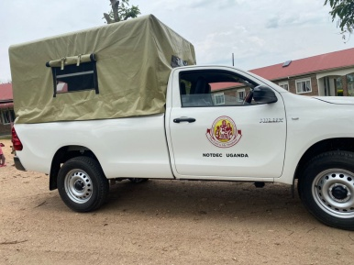
PACO THE PICKUP
… can take a dozen kids to school or on a trip, buy food, move children to live with family, and shift materials if we build a house or install solar panels. No PACO, no go! And right now PACO’s always busy!

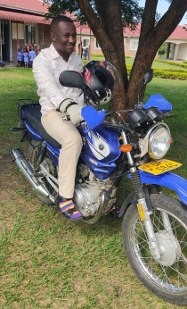
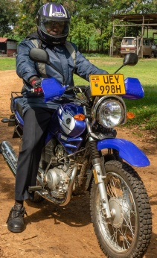
BODA-BODAS
… our run-arounds, they get Social Workers quickly & cheaply to the kids they need to visit, even on narrow mountain tracks. Some Ugandan bodas take passengers, but you can’t safely carry furniture, children or several adults that way.

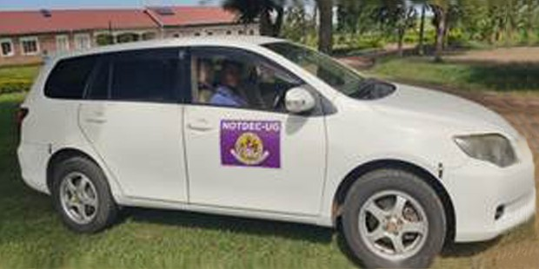
FIELDER ESTATE
… it looked fine – ideal for taking staff to meetings or going into town. But it kept breaking down, costing a fortune. So we had to sell it!

OUR GREAT FLOOD
(OF NEEDS)
No organisation NOTDEC’s size can manage with just a Pickup. When that needs repair, we’ll be helpless! The Pickup can carry only one front passenger. For adults, travelling far on its rear benches is agony! And we could NEVER transport government officials by Pickup!

Yet – with the Pickup fully occupied – more & more trips call for another substantial vehicle:
- Home & school visits: our female social worker can’t ride a boda-boda.
- Trips to town (Kasese): for the bank, pharmacy, or light purchases.
- Hospital trips: a child’s appointment, or for staff to support a child.
- School-going: taking a few children to/from the local school.
- Staff travel to/from work: staff do not own vehicles so NOTDEC must facilitate this.
Since selling the Fielder, we’ve had to hire an extra vehicle to take staff to consult with village elders, and to inspect a new house nearing completion & meet with the child’s family there.

NOAH TO THE RESCUE!
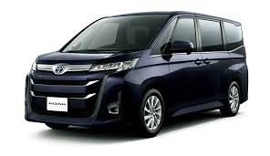
For journeys like these, and to cover any Pickup problem, we’d like to buy a Toyota Noah “people-carrier”. We’re advised to look for a reconditioned one about 5 years old (eg c60,000 miles). For better rough road clearance, we’d raise it 2+ inches.

Cost
Refurbished Toyota Noah (Japan - Mombasa - Kampala) £11,300
Any excess donations may be used as decided by Trustees within the objects of NOTDEC UK
Import Duty & registration fees £8,000
Suspension spacers to increase ground clearance £1,000
Sale of Fielder (£2,300)
Total required: £18,000

As NOTDEC UK Trustees, we believe the Lord has led us all to fight against infant death and destitution in Uganda. After dark winter months we now say prayerfully – to Him and to you:
"Give us the tools, and we will finish the job".

If you are able, please donate towards the cost of the NOAH.
If you pay tax, please Gift Aid your donation.
If we already hold a GA form from you,
we will automatically claim Gift Aid on your donation
unless you say otherwise.
OUR BANK DETAILS

CAF bank sort code: 40-52-40
Account number: 00096601
Account name: NOTDEC UK

Janet Johnston
for NOTDEC UK Trustees

