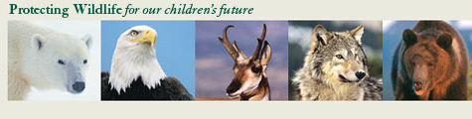
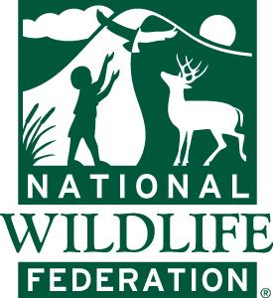

Adopt –a-Wildlife Acre Project Overview:
National Wildlife Federation’s Adopt-a-Wildlife-Acre program is a proven solution that gives the majestic bison and other wildlife the room they need to roam safely. For decades there has been conflict between livestock and wildlife on public lands. National Wildlife Federation's Adopt a Wildlife Acre program resolves these conflicts in a manner that everyone wins—wildlife, ranchers and livestock.

How Does Adopting Wildlife Acres Work?
- NWF contacts ranchers who hold leases on allotments that are on our priority list for retirement. If the rancher is interested, we negotiate a reasonable price.
- Next, we approach the land management agency (the U.S. Forest Service) to make sure it’s willing to permanently close the allotment.
- When all three parties voluntarily agree, the agency retires the grazing permit. Through this program, we recognize the economic value of livestock grazing permits and fairly compensate ranchers for retiring their leases.
5 Adopt-a-Wildlife Acre Priorities
- Focus on core recovery areas and key wildlife corridors
- Prioritize domestic sheep allotments over cattle allotments (sheep create more conflict with wildlife)
- Give preference to retirements that create large areas without livestock
- Identify allotments with the greatest number and frequency of livestock losses
- Restore wild free-ranging bison to their native grassland habitat.

Fundraising Goal: $450,000
Funds raised for Adopt-a-Wildlife Acre support the following work:
- Organizing meetings with local ranchers and opinion leaders to make bison restoration work for local communities and to examine what economic incentives make restoration more acceptable.
- Conducting an outreach effort around both the state and the country to raise the visibility of the campaign.
- Protecting habitat so wildlife have a place to roam safely without running into livestock conflict.
- Retire 2 critical allotments (map below) spanning 12,000 acres to protect bighorn sheep from deadly disease

Current Success:
To date, NWF has already secured more than 620,000 acres of vital wildlife habitat. NWF restored 61 wild, Yellowstone bison to the Fort Peck Indian Reservation in March 2012, and since then, more than 20 calves have been born to the herd. This was the first-ever return of wild bison to tribal lands after more than a century of being absent from their native prairie habitat. Through these efforts and more, bison have slowly begun to recover and thrive. With the help of our supporters, we will continue to move forward with our Adopt-a-Wildlife-Acre program and our project to restore bison to the expansive Charles M. Russell National Wildlife Refuge (CMR).

The Next Opportunity to Protect Wildlife:
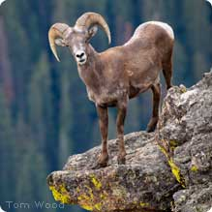
Wild bighorn sheep in Montana are facing devastating, deadly outbreaks of pneumonia when coming into contact with domestic sheep carrying the disease. The diseases are highly contagious and often fatal, leading to slow and painful deaths. The situation is complicated because scientists don’t fully understand how these diseases spread. As long as domestic sheep continue to graze on public lands near major herds of bighorn sheep, the bighorns will remain at risk of catastrophic illness.

Another problem - bighorn rams roam far and wide in search of a mate, often onto public lands where domestic sheep grazing is permitted. Entire herds of bighorn sheep are at risk of contracting deadly diseases if they come into contact with those domestic sheep. One recent study found a single domestic sheep caused more than 86 bighorn deaths between 1997 to 2000.

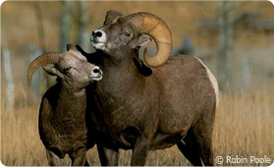
Fortunately, we have chance to resolve these conflicts. Just as we have done in the past for bison, we now have the chance to “retire” domestic sheep grazing privileges in key areas adjacent to bighorn sheep habitat, including two critical allotments spanning 12,000 acres in southwest Montana. The two bighorn herds that are adjacent to these domestic sheep allotments have suffered two 75-percent reductions in their populations in the last thirty years due to disease outbreaks. Retiring grazing privileges would be a huge improvement for the health of local bighorn herds. To take advantage of this rare opportunity, NWF must raise a total of $450,000 so we can purchase domestic sheep grazing allotments that border bighorn sheep habitat, and retire these lands from grazing by domestic animals.

We have made great strides in our efforts to protect wildlife and will continue working to ensure that bison, bighorn sheep and all wildlife have the room they need to roam the way nature intended – wild and free.

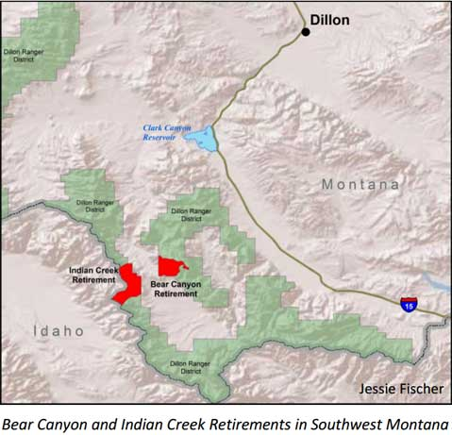

Budget:
For every $1 donated to Adopt-a-Wildlife Acre, 82% goes to retiring grazing allotments. The remainder of the budget for this wonderful program supports staff time and travel associated with securing and managing the allotments and contracting.

