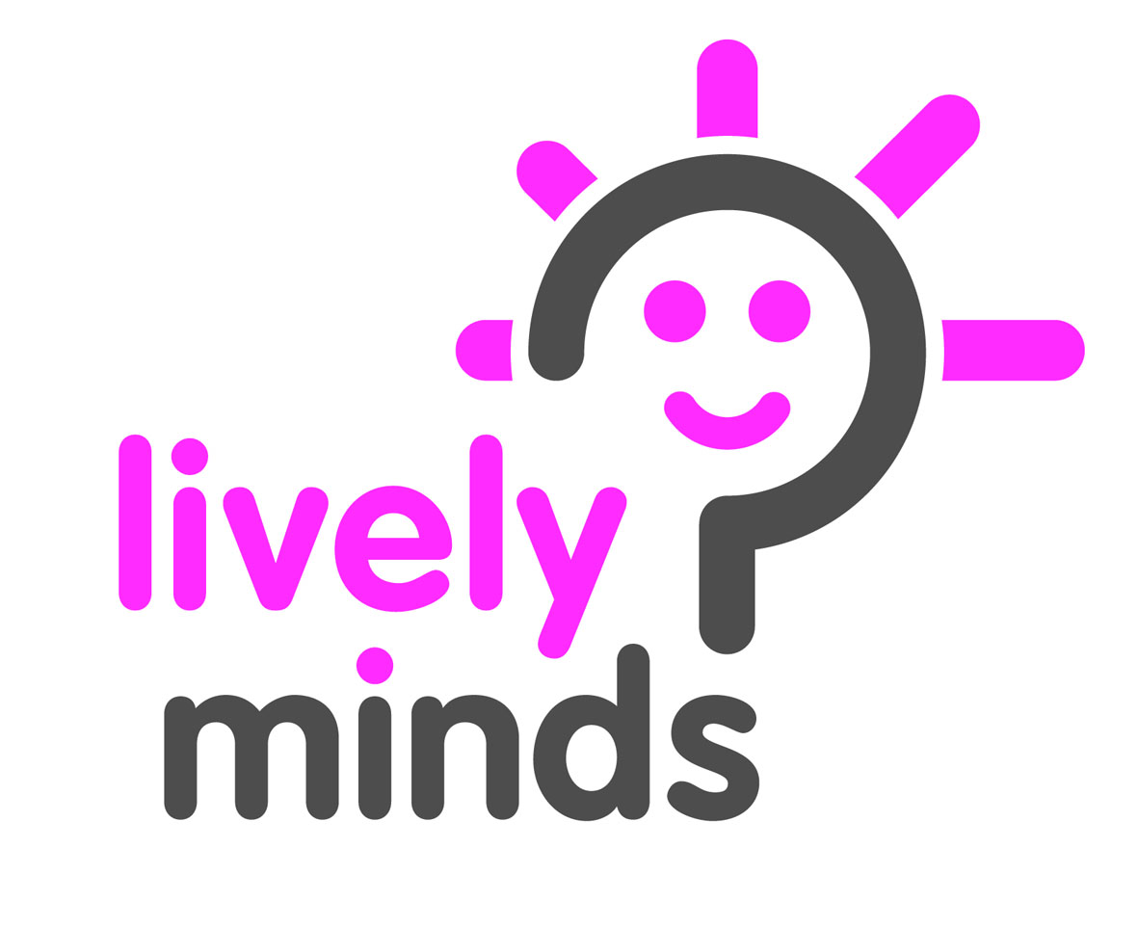
Prevent Child Sacrifice in Uganda
Summary of project
Child Sacrifice is a terrible crime of violence against children and, unfortunately, the frequency of its occurrence has increased drastically in Uganda over the last few years. Our project aims to prevent child sacrifice by changing the beliefs and mindsets that are sustaining it. We will do this by conducting a schools education workshop to over 15,000 students to help them protect themselves from child sacrifice and take action to prevent it.

Why is our programme needed?

Child sacrifice is the killing, mutilation or removal of body parts of a child for ritual purposes of for sale. Research has revealed that close to 3000 children are believed to be sacrificed each year in Uganda. Eliminating child sacrifice is a strategic priority for many large-scale NGOs. Surprisingly however our behavioural change programme is the only planned programme of work to address child sacrifice prevention.
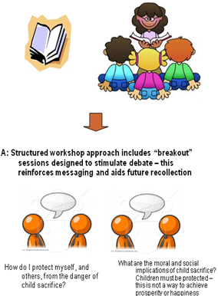
Our activities

Between February and August 2011 Lively Minds will conduct 100 workshops in 50 secondary schools in Mukono and Jinja districts to tackle the beliefs and mindsets that sustain child sacrifice and to give children the tools to protect themselves.
Creative & sustainable education: We have commissioned and illustrated a children’s book called “Saving Little Viola” and use this as a discussion tool. This ensures that the workshops are powerful, memorable and informative. We will also distribute copies of the book - which also contain a factsheet about child sacrifice- so that the schools and students can continue to use this resource. We will also train teachers and provide a manual for teachers so that they can cascade this training to a wider audience.

Action and empowerment: The programme will also be accompanied by a high profile youth-led campaign to raise awareness in the general population and to demonstrate peaceful ways to achieve positive change. Key elements include a creative writing competition with winning entries published in national newspapers; a Facebook campaign and a pledge signed by thousands of participants.
The beneficiaries
We will deliver 100 workshops in 50 secondary schools in Jinja, Mukono and Kampala districts. These are districts where there have been high numbers of incidents of child sacrifice. Based on 50 students per class your help will reach 5000 direct beneficiaries. In addition, we will train one member of staff in each school, who will be tasked with replicating workshop to 5 other classes in the 6 month period (therefore reaching at least 250 additional pupils per school). If, with your help, Lively Minds reaches 50 schools in a 6 month period that will equal 10,000 indirect beneficiaries.
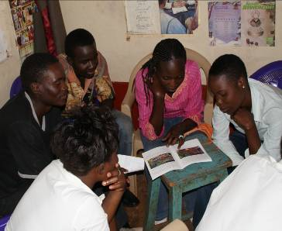
Jennifer from Buakya took part in our workshop. She says
“I had never read something like this before. It was so interesting. When Viola was caught I felt so worried and unhappy. Now I know how to protect myself and my junior brothers and sisters. We must stop child sacrifice. It is a very terrible thing.”

Support requested
In order to fully implement this phase of our campaign we need a total of UGX15m. This sum will allow us to:
- Print and distribute over 1000 copies of “Saving Little Viola” including information packs, together with teaching manuals.
- Conduct 100 workshops
- Conduct a creative writing competition
- Implement a high profile communications campaign

Based on reaching 15,000 students, the unit cost per beneficiary is just UGX1000. We would kindly request that you contribute towards this total and help us make a lasting social impact.

For more information about Lively Minds visit www.livelyminds.org or contact:

