SECTION A – ORGANISATION DETAILS
- Date of Application: 24th December 2025
- Organisation Name: Groupe Scolaire Busogo I, Saint Benoît
- Address: Busogo Sector, Musanze District, Northern Province, Rwanda
- Contact Person:
  - Name: Fr. Jean Damascène TUYISHIMIRE
  - Position: Head Teacher
  - Phone: +250 785 010 182
  - Email: nahum990@yahoo.fr

Project Title:
Support for Vulnerable Students at Groupe Scolaire Busogo I in Academic Year (2025–2026)

1. Background
Groupe Scolaire Busogo I, Saint Benoît is a Catholic school located in Busogo Sector, Musanze District. It provides both primary and secondary education to over 2,350 students. Rooted in Catholic values, the school fosters a strong culture of solidarity and compassion, frequently supporting vulnerable students through partnerships with the Church and donors.
At the conclusion of the 2024–2025 academic year, the school identified 58 primary and 40 secondary students from families unable to afford basic schooling needs. These include school fees, learning materials, and now most urgently school uniforms, which are essential for dignity, discipline, and inclusion in the school community.

2. Problem Statement
Despite existing efforts and past support, many vulnerable students remain in need. Without help, 98 children may drop out or face stigma due to the lack of school fees, materials, and proper uniforms. This creates an urgent need for external support to uphold their right to education and dignity.

3. Project Objectives
- To pay school fees for 98 vulnerable students (58 primary, 40 secondary) for the entire academic year (3 terms).
- To provide complete school material kits, including notebooks, pens, school bags, and other essentials.
- To provide school uniforms to ensure full integration and confidence among all learners.
- To promote inclusive and equitable education, in line with the school's Catholic mission.

4. Target Group
Level | Number of Vulnerable Students
Primary | 58
Secondary | 40
Total | 98

5. Expected Results
- All targeted students continue schooling without financial or material barriers.
- Uniform access promotes self-esteem and a sense of belonging.
- Improved school attendance and academic outcomes.
- The school continues to live out its mission of caring for the vulnerable.

6. Updated Budget Estimate (Year – 3 Terms)
Item Description | Unit Cost (FRW) | Quantity | Subtotal per Term (FRW) | Total for 3 Terms (FRW)
Primary School Fees | 5,000 | 58 | 290,000 | 870,000
Secondary School Fees | 30,000 | 40 | 1,200,000 | 3,600,000
School Materials (once per year) | 25,000 | 98 | — | 2,450,000
Uniforms (once per year) | 35,000 | 98 | — | 3,340,000
Total Estimated Budget |  |  |  | 10,350,000 FRW

1$ =1400 FRWS
🔹 Note: School materials and uniforms are assumed to be provided once per academic year.

7. Implementation Plan
- Beneficiary Identification: Already completed through school staff and community leaders.
- Procurement: Materials and uniforms will be sourced from local suppliers.
- Distribution: All items will be distributed before the 2025–2026 school year begins.
- Follow-Up: School staff will monitor attendance, use of materials, and student wellbeing throughout the academic year.

8. Conclusion and Appeal
G.S. Busogo I, Saint Benoît continues its mission to provide not just education, but dignity, hope, and opportunity for all—especially the most vulnerable. We invite your support to empower 98 students with what they need to learn and thrive for a full academic year. Your contribution—no matter the size—can change a life.
"Whatever you did for one of the least of these brothers and sisters of mine, you did for me." (Matthew 25:40)

Photos

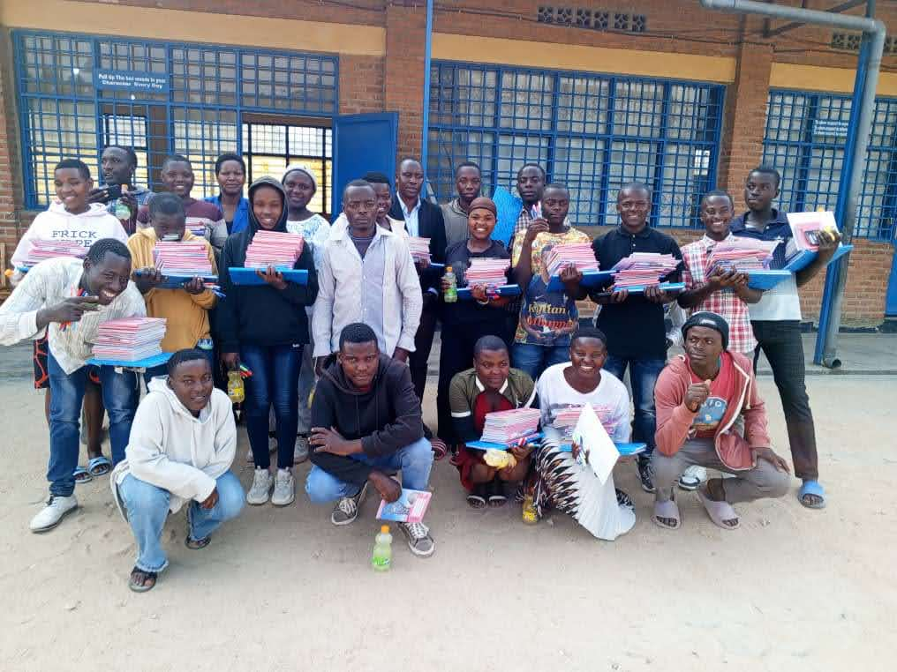

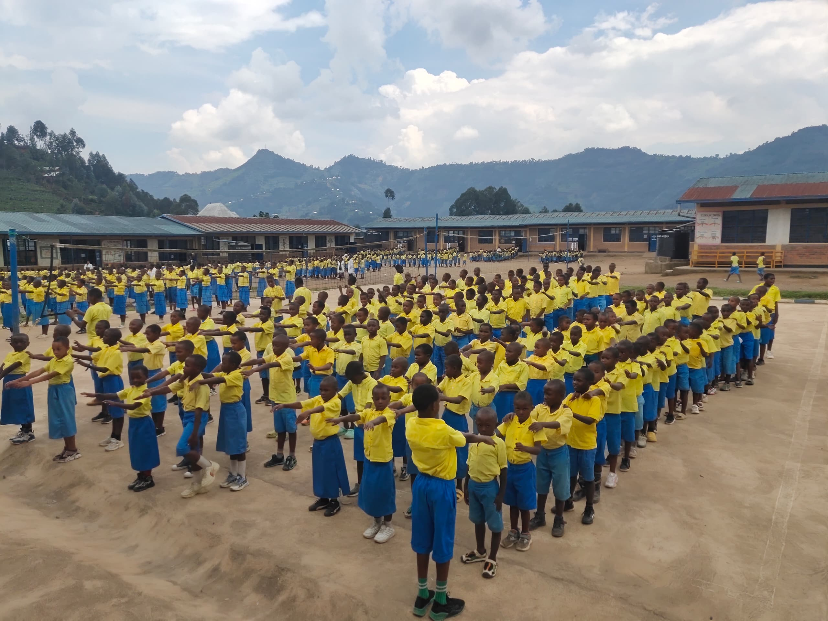

To contribute or get more information, please contact:
Fr. Jean Damascène TUYISHIMIRE
Head Teacher, G.S. Busogo I, Saint Benoît
📧 nahum990@yahoo.fr
📞 +250 785 010 182

