Kalobeyei Art Learning Center (KALC)
Quarterly Project Progress Report
Project Title: Empowering Refugee and Host Youth in Kalobeyei Through Arts, Skills, and Healing
Project ID: 73960
Organization: Kalobeyei Art Learning Center (KALC)
Reporting Period: 14 December 2025 – 31 March 2026 (First Quarterly Report since joining GlobalGiving)
Prepared by: Socrate Rushigira
Title: International Head / Head Leader
Location: Kalobeyei Integrated Settlement, Turkana West County, Kenya
Date: April 2026

1. Introduction
Kalobeyei Art Learning Center (KALC) is pleased to submit its first quarterly progress report to GlobalGiving since officially joining the platform on 14 December 2025.
This report covers the period from 14 December 2025 to 31 March 2026 and highlights both our pre-campaign fundraising efforts and the strong results we achieved during the Little by Little Campaign in March 2026.
Our project, “Empowering Refugee and Host Youth in Kalobeyei Through Arts, Skills, and Healing,” continues to support refugee and host-community youth, women, and vulnerable children through arts education, instrumental music training, psychosocial support, physiotherapy for children, and peacebuilding activities.
Even though we have not yet reached our overall project goal of USD 7,500, the donations received so far are already making a real difference. Every dollar raised is being directed toward the activities described in our project proposal and will directly support the programs that are already running in the community.

2. Visual Impact and Activities
The following images illustrate the kind of activities that your generous donations are helping us deliver and expand. These programs are already benefiting dozens of young people every week.
Psychosocial Support Sessions:
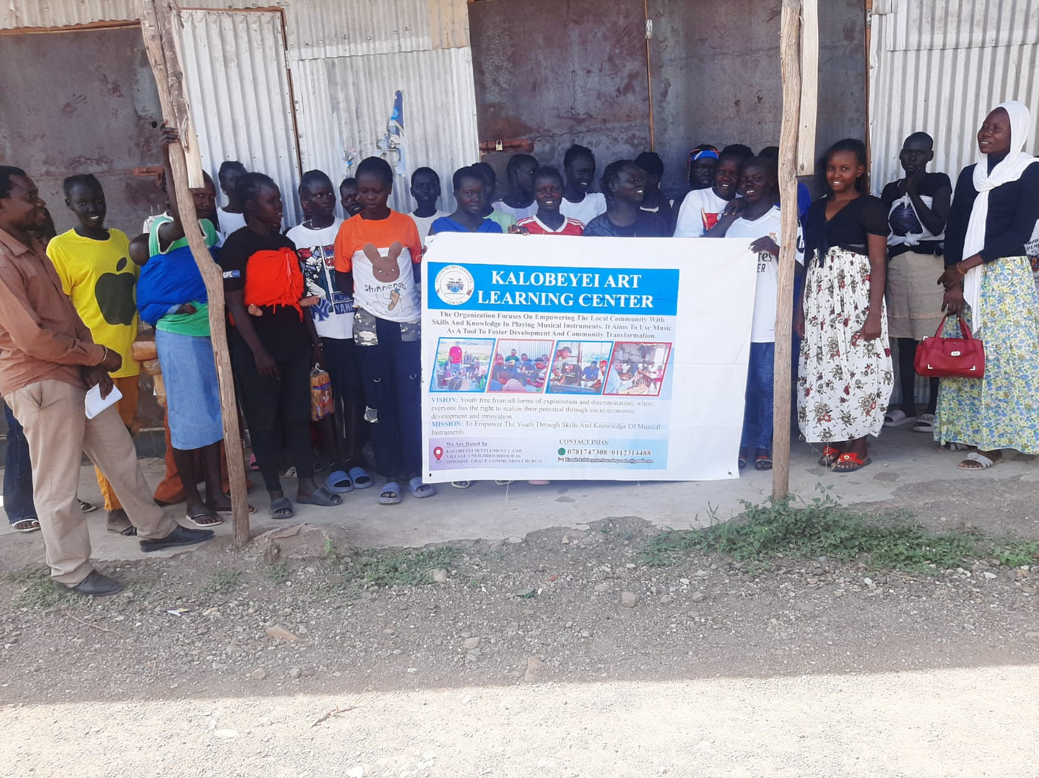
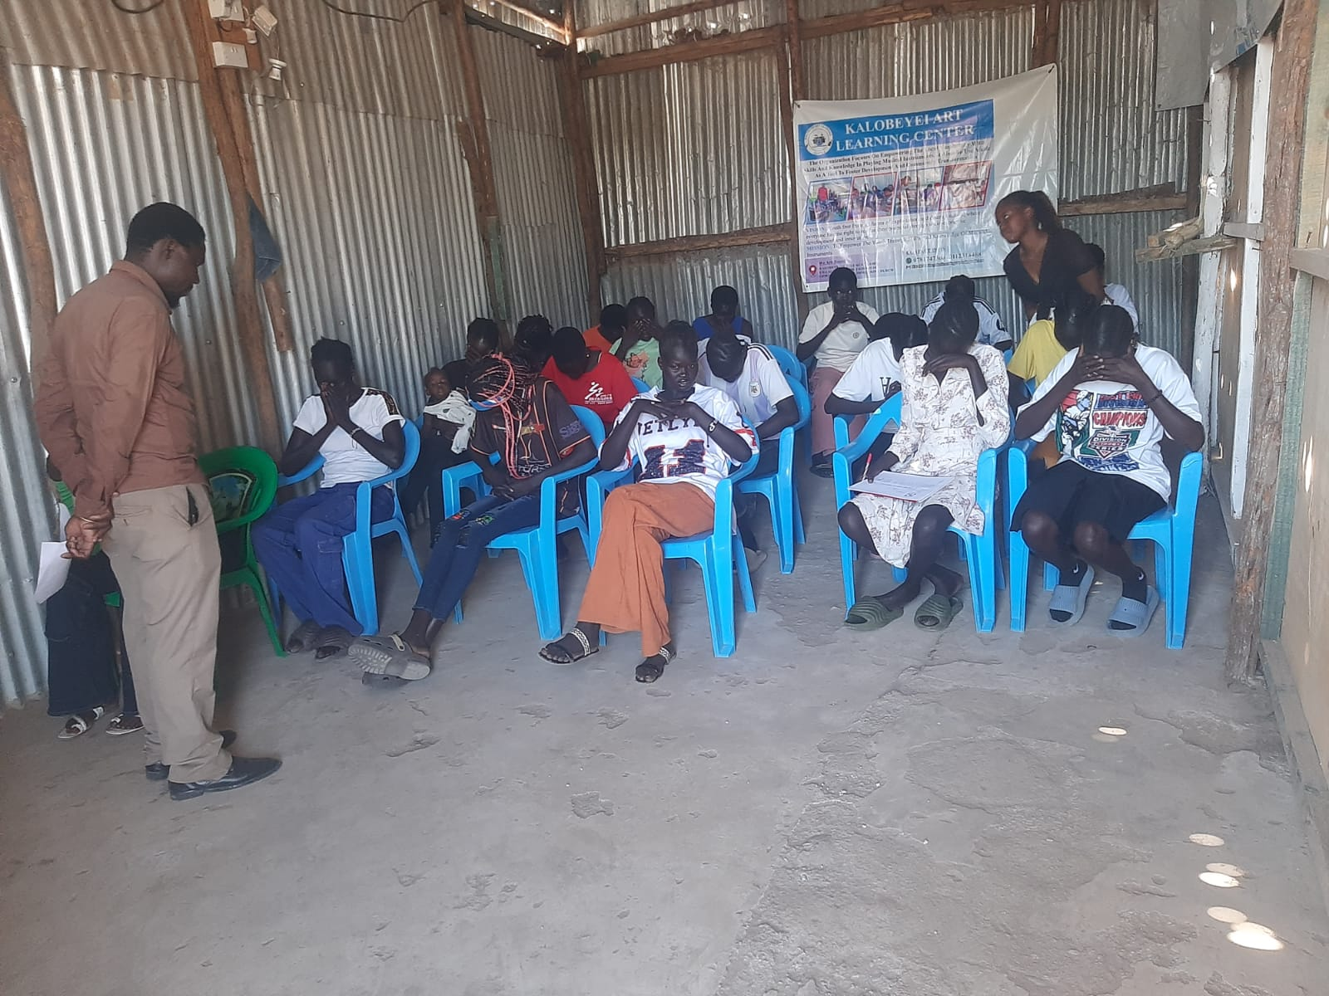
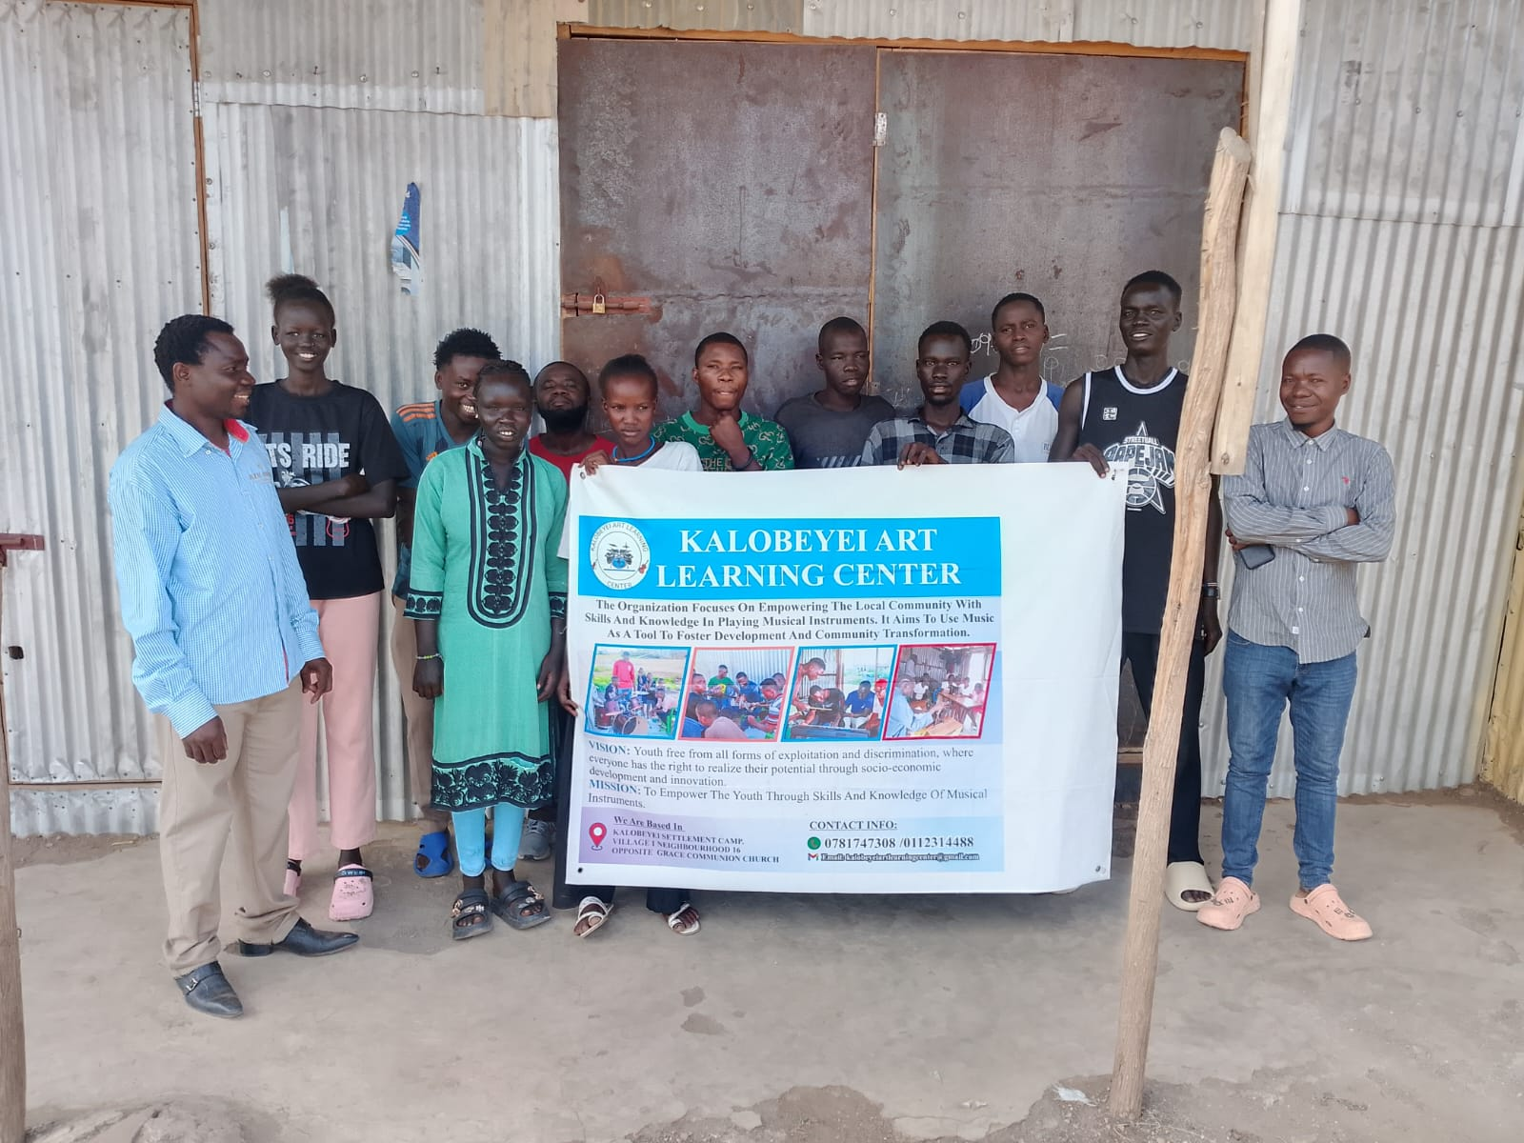
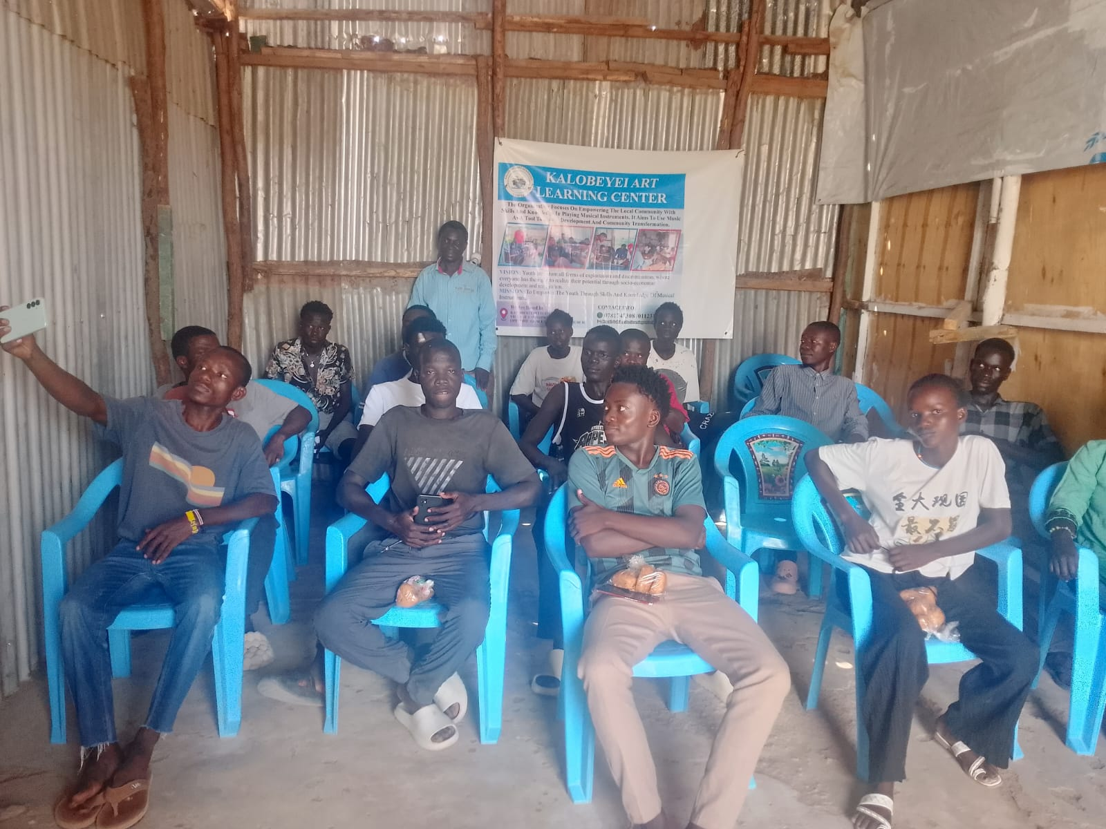
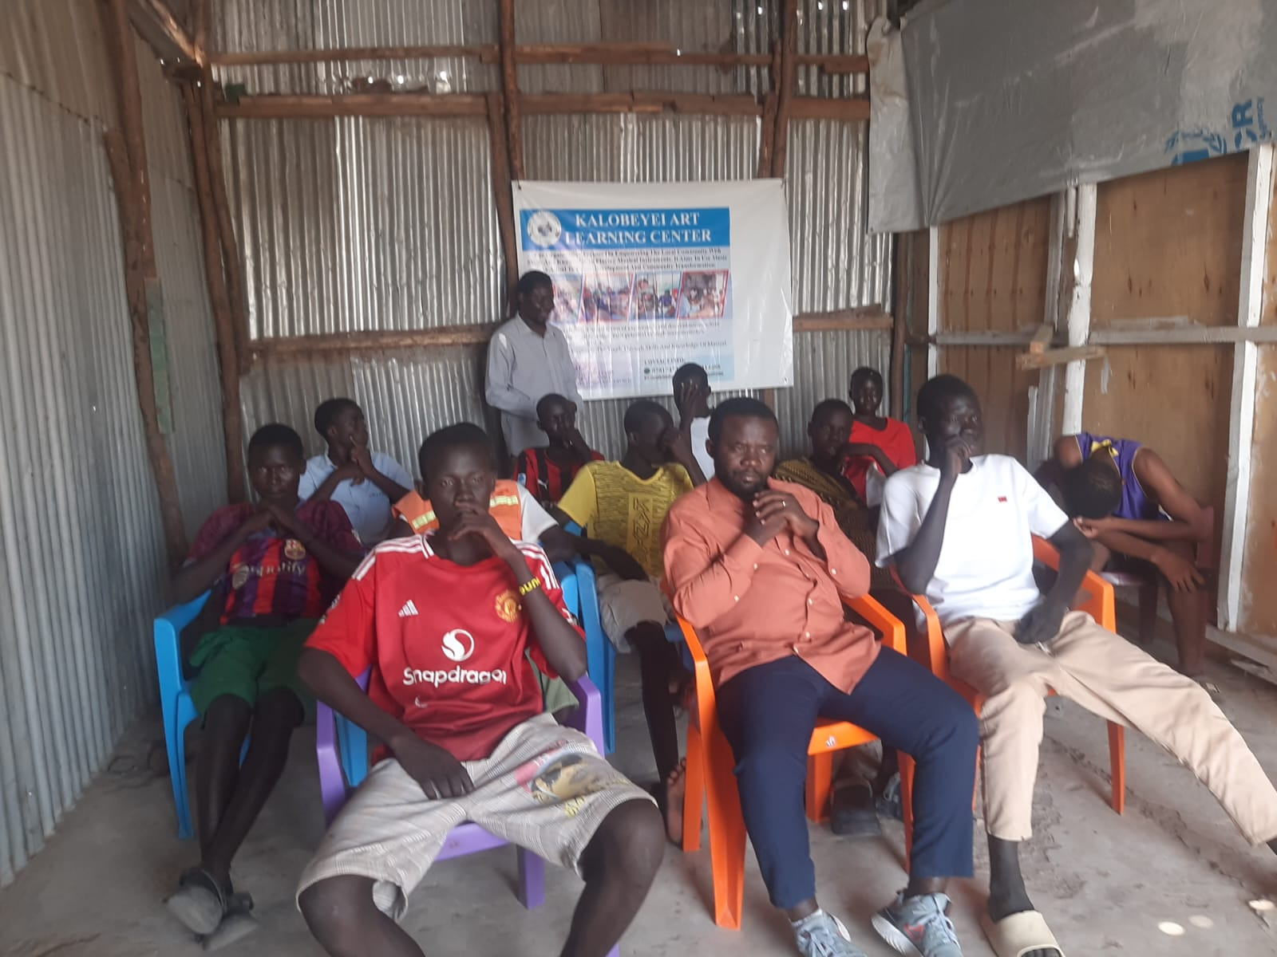
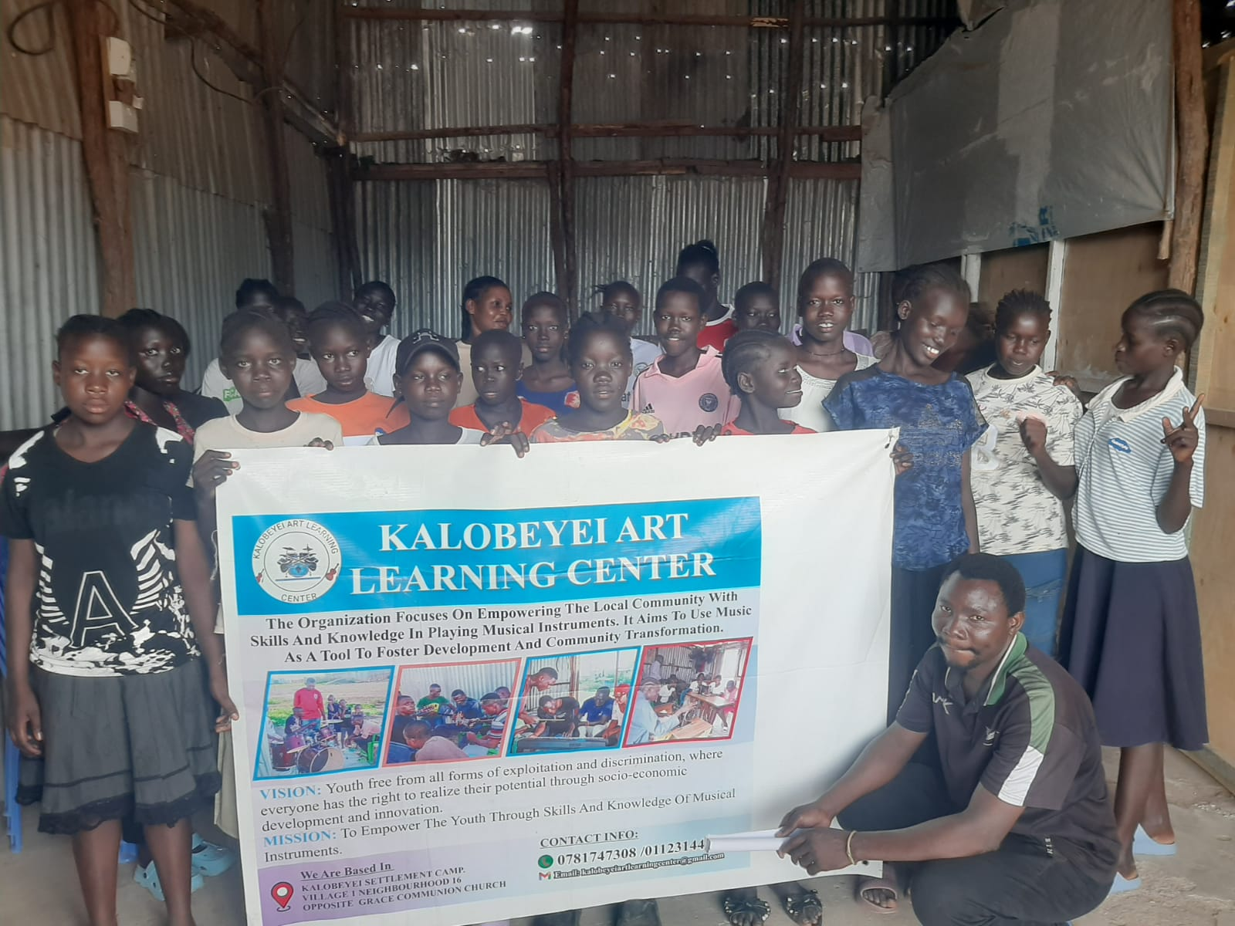
Youth participating in psychosocial support activities, creating a safe and supportive environment for healing and emotional growth.
Music Workshops
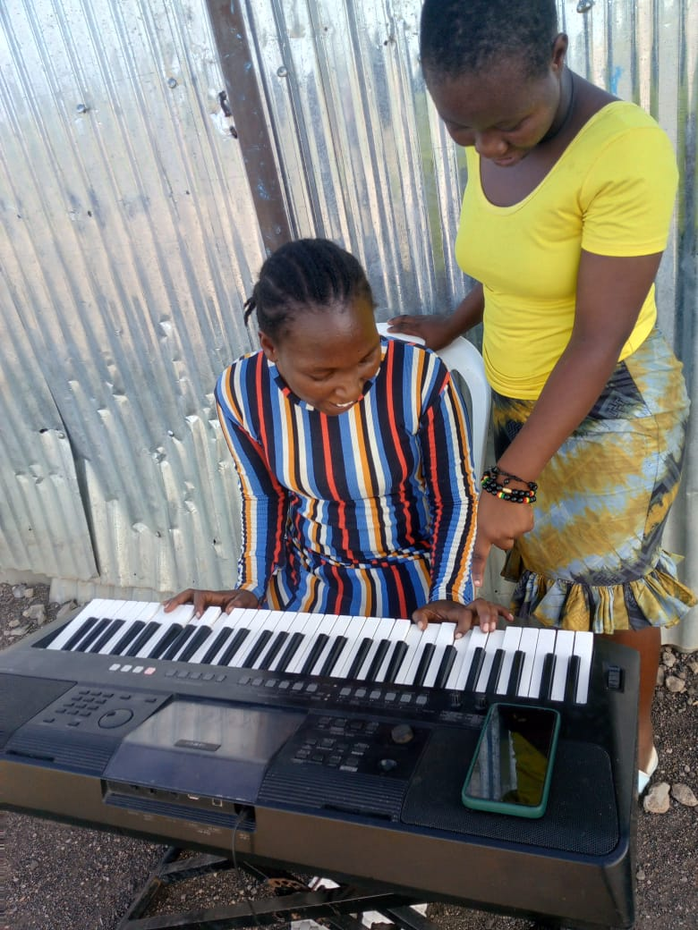
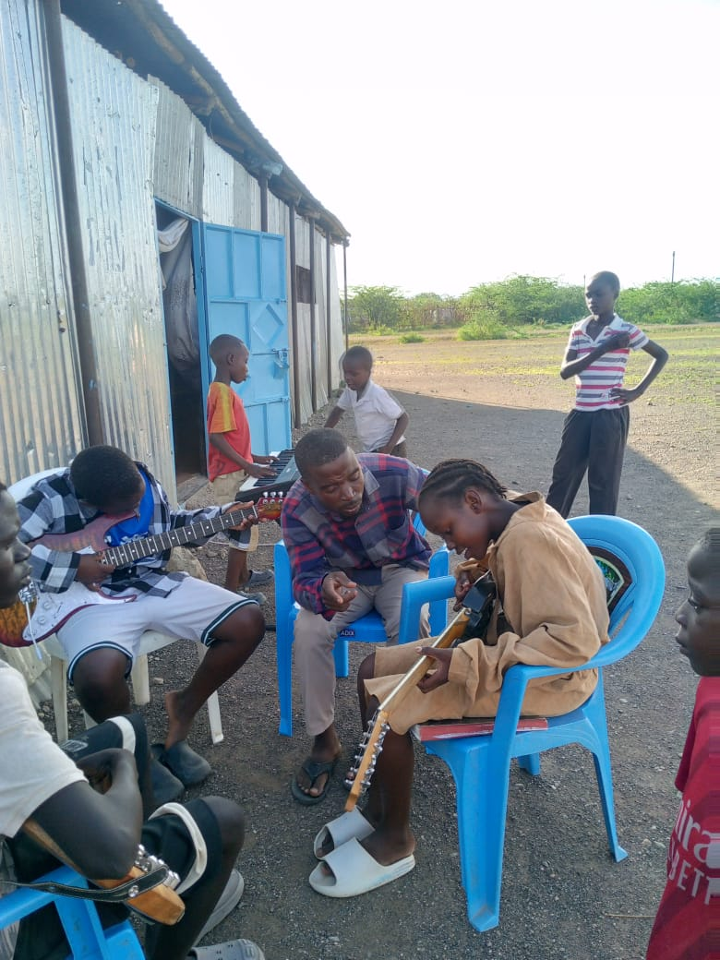
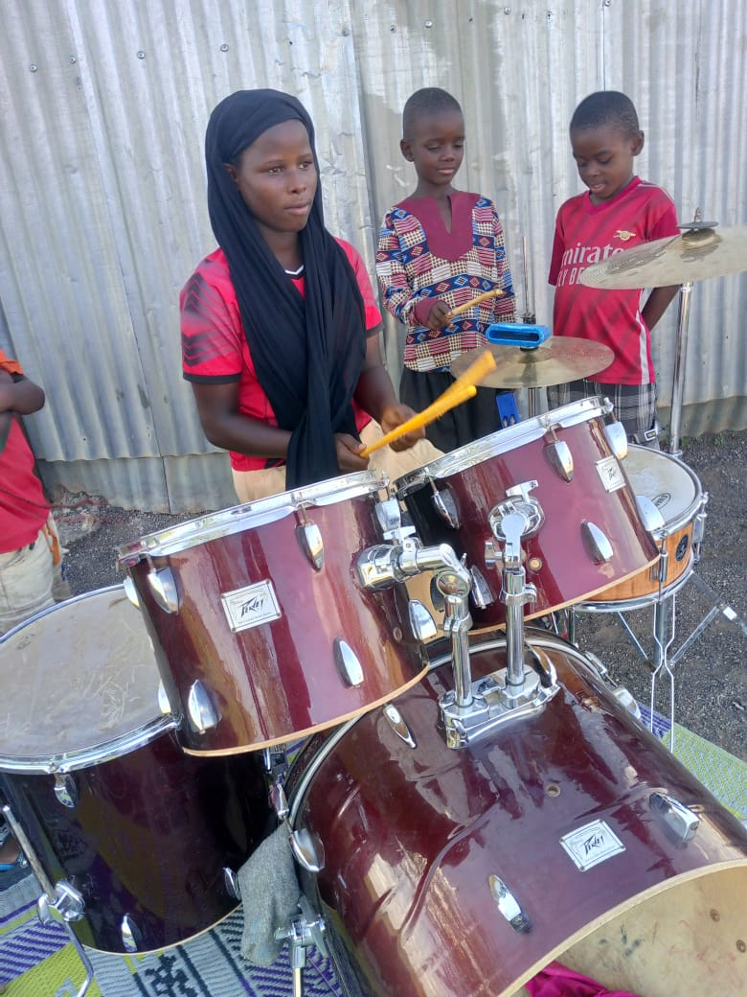
Young people learning and playing musical instruments, showing high levels of enthusiasm, focus, and joy.
Mental Health Training Sessions
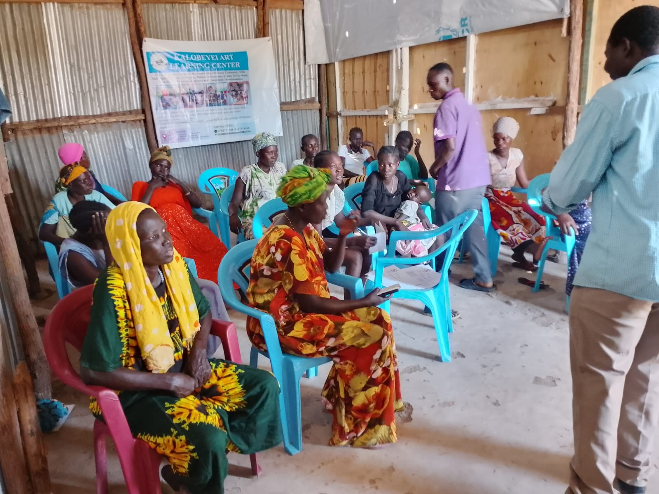
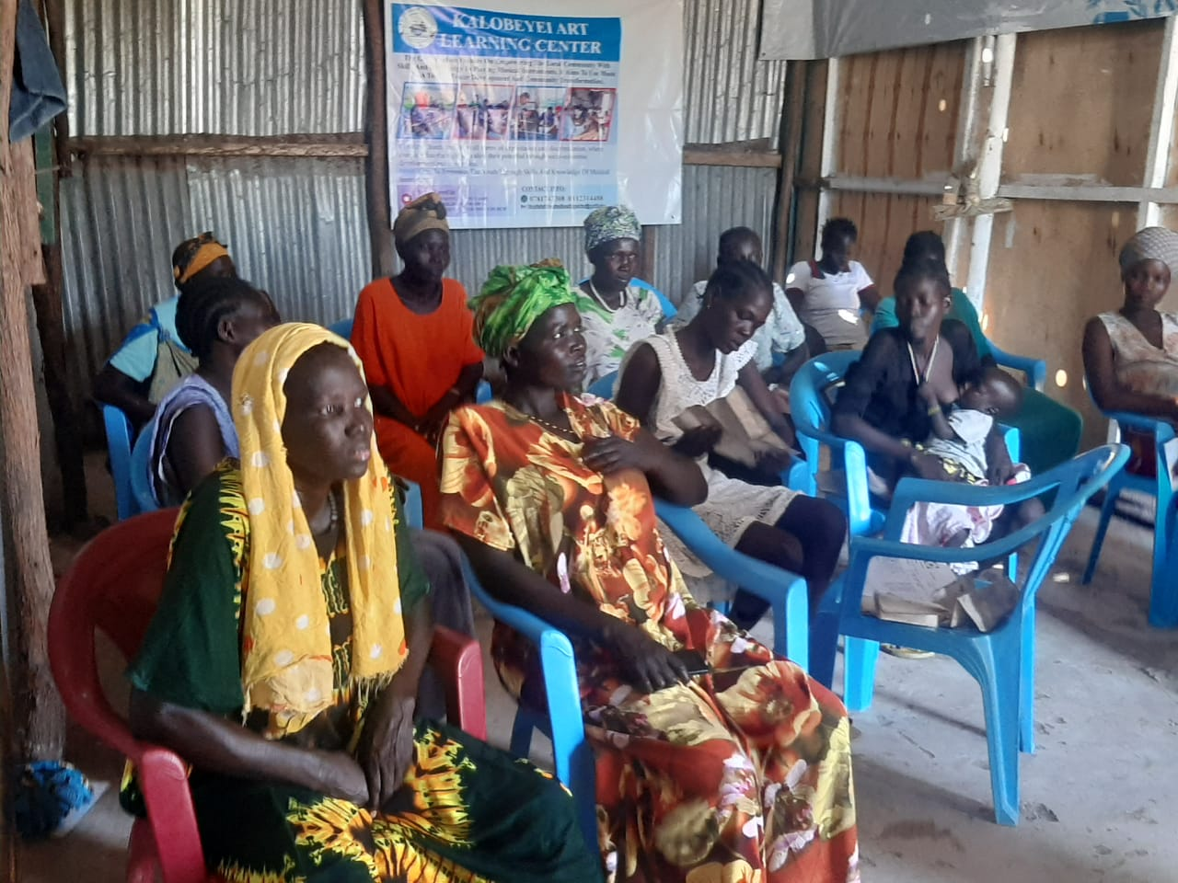
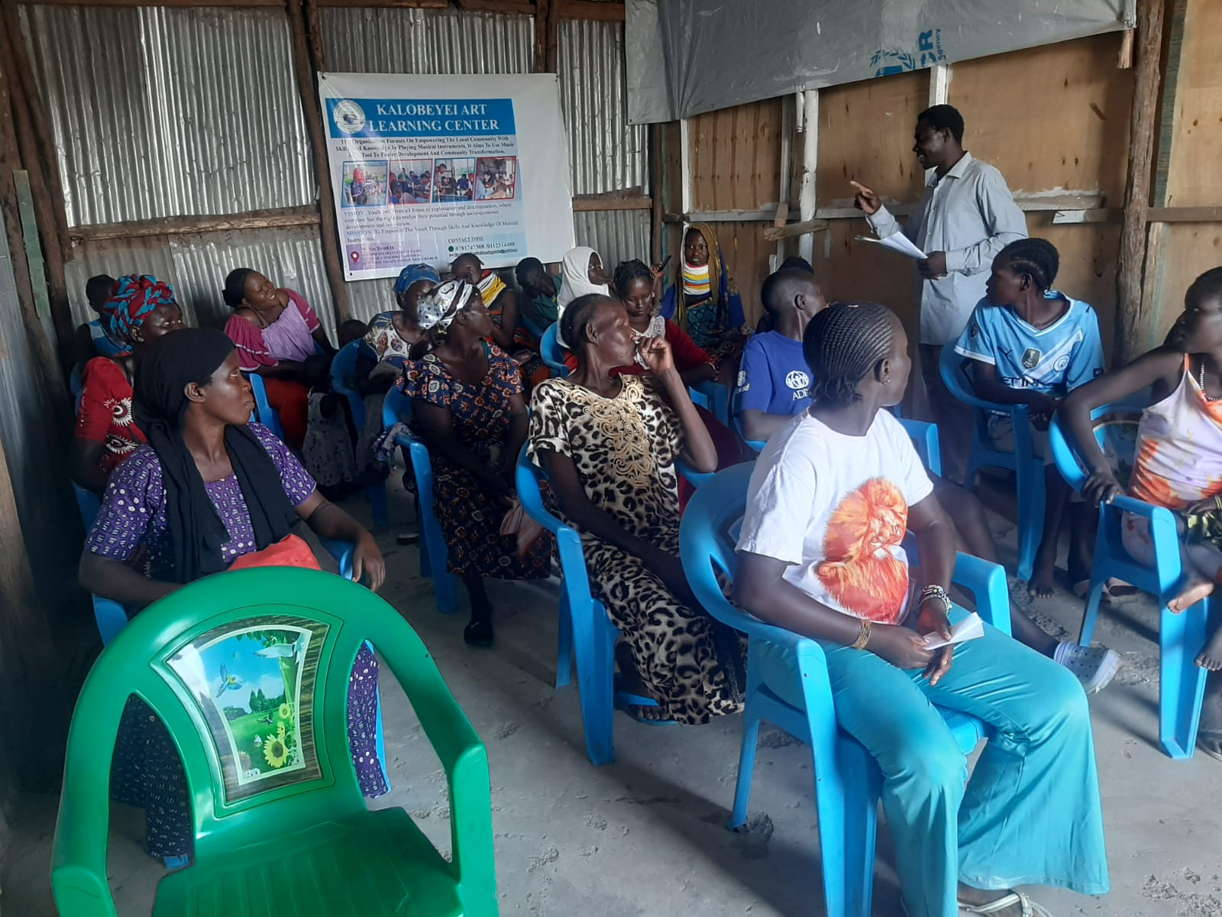
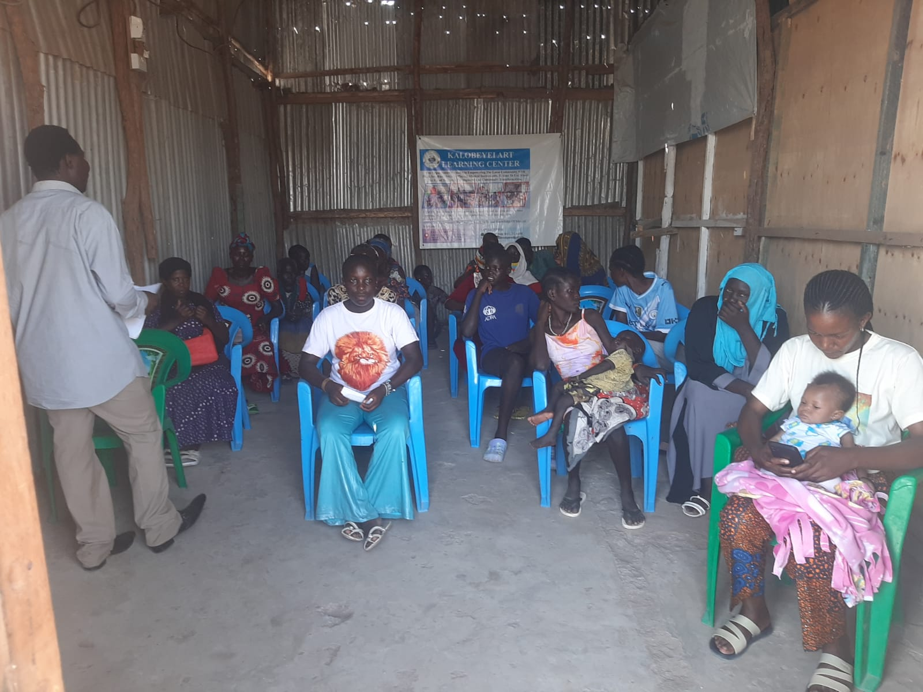
Women fully engaged in mental health training sessions, learning important life skills for resilience and well-being.
These photos represent the real-world impact of the funds we have received. The donations raised during this quarter will enable us to continue and scale up these exact activities.

3. Campaign and Fundraising Results Summary
Total funds raised since joining GlobalGiving (14 Dec 2025 – 31 Mar 2026):
- Pre-campaign donations (14 Dec 2025 – February 2026): USD 102
- Direct donations during Little by Little Campaign (March 2026): USD 1,231
- Total direct donations received: USD 1,333
- Estimated matching funds earned (Little by Little Campaign): USD 598
- Total campaign value (donations + matching): USD 1,931
- Leaderboard ranking achieved: #116
- Overall project fundraising goal: USD 7,500
We are extremely encouraged by these results. For a small, refugee-led organization in its very first GlobalGiving campaign, raising USD 1,333 in direct donations plus USD 598 in matching funds is a significant achievement. These funds will be fully used to support the arts, music, psychosocial, and peacebuilding programs outlined in our project.

4. How the Funds Raised Will Support Project Activities
The USD 1,931 already secured will be allocated as follows:
- Purchase of art materials and musical instruments
- Facilitator stipends for psychosocial support and mental health sessions
- Physiotherapy equipment and supplies for vulnerable children
- Community peacebuilding events and follow-up activities
- Transport and refreshments to ensure maximum participation
Even though we have not yet reached the full USD 7,500 target, the money received so far is already being put to work immediately to sustain and strengthen the programs that are transforming lives in Kalobeyei.

5. What Worked Well
- The Little by Little matching opportunity created healthy urgency and motivated both our team and our supporters.
- We combined WhatsApp outreach, personal messages, social media, community mobilization, and live online sessions.
- GlobalGiving’s regular emails, instructions, and support helped us stay organized and confident.
- Appearing on the leaderboard increased our visibility and credibility.

6. Challenges Encountered
- As a young refugee-led organization, our international donor network is still growing.
- Limited resources for digital fundraising and donor follow-up.
- Many supporters in the refugee and host communities face economic hardship.
- Digital access and payment barriers in our remote location.
These are expected challenges for a grassroots organization, and we are already applying the lessons learned to do better in the next campaign.

7. Lessons Learned
- Early mobilization is essential in matching campaigns.
- Personalized outreach and simple, repeated messaging work best.
- Social proof (leaderboard position) builds donor confidence.
- We need stronger pre-campaign planning and capacity building for future success.

8. Future Plans and Support Needed
With the funds already received, we will continue running weekly arts, music, psychosocial, and peacebuilding sessions. We plan to expand the number of beneficiaries and deepen our impact in the coming months.
To grow even stronger, we would welcome any additional support from GlobalGiving in the areas of:
- Digital fundraising training
- Storytelling and communications guidance
- Visibility opportunities for refugee-led organizations

9. Appreciation
We sincerely thank every donor who contributed during this first quarter and during the Little by Little Campaign. Your support means the world to the young people of Kalobeyei.
We are also deeply grateful to the entire GlobalGiving team for the platform, the matching funds, the guidance, and the belief in small, community-led organizations like ours. This partnership is already changing lives.

10. Conclusion
This has been a very encouraging first quarter on GlobalGiving. We have raised a solid USD 1,931 (direct donations + matching) and achieved a respectable #116 ranking in our very first campaign.
Although we have not yet reached our USD 7,500 goal, the funds we have received are already being used to deliver the exact programs we promised: arts, music, healing, and peacebuilding for refugee and host youth.
We remain fully committed to this project and look forward to reporting even greater impact in our next quarterly update.
Thank you once again for believing in us.
Submitted by:
Socrate Rushigira
International Head / Head Leader
Kalobeyei Art Learning Center (KALC)
Email: kalobeyeiartlearningcenter@gmail.com
Phone (Kenya): +254 112314488
Phone (Germany): +49 1525 9550502

