SPORTS EQUIPMENT ACQUISITION PROJECT

1. IDENTIFICATION
School Name: Groupe Scolaire Busogo I, Saint Benoît
Diocese: Catholic Diocese of Ruhengeri
Country: Rwanda
Project Manager / Contact Person:
Name: Father Jean Damascène TUYISHIMIRE
Phone: (+250) 785010182
Position: Headmaster of G.S. Busogo I, Saint Benoît
Email: nahum990@yahoo.fr / gsbusogoistben57@gmail.com
Bank Details:
Bank Name: Bank of Kigali
Account Name: Groupe Scolaire St Benoît Busogo I
Account Number: 100101821457

2. PROJECT TITLE
“SPORTS EQUIPMENT ACQUISITION PROJECT”

3. Description of Groupe Scolaire BUSOGO I, Saint Benoît

3.1. Location
Groupe Scolaire BUSOGO I, commonly known as GS BUSOGO I – Saint Benoît, is a publicly subsidized private school belonging to the Catholic Diocese of Ruhengeri. It was built in 1957 by Brother Hyacinthe of Nyundo, under the mandate of Bishop BIGIRUMWAMI, then Bishop of Nyundo.
The school is located in Busogo Parish, Gahanga Village, Gisesero Cell, Busogo Sector, Musanze District, in the Northern Province. Situated in the center of Byangabo, 12 km from Musanze City and 115 km from Kigali, it benefits from a rapidly growing demographic and economic environment.

3.2. Student Population
The school currently has 2,360 students, distributed as follows:
- Primary: 1,576 students
- Secondary: 794 students
- Primary level staff: 28 teachers (19 women and 9 men)
- Secondary level staff: 29 A0-level teachers (12 women and 17 men)
Thanks to the rigor of its teaching and students’ success in national examinations, GS Busogo I has built a reputation for excellence, attracting an increasing number of students from various backgrounds every year.

3.3. Context and Justification of the Project
Sport plays a vital role in the holistic education of children. It contributes to their physical, emotional, social, and cognitive development.
With a constantly growing student population, the school, in collaboration with parents, has managed to build a basketball court, two volleyball courts, and a handball field.
However, despite these efforts, the school is currently unable to provide sufficient sports equipment, and the equipment available has become worn out. Therefore, we are seeking support to provide the school with adequate and durable sports equipment.
Identified Problems
- Insufficient balls and nets for daily training
- Missing or outdated equipment for some sports disciplines
- Worn-out, non-uniform, or insufficient sportswear for competitions
- Difficulty organizing inter-class and inter-school matches
- Lack of appropriate equipment for girls’ teams
- Challenges for physical education teachers due to inadequate equipment

3. Problem Statement
With more than 2,360 students and school teams participating in various competitions, the lack of adequate sports equipment greatly limits the development of school sports. The school struggles to meet the needs of its four main sports: basketball, volleyball, handball, and football.
Without sufficient equipment:
- training sessions are sometimes interrupted or postponed,
- teachers cannot implement full training programs,
- students lose motivation,
- the school cannot fully develop its sports potential.
Central Problem:
👉 How can we ensure that all students of GS Busogo I have access to adequate, safe, and sufficient sports equipment that promotes quality physical education?

4. Project Objectives

4.1. General Objective
To improve sports practice conditions within Groupe Scolaire Busogo I, Saint Benoît, in order to promote the physical, social, and psychological development of learners through fair access to adequate, quality sports equipment.

4.2. Specific Objectives
- Provide the school with sufficient and appropriate sports equipment for the different disciplines practiced (basketball, volleyball, handball, athletics, etc.).
- Strengthen the school’s capacity to organize sports activities, including training sessions and inter-class/inter-school competitions.
- Improve sports coaching by facilitating the work of physical education teachers with proper equipment.
- Promote girls’ participation in sports by providing equipment adapted to female teams.
- Support the emergence of sports talent by ensuring a safe and motivating learning environment.
- Contribute to students’ holistic education by encouraging teamwork, discipline, perseverance, and good physical health.

5. Sports Equipment to Be Acquired
A. Balls and Equipment
- Basketballs
- Volleyballs
- Handballs
- Footballs
- Volleyball nets
- Handball nets
- Ball pumps
- Whistles and stopwatches
B. Sportswear
- Full sports uniforms for 400 student athletes
- Special uniforms for goalkeepers (football and handball)
- Professional uniforms for coaches

6. Detailed Material Table and Estimated Costs (in Euros)

No. | Item | Quantity | Unit Price (€) | Total (€)
1 | Basketballs | 10 | 56.2 | 562
2 | Volleyballs | 10 | 60 | 600
3 | Handballs | 15 | 30 | 450
4 | Footballs | 20 | 35 | 875
5 | Volleyball nets | 4 | 70 | 280
6 | Handball nets | 4 | 70 | 280
8 | Ball pumps | 6 | 15 | 90
9 | Whistles + stopwatches | 10 | 10 | 100
10 | Full sports uniforms | 200 | 38 | 7,600
11 | Goalkeeper uniforms | 8 | 30 | 240
12 | Coach uniforms | 10 | 40 | 400
 | Estimated Total: 11,477 € |  |  | 11 477 €

7. General Project Budget
Total material cost: 11,477 €
(Exchange rate: 1 Euro = 1,600 Rwandan Francs)

8. Expected Impact
For students
- Fair and safe access to sports
- Increased motivation and improved performance
- Development of teamwork, discipline, and leadership
- Improved health and reduced sedentary behavior
For the school
- Strengthened reputation in the region
- Increased participation in competitions
- Better performance in inter-school and inter-class tournaments
- Improved organization of physical education programs
For the community
- Strengthened school–parent relationships
- Promotion of sport as an educational and social cohesion tool

9. Project Sustainability
To ensure long-term use of the acquired sports equipment:
- Establish a quarterly inventory system
- Train teachers on equipment maintenance
- Raise student awareness about responsible use
- Assign a person responsible for sports equipment
These measures guarantee optimal and durable use of the materials.

10. Photos of the Sports Grounds

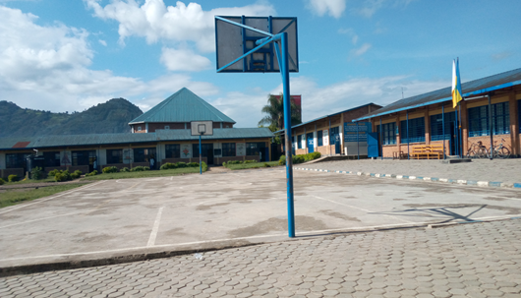
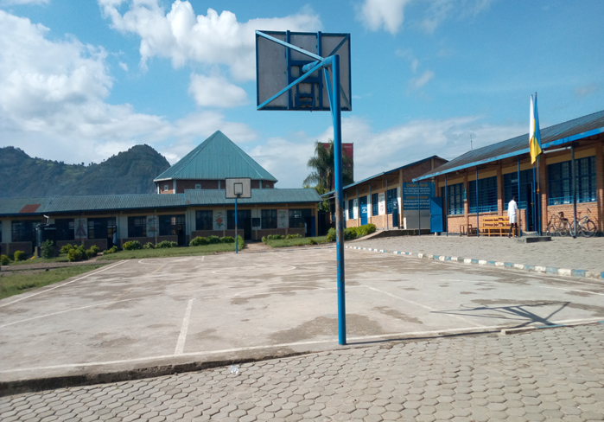
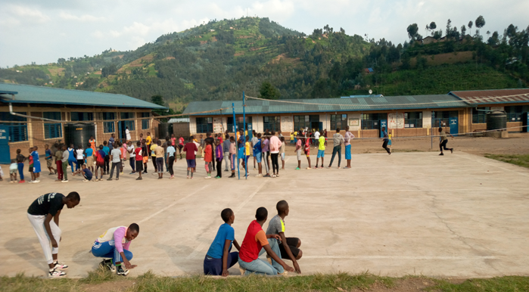
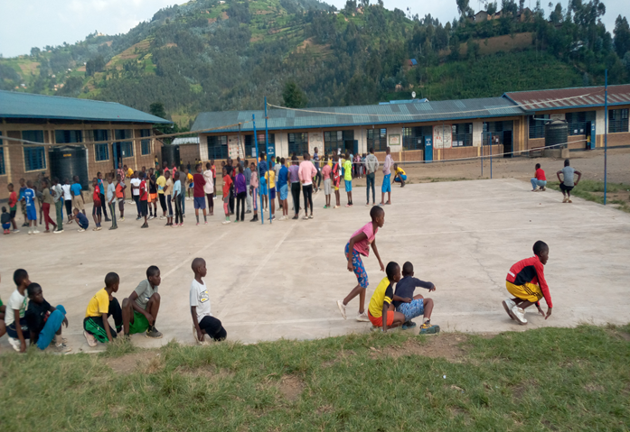
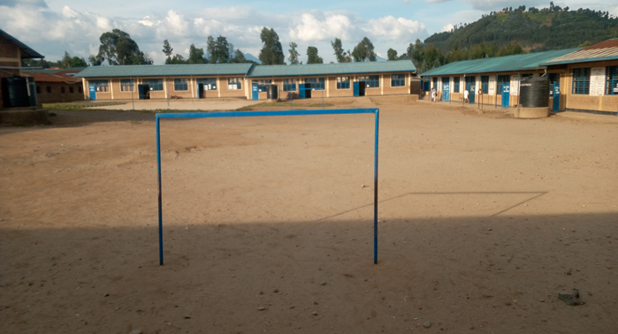
Terrains de Basketball
Terrains de volleyball
Terrain de handball

11. Conclusion
This project aims to respond to the urgent and real need to improve the sports environment at Groupe Scolaire BUSOGO I – Saint Benoît. With over 2,360 students, investing in modern, sufficient, and appropriate sports equipment is essential to support children’s holistic development.
Implementing this project will:
- improve the quality of physical education,
- promote gender inclusion,
- strengthen school teams' performance,
- contribute to students’ health, discipline, and motivation.
We therefore seek the support of any benefactor willing to contribute to the promotion of education and sports in Rwanda.

Done at Busogo,
Groupe Scolaire BUSOGO I, Saint Benoît
Father Jean Damascène TUYISHIMIRE
Headmaster

