 Tell Our Story

Project Title:
NOTDEC working to save babies in Western Uganda whose mother’s have died in childbirth
Summary:
We work in a remote mountainous area of Western Uganda, with high maternal death rates. When a mother dies in childbirth the family has no means to replace mother’s milk, the baby will also die without intervention.

Bottle feeding is not widespread, and formula milk is generally inaccessible and unaffordable, particularly in remote rural districts.

NOTDEC can train a family member to care for the baby, or we care for the baby at the centre. We provide milk until the child is 12 months old, at a cost of 1,500 US$. At any one-time NOTDEC can be supporting up to 16 babies in this way.

Recommended 500 character maximum
Funding Amount/Goal: We hope to raise initially US$ 5000

Challenge  A rapid response is needed to save the baby’s life. Once a motherless baby has been located, and NOTDEC alerted, we must consider if we have adequate resources to fund formula milk for 12 months.  Should the baby need to be admitted to the centre there will be long-term costs including education till the child reaches an age of independence.  This can be a very difficult decision. If NOTDEC cannot provide support, it is most likely the baby will die. | Solution  A commitment to provide milk for the first 12 months is normally enough to guarantee a baby will survive. We have had to turn babies away when we do not have enough funding.  We can have 12 new babies admitted to our centre every year.  Additional funding in this area will enable NOTDEC to provide an intervention to save a baby’s life.  A local municipal health review said there were 488 maternal deaths in Kasese district alone in 2024/5.  Kasese is just one of the districts NOTDEC serves. | Long-Term Impact  Saving a baby’s life is why NOTDEC exists, and what NOTDEC continually tries to do in very challenging circumstances.  This would be the first step in a child’s life, with the possibility of ongoing support through close family or in our centre for years to come.  This then raises issues in how we can provide support to cover the years ahead, and work with Ugandan agencies and relatives to ensure the child has the best chance in life.

Donation Options: How can you illustrate the impact of a person’s donation? For the purpose of this exercise, we recommend outlining three donation options under $100.

Amount | Description
$22 (£16) | Cost to train caregiver on how to bottle feed
$65 (£48) | Travelling costs for social workers to check on one baby’s progress six times in year
$100 (£75) | 7 tins of Cow and Gate milk for one baby for 3 weeks
Photo Gallery

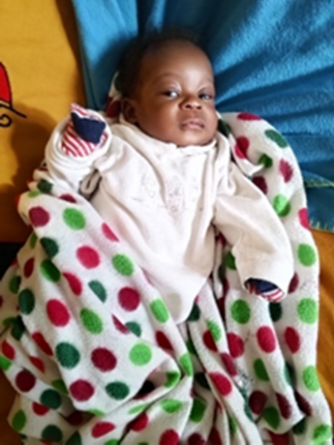 | 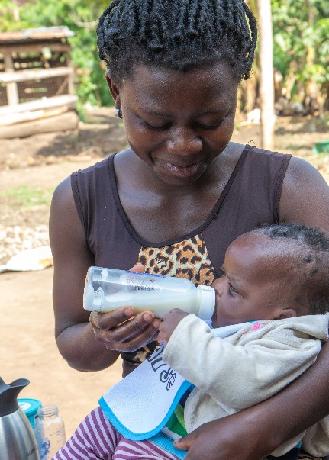
Apton’s son Alvin | Feeding bottled milk
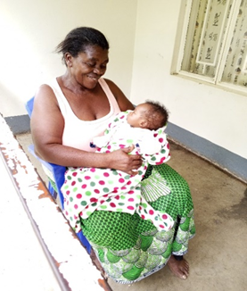 | 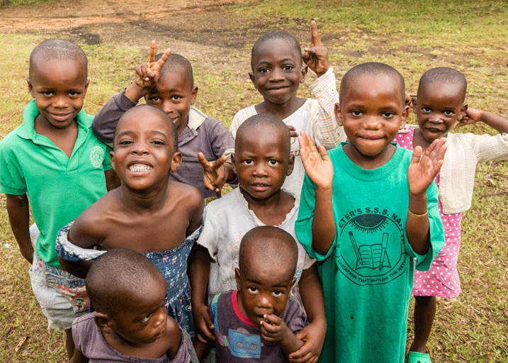
Mother Jesca with Alvin at NOTDEC | NOTDEC children

