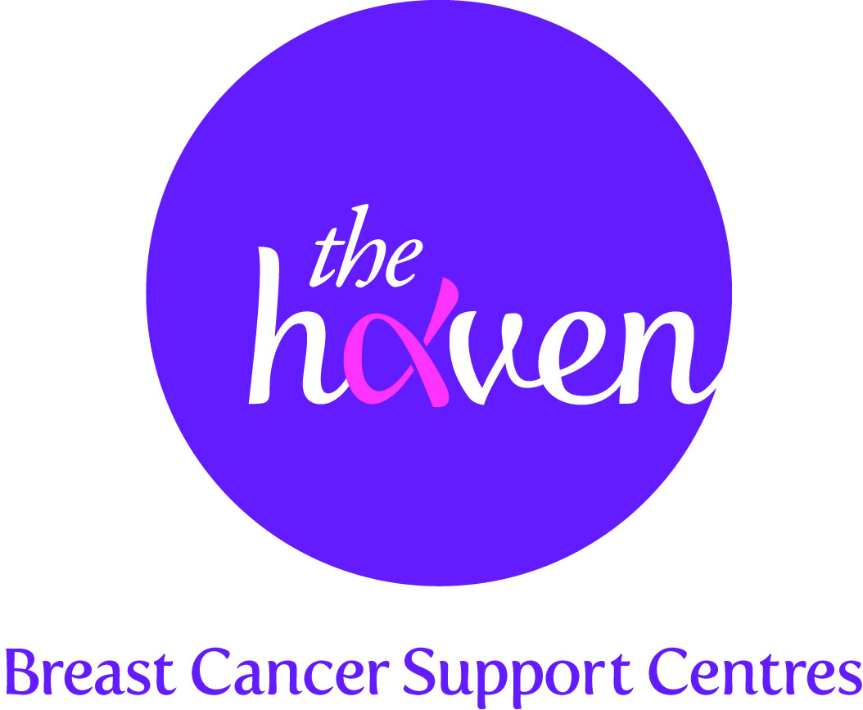
The Haven: Breast Cancer Support Centres

An update on recent activities, November 2015

- We have opened our fourth centre – The Wessex Haven
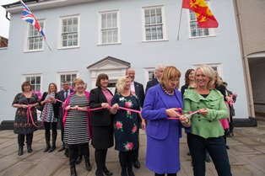Following our successful £1.5m campaign, we were very proud to open our fourth centre, The Wessex Haven on 23 October. This coincided with the global campaign, Breast Cancer Awareness Month. A range of VIPs and guests helped us celebrate the opening as our CEO cut the ribbon. Since opening we have welcomed around 30 breast cancer patients to this new centre.

- The Haven receives £2.65m from central Government
In the Chancellor of the Exchequer’s Autumn Statement, we were absolutely thrilled to receive a huge grant of £2.65m. This includes £2.5m towards a new Haven centre in Solihull in the West Midlands. Over the last two years our Hereford Haven has been hosting breast cancer support days in Solihull which has been very popular. For the many hundreds of women affected by breast cancer in the region a new Haven centre will come as extremely good news.

- #NeverByMySelfie celebrity t-shirt campaign trends on Twitter
Our celebrity t-shirt campaign for Breast Cancer Awareness Month, dubbed #NeverByMySelfie, proved to be a huge success. Not only did the two stunning designs fly off the shelves on the UK’s largest online clothing retailer, ASOS, but the response from celebrities backing the campaign was beyond our dreams. International pop star, Kylie Minogue and top chef, Gordon Ramsay were just two stars who took selfies wearing the tee and posting the images onto social media. Teen sensation, Harry Styles, signed a t-shirt for a Twitter competition organised by top magazine, Heat. The star’s massive following resulted in #NeverByMySelfie trending on Twitter.

- Best ever fundraising event for The London Haven
To kick off Breast Cancer Awareness Month we held our annual signature fundraising event, Blush, on 1 October at the plush West End venue, One Mayfair. Stars from stage and screen joined us in making this a memorable occasion and a huge £160,000 was raised on the night. This is the most we have ever raised from a Blush event.

- A Visitor’s story, Daniel Wellinder – our emotional help is also available to family members and close friends

“The Haven helped us to support each other much better and I would say to anyone who may be the partner of someone going through breast cancer, don’t be afraid to ask for help especially as these are people who really understand what you are going through”

Victoria and I have been together since we were 17 and married for six years and although we both had demanding careers, we were at the point of really settling down and starting a family. It all started when my wife Victoria mentioned that something didn’t feel right in her left breast. Our doctor quickly referred us to a consultant who immediately sent Victoria for a scan and a biopsy. We were both called back into the consultant’s office and I noticed that a breast care nurse was also present. The doctor told us that they had seen something they didn’t like and this made me feel frightened as you know when they use a phrase like this they are trying to soften bad news. When the results of the biopsy came in they confirmed breast cancer and when I heard this my whole world fell apart, I was shocked and surprised and didn’t know what to feel.

wondered how I was going to help Victoria, I had no idea, and They told us that they wanted to carry out an operation to examine Victoria’s lymph nodes first, then she would undertake chemotherapy to shrink the tumour before having surgery to remove it. Before she started her chemotherapy course Victoria and I went shopping for a wig and we tried to make it fun but I must admit that I really didn’t think that I would be doing something like this at our age.

Victoria bore the chemotherapy well, the after effects would hit her 24 hours later but she said it was just like having flu with aching limbs. I felt terrible for her but she was remarkably sanguine and It was during this period, that we started visiting The Haven. Victoria benefitted from a whole range of treatments and for me the counselling gave me a chance to open up and expose my emotions. I think it’s a guy thing not to show emotion and although I was very close to and well supported by my parents, I didn’t want to upset them.

Victoria had her breast surgery last August and the doctor told us she was free to get on with her life. I was over the moon at this news. Going through something like breast cancer does put a huge strain on your relationship; you have to put things like ambition and dreams for the future on hold. The Haven helped us to support each other much better and I would say to anyone who may be the partner of someone going through breast cancer, don’t be afraid to ask for help especially as these are people who really understand what you are going through.

