Breast Cancer Haven: An update on recent activities, May 2016

We have refreshed our brand

As we seek to expand our services across the United Kingdom we thought it was time to refresh our identity. We were delighted to receive pro-bono support from a top UK branding agency which has evolved the existing brand to give it greater impact and resonance with our target audiences. The charity has been renamed Breast Cancer Haven with the tagline Your help through the toughest times. We hope you like the new look.

We have found a building for our West Midlands Haven

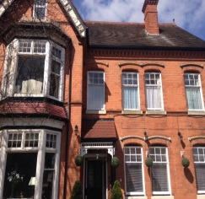Following the generous gift from the Government, we have been able to purchase a property in the town of Solihull, which will be home to our West Midlands Haven. The West Midlands Haven will be available to women across a region that has around 2,478 new cases of breast cancer every year. We intend to open this new centre in October 2017.

London Marathon runners raise $56,000 for Breast Cancer Haven
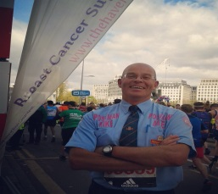On 24 June we had fourteen runners pound the London streets as they took part in the capital’s world-famous Marathon. So far they have raised an amazing $56,000 for the charity which will go towards supporting around 38 women through breast cancer. We are indebted to them for taking part in this gruelling challenge for the cause.

Opening our London Haven on Saturday mornings

In an effort to ensure that our support services are as accessible we have opened our London Haven on Saturdays mornings. Many of our visitors struggle to attend our programme during the working week so being open at the weekend offers a more flexible choice for those who have returned to work after the breast cancer treatment has finished.

Jess’s story

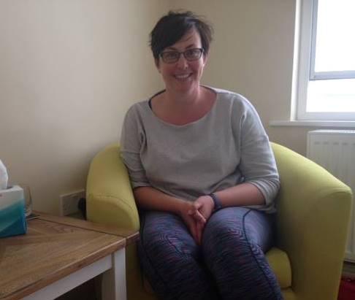Jess is 38 years old, has a 5 year old son, and lives in Gosport (Hampshire) and is a teacher in a local school. Jess’s life was turned upside down in January when she received a breast cancer diagnosis, it was a huge shock and life’s priorities suddenly changed overnight.

Jess was given a leaflet about The Haven from her sister and was able to attend an introductory day in February where she learnt about how we were able to assist her with the side effects of surgery and treatment that lay ahead.

Jess faced a mastectomy and reconstruction in March, and has begun chemotherapy this week; she is bravely facing her breast cancer head on and with great spirit. Jess said:

“The Wessex Haven is so friendly and welcoming and is helping me be positive about my breast cancer diagnosis. I have the opportunity to speak to people whose knowledge and expertise is specific to breast cancer, and receive tailored support and therapy that is unique to me. Where else would I go for such support, my friends are wonderful but here is about a process of moving forward and is somewhere for me to be reassured, with expert care and understanding. At the Haven I am given time to talk, to just be. I have found the breast cancer support group for younger women a positive way of sharing fears, experiences and making friends going through similar things”

