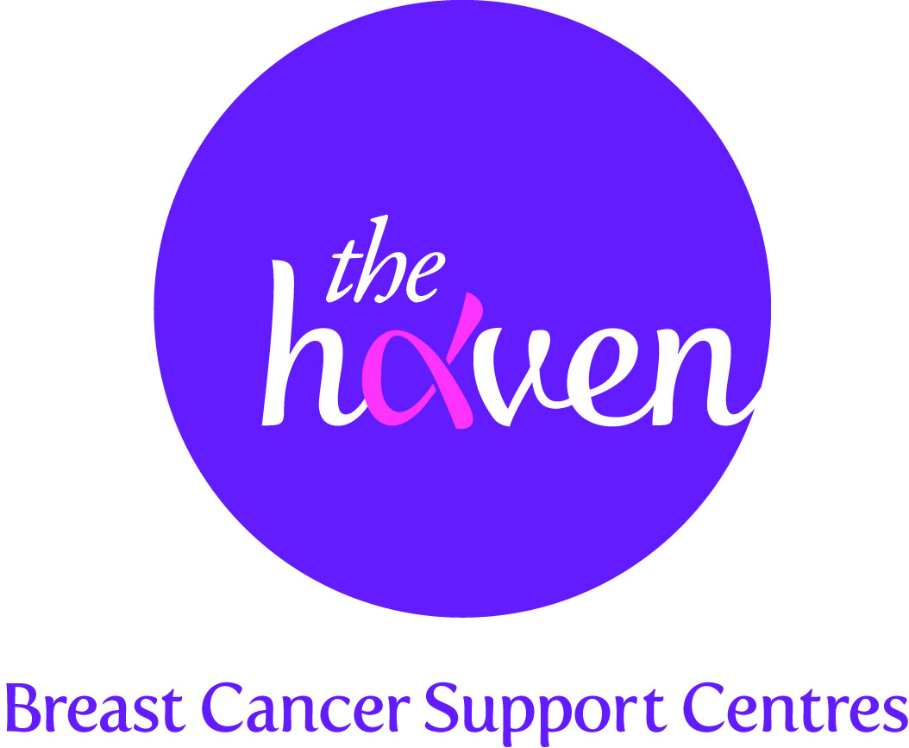
The Haven: Breast Cancer Support Centres

An update on recent activities, May 2015

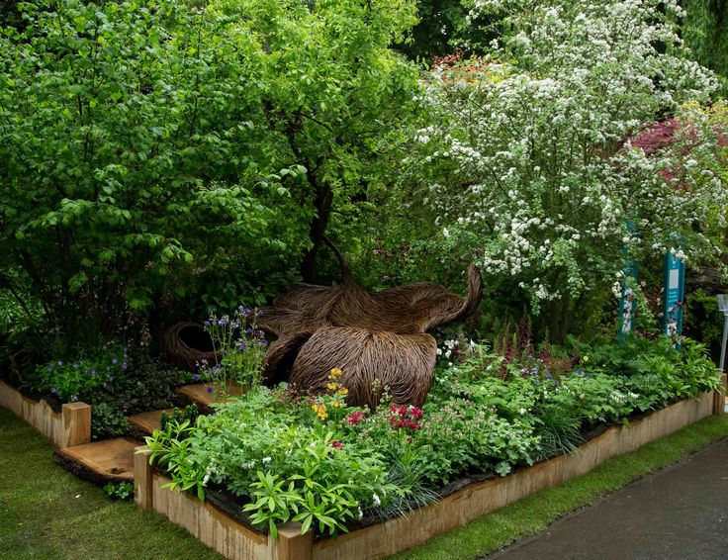
- We won a Gold Medal at the RHS Chelsea Flower Show
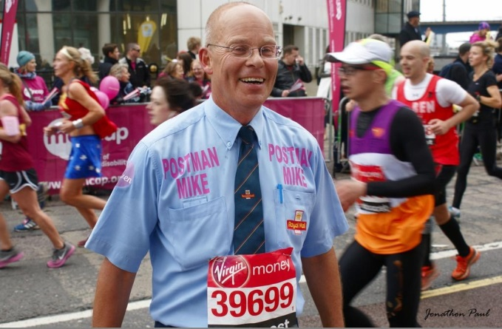
For the first time ever, The Haven exhibited a garden at the world famous RHS Chelsea Flower Show. The artisan garden, designed by nine times gold medal winner Sarah Eberle, was called Breast Cancer Haven and aimed to evoke the feelings that our Visitors get when they walk through the doors of our Haven centres. The stunning garden design, which centres around a willow woven oak leaf ‘nest’, is inspired by The Haven’s uplifting and reassuring support programme. We were all delighted to win one of the coveted Chelsea gold medals. The whole Chelsea experience has given us an unprecedented opportunity to raise awareness of our charity’s breast cancer support programme to around 200,000 members of the public that visit the Show every year.

- Another great London Marathon for The Haven
We had more runners than ever taking part in the London Marathon for The Haven in April. And for the tenth year running, a postman from Hereford, took part in his postie uniform and managed to raise an amazing £20,000. We are so grateful to these amazing people who help raise the vital funds we need to run our services.

- Our service users take to the catwalk
Leading UK premium clothing brand, LK Bennett, organised an evening of fashion and beauty to raise money for The Haven. Six of our London Haven service users took to the catwalk to model the brand’s spring/summer collection. We were delighted that the event raised well over £2,000 for the charity.

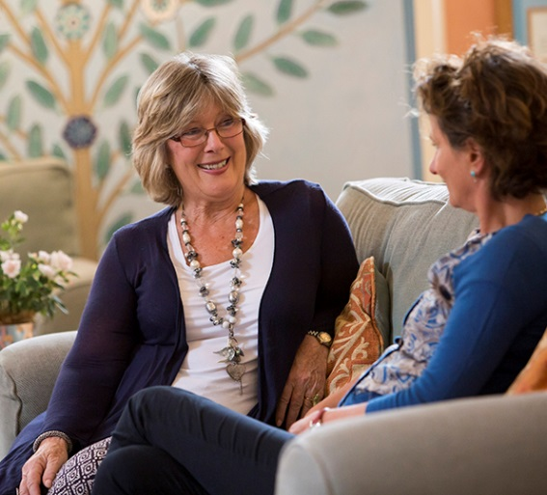

- Putting secondary breast cancer patients first
In conjunction with the UK’s leading website for parents, Mumsnet, we have just launched a spring campaign which aims to raise £50,000 to provide tailored support services for people coping with the emotional fallout and long-term treatment for secondary breast cancer.

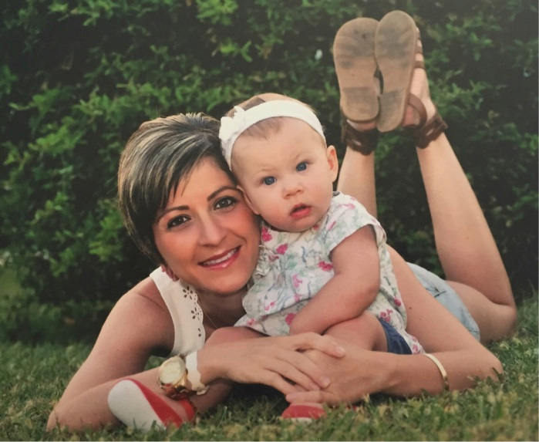
- A Visitor’s story, Hannie

“The people at The Haven have been my saviours. They gave me support when I needed it, helped me to understand what’s important and get my life back on track.

I was 29 when I noticed a lump in my left breast. I went to the hospital and they didn’t think it looked too suspicious and told me not to worry about it, but I just knew that there was something wrong. After the lump became larger my GP sent me back for a biopsy and the results showed abnormal cells.

My mother and brother were with me when they told me the diagnosis and they both started crying but I started laughing, I couldn’t control it, I think it was just total shock. The doctor looked at me and asked if I was alright but I just said I was fine, I then turned to my mother and brother and said it’s alright I’m fine. That same week I had a pregnancy test and found out I was pregnant.

I was advised to terminate the pregnancy - they needed to concentrate on looking after me but I told them that I wasn’t prepared to do that and would let nature take its course. I moved back in with my mum.

Within a week I went in for surgery and as I was 6 weeks pregnant at the time they changed the order of my treatment and decided to give me chemotherapy no earlier than my 2nd trimester.

When I started my chemotherapy I was working as a media consultant for a local newspaper and I did this right up until my daughter was due, looking back I don’t know how I managed this . The weekend after I left work my contractions started and my daughter was born on the Monday. It was a traumatic birth, I lost lots of blood and later haemorrhaged and they had to rush me back into hospital and give me a blood transfusion. Because she was premature my daughter was born with a serious stomach condition Necrotizing Enterocolitis (NEC) and was given special fluids and kept in hospital for 6 weeks. The day that she came home I had to go and have my second round of chemotherapy. In the meantime my relationship broke up, my partner had promised to support me through my treatment but found he just couldn’t handle it.

I was determined to look after my daughter myself and I think I went into automatic “Mother” mode which just kept me going.

This should have been the end of it but unfortunately the cancer came back very aggressively. They put me on a new course of chemotherapy drug and said if this didn’t work they didn’t know what they could do but they would help me through it. My chest was the size of a watermelon but the new drug had an amazing effect, it halved in size with the first treatment and continued to reduce in size with each treatment. I then went in for a double mastectomy.

While all of this was going on I was living at my parent’s home but declined their help because if anything happened to me, I wanted to be the one who had done everything for my daughter. My scars from my mastectomy were having trouble healing which they put down to my weakened immune system and then just as I was about to start my radiotherapy more lumps came up and so I had to go in for more surgery. I had my 16 sessions of radiotherapy and that was all fine. More recently I had a lump come up in my right breast so I had yet more surgery and a further 15 sessions of radiotherapy. The latest scan shows that it has not come back but I feel as if I am in limbo at the moment. I have been through an awful lot but my daughter has been my saviour. She’s 18 month’s old now. I think if she hadn’t been there I would have lost myself.

Recently one of my friends from work was diagnosed with breast cancer last year and she asked me for advice. I gave her what advice I could and she told me all about The Haven. I’m so glad that I picked up the phone and went along. They have been an amazing support and made me feel so welcome. They really listen which is so helpful especially when there is so much going on in your head. Sometimes I have to take my daughter and they are always so nice to her, they don’t judge you they listen to you. I wish I had known about The Haven a lot sooner as it could have really helped me as I went through my treatment. I have had various therapies, acupuncture was amazing, massage left me feeling really relaxed and the nutritionist gave me some good dietary advice and recommended vitamins to take. I’m now looking forward to going to “Mind and Body” session to help with stress.

I look at the future now more positively, a year ago I had been really scared not knowing if I was going to make it or not but I just want to be here with Grace and watch her grown up. I really appreciate that I have had 18 months with her and now when I look to the future I think if it comes back, it comes back, I’m not going to get upset about it, I’ll just deal with it.

The people at The Haven have been my saviours. They gave me support when I needed it, helped me to understand what’s important and get my life back on track.”

