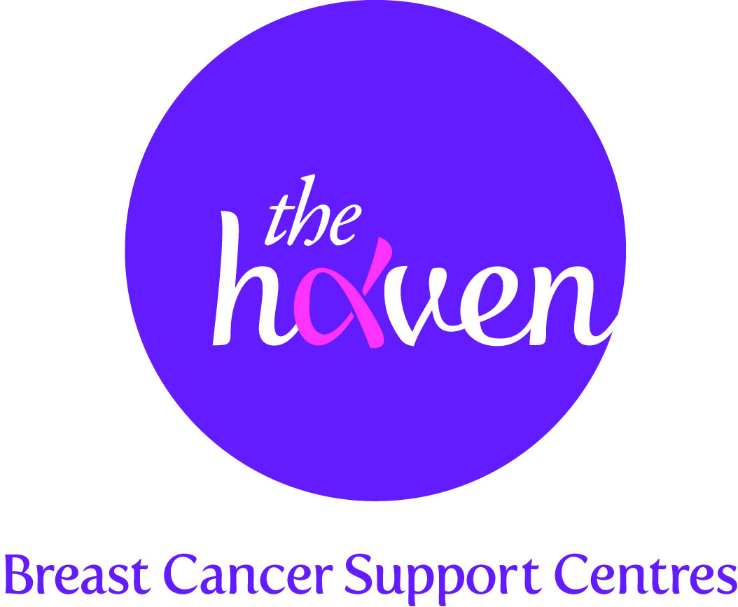
The Haven: Breast Cancer Support Centres

An update on recent activities, December 2012

- Breast Cancer Awareness month (BCAM)
The Haven was very busy during October which is globally known as Breast Cancer Awareness Month (BCAM). This focus on breast cancer issues gives charities like ours a valuable opportunity to raise awareness about what we do and also helps to raise precious funds. We were delighted to work with a new corporate partner this year – Ugg Australia, the US makers of the famous sheepskin boots. They produced a Pink Ribbon Collection which was sold globally to help breast cancer charities the world over. The Haven was lucky to be selected as the UK charity to benefit from this campaign. We hope to raise $32,500 from this partnership.

- Husband pushes himself to the limits for wife & The Haven
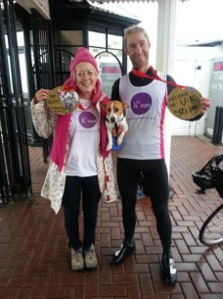
A young husband whose wife had breast cancer undertook the physical challenge of his life to help raise money for The Haven. His wife, Patricia, attended our London centre and her husband was so impressed by how much this boosted her recovery that he felt compelled to put something back. Ettienne de Beer, circumnavigated the entire UK coastline (4500 miles) by running and cycling in just 50 days in September/October. Having successfully completed this gruelling challenge, Ettienne hopes to raise around $160,000 for The Haven.

- Easing the financial concerns of breast cancer patients
Having money worries on top of coping with a serious illness can be overwhelming. Many people find that they are unable to work but still have bills to pay, or they are in retirement and finding their savings depleted. In the first two months of a new Welfare Benefits & Money service, our Adviser has helped over 50 people gain available benefits and grants.

“At a time when I was mentally and physically low – not to mention financially desperate – I benefited greatly from The Haven’s exceptional care and assistance. The service was of the greatest value to me” – Alexandra, London Haven

- Helping the Storm Sandy victims

The Haven’s Chief Executive, Pamela Healy, was planning take part in the New York Marathon to raise money for the breast cancer charity, Walk the Walk, in November. Because of the devastation caused by Storm Sandy the event was understandably cancelled. As Pam was already in New York, she, along with several other women, took part in the rescue effort, taking food and supplies to those affected in Statten Island. She found it a particularly moving experience but was glad that she could be some help during this dreadful time for the city.

- New acupuncture study

The Haven was delighted to provide case studies and its Acupuncture therapists for a new study into how the practice can alleviate cancer related fatigue. The research conducted by the University of Manchester in conjunction with the charity, Breakthrough Breast Cancer, found acupuncture to be effective in helping patients affected by fatigue. Acupuncture is one of the most popular therapies offered at The Haven with many of our Visitors saying that it helps with a range of side effects caused by breast cancer treatment.

- A Visitor’s story, Lisa Morgan, London

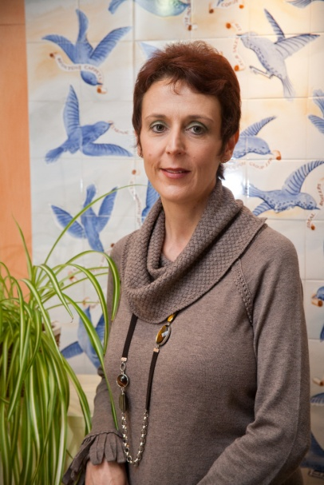
It sounds crazy but when I was diagnosed, my initial thought was “how on earth am I going to tell my family?” I was 42, about the same age as my mum was when she had breast cancer over 20 years ago so it was going to bring back a lot of painful memories. Although I already knew a fair amount about treatment, I was pretty emotional and knew I needed some post-op support.

My breast care nurse gave me a leaflet about The Haven so called them up and the lady I spoke to was really kind and reassuring. After listening patiently as I blurted everything out she said “we can help” and invited me in. It was incredible; I felt an immediate sense of relief just knowing that I wouldn’t have to burden my husband and family with my emotional outpourings quite so much. I came in to see The Haven’s nurse, and again let it all out whilst she explained how the Haven worked. She really listened to me and suggested things I would find helpful. At the end of it, I had a personalised, tailored programme of therapies which helped me feel as though I could start to regain a sense of control.
Mind Body therapy was amazing. The therapist asked some quite challenging, emotionally charged questions and showed me some powerful visualisation techniques to help with my anxiety. She has a very calming influence and I always left her sessions a lot more composed than when I walked in. She made me start to think about things in a different way. I started to take stock of where I was rather than just rushing around trying to figure it all out for myself.

I went to see the Medical herbalist and believe that the herbs she prescribed- a tincture to help with the toxifying effects of radiotherapy, a calming tea and some soothing skin cream to treat the affected area - made my radiotherapy a lot more bearable than it might have been. I didn’t suffer any of the burns or the fatigue that I’ve heard some other people have.

The ‘Living Well. Moving On’ course I attended was also really helpful. We were all at slightly different stages of our post-treatment journey so it was great to share experiences and realise that my current emotional state was ‘normal’ and simply part of the healing process. I found the life coaching models and homework we were given particularly helpful in focussing my mind and helping me look ahead.

And what next? Well, I learned that it was important to give myself time to heal, physically and emotionally, so I did just that and I’m now moving forward. I eat a healthy and well balanced diet. I’m doing some voluntary work and starting to think about returning to permanent work. Who knows, maybe I’ll even try something different. Whatever I end up doing, thanks to The Haven, I now have a number of self-help tools to help me cope, regain a sense of control and simply get on with normal life. I can’t begin to explain how incredibly beneficial all my sessions were and, I really believe that I’m in a much better place to move on with my life thanks to all the wonderful people at the Haven. Thanks to them, the old Lisa is back!

