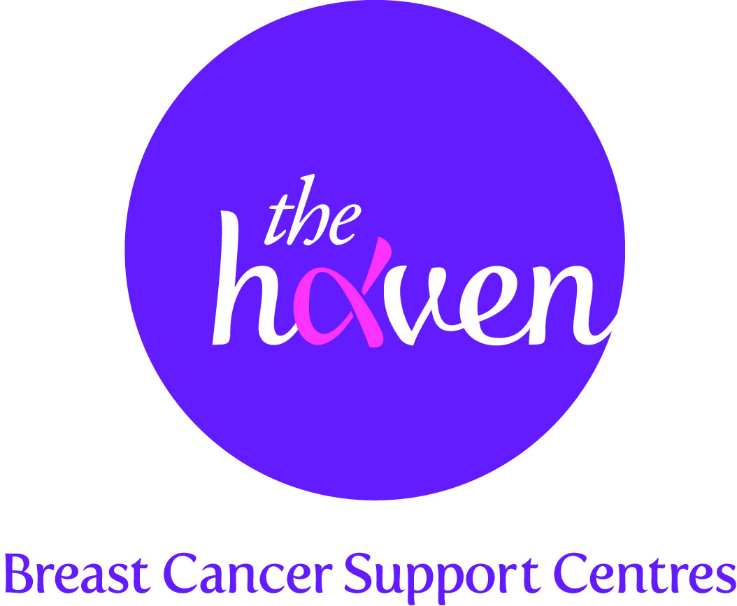
The Haven: Breast Cancer Support Centres

An update on recent activities, August 2015

- We won a Gold Medal at the RHS Chelsea Flower Show
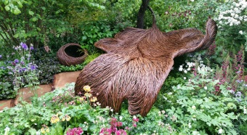For the first time ever, The Haven exhibited a garden at the world famous RHS Chelsea Flower Show. The artisan garden, designed by nine times’ Gold medal winner Sarah Eberle, was called Breast Cancer Haven and aimed to evoke the feelings that our Visitors get when they walk through the doors of our Haven centres. The stunning garden design, which centred around a willow woven oak leaf ‘nest’, was inspired by The Haven’s uplifting and reassuring support programme. We were all delighted to win one of the coveted Chelsea Gold medals. We also won the support of the public who voted our garden The People’s Choice. The whole Chelsea experience has given us an unprecedented opportunity to raise awareness of our charity’s breast cancer support programme to around 200,000 members of the public that visit the Show every year.

- Opening date for our new Wessex Haven
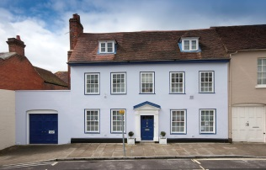The excitement is building as we now have an opening date for our new Wessex Haven. During Breast Cancer Awareness Month on 23 October we will be opening our doors to the many hundreds of women affected by breast cancer in the Wessex region. This will include the counties of Hampshire, Sussex, Dorset as well as the Isle of Wight and the Channel Islands. This will now take the total of Haven support centres to four, with more planned to open in the future.

- Our website will be getting a bright new facelift
A generous donor has enabled us to build a brand new website for the charity. The new site, which will be fully mobile optimised, will have a simple, but eye-catching contemporary design, where visitors will be able to access information at just one click. Our growing social media presence will also be fully integrated into the site. The site is due to go live at the end of August.

- Celebrities get behind our designer t-shirt campaign
Top celebrities, including singing sensation, Kylie Minogue and Olympic medallist, Louis Smith MBE, will be getting behind our new designer t-shirt campaign. Clothes designer, Savannah Miller, sister to international film-star Sienna, has designed two exclusive t-shirts for The Haven which will be sold on the UK’s top clothing website ASOS during Breast Cancer Awareness Month. A long list of celebrities will be photographed modelling the t-shirt which will be shared across social media. We are hoping that the celebrity endorsement will help raise awareness of the charity and boost sales of the t-shirt which will benefit several women who need our vital services.

- A Visitor’s story, Michelle

“I had a serious bicycle accident and then received a letter saying I needed breast surgery within the same week!”

A year ago I found a lump when I was doing yoga, I’ve always had lumpy breasts and so I usually ignored it but this time the lump was sore. I went to the doctor and within a week they saw me at Guy’s Hospital. A scan discovered lots of cysts so they took a biopsy.

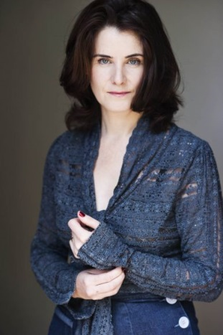
The following day I went cycling with my husband and I was belting down Camberwell High Rd when I was thrown off my bicycle and was knocked unconscious. I was rushed to King’s trauma unit with a head injury and a hairline fracture to the jaw. It was very traumatic and that week passed in a daze of pain killers. At the end of that week I received the next shock - a letter from Guy’s saying that I had to have breast surgery.

Three weeks after my accident I had the surgery and then because I am an actor and singer, almost immediately I had to go on stage to do a play. After the play had finished I had more surgery where they removed a collection of pre-cancerous cells. My next appointment was on New Year’s Eve where the Oncologist told me that I should have radiotherapy. I couldn’t really take in what was happening to me. I thought “come on then, let’s get this thing over with” but really I was confused, angry and still in shock.

Having the radiotherapy and sitting with all the other people was when I woke up to it all and took a huge nose-dive. It knocked me for six. I couldn’t stop sleeping, I felt leaden with limited energy and lost my usual vivacious self.

After my penultimate radiotherapy session I spoke to someone at Guy’s Dimbleby Cancer Centre who told me about The Haven. After my first chat with a senior therapist I just felt like I had found my people and everything was going to be OK. The therapist suggested various therapies such as acupuncture and craniosacral therapy, which amongst other things eased the shock I was still suffering from. The nutritionist has revolutionised my life and the financial adviser was incredibly informative and helpful. The mind, body therapy sessions have really hit a chord and prompted me to make significant changes in my life around my career, relationships and what makes me happy.

I am feeling good now; much more positive about the future. I want to take the time to recalibrate the last year and move forward positively. I’m actually in a much better mind-set than even before my diagnosis and a lot of this has been down to the inspiring people at The Haven.

